CYNGOR CYMUNED

GOETRE FAWR

COMMUNITY COUNCIL
MINUTES OF THE MEETING HELD AT LLANOVER VILLAGE HALL & BY TELECONFERENCE ON MONDAY 17th OCTOBER 2022

Present: Community Councillors Owen Dodd, Andy Barnes, Jan Butler,
Nigel Morrey, Janet Robins, Peter Daniel and Morgan Chandler

Guests None
In Attendance: Jonathan Lazenby (Clerk)
Apologies: Community Councillors Scott Grayland and Youth Representative Chloe-Marie Tapper
 |  | ACTION
1 | Apologies for Absence.  As above.
2 | Declarations of Interest.  The Chair commenced by asking the members present whether they had any declarations of ‘interest’ to make, which includes previous declarations already made. The Chair reminded members that they should notify the meeting of any additional interests which became apparent during the progress of the meeting. No interests were forthcoming. | All / Clerk
3 | Chairman’s Remarks.  The Chair welcomed everyone to the meeting.
4 | Approval of minutes of the Council meeting held on 27th September 2022.  The last line under item 5 should read, ‘there were no other matters arising (not maintenance). The Clerk corrected this. Councillor Dodd also asked that the reason for absence for himself and Councillors Butler, Morrey and Robins reflect their appointment to the Community Centre Management Committee by the Community Council. The minutes were then proposed as a true and correct record by Councillor Barnes and seconded by Councillor Chandler. However, as there were no other Councillors present from the previous meeting, a quorate vote could not be obtained, and so the minutes were taken as read. | Clerk
5 | Matters Arising.  - Item 5(ii) – The final Conduct presentation, organised by MCC has now taken place with all members of Council having now attended.  - Item 5(iii) – Chloe Tapper (Youth Representative), has now submitted her declaration of ‘interests’.  - Item 6(i) – The hedges bordering Ton Land have now been cut and the bill paid.  - Item 9 – The Clerk has confirmed to Mr Naveed, the Community Council’s permission (under the terms of the lease), to the sale of alcohol in the Olde Pounde Shop (subject to MCC Licensing). A letter has been sent which Mr Naveed has signed confirming he will observe any MCC terms.  - Item 10 – The lease on Ton Land has now been advertised.  - Item 13 – The cheque from Gobion Fawr in respect of the assets being transferred from the old Llanover Ward is still awaited due to a new bank account mandate being put in place. Clerk to diarise for receipt.  There were no other Matters Arising. | Clerk
6 | Maintenance (including items previously reported but not yet addressed).  - The repairs to the footpath by the Scout Hut are still outstanding. Council Butler to approach MCC for an update.  - Councillor Butler has previously flagged to the Clerk that the large round planters by the park gate, opposite the chip shop, have now fallen apart, and queried whether the Council wished them to be replaced. It was agreed that, depending on whether the proposed war memorial was to go ahead, a decision on their replacement should be deferred until next year. In the meantime, Councillor Butler is to approach MCC to see if they are able to remove the existing planters and soil, (the latter infested with an ants nest), to tidy up the area in readiness for any Armistice Day service.  - Councillor Butler advised that there is a tree overhanging the pavement from a property in Longhouse Barn. As we do not wish to involve MCC at this stage, Councillor Butler is to approach the owner to see if they can arrange to have it cut back.  - No action has been taken regarding the footpath between Longhouse Barn and Newtown Road. MCC have reportedly stated that they do not own it, although the Clerk believes it is listed on MCC’s map of public footpaths and will investigate.  - The recently removed traffic calming pad opposite Councillor Barnes’ property has still not been replaced, with vehicles sometimes swerving onto the opposite side of the road to avoid the remaining pad. Councillor Butler to chase its replacement, at the same time, calling for an update on the repositioning and completion of the zebra crossing. | Cllr. Butler  Cllr. Butler  Cllr. Butler  Clerk  Cllr. Butler
7 | Finance  - Payments made since the previous meeting.  The Clerk confirmed the following payments have been made.  £  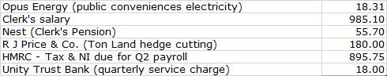  - Review of accounts / cashflow  The Clerk presented the meeting with a copy of the Sept 2022 cashflow. It was confirmed that during the Finance meeting held on 4th October, the cashflow balances had been verified to the closing balances in the Unity Trust Bank statements at the end of July/Aug/Sept 2022, with Councillor Daniel signing to confirm, in accordance with section 2.2 of the Community Council Financial Regulations (Wales).  The Clerk advised that the £5000 transfer from the current to the savings account (agreed at the last meeting) has now taken place. Rates of interest on this account have just risen from 0.65% to 0.95%.  There was no further comment or observation.  - Councillor Allowances inc attendance at Community Centre Meetings  The Clerk has now forwarded the required HMRC documentation to Beverley & Williams and will be arranging to pay the £150 Councillor Allowances next month. Signed HMRC starter forms are still outstanding from Councillors Dodd, Daniel and Grayland, and if to be completed, must be returned by the end of the month. Alternatively, waiver forms, (a legal requirement), must be completed for those who do not wish to claim. The Clerk to re-send forms to Councillors Dodd and Daniel for their completion.  After discussion with the IRPW, it was recommended by the Clerk that attendance at Community Centre meetings should not be included as part of any attendance allowance claims. Although the Community Centre Trust Deed allows for the appointment of Councillors to the Committee, they do not represent the Community Council, but are independent Trustees of the Centre Management Committee, and should therefore probably fall outside of the scope of attendance allowance payments (although this is to some extent a subjective call). After consideration, it was agreed that payments shouldn’t be made for the time being, but that the decision should be reviewed at the next Annual Statutory Meeting in May 2023.  This was proposed by Councillor Dodd, seconded by Councillor Morrey and carried on a show of hands with all in favour except Councillor Butler who abstained.  - Finance Committee update including Risk Review  Risk Review Document. Following Councillor Morrey’s suggestion at the July Finance meeting, the Clerk has added an additional column to the Risk Review Document. This will record the previous risk classification and the date on which it was last recorded, and over time enable the risk assessment scores to be tracked as they change. After careful consideration, (and given that the VAT claim has been undertaken each year without problem), it was agreed that the following ‘scores’, (highlighted in yellow), should change as shown below:  Item Potential Consequence Likelihood Severity New Classification  7. VAT Payment - Recovery of  a). Improper recording of input / output VAT 5 1 (was 2) 5 (was 10) Low (was Medium)  b) Improper Identification of Non-Business Activities 5 1 (was 2) 5 (was 10) Low (was Medium)  All other risk assessments to stay the same.  In addition, it was agreed that the comments under Section 22 (Welsh Language Policy), be updated to reflect that this item was completed some time ago.  The Health & Safety Checklist was also reviewed during the Finance meeting on 4th October. All the recommended work on the four oak trees on Ton Land, recommended by Dan Sainsbury, Tree Officer at MCC has now been completed. The headstone stability check at St Bartholomew’s Graveyard has now been commissioned by the Clerk via MCC. Timescales to be confirmed. The cost will be £1100 + VAT, plus £150 + VAT to secure each headstone which is unstable, although it’s not anticipated that many will ‘fail’.  It was proposed by Councillor Morrey and seconded by Councillor Chandler, that both the Risk Assessment and Health & Safety documents, (previously circulated to Councillors), be accepted on behalf of Full Council. This was carried unanimously.  - Draft Budget 2023/24  The Clerk presented the draft budget for 2023/24 for consideration. At present it shows a small deficit of £1435, with no change to the current precept of £37000. he Clerk explained some of the key figures in the budget.  INCOME  - Nominal 5% increase to Old Pounde Shop rent. However, a new lease is due Sept 2023, therefore Council could delay any increase until then.  - Ton Land income based on £30 a month.  - No budgeted income for burials – extremely variable from year to year.  - VAT reflects last year’s spend.  EXPENDITURE  - The Clerk’s budgeted salary has been increased by c£912 (pro-rata) to reflect the proposed £1925 annual increase (currently subject to negotiation).  - Wages have been increased to £10.32 per hour to reflect projected new living wage.  - Provision has been made for 11 meetings in Llanover VH @ £25 per  meeting.  - The figure for the various Councillor allowances have been reduced to  reflect likely claims, but could probably be reduced further.  - The budget for the maintenance for both villages has provisionally been increased by 5%, although the exact price is yet to be confirmed.  - Perhaps reduce donations to £750 (from £1000)? Clerk suggested we could consider pre-allocating to existing causes – Wales Air Ambulance / Mon Citizens Advice etc.  - Capital expenditure to increase from £0 to £500 for small item purchases.  - Public conveniences increased by £600 to reflect increased electricity standing charge, although the last quote was for £1000. Should we increase further? (see also agenda item 15 below).  - Dog waste budget increased to £7 per bin (in anticipation of April  price rise).  The initial draft (v3) is shown below, based on the original proposals and recommendations above, with the areas highlighted in blue representing the budget lines with the most discretion for adjustment.  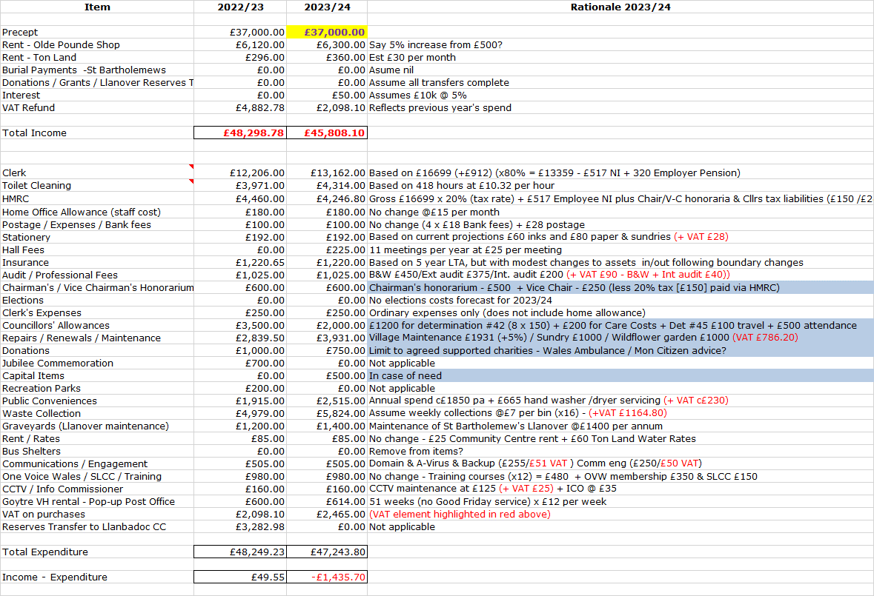  The following changes were agreed:  - The allowances for Councillors to be increased by £464, to reflect the latest IRPW recommendations (just received), although it’s not clear that all Councillors will claim. Care costs to be reduced to £100 – giving a net increase of £364.  - Donations to be increased back to £1000 (so the same as the current year) – an increase of £250.  - Capital items (in case of need) to be reduced from £500 to £200 - giving a net reduction of £300.  - The increase for the electricity to be reduced from £600 to £300, based on a conversation between the Clerk and our Energy supply broker – giving a reduction of £300 + plus £15 of VAT (at 5%).  Overall, these changes would lead to no real change in the modest forecast budget deficit for next year of -£1434.70.  The Clerk to make the suggested adjustments and forward the updated forecast (version 4), to Councillors to reflect upon for further consideration at the November meeting. He noted that, based on previous years, c£1400 of the available Councillor Allowances/Payments might not be claimed, which would effectively cancel any deficit and lead to a balanced budget.  - Audit Update  The Clerk delivered the additional books and papers to Wales Audit at the end of August (required as part of the in-depth three-yearly transactional audit). At present there has been no further communication from Wales Audit. | Clerk  Clerk
8 | Planning.  - To accept the responses of the Planning Committee meetings held on 28th September, to consider the following:  - DM/2022/00966 Planning Permission  New covered area for additional retail space in existing garden centre.  The Secret Garden, Pentwyn Farm, A4042 T Goytre to Penperlleni, Penperlleni, Goytre, NP4 0JE.  Acceptance of the minutes (previously circulated), was proposed by Councillor Dodd and seconded by Councillor Morrey and passed unanimously.  - Any other updates  The Planning Committee are next due to meet on 24th October to discuss application DM/2022/01419, a proposed extension at the rear of the cottage known as Glencoed Cottage, Croes Y Pant Lane, Mamhilad, Monmouthshire, NP4 0JD.
9 | Annual Report Update.  It was agreed to defer this to the November meeting. Clerk to place on the next agenda. | Clerk
10 | Council Plan for 2023/24.  It was agreed to defer this to the November meeting. Clerk to place on the next agenda. | Clerk
11 | Appointment of Biodiversity Representative – Cllr Janet Robins.  Our original Biodiversity and Resilience of Ecosystems Plan, prepared as part of our duties under section 6 of the Environment (Wales) Act 2016 Part 1, stated that we would appoint a representative to oversee and monitor our response to biodiversity. Previously, ex-Councillor Awni undertook this role on a non-appointed basis, but left Council at the May elections. Therefore, it is important that we appoint a replacement and Councillor Robins has kindly agreed to undertake this role. Councillor Robins’ appointment was proposed by Councillor Dodd and seconded by Councillor Daniel. The appointment was carried unanimously.  One of our duties is to undertake the statutory three-yearly review of our Biodiversity plan, which the Clerk has already prepared. He will forward to Councillor Robins for further review and publication by the year-end. | Clerk
12 | Post -16 home-to-school transport – Chloe Tapper – Youth Representative.  Due to the absence of the Council’s Youth Representative, it was agreed to defer the item to the November meeting. Clerk to place on the next agenda. | Clerk
13 | Council Training Plan 2022/23 and 2023/24.  Section 67 of the 2021 Local Government and Elections (Wales) Act requires Community Councils to make and publish a plan about the training provision for its members and staff. The Act came into being on 5th May and requires the publication of a plan within 6 months (so by 5th November). Section 67(4) of the 2021 Act places a duty on Councils to review their training plan from time to time. As a minimum, this would be at least at every ordinary election of Community Councillors. However, the Clerk intends this to be a ‘living’ document with regular (minimum quarterly) reviews to ensure it is always up to date and reflects the latest training requirements. The template recently provided requests a five-year plan, although the Clerk has focussed on the next two years to ensure that all the foundation courses are covered. There will then be the opportunity to concentrate on other areas. The Clerk has prepared the plan (previously circulated), based on a training needs analysis using key roles and the need for newly appointed Councillors to attend ‘foundation’ courses, rather than by reviewing specific personal competencies / behaviours for each Councillor.  The Clerk would like it published without the removal of names, but this requires the permission of everyone present before he is able to do so. When asked, no Councillors raised an objection to this (Clerk to check with Councillor Grayland).  Publication of the initial plan was proposed by Councillor Morrey, seconded by Councillor Daniel, and carried unanimously. Clerk to action. | Clerk  Clerk
14 | Donation requests.  - Cerebral Palsy Cymru  We have received an open letter from Cerebral Palsy Wales requesting a donation to their work across Wales. Councillors had previously questioned whether the charity provided services specific to the local Community to support a donation. It is thought highly likely that support is provided to residents in the village, although current/specific details were not known. However, it was suggested that a donation of £50 be made and this was formally proposed by Councillor Morrey, seconded by Councillor Barnes and carried unanimously.  - Ronald McDonald House Charities (UK)  Similarly, we have received an open letter from Jordan Harbin, Community and Corporate Fundraiser for Wales. Jordan presented to Council a few months ago, explaining that the charity provides parents with short term accommodation, whilst their child receives specialist hospital treatment away from their home location. Councillors were uncertain as to the level of support required by / provided for local residents, and given the competing demands for donations did not feel able to contribute on this occasion. This was proposed by Councillor Morrey, seconded by Councillor Barnes and carried unanimously.  - Wreath for Armistice Day in Llanover  Councillor Chandler has advised that a bugler has been booked for the ceremony on Armistice Day which is held on Llanover village green (and organised by the Village Hall). The cost of the wreath to be laid on behalf of the community has been paid by the Community Council in the past, and Councillor Chandler asked whether this could be arranged again this year. (Councillor Chandler attended last year and is happy to lay the wreath). The likely cost will be in the region of £35 to £40. A maximum sum of £50 was agreed and formally proposed by Councillor Morrey, seconded by Councillor Barnes and carried unanimously. It was also agreed that a similar sum should be made available for Goytre, if required, and this was proposed by Councillor Dodd, seconded by Councillor Daniel and carried unanimously. Councillor Daniel to follow up.  - Sight Cymru Charity ball and Auction  Sight Cymru (who we support), are hosting a Charity Ball and Auction on 12th November 2022, and are looking for support for the event, either through a donation for their auction or through ticket sales to attend the evening. The Community Council has undertaken a lot of work with Sight Cymru, and although no-one was able to attend the ball, a donation of £50 was proposed by Councillor Dodd and seconded by Councillor Barnes and carried unanimously. | Clerk  Clerk  Cllr Chandler  Cllr Daniel  Clerk
15 | Communications.  - Electricity Contract  The Clerk spoke with our utility broker this morning, who expected our electricity bill to double to around £400 per annum (rather than the previously projected £1200). He agreed that a provision of £500 (included in the budget forecast discussed today), should be adequate, and suggested we look for quotes in the spring of next year. The Clerk to diarise for next year. | Clerk
16 | Advertising - Usk and Raglan Diary contributions Jan/ Feb 2023.  The closing date for submissions for the Jan/Feb 2023 edition of the Diary will be towards the end of November. To date there were no items for inclusion | All
17 | Date of next meeting and close.  The next meeting to be held on Monday 14th November at 19.45.  The venue to be in Llanover Village Hall and by teleconference via: https://meet.jit.si/GoetreFawrCommunityCouncil | All/  Clerk

Chairman: …………………………………….…………… Date:…………………….

