CYNGOR CYMUNED

GOETRE FAWR

COMMUNITY COUNCIL
MINUTES OF THE MEETING HELD AT LLANOVER VILLAGE HALL & BY TELECONFERENCE ON MONDAY 9th OCTOBER 2023 @ 19.45

Present: Community Councillors, Owen Dodd, Andy Barnes, Peter Daniel, Janet Robins, Nigel Morrey, and Community / County Councillor Jan Butler.

Guests Lewis Carter, Llanover resident.
In Attendance: Jonathan Lazenby (Clerk).
Apologies: None.
Absent without Apology: Councillor Scott Grayland
 |  | ACTION
1 | Apologies for Absence.  As above. | Clerk
2 | Declarations of Interest.  The Chair commenced by asking the members present whether they had any declarations of ‘interest’ to make, which include previous declarations already made. The Chair reminded members that they should notify the meeting of any additional interests which become apparent during the progress of the meeting. Councillor Barnes re-declared an interest in the MUGA as, depending on its siting, (if on the lower section of the park), he was likely to object on the grounds of noise. No further declarations from the members were forthcoming. | All / Clerk
3 | Chairman’s Remarks.  Councillor Dodd took the opportunity to welcome everyone to the meeting, in particular Lewis Carter, who is considering standing for the vacant Councillor position in Llanover Ward, following the recent resignation of Morgan Chandler.
4 | Approval of Minutes of the Meeting held on 11th September 2023.  The minutes were proposed as a true and correct record by Councillor Robins, seconded by Councillor Barnes, and carried with the additional vote of Councillor Daniel, being the three Councillors in attendance today and who were present at the September meeting. | Clerk
5 | Matters Arising.  - Item 6(i) - The leaks in the ladies’ toilets have now been repaired, and the broken toilet seat replaced. The total repair cost came to £315.60 including VAT. The vandalised front door of the gents’ toilets has also been replaced, and padlocks put on the hatch cover to the loft void (cost £675 as per quote).  - Item 7 (iii) – The claim for the new laptop has now been settled, with the sum of £553.85 received from Zurich Insurance.  - Item 7 (i) – The One Voice Wales Annual Conference (the £90 fee was shown in last month’s list of payments), was cancelled due to lack of numbers. A full refund will be received.  - Item 7 (iv) – The new Electricity (BG Lite) contract for the public conveniences is now in place.  - Item 12 (i) – The full radar ground survey report for St Bartholomew’s graveyard has been received and distributed to Councillors.  - Item 12 (ii) – The salt bin and salt/grit for St Bartholomew’s graveyard has been purchased and installed inside the front gate of the churchyard.
6 | Maintenance. (including items previously reported, but not yet addressed).  - The (three-yearly) electrical safety test was undertaken at the public conveniences today. One of the RCD’s failed its test, and so has been replaced. The electrician has verbally confirmed that all is satisfactory and will issue a certificate of compliance / safety in due course.
7 | Finance.  - Payments made since the previous meeting.  £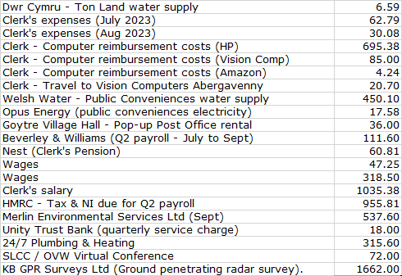  - Review of accounts and cashflow  The Clerk presented the meeting with a copy of the September 2023 cashflow.  It was confirmed that during the Finance meeting held on 3rd October, the cashflow balances had been verified to the closing balances in the Unity Trust Bank statements at the end of July/Aug/Sept 2023. Councillor Daniel signed to confirm the verification, in accordance with section 2.2 of the Community Council Financial Regulations (Wales).  There were no comments or observations.  - 2024/2025 budget – first draft to Councillors  The Clerk presented latest version of the 2024/25 budget for consideration by Councillors (see below). This had previously been distributed to all the members, so that they could familiarise themselves with the content, prior to the meeting. The items highlighted in yellow, are the budget lines which the recent Finance Committee requested be amended as part of their review.  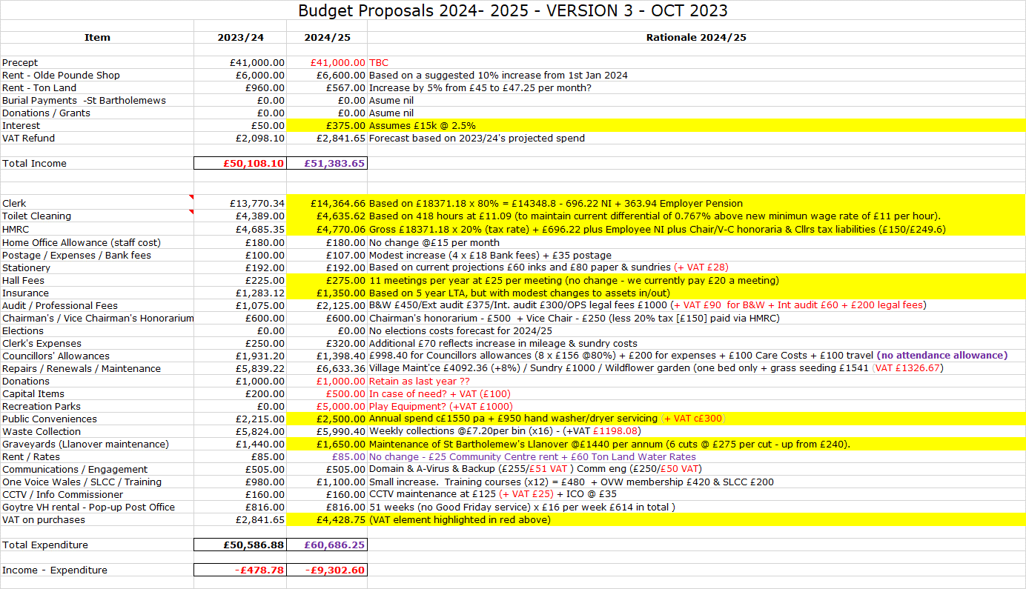  During the discussion, the following requests were made.  - The Clerk to provide Councillors with a list of donations made over the past three years, to enable them to consider an appropriate budget going forward.  - The budget for the flowerbeds to be reduced to £300 as per item 15 (iii) below.  - The budget for the play equipment should be left in for the moment, pending the outcome of the engagement survey and the work being undertaken by Johnathan Wassall at MCC to obtain some additional equipment.  - Similarly, the outcome of the proposed community engagement will help Councillors understand the level of precept that the majority of residents are willing to pay.  The amendments will be incorporated in an updated budget for Councillors to consider at the November meeting, by which time some initial outcomes of the engagement survey should be known.  - Councillor Allowances  The Clerk is preparing the documentation for the payment of Councillor Allowances and Honoraria, although individual members can decline if they so wish. Approval for the payments (unless otherwise declined) was proposed by Councillor Morrey, seconded by Councillor Barnes, and carried unanimously. | Clerk  Clerk  Clerk  Clerk
8 | Planning.  - To accept the responses of the planning committee meeting held on 26th September  The following application was listed for consideration during the meeting:  - DM/2023/01175 - Planning Permission: Change of use for annexe in the garden. Deerleap, 86 Newtown Road, Penperlleni, Goytre, Pontypool, NP4 0AZ  The outcome of the meeting was that there were no concerns regarding the proposal.  Acceptance of the minutes (previously circulated), was proposed by Councillor Daniel and seconded by Councillor Butler, and passed unanimously.  - Any other updates  A meeting will be scheduled shortly to discuss the following applications received on 4th October from the BBNPA. The reason for the two apparently identical requests is that one is a full planning application, and the other is a listed building consent.  23/22347/FUL - An application for the conversion of a barn to a residential use (C3). Occupancy of the barn to be restricted to be only used in conjunction with the main house by a family member.  Pwll Yr Hwydd Farm, Ancient Road, Llanover NP7 9ES  23/22348/LBC - An application for the conversion of a barn to a residential use (C3). Occupancy of the barn to be restricted to be only used in conjunction with the main house by a family member.  Pwll Yr Hwydd Farm, Ancient Road, Llanover NP7 9ES | Cllr. Barnes

9 | County Council update – County Councillor Jan Butler.  - For information Councillor Butler advised that she sits on the Planning and Public Scrutiny committees.  - Councillor Butler has been to a meeting with ‘Llais’ regarding the proposed overnight closure of the Minor Injuries Unit at Nevil Hall Hospital. This is to try and save some £400k a year on agency staff. It was agreed that a full communications exercise was needed, to ensure it is being properly utilised at present, with many people still going to the Grange A&E Dept. The ABUHB are currently consulting and have extended the exercise for another four weeks.  - There have been complaints regarding the footpath behind the doctor’s surgery which is difficult to pass, due to overhanging vegetation, and which is now pushing a fence over into the way of pedestrians. The resident has been contacted and has said that he will address the issue.  - MCC are visiting the village on Wednesday and will be looking at where additional ‘dropped kerbs’ should be installed for the benefit of residents.
10 | GDPR - Review of and update (as necessary), of GDPR document retention policy.  Councillor Dodd has been investigating the position of this over the past few months and, as a result of his review, has concluded that they are fit for purpose. However, he has asked that the Clerk check the appropriate retention period for the accounts, together with any accompanying financial information which might relate to individuals. The Clerk will check the Practitioners guide for Finance, as well as speak to the Independent Remuneration Panel for Wales for guidance. However, many of the documents (e.g. payments to Councillors) are in the public domain (and have to be by law), and so it is quite possible that records / copies may have been made elsewhere.  Clerk to check, update if necessary, and bring the document back to the November meeting for formal approval. | Clerk
11 | Community Engagement – Councillors Janet Robins / Jan Butler / Nigel Morrey.  Following the presentation made at the September meeting, Councillors Robins and Morrey met again as proposed. Unfortunately, Councillor Butler was unable to attend. Following their discussions, the final recommendations for the survey introduction, and the survey itself, have been distributed to Councillors.  - There are now a total of eight questions with an additional section having been added, to ask residents their preferences on the level of precept. The suggested options are: reduced precept with fewer services / the same precept to provide the current services / higher for more or better services. The Clerk suggested some wording which he will forward to Councillor Robins.  - It is proposed to have a face-to-face engagement event at Goytre Village Hall on Saturday 11th November. The suggested time was 11.00 am until 3 pm (KIV the two-minute silence at 11.00 am for Armistice Day). Tea / Coffee / refreshments will be available.  - The survey will be available on the village Facebook page and on the Community Councils’ web site.  - It was agreed that section 4, (service priorities), should be simplified, with residents just ticking their preferred services, rather than using a ranking system.  - It is planned to make the survey available in the chip shop, and if possible, Goytre Stores.  - The survey will go live on the web site on 19th October and on the Facebook site from 25th.  - It was recognised that we need to hold a similar event in Llanover – Councillor Butler to check the hall availability. Ideally it should be attended by the new Llanover Councillor, who can be ‘inaugurated’ on 13th November. | Clerk  Cllr, Robins  Clerk  Cllr. Butler
12 | Vacant Councillor Position – update: Election or co-option of replacement.  The Clerk has confirmed with the Democratic Services Team at MCC, that, as of today, there had been no requests from the residents of Llanover Ward for an election to replace Morgan Chandler, who resigned as a Councillor at the end of the last meeting. Unless the requirement for 10 election requests is reached by midnight tonight, it will be necessary for the Community Council to co-opt an individual for the vacant position. In anticipation of this, the Clerk has recently circulated a proposed advert to be placed on the noticeboard and web sites. It was agreed that the advert should be open for one week, with confirmation of the successful candidate at the November meeting. Approval for the advert (should the election threshold not be met), and timescales was proposed by Councillor Daniel, seconded by Councillor Morrey, and passed unanimously | Clerk
13 | MCC Public Space Protection Order – outline approval of proposed areas.  The Clerk has previously circulated the papers on the public consultation, which began on 2nd October. In Goytre dog exclusions are proposed for  - The School,  - The recreation ground (except the dog walking area),  - The Clos Telyn play area.  MCC have asked Councillors that they revisit this and confirm their agreement together with the PSPO principles of:  - Requiring dog fouling to be picked up in all public areas;  - The requirement for dog walkers to carry bags and to show them if asked;  - Dog owners being required to put their dog on a short lead if directed to do so (by an Enforcement Officer).  Agreement to the exclusion areas and the principles outlined above was formally proposed by Councillor Morrey, seconded by Councillor Daniel, and passed unanimously. Clerk to advise MCC. | Clerk
14 | Dog Awareness Day (Abergavenny & Goytre) – 12th October. Recommendations for key areas to visit.  The MCC ‘Give Dog Fouling the Red card’ team will be visiting Goytre on Thursday 12th October. The Clerk will also be in attendance. The ‘day’ will take the format of encouraging anyone we meet to pick up their mess using dog bags, and the spraying of footpaths using the template spray etc. It was agreed during the meeting that the following areas were a priority for the visit.  - At the junction of Newtown Road and Fairfield.  - Turning into Longhouse Barn from Capel ed Lane – by a large Oak Tree on the left-hand side.  - Travelling from the pub towards the shop, turn left into Fairfield - on the right-hand side by some metal gates to an electricity substation.  Clerk to advise Sue Parkinson | Clerk
15 | Goytre Recreation Park.  - Sports recreation hub inc MUGA update  Councillor Butler has now had the opportunity to meet with Mike Moran and Nigel Leaworthy. It has been confirmed that we are working to a deadline of Nov 2024 for the s106 monies to be spent. We have also been advised that the costs of the SUDs survey would be c£4000. However, even with inflation, the MUGA is still just about do-able. MCC have now offered to undertake a survey to find out what people want, which would include a face-to-face engagement in the village hall. They have also suggested some other offerings such as a walking track (but may be too expensive), and equipment for older children. Ideally any new equipment should address the need for sports / exercise facilities for girls, and be disability inclusive. It was agreed that the output of our engagement survey would be provided to MCC to help inform any decisions.  It was agreed that MCC should be invited to undertake an engagement survey/ exercise, to help determine the most appropriate way to use the s106 monies. This was then formally proposed by Councillor Daniel, seconded by Councillor Morrey and passed unanimously. Cllr. Butler to liaise with MCC.  - Playground equipment update (inc. table tennis table)  The Clerk met with Johnathan Wassal from MCC on 3rd October. He is hoping to secure funding for an additional piece of equipment (ideally a multi-activity climbing frame etc) which would be installed in the centre of the current equipment. The table tennis table would need to be moved to accommodate this, and the moving costs would be covered as part of the overall work, thus saving the Community Council additional expense. Thankfully the anti-social behaviour appears to have abated for the time being. It is possible that if the funding comes through in time, the work can be undertaken early next year before the longer nights might encourage a repetition of this year’s poor behaviour on, or around, the table.  - Flowerbeds  Following the September meeting, the Clerk has approached Nigel Leaworthy for alternative options for preparing the flowerbeds in the park. The options are:  - Plant & seed both beds and bus stop (as before) - £1650.00.  - Plant & seed just the one large bed (leaving the other to self-seed) - £1134.00.  - Plant & seed just the one large bed (leaving the other to self-seed), but including a cost for periodic weeding of the second bed. However, apparently, weeding is not possible, as they are not formal beds.  - Plant & seed just the one large bed, but, include the cost of re-seeding the other flower bed with grass - £1541.00.  - Leave the flower beds to re-seed, providing an excellent natural habitat for wildlife with just an annual topping (price to be confirmed but budget for £300).  It was confirmed by Councillors that option (e) above should be included in the budget for 2024/25 as discussed under item 7. | Cllr. Butler  Clerk  Clerk
16 | Village Committees’ Reports – questions based on previously distributed updates.  - Goytre Village Hall  - No report submitted.  - Llanover Village Hall  - No report submitted.  - Goytre School Governors  - No report submitted  - Goytre Community Centre  - An Open Day is to be held on 14th October from 10 am to 3 pm – Councillors are asked to support.  - Councillor Butler is currently working with the architect Stephen Peel on design plans.  - A fundraiser quiz night has been arranged for Wednesday 25th October - 7:30 for an 8 pm start. Soup and puddings will be provided. Tickets are £6. A team of Councillors would be appreciated!  - Other Reports  - There are no other reports
17 | Donation requests.  Wales Air Ambulance have just submitted a request, although it was received too late to be discussed at today’s meeting. The Clerk will add to November’s agenda. | Clerk
18 | Communications.  - Remembrance Service in Goytre  The Clerk advised that Mike Jones had made a request via the Chair, for the Community Council to ‘adopt’ this year’s Remembrance Service by the site of the proposed war memorial. This is so that the British Legion can take advantage of our Public Liability Insurance. Mike initially offered his services, together with Rev’d Sue Davies-Fletcher, to help with any organisation and risk assessment, but subsequently advised that they would not be able to help. The Clerk has investigated the situation, and the main issues are likely to be those of highway / footpath obstruction and the potential danger to pedestrians and drivers, due to possible road sight issues for motorists. As a result, the responsibility for any risk assessment would have to rest with MCC Highways. The event would probably require stewarding to minimise the risk of any identified hazards. Whilst supportive of a local initiative, Councillors felt that the best way forward would be for Mike Jones to approach MCC Highways, who could advise if the proposal was acceptable. If so, they may be able to provide the necessary liability cover for the event, which would of course, take place on their property. This suggestion was proposed by Councillor Morrey, seconded by Councillor Butler, and passed unanimously. Councillor Dodd to contact Mike Jones.  - Domain hosting renewal (£29.99 plus VAT)  The annual fee for hosting the CC’s domain (goytre.gov.uk) is now due. Renewal was proposed by Councillor Dodd, seconded by Councillor Barnes, and passed unanimously | Cllr Dodd  Clerk
19 | Advertising - Usk and Raglan Diary contributions Jan/Feb 2024.  The closing date for submissions will be towards the end of November. It was agreed that, at present, there were no submissions for the next edition, although it is likely that we will wish to include the results of the forthcoming community engagement, once the outcomes are known and the priorities agreed. In addition, we can also announce the appointment of the new Councillor for Llanover. | Clerk
20 | Date of next meeting and close.  The next meeting is to be held on Monday 13th November at 19.45. The venue to be Llanover Village Hall, and by teleconference via: https://meet.jit.si/GoetreFawrCommunityCouncil  Councillor Butler submitted her apologies for the next meeting. | All/  Clerk

Chairman: …………………………………….…………… Date:…………………….

