CYNGOR CYMUNED

GOETRE FAWR

COMMUNITY COUNCIL
MINUTES OF THE MEETING HELD AT LLANOVER VILLAGE HALL & BY TELECONFERENCE ON MONDAY 11th DECEMBER 2023 @ 19.45

Present: Community Councillors, Andy Barnes, Peter Daniel, Janet Robins,
Nigel Morrey, Scott Grayland, Lewis Carter, and Community / County Councillor Jan Butler.

Guests None
In Attendance: Jonathan Lazenby (Clerk).
Apologies: Owen Dodd (working away, unable to connect)
Absent without Apology: None

 |  | ACTION
1 | Apologies for Absence.  As above. | Clerk
2 | Declarations of Interest.  In the absence of the Chair, Councillor Barnes, as Vice-Chair, took the role of Presiding Officer for the meeting, and commenced by asking the members present whether they had any declarations of ‘interest’ to make. This includes previous declarations already made. Councillor Barnes reminded members that they should notify the meeting of any additional interests which become apparent during the progress of the meeting. Councillor Barnes also re-declared his own personal interest in the MUGA as, depending on its siting, (if on the lower section of the park), he was likely to object on the grounds of noise. No further declarations from the members were forthcoming. | All / Clerk
3 | Chairman’s Remarks.  Councillor Barnes took the opportunity to welcome everyone to the meeting, in particular, Councillor Carter, who was attending his first meeting in his capacity as Councillor for Llanover ward.
4 | Minutes  - Correction to the Minutes of 9th October 2023  The Clerk advised that Councillor Grayland was not in attendance, as was (incorrectly) recorded in the minutes.  This was accepted and it was agreed that for good order the minutes be amended to show the correct situation. This was formally proposed by Councillor Daniel, seconded by Councillor Morrey, and carried by a show of hands from the Councillors present at the October meeting.  - Approval of Minutes of the Meeting held on 13th November 2023.  The minutes were proposed as a true and correct record by Councillor Daniel, seconded by Councillor Morrey, and carried by a show of hands from the Councillors present at the November meeting.  - Approval of Minutes of the Closed Session Meeting Minutes held on 13th November 2023  The minutes were proposed as a true and correct record by Councillor Barnes, seconded by Councillor Morrey, and carried by a show of hands from the Councillors present at the November meeting. | Clerk  Clerk  Clerk
5 | Matters Arising.  - Item 5 (ii) - The Electrical Safety Test Certificates are public conveniences (and community Centre), are still outstanding. The Clerk has chased them again, and all being well, they should be received later this week.  - Item 6 (ii) – The blocked drain by the bridge past the Scout hut has been reported to MCC. The service request status on the web site states that it is currently ‘under review.’  - Item 7 (iv) – The signing authority update at Unity Trust has now been completed.  - Item 11 – GDPR retention review document – The renewed timescales document has been posted on the web site  - Item 13 – Councillor Allowances – the Clerk has now updated the Basic Allowances form for Councillors to sign, to contain a declaration regarding the Working from Home Allowance. The Clerk to distribute to Councillors, except for those who have declared they will not be claiming the allowance for 2023/24.
6 | Maintenance. (including items previously reported, but not yet addressed).  - Repairs to St Bartholomew’s Lichgate – The stone mason, (who undertook the rebuilding of the church wall after it was damaged), has emailed with a quote for the replacement of the two missing tiles. The cost is £245 + VAT. As per our financial regulations 11.1 (g), it was agreed that as the amount is under £500, and given the more specialist nature of this work and track record of the contractor, it was not appropriate to obtain further quotes. Approval of the repair quote was formally proposed by Councillor Morrey, seconded by Councillor Daniel and carried unanimously.  - A local resident has asked for a grit bin to be provided by MCC on Chapel Mead. Councillor Butler to investigate if this would be possible. Councillor Butler was able to confirm that MCC have agreed to provide a grit bin near the corner of Star Road and Plough Road.  - There are a number of pot holes on Capel Ed Lane. Local residents to be encouraged to report these, by using the ‘My Mon’ app (which is MCC’s preferred method of reporting), or ‘Fix My Street’. | Clerk  Cllr. Butler
7 | Community Engagement – Survey results & conclusions for 2024/25 precept - Councillors Janet Robins/Jan Butler/Nigel Morrey.  Councillor Robins led the summary feedback from the report which was:  - Responses: In total 74 survey forms were completed (including 7 which were completed face to face). The vast majority of respondents (64) were from Goytre, 5 from Nantyderry, but only 1 from Goetre Wharf and Llanover. Three respondents were unsure of their ward.  - Age Profile: Generally there was a reasonable spread across the age ranges, with the exception of the 70+ category which attracted by far the most responses (54), (probably reflecting the age profile of the village)  - Preferred Communications Channel: The Village Facebook page was the preferred choice, with the village noticeboard in second place.  - People’s Priorities: These were maintenance and cleaning, plus the dog waste collection.  - Precept: 53% wanted increases broadly in line with inflation, 16% wanted a higher precept to pay for more / better services, with 25% looking for a reduction with fewer services. 5% did not respond.  - What residents would like to see more of (open question):  More facilities for children and young people was a strong theme (32% of respondents) with 21% specifically mentioning improving the play equipment in Goytre Park. The comments were generally not age specific, although a couple of responses referred to ‘teenagers’.  - Examples of what GFCC does well and doesn’t do, or should do more  of (open question):  Does Well: Village maintenance / vleaning / public conveniences. The Council is efficient / effective, supports local causes and the village post office.  Doesn’t do well: Engage with residents (twice as many as thought we were good), is slow at decision making, doesn’t carry things through. Communicating.  - Other comments (open question):  Residents commented about the Community Council, including having a FB page, changing the members every 3-5 years and the replacing the Chairman. Another theme the MUGA. Two people asked about its progress and said that they were looking forward to it, whereas eight people voiced their opposition.  Councillors felt that the next step should be to use the responses to put together a Community Plan. Councillor Butler said that she was happy to lead a small working group with some community representatives. Councillor Daniel mentioned that he is planning to have a meeting in the Village Hall in Jan/Feb to talk to residents, and suggested this could be a vehicle for the CC to engage further with residents.  Councillors agreed to accept the report, with the following five key outcomes published on the FB page.  - The results of this survey indicated that residents’ priorities are in line with current Council spending (village cleaning/maintenance/dog waste collection).  - Overall, residents’ preference was to increase the precept in line with inflation.  - The CC could do more to engage with residents, listen to their views and communicate what they do and needs a better social media presence.  - In the New Year, the CC will look to form a working group with community representation to produce a Community Plan.  - Residents in this survey feel strongly about improving play equipment in the park, and also have opinions (both for and opposing) the Multi Use Games Activity (MUGA).  A full copy will also be made available on the web site (if people want to read more detail). The summary and full reports were then formally proposed by Councillor Daniel, seconded by Councillor Carter and carried unanimously. | Cllr. Robins /  Clerk
8 | Finance.  - Payments made since the previous meeting.  £ 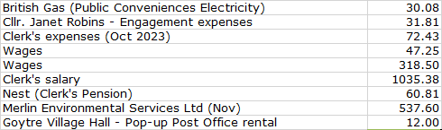  - Review of accounts and cashflow  The Clerk presented the meeting with a copy of the November 2023 cashflow.  There were no comments or observations.  - Clerk’s Salary increase for 2023/24 (Closed session)  During the closed session meeting, it was agreed to implement the NALC flat rate pay increase, pro-rated, based on the Clerk’s current contract of 77 hours per month. This was proposed by Councillor Barnes, seconded by Councillor Morrey, and carried unanimously. Clerk to incorporate the knock on effect for the 2024/25 financial year in the latest budget – see item 8 (iv) below.  - 2024/2025 budget – latest draft – update as required  The Clerk presented the latest version of the 2024/25 budget (distributed prior to the meeting), for consideration. Since the October meeting it has been updated to reflect the taxable status of Councillors Allowances, and the exact cost of the flowerbed ‘topping.’  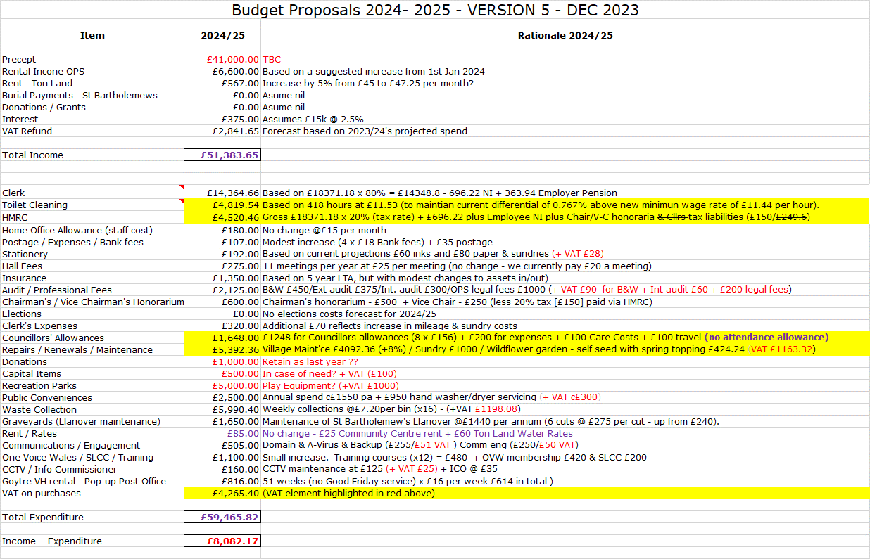  Johnathan Wassal at MCC has confirmed that he has submitted a financial request for additional play equipment in the Park. No mention was made of the amount involved, but he is confident that it will be sufficient to enable MCC to purchase a ‘decent sized’ multi-activity unit. He is now awaiting the outcome, although no timescales are known at this stage. Councillors therefore discussed the need for the £5,000 + VAT provisionally included for park equipment in the budget. It could provide money for a ‘trim trail’ for example, in addition to the new MCC equipment. The engagement survey has highlighted the desire for more equipment in the park, but this is tempered by the number of residents wanting to limit any precept increases.  The Clerk advised that he had now received the renewal premium for our Insurance with Zurich for 2024/25, which is £1266.97. However, this only includes the potential loss of rental income from the OPS at the current monthly rate. Clerk to advise Zurich of any increase and to bring back the final policy for approval/renewal at our January meeting.  It was agreed that, subject to final approval of any budget for play equipment, and any potential (minor) amendments between now and the end of March 2024, the budget proposed above should form the basis of the CC’s finances for 2024/25. As a result, the CC was now able to determine its precept – see item 8 (v) below. This approach was proposed by Councillor Daniel and seconded by Councillor Morrey.  - Agree and set precept for 2024/25.  Based on the budget above, it was agreed that GFCC should set a precept of £45,000 (a rise of c9.8% - an annual increase of c£3.26 per band D property). This was proposed by Councillor Barnes, seconded by Councillor Morrey, and carried unanimously. Clerk to advise MCC. | Clerk  Clerk  Clerk  Clerk
9 | Planning.  - To accept the responses of the Planning Committee meeting held on 27th November.  The following application was listed for consideration during the meeting:  - 23/22403/FUL - The installation of an Air Source Heat Pump and the installation of Solar Panels to the roof.  Dy Westy, Pen-Croes-Oped Road, Pencroesoped Llanover NP7 9EL  Unfortunately, the meeting was inquorate and was therefore unable to consider the application. Clerk has advised APCBB/BBNPA  Councillor Barnes asked for greater commitment in attending meetings to be shown by Councillors, as this was not the first time that a planning meeting had had to be ‘abandoned.’ As a result, the considerable time and effort in the organising of meetings, preparing and posting agendas was being wasted, in addition to our lost opportunity to comment.  - Any other updates  There are currently no other updates of outstanding applications waiting to be considered.
10 | - Olde Pounde Shop Rent Review  Rent Review – closed session.  The session considered the three-yearly rent review, with any changes due to be implemented from 1st January 2024. The agreed fee will run until the lease is (potentially) renewed on 29th September next year.  The recommended increase was proposed by Councillor Butler, seconded by Councillor Morrey, and passed unanimously. This will be communicated to the shop owners by the Clerk.  - Asbestos – duty to check for, and assess condition under the Control of Asbestos Regulations 2012.  The CC has a duty to check for, assess and manage asbestos in any buildings it owns. Having had asbestos taken out of the public conveniences a couple of years ago, that just leaves the Old Pounde Shop. There are no planned renovations, so there is no immediate urgency. However, given the age of its construction, it is likely that asbestos will be contained somewhere in the fabric of the building. This leaves us with the duty of assessing its likely location, and the condition of any relevant building materials. We can then manage this within our normal building risk assessment process.  We have two options  - Undertake the assessment ourselves – perhaps Councillor Morrey with his building expertise could undertake this? Or  - Pay for a formal risk assessment – HSL Ltd in Hereford (who undertook the survey of the public conveniences), have recommended that if we are not planning any works, they would advise an asbestos management survey. This will not be intrusive, but will provide a report showing asbestos items which could be disturbed during day to day activities. The cost for this service would be £550 + VAT.  After due consideration, and Councillor Morrey’s recommendation re (a) above, it was agreed that we should pursue option (b), and then, depending on the outcome of the survey, manage this in the normal way though the Finance Committee’s quarterly risk management review. This was formally proposed by Councillor Daniel, seconded by Councillor Barnes, and passed unanimously. | Clerk  Clerk
11 | County Council update – County Councillor Jan Butler.  - Lee Waters has confirmed that the Goytre pedestrian crossing on A4042 is still planned, post the April 2024 budget.  - MCC are still undertaking their engagement on the local transport plan, which has now been extended until Friday 5th Jan (Councillor Carter will update the previous FB post to reflect this).  - Councillor Butler is continuing to work with MCC on providing dropped kerbs for the local bus stops.  - The local petition for additional train stations between New Inn and Abergavenny reached >300 signatures, so was sufficient to go before the Senedd Petitions Committee. TfW are aware, but this is likely to be a long-term plan – (15 to 20 years).  - ‘Boys Need Bins’ is a nationwide campaign looking to provide sanitary wear bins in gents toilets (due to prostate problems).  - Councillor Barnes asked where Councillors accessed NHS dental treatments. Abergavenny, Cwmbran, Ponthir and Abersychan were among the responses obtained.  - The Neighbourhood Policing team are proving difficult to get hold of. In addition, some of the incidents contained in the reports (e.g. on the A472) are no longer in our area. Clerk to provide the team with the latest boundary map of the ward. | Clerk
12 | Data Back-up – problems with ICT Vision – Alternative Options  The Clerk believes that the existing real time data back-up system has been responsible for many of the laptop problems (e.g. ‘blue screen of death’), that he has had over the past 2 or 3 years. Problems are still being experienced on the new laptop (inability to send emails), as soon as the system is reactivated. He has therefore deactivated the system until an alternative can be sought.  Having looked at alternative back-up systems with the Digital Officer at OVW, the best option appears to be a system called Idrive (the links previously provided to Councillors for review prior to this meeting).  There’s an introductory offer on at the moment at $34.95 for year 1 (thereafter $69.50) – but still cheaper than our current service of £120 + VAT.  Councillor Morrey agreed that we should have real time back-up in place and proposed the purchase of the new system, which was seconded by Councillor Daniel, and then passed unanimously. | Clerk
13 | Independent Review Panel for Wales – Feedback on draft 2024/25 report  There are no proposed changes to the allowances / amounts payable during 2024/25. The key change falls under the reporting requirements of such payments Previously C&TCs were required to submit an annual statement to the Panel by 30th September each year, showing individual payments made to Councillors, and also to publish this on their website.  The Panel proposes that from September 2024, the returns need only show the total amounts paid in respect of the mandatory payments. That is the £156 contribution to the costs of working from home, the £52 consumables allowance, together with any travel and subsistence expenses paid. This brings these in line with the reporting of the costs of care and personal assistance allowances.  The Clerk felt that the layout of the report could be clearer, but otherwise, it was agreed there were no material issues with the content. There was no other comment or feedback from Councillors.
14 | Goytre Recreation Park.  - Sports recreation hub  The Clerk has confirmed that the s106 ‘spend by date’ is 18th October 2024.  .  - Playground equipment update  As advised under item 8 (iv) above, the Clerk has spoken to Johnathan Wassal who has submitted a financial request for additional play equipment in the Park. No amount or timescales are known at this point.
15 | Council representatives on Goytre Village Hall & Community Centre Committees.  This item was deferred from last month’s meeting. As was stated in November, Councillor Dodd had recently been appointed Vice Chair of the Social Club, and so had resigned his post as Council representative to the Village Hall Committee. Councillor Daniel had also resigned from the Community Centre Management Committee. There are, therefore, opportunities for the CC to appoint new representatives to both committees.  No one volunteered to undertake the vacancy on Goytre Village Hall and so it was agreed to defer the item again until next month’s agenda.  However, Councillor Carter came forward to volunteer for the vacancy on the Community Centre Committee, and his ‘appointment’ was proposed by Councillor Butler, seconded by Councillor Morrey and passed unanimously. | Clerk
16 | Village Committees’ Reports – questions based on previously distributed updates.  - Goytre Village Hall  - The Gents Toilets (both in the hall and club), have now been renovated.  - Plenty of functions such as Ballroom dancing, Bingo, Well-being Cafe, Indoor bowls, and other activities are well attended and booked for next year.  - Free food hall also doing well.  - Looking into a new type of license for alcohol consumption within the hall.  - Llanover Village Hall  - Overall bookings for the hall are good.  - Glazing on blown windows recently replaced.  - Main Issue is repair work, needing to fix damp issues (thought to be rising damp) on old external wall between hall and kitchen area. Want to apply for some grants but haven't identified any yet. May need to consult community on spend in support of the grant application.  - Recent Llanover Christmas Cracker event was a good success at bringing the community together.  - Next meeting will be Jan 14th 2024  - Goytre School Governors  - Last full meeting held on the 6th December for this year.  - All appears to be well organised with over 90 per cent of children in attendance.  - The new asymmetric system is going well, allowing teachers to get more training on Fridays.  - Although their budget has been cut, they still, when needed, find ways of funding certain projects.  - No major issues of concern.  - Goytre Community Centre  - Approaches have been made to bring early years groups back to the Community Centre.  - Community Coffee and Mince pies morning. 10:30 till 12:30 Tuesday 19th December. All welcome. Free entry. Please join us  - Other Reports  - There are no other reports
17 | Donation requests.  The Clerk reminded everyone that this year’s donations budget has been exhausted. However, he has suggested, that, if Councillors wish to make a donation to any organisations during the remainder of this financial year, they could consider transferring the honoraria budgets (totalling £750), neither of which it is proposed will be claimed this year with both the Chair and Vice Chair ‘comfortable’ with such a proposal. In the meantime, the following donation requests have been received.  - Wales Air Ambulance  Previous donations have been £500 (in both 2020/21 and 2021/22), and £250 in 2022/23. The Air Ambulance is a regular sight in the area and as a result Councillor Morrey proposed that a donation of £250 be made. This was seconded by Councillor Butler and carried unanimously.  - Urdd National Eisteddfod Maldwyn 2024  We have received a ‘round robin’ request (sent to all C&TCs) asking if we will support next year’s Eisteddfod in Maldwyn. Traditionally the CC has not supported the event directly, but instead, has offered to contribute towards the travel / coach costs should Goytre Fawr Primary wish to send any pupils. This has not been taken up in recent years, but Councillor Robins, who sits on the Board of Governors, believes the school is planning to take a coach next year and so will suggest that they approach the CC for a donation.  - Hope Rescue Dog Shelter  A donation request has been received from the Hope Rescue Dog Shelter in Cardiff. However, given the limited budget available, and the fact that the shelter was based in Cardiff, Councillors did not feel able to support the request and a decision to ‘decline’ was proposed by Councillor Daniel, seconded by Councillor Carter, and passed unanimously. | Clerk  Clerk  Clerk

18 | Communications  There have been no received communications.  - Appointment of Communications Officer and adoption of social media policy.  The Clerk has identified the need for the regular posting of useful community information on the Village Facebook sites. Currently, most of the communications sent out by the Clerk etc go ‘nowhere’. A dedicated ‘Communications Officer’ would be ideal (they could also provide regular briefings to ‘The Diary’). Everyone, therefore, welcomed the offer from Councillor Carter to help manage the social media / online engagement for the CC. He is looking to set up a dedicated Facebook page for the Council, so that any Councillor who is on Facebook will have ‘admin rights’ to post articles etc.  The appointment of Councillor Carter as the CC’s Communications Officer was proposed by Councillor Robins, seconded by Councillor Butler, and passed unanimously  - To support the proposed increased level of activity on FB and other platforms, the Clerk presented Councillors with an example social media policy provided by OVW and a version currently used (in slightly amended form), by Paul Egan, Deputy CEO at OVW, in his role of Clerk at Llandough CC. Councillors agreed that this should form the basis of a policy for GFCC, and asked the Clerk to ‘top and tail’ the example provided, for use by ourselves, and to present it for formal sign-off at the January (2024) meeting. | Clerk
19 | Advertising - Usk and Raglan Diary contributions March/April 2024.  The closing date for submissions for the March / April edition will be in January 2024  There are no announcements /articles for consideration at present.
20 | Date of next meeting and close.  The next meeting is to be held on Monday 15th January at 19.45. The venue to be Llanover Village Hall, and by teleconference via: https://meet.jit.si/GoetreFawrCommunityCouncil | All/  Clerk

Chairman: …………………………………….…………… Date:…………………….

