CYNGOR CYMUNED

GOETRE FAWR

COMMUNITY COUNCIL
MINUTES OF THE MEETING HELD AT LLANOVER VILLAGE HALL & BY TELECONFERENCE ON MONDAY 13th NOVEMBER 2023 @ 19.45

Present: Community Councillors, Owen Dodd, Andy Barnes, Peter Daniel, Janet Robins and Nigel Morrey.

Guests None
In Attendance: Jonathan Lazenby (Clerk).
Apologies: Community / County Councillor Jan Butler.
Absent without Apology: Councillor Scott Grayland
 |  | ACTION
1 | Apologies for Absence.  As above. | Clerk
2 | Declarations of Interest.  The Chair commenced by asking the members present whether they had any declarations of ‘interest’ to make, which include previous declarations already made. The Chair reminded members that they should notify the meeting of any additional interests which become apparent during the progress of the meeting. Councillor Barnes re-declared an interest in the MUGA as, depending on its siting, (if on the lower section of the park), he was likely to object on the grounds of noise. Councillor Dodd advised the meeting that he was now the Vice Chair of the Social Club Committee at Goytre Village Hall. No further declarations from the members were forthcoming. | All / Clerk
3 | Chairman’s Remarks.  Councillor Dodd took the opportunity to welcome everyone to the meeting.
4 | Approval of Minutes of the Meeting held on 9th October 2023.  The minutes were proposed as a true and correct record by Councillor Morrey, seconded by Councillor Daniel, and carried unanimously. | Clerk
5 | Matters Arising.  - Item 5 (iii) – The fee of £90 for the cancelled One Voice Wales Annual Conference has now been refunded.  - Item 6 (i) – The Electrical safety test certificate for the public conveniences is still outstanding (although verbally confirmed OK) – Clerk to chase.  - Item 7 (iv) – The Clerk has delayed the payment of the allowances due to Councillors for this financial year, following confirmation, (from the IRPW), of the tax treatment for these payments, as well as for the reimbursement of consumables. This will be further discussed under item 13 in these minutes.  - Item 14 – Dog Awareness Day – three additional posters (re dog fouling), were put up around Goytre. Unfortunately, the ‘no fouling’ template was unavailable on the day, so Sue Parkinson will revisit the village to spray the pavements at a layer date. | Clerk
6 | Maintenance. (including items previously reported, but not yet addressed).  - St Bartholomew’s - Two of the roof tiles are missing from the Lichgate. The Clerk to investigate the cost of replacement.  - The drain by the bridge on Capel Ed Road (past the Scout hut into the wooded area), is blocked. Clerk to report to Highways. | Clerk  Clerk

7 | Finance.  - Payments made since the previous meeting.  £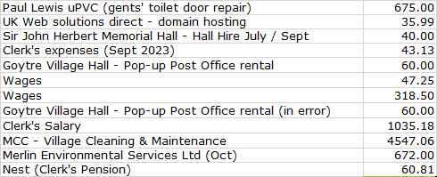  - Review of accounts and cashflow  The Clerk presented the meeting with a copy of the October 2023 cashflow.  There were no comments or observations.  - 2024/2025 budget – latest draft  The Clerk presented the latest version of the 2024/25 budget, for consideration by Councillors (updated with comments from the meeting on 9th October). This version had previously been distributed for further review / familiarisation. The items highlighted in yellow, are the budget lines amended following last month’s meeting. Since then, the National Pay award for Clerks has been agreed, (it will be formally discussed by Councillors next month). If the award is accepted in full by Council, the projected Clerk’s salary will be £96 too low. However, as the amount is not significant, no adjustments are to be made at this stage.  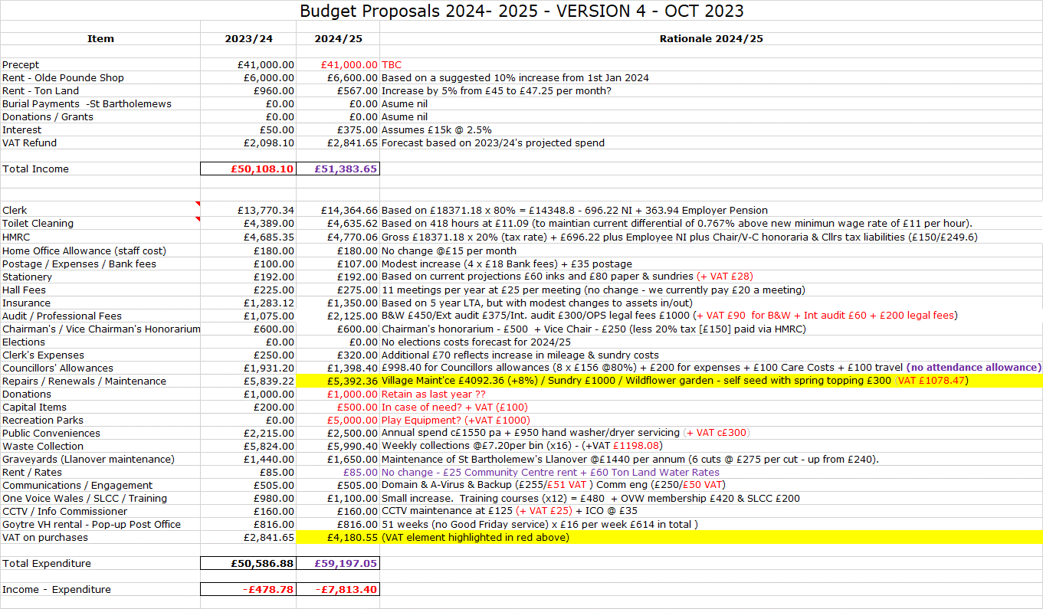  No further amendments were proposed at this stage. A final decision will be made at the December meeting when the full outcomes of the community engagement exercise will be known and understood. They will then be incorporated as appropriate. The Clerk will also contact Johnathan Wassal at MCC, to obtain the latest situation regarding the provision of additional play equipment for the Park.  - Signing authority update  The Clerk confirmed that he has contacted Unity Trust Bank and has obtained an account management form to remove ex Councillor Chandler as a signatory, and from accessing the CC’s on-line account. This has now been signed by Councillors Dodd and Morrey (both signatories on the account), and will be returned to UTB by the Clerk.  - Outcome of 2022/23 External Audit  The Clerk is pleased to confirm that the 2022/23 Annual Return has now been reviewed by Wales Audit, who have provided an unqualified report, meaning that, in their opinion, no matters have come to their attention which give cause for concern in any material respect.  The Chair and Councillors thanked the Clerk for his work in his role as the Council’s ‘Responsible Financial Officer.’ | Clerk
8 | Planning.  - To accept the responses of the planning committee meeting held on 23rd October  The following application was listed for consideration during the meeting:  - 23/22347/FUL - An application for the conversion of a barn to a residential use (C3). Occupancy of the barn to be restricted to be only used in conjunction with the main house by a family member.  Pwll Yr Hwydd Farm, Ancient Road, Llanover NP7 9ES  - 23/22348/LBC - An application for the conversion of a barn to a residential use (C3). Occupancy of the barn to be restricted to be only used in conjunction with the main house by a family member.  Pwll Yr Hwydd Farm, Ancient Road, Llanover NP7 9ES  The meeting agreed there were no concerns regarding either of the above proposals.  - DM/2023/01385 - Householder: Conversion of existing detached workshop into proposed Hobby room and Store.  Royal Oak Cottage, Plough Road, Penperlleni, Goytre, Usk, Monmouthshire. NP15 1QP  It was commented that light spilling from the new dormer window facing into the road might be a distraction to motorists. Otherwise, there were no concerns with the proposal.  - 23/22372/FUL - 1.5 storey side extension to SE-facing elevation, comprising living area, w/c, additional bedroom and ensuite. Glazed gable to SE-facing elevation, and timber-frame balcony with glass balustrade. Lean-to structure to rear for additional access and boot room.  Pant Bach, Ancient Road, Llanover NP7 9ES  - 23/22379/LBC - 1.5 storey side extension to SE-facing elevation, comprising living area, w/c, additional bedroom and ensuite. Glazed gable to SE-facing elevation, and timber-frame balcony with glass balustrade. Lean-to structure to rear for additional access and boot room.  Pant Bach, Ancient Road, Llanover NP7 9ES  The meeting agreed there were no concerns regarding either of the above two proposals.  Acceptance of the minutes (previously circulated), was proposed by Councillor Daniel and seconded by Councillor Dodd, and passed unanimously.  - Any other updates  A meeting will need to be scheduled shortly to consider BBNPA application 23/22403/FUL for the installation of an air source heat pump, and solar panels to the roof of Dy Westy , Pen-Croes-Oped Road, Pencroesoped, Llanover NP7 9EL | Cllr. Barnes
9 | County Council update – Written submission from County Councillor Jan Butler.  - Officers visited Penperlleni with me walking the whole village looking at state of footpaths and the need for dropped curbs. The team is not funded directly by MCC but by grants direct from WG. I am hoping we will see some improvements in due course. There are an increasing number of residents who use scooters and walking aids, who I hope will benefit.  - As a result of the survey, I was able to see many properties where hedges are not being properly maintained and are causing restrictions to pavements either by overgrowth or build-up of moss where the pavement is put into shade. I was reminded that the County Council has a role here and can require residents to maintain their hedges.  - Pavement parking is a serious problem on all streets forcing pedestrians into the road.  - I asked a question at the last Full Council Meeting. The result of this being that the revised policy regarding Community buildings leases will be updated by early December. This will directly benefit Goytre Community Centre and enable the committee to move forward.  - The Revised Local Development plan was passed last month. There is no change to candidate sites in Penperlleni or Llanover.  - At present the phosphate ban on building in the Usk catchment continues. A review of the Penperlleni and Llanover sewage treatment works is expected shortly and this may result in mitigation being put in place and the lifting of the ban. Current housing policy is for 50% affordable housing. It remains to be seen whether developers will show any interest in building in Penperlleni or Llanover.  There were no comments, observations or questions from Councillors.
10 | Community Engagement – Councillors Janet Robins / Jan Butler (absent) / Nigel Morrey.  The engagement event was held at 11.00 am on Saturday 11th November in Goytre Village Hall. There was a very disappointing turn-out, with just three Councillors in attendance (plus the Clerk), and only five residents, visiting the hall during the four hours of the event. Councillor Robins felt that this perhaps reflected a lack of interest from all parties. On a more positive note, some 55 surveys have been returned to date (one still to be analysed), and with, we believe, a handful of forms still to be returned.  Key headlines to date are (draft figures at this stage):  Q1. Location of Respondents  Goytre 47 Nantyderry _3 Llanover 1 Goetre Wharf 0 Not sure 3  The vast majority of respondents are from Goytre. Obviously Llanover reduced because of no Councillor, but more effort needs to be made to engage with Nantyderry and Goetre Wharf residents. Perhaps it would have been better to put Mamhilad rather than Goetre Wharf, as many people were unsure where the boundary of GW was?  Q2. Age of Respondents  Age 0-5 6-11 12-18 19-30 30-50 51- 70 70+ Prefer not to say  Number 6 6 3 9 22 21 41 4  As expected, there were more respondents in the 70+ category, but we also received a healthy number of returns from the 30-50 and 51-70 age groups. It would be interesting to see how this reflects the actual demographic make-up of the area.  Q3. Preferred communication channel with the Community Council? (score 1 for main, 2 and 3 for secondary and third):  Village Facebook pages 37(first). 1 (second) 3 (third)  Community Council website 3 20 10  Council noticeboard by park 19 11 13  The most preferred communication choice is FB, with Council noticeboard next most popular. Not so many people look at the website. This suggests we need a regular and positive FB presence, communicating what the Council is doing.  Q4. Not analysed yet.  Q5. Bearing in mind the increased costs the Community Council expects to incur in the next financial year, please tick the statement that you agree with:  I would prefer to pay a reduced precept and have reduced services 14  I would prefer to pay a slightly increased precept (broadly in line with inflation) and have the same level of council services 28  I would prefer to pay a higher precept (above the level of inflation) for more/ better services 10  No answer given 2  Total 54  These results suggest the middle option (i.e. slightly increased precept) is the most preferred.  Qs 6, 7 and 8 are still to be analysed.  A comment was made that the introduction to the survey, which gave details of the services delivered by the Community Council, should be included on the main web page and noticeboard (after appropriate editing to make it suitable). The Clerk to arrange. | Clerk
11 | GDPR – Final review & confirmation of GDPR document retention policy.  Following October’s meeting, the Clerk has undertaken further research regarding retention timescales, particularly with regard to audit papers and Councillor allowances. Our existing retention document confirms Audit papers should be retained indefinitely (although paid invoices can be destroyed after six years). Similarly, the ‘cashbook’ (the record of all receipts and payments), should be retained indefinitely.  The IRPW have confirmed that the time limit for the retention of published documents (in our case the Councillor’s payments statement), is covered in Annex 5 of their 2022-2023 annual report, which states:  - Retention. The time limit for the publications to be retained should be consistent with the Council’s policy on document retention.  On the basis of the above, the Clerk feels that all our existing timescales comply with GDPR retention legislation, and as such, our current policy guidelines should be renewed for another three years, with the Chair signing to confirm.  This was proposed by Councillor Morrey, seconded by Councillor Daniel, and passed unanimously. Chair to sign and Clerk to action. | Chair / Clerk
12 | Pre-Order Consultation – Proposed Public Footpath Diversion (path no. 138) – Mount Pleasant, Goetre Fawr  The CC has been asked by MCC to consider an application from a Mamhilad resident to divert part of path 138 in the community of Goetre Fawr, under the provisions of Highways Act 1980 – Section 119.  The proposal would have the effect of moving the current legal alignment of the path from the driveway and garden of a residential property and into the adjacent field. This is with the intention of improving the security and privacy for the owner of the residential property, and improving the route for the path user. The landowner of the field into which the path is to be moved has signed a consent to the proposed changes.  MCC believe that the proposed diversion meets the requirements set out in the Highways Act 1980, but have requested the CC’s views and comments.  Having considered the plans (previously circulated by the Clerk), it was agreed that there were no concerns with the proposals and this was formally proposed by Councillor Daniel, seconded by Councillor Morrey, and passed unanimously. | Clerk
13 | IRPW – Confirmation of tax status for Councillor Allowances – Review of payment for Councillors’ expenses, in light of the confirmed new tax status.  The IRPW has now formally confirmed the taxation status of both the Councillor allowances and payments to cover the costs of consumables as follows.  - Allowances  It has been expressly confirmed that the annual £156 allowance can be claimed tax free under the ‘working from home allowance’. The Clerk will create a new claim form, to which he will add a declaration for Councillors to confirm that, in claiming the allowance tax free, they will not exceed the HMRC annual limit of £6 a week / £312 per year.  The Clerk asked those Councillors, who had previously indicated they wished to decline receipt of this payment, to advise him if they wished to change their minds following the receipt of this new information. All Councillors were happy with their original decision.  - Consumables  Previously the tax treatment of consumables was unclear. As a result, the CC took the decision that all payments should be made on the basis of a claim supported by receipted invoice (none made so far this financial year). However, it has now been confirmed that an up-front payment of £52 can be paid tax free. As a result, the Clerk asked Councillors if they now wished to change the policy and adopt the tax-free payment. At this stage, it is unclear that, if adopted, whether Councillors can claim using the previously agreed receipted invoice option instead.  The options are therefore:  - Retain the existing claims policy of using receipted invoices  - Accept the tax-free payment of £52 per annum  - If allowable, to provide Councillors with the option of choosing either (i) or (ii) above.  Following a brief discussion, Councillors agreed that they wished to retain the existing policy of payment against receipts (so option 1 above), and this decision was proposed by Councillor Morrey, seconded by Councillor Daniel, and passed unanimously. Clerk to bring the updated basic allowances forms (to include the home allowance declaration), to the next meeting for signature. | Clerk
14 | Goytre Recreation Park.  - Sports recreation hub  There were no updates to report. Clerk and Councillor Butler to check with Mike Moran when it is planned that MCC will undertake their engagement with residents, to decide on how to spend the s106 monies. Councillor Morrey asked the Clerk to confirm the closing date for works to commence before the monies must be returned to the developer. The Clerk to check and advise all Councillors.  - Playground equipment update  There were no updates. However, the Clerk will contact Johnathan Wassal at MCC, (as noted under item 7(iii) above), to obtain the latest situation, regarding the provision of additional play equipment for the Park. | Clerk  Clerk
15 | Village Committees’ Reports – questions based on previously distributed updates.  - Goytre Village Hall  - Wellbeing Cafe well attended between 30 / 40 people in attendance.  - Events have been booked right up to December.  - Men’s toilets being upgraded in November including the toilets in the club.  - Free food hall again well attended.  - Still waiting on the new alcohol licence(s), either one to cover both the Hall & Social Club, or two individual licences.  - Llanover Village Hall  - No report submitted.  - Goytre School Governors  - Asymmetric plan going well.  - A new 1st year teacher is starting in January.  - Teaching is reaching its targets.  - Goytre Community Centre  - Application for significant grant from MCC has been applied for.  - The Open Day attracted over 50 visitors. The Secretary of State for Wales, David TC Davies, attended and continues to give support.  - Outline plans have been drawn up by architect Stephen Peel and are available for sight (could include in the CC’s engagement day).  - Successful fundraising quiz night was held on 25th October. More to follow.  - Transfer of leasehold to Community Centre Committee is in train following site visit from Nick Keyse (Estates Manager MCC).  - Other Reports  - There are no other reports.
16 | Council representatives on Goytre Village Hall & Community Centre Committees.  Councillor Dodd has recently been appointed Vice Chair of the Social Club, and so has resigned his post as Council representative to the Village Hall Committee. Councillor Daniel has also resigned from the Community Centre Management Committee. There are, therefore, opportunities for the CC to appoint new representatives to both committees.  There were no volunteers to undertake either position from those Councillors present, and so it was agreed to defer the item until next month’s agenda. | Clerk
17 | Donation requests.  Wales Air Ambulance submitted this request last month, although it was received too late to be discussed at October’s meeting. Previous donations have been £500 (in both 2020/21 and 2021/22), and £250 in 2022/23. However, as has been previously recorded, this year’s donations budget has now been exhausted. The Clerk suggested, that, if Councillors wish to make a donation to WAA (and other organisations this financial year), they could consider transferring the honoraria budgets (totalling £750), neither of which it is indicated will be claimed this year. Both the Chair and Vice Chair were comfortable with such a proposal if formally made. However, it was agreed to defer this item to the next meeting when question 4 in the survey (which includes donations), has been properly analysed. | Clerk
18 | Communications.  - As Councillors are aware, the Clerk has received an email from the Rev. Sue Davies-Fletcher, who has written on behalf of the local Church Committee in Llanover, to express their concerns about the condition of St. Bartholomew's churchyard, following the grass-cutting in preparation for a funeral on 25th October. The Committee advised that several small memorial ornaments, pots, and artificial flowers have been damaged and scattered across the area and some of these items are now disassociated from their respective graves. In another place, a bunch of flowers was covered by the grass cuttings and knocked over. In addition, the cuttings in certain areas were reported to be quite deep, making the ground challenging to walk on. Some had accumulated on the bench, and splattered against memorial stones, making the area look uncared for. Sue has also reported a substantial amount of green moss on the path, which she felt posed a slipping hazard.  In Sue’s absence on leave, the Clerk has spoken with the Team Rector, Kevin Hasler, who has confirmed that this has not been a problem before, and so it is unclear exactly what has happened on this occasion. It is quite possible that the recent storms have scattered some of the memorial flowers etc. It seems unlikely that the strimming would encroach onto the graves themselves. Unfortunately, the grass was long and wet at the time of cutting, and so is likely to have been scattered around. Kevin acknowledges that it is not feasible for the CC to take responsibility for the cleaning down of all the headstones.  The Clerk has not, as yet, been able to meet with the Church Warden, but has assured her of our determination to provide a clean and tidy graveyard, within the realms of our budget. Usually, the Clerk visits the graveyard in advance of any burials, but on this occasion, he was away on leave. However, he will attend where possible in future, and make sure all is presentable. He has also treated the areas of moss with the salt provided for icy conditions and will monitor the effectiveness of this approach. | Clerk
19 | Meeting Dates for 2024/2025  The following dates were agreed for future meetings  2024  May 20th / June 17th / July 15th / Sept 9th / Oct 7th / Nov 11th / Dec 9th  2025  Jan 13th / Feb 17th / Mar 24th / Apr 28th  The dates were proposed by Councillor Morrey, seconded by Councillor Robins and passed unanimously.
20 | Advertising - Usk and Raglan Diary contributions Jan/Feb 2024.  The closing date for submissions is Friday, November 24th. It was agreed that the following items be sent for inclusion:  - The appointment of the new Councillor (next item) to represent Llanover ward  - The key outcomes from the engagement event | Clerk  Cllr.  Robins
21 | Co-option of a Councillor for Llanover Ward (Closed session)  The Community Council has received two excellent nominations for the appointment of a Community Councillor for Llanover ward. Unfortunately, only one of the candidates had attended a Council meeting, and whilst Councillors felt that it is always preferable to have had the opportunity to meet with all the candidates before making a co-option decision. However, on this occasion, there was a certain urgency to appoint, given the need to undertake a community engagement event in Llanover at the earliest opportunity.  Therefore, after due consideration of both candidates’ ‘applications’, the appointment of Mr Lewis Carter was proposed by Councillor Daniel, seconded by Councillor Morrey and carried unanimously. The Chair will write to both candidates. The Clerk to meet with Mr Lewis Carter to arrange for the signing of the ‘Declaration of Office’, thereby completing the appointment formalities and enabling him to take office with immediate effect. | Clerk
22 | Date of next meeting and close.  The next meeting is to be held on Monday 11th December at 19.45. The venue to be Llanover Village Hall, and by teleconference via: https://meet.jit.si/GoetreFawrCommunityCouncil | All/  Clerk

Chairman: …………………………………….…………… Date:…………………….

