CYNGOR CYMUNED

GOETRE FAWR

COMMUNITY COUNCIL
MINUTES OF THE MEETING HELD AT LLANOVER VILLAGE HALL & BY TELECONFERENCE ON MONDAY 11th NOVEMBER 2024 @ 19.45

Present: Community Councillors Lewis Carter, Andy Barnes, Peter Daniel,
Owen Dodd, Janet Robins and Community / County Councillor Jan Butler.

In Attendance: Jonathan Lazenby (Clerk).

Apologies: Community Councillor Nigel Morrey.
Absent without Apology: Community Councillor Scott Grayland.
 |  | ACTION
1 | Apologies for Absence.  As above. | Clerk
2 | Declarations of Interest.  In the absence of the Chair, the Vice-Chair, Councillor Carter, commenced the meeting by asking the members present whether they had any declarations of ‘interest’ to make, which includes previous declarations already made. Although not an agenda item at this stage, Councillor Robins wished it to be known that the founder of Edenstone homes (the possible developer of additional houses at Trem Yr Ysgol) is a personal friend. His son is the Chairman. To date she has had no involvement in any decisions relating to this development, and has not discussed it with him or his son. As a result of her ‘interest’ she will not attend the planned meeting in the village hall, in early December, to discuss the item. The Clerk noted this interest, and will add it to the register of interests. No further declarations from the members were forthcoming. | Clerk
3 | Vice-Chairman’s Remarks.  Councillor Carter welcomed everyone to the meeting. In recognition of Armistice Day, he said that he would like to take a moment to remember and thank all those from across Goetre Fawr, who have given their lives in the service of the Country. This extends to all those who have served and are currently serving in HM Armed forces.  Secondly, he wanted to thank everyone who has helped organise the remembrance services throughout the wards, commenting that it had been wonderful to see so many in our community turn out to remember the fallen, loved ones and those suffering as a consequence of war across the globe.  Lastly, he wanted to take a moment to express his deepest sympathy to everyone affected by the awful fire on Abergavenny high street. This has seen the loss of a number of businesses and historical architecture from the town, and many in our community have commented on their sadness at this loss. His thanks go to the emergency services for their quick response and tireless efforts in extinguishing the fire.  Councillor Carter hoped that councillors will join him in expressing the sentiments above, and in thanking all members of the armed and emergency services.
4 | Minutes.  Approval of the Minutes of the meeting held on 14th October 2024.  The minutes were proposed as a true and correct record by Councillor Daniel, seconded by Councillor Carter, and carried by all who were present at the October meeting (Councillors Butler & Dodd did not vote, having been absent from the October meeting). | Clerk
5 | Matters Arising.  - Item 6 (iv) – For information purposes only. The latest pledge number for the Nantyderry fibre build project still stands at 57.4% (having not moved since last month).  - Item 6 (v) - Following the Clerk’s query, a credit note was issued. which brought the cost of the upgraded hard drive back down to the quoted price of £220 plus VAT. This has now been paid.  - Item 16 (v) – St Bartholomew’s Church Hall. The letter of endorsement supporting their funding application was sent by the Chair on 22nd Oct. Councillor Carter reported that this was gratefully received and the grant application has now been submitted.
6 | Maintenance. (including items previously reported, but not yet addressed).  - Repairs to / replacement of Olde Pounde Shop side door.  Following October’s meeting, the Clerk approached Paul Lewis to see if there were any cheaper options, to either repair or replace the side door of the OPS. Much of the bottom of the door and frame is completely rotten, and so a further repair is not realistic. A soft wood replacement would cost £2200 fitted and painted, (so £600 more than the uPVC door), and hardwood would cost £2674 (£1074 more). Clearly the uPVC option is the most attractive price wise (and is the same material as the shop front). The Clerk will contact the tenant to discuss the way forward once the new lease has been signed.  - The defibrillator pads at Goytre Village Hall, The Star Inn and the Secret Garden are all due to expire within the next month. Normally the Clerk would just order a new set, but given the amount and the convenient timing of this meeting, he felt it appropriate to confirm the purchase with council beforehand. The total cost will be in the order of £200 + VAT. This was approved and proposed by Councillor Dodd, seconded by Councillor Daniel and carried unanimously. | Clerk  Clerk
7 | Finance.  - Payments made since the October meeting.  £  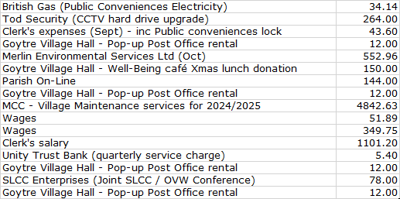  - Review of accounts / cashflow.  The Clerk presented the meeting with a copy of the October 2024 cashflow.  There was no further comment or observation.  - 2023/2024 External Audit – Acceptance of the report.  Although the Auditors Report was presented to the last meeting, due to an oversight, it was not formally accepted by councillors. There was no ‘qualification’ to the report, or issues raised, but nevertheless, the Clerk felt that for good order, the report should be formally accepted by council. This was proposed by Councillor Daniel seconded by Councillor Robins and carried unanimously. The Clerk confirmed that the report has already been published on the web site and placed on both noticeboards.  - 2025/26 budget – Latest updates.  The Clerk presented the latest draft Budget (v4) for consideration. The changes from v3 (presented at the October meeting), have been highlighted in block yellow, and are as follows:  - The Clerk’s salary and associated NI & Pension Payments. These are still calculated on an estimated pay increase for 2025/26 (3%), but are now based on the recommended (rather than estimated) pay level for 2024/25 (to be discussed under item vii below). This sees a reduction in the projected gross salary of £403.  - The budget on 30th October confirmed the new National Minimum Wage will be £12.21 per hour, which has now been included in our calculations. This will see a wages increase to £12.30 per hour, giving a modest cost increase of £125 per annum.  - The cost of individual dog bin empties has now been confirmed by Merlin Environmental at £7.35 per bin (less than the anticipated £7.50). This reduces the projected cost by £148.20 + VAT.  - Confirmed costs for the village maintenance scheme are still awaited.  Full details of the current proposal are shown below:  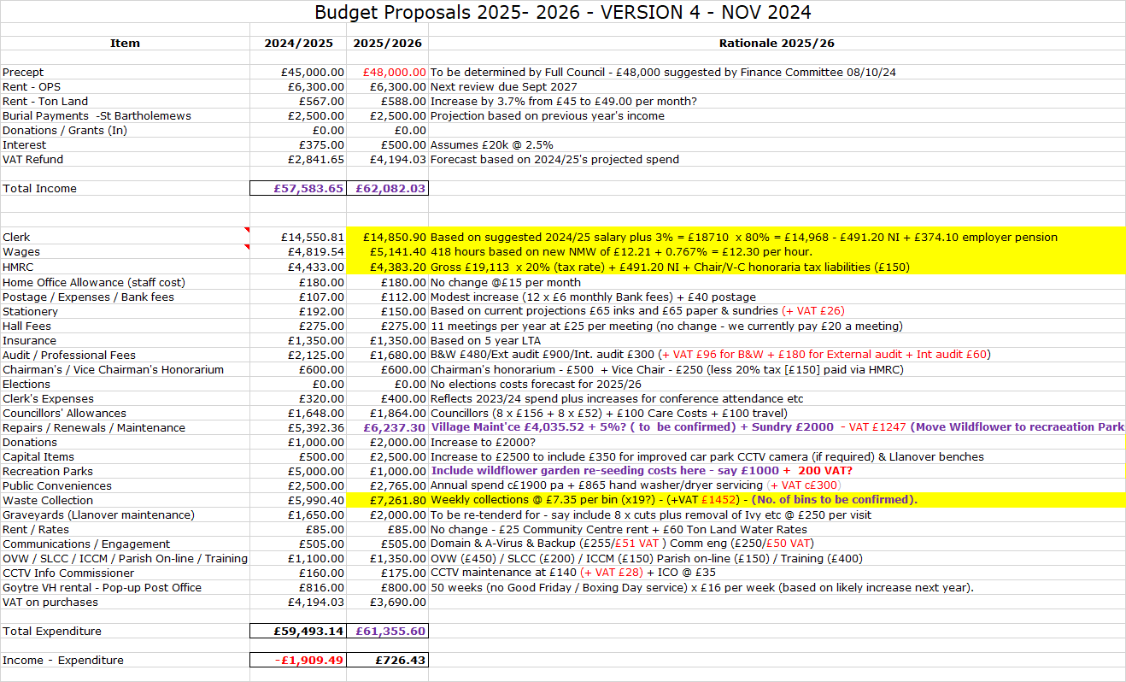  Based on the suggested precept of £48,000, this would see a small operating ‘surplus’ of £726. The plan is still to have formal sign-off in December.  - Adoption of the new 2024 Financial Regulations.  New regulations have been prepared by the National Association of Local Councils, together with One Voice Wales, and have been forwarded to us for adoption. The Clerk had previously distributed the document, with suggested additions shown in block green, and deletions shown by a double strike-through. The items shown in block purple are those areas where T & CCs have the ability to amend, as they feel appropriate (usually financial limits). The members took some time to review the content. Councillor Barnes suggested that we add a note to explain that references to the Clerk and/or RFO refer to the same individual, (in our case the Clerk), as the roles are combined (in common with most small community councils). Given the amount of content to review, the members felt that they would like more time to consider the full document. It was therefore agreed to defer making a final decision until the December meeting.  - New Lease on Old Pounde shop (Closed session).  At the request of the tenant’s solicitors, it was agreed that an existing clause covering the rent review process should be included in the new lease. This was formally proposed by Councillor Butler, seconded by Councillor Barnes and carried with five votes in favour and one abstention. Clerk to notify our solicitors.  - Clerk’s salary 2024/25 (Closed session).  At this point the Clerk left the room.  The 2024/25 pay agreement for local government employees has now been agreed at national level. Councillors agreed that the new rate be adopted by GFCC, (and backdated to 1st April), with this being proposed by Councillor Daniel, seconded by Councillor Robins and passed unanimously.  The Clerk then rejoined the meeting. He will notify Beverley & Williams (our payroll providers). | Clerk  Clerk  Clerk  Clerk
8 | Planning.  - To accept the responses of the planning committee meeting held on 22nd October.  The meeting covered the following application:  - MCC: DM/2024/01223 (retrospective application for retention of timber fence) - 80 Newtown Road, Penperlleni, Goytre NP4 0AZ.  The members present at the meeting passed a resolution that there was insufficient justification for the front garden fence, at 1.4 meters high, to exceed the UK norm of 1 metre, from ground level, when the fence is next to a road, footpath, or public highway. The review had no comment to make regarding the addition of an off-road parking area.  The minutes of the meeting have been published on the web site. Acceptance of the minutes was proposed by Councillor Robins, seconded by Councillor Daniel and carried unanimously.  - Any Other updates.  There are no updates at this time.
9 | County Council update – County Councillor Jan Butler.  Revised Local Development Plan (RLDP). The proposed plan was recently passed at MCC Council and will now go out to county-wide consultation. As part of the this process, Councillor Butler has secured an engagement event specifically for the village. This will be held in Goytre Village Hall on Monday 2nd December from 2 pm to 7pm. It was noted that none of the candidate sites put forward in Llanover were adopted, with one supposedly rejected through lack of information. However, the Estate has advised Councillor Carter that they were not aware of any problems or omissions with their submission.  Ultimately, the RLDP will go to Welsh Government for approval. This is unlikely to be before next July, and so it will be some time before it becomes a formal development plan.
10 | Green Corridor Project.  There has been no update from Jane Clarke at MCC regarding the project. In the interim Johnathan Wassal at MCC has confirmed that the seeding of the wildflower area will be covered from the Green Corridor funding (so there’ll be no cost next year). However, the Clerk has left the £1000 allowance in the budget, as this will potentially cover Spring 2026 costs. The excess soil and turf has been used to create a mound which will be either seeded or laid to turf.
11 | Trydani – Charge Place Wales (CPW). Interest Shown and Next steps.  Councillor Carter acknowledged that he had only recently re-promoted the plan, and hence it was too soon to know whether there was sufficient interest from potential users, or a co-ordinator (on whose shoulders the success of the scheme is likely to rest). It was agreed therefore, to again defer the item, this time to the December meeting. Clerk to place on next month’s agenda. | Cllr. Carter /  Clerk
12 | Goytre Recreation Park.  - Update.  The installation of most of the items has now been completed, with the exception of the ‘swingo’ and the additional pieces of adult exercise equipment.  - Purchase of additional adult equipment.  Mike Moran has confirmed that the remaining s106 monies amount to £2371, to which we can add £5,000 from our own resources, giving a maximum available spend of £7,371. Johnathan Wassal has now provided costings for the following items of adult equipment. These prices all include installation with a grass matrix protection matting.  - Rider Outdoor Fitness station £2454.00  - Rower Outdoor Gym £2412.00  - Twister ski Trainer £2295.40  Total £7,161.40  This would require us to utilise all but £210 of the £5000 set aside in the budget to pay for additional equipment in the park. The purchase of the additional equipment, together with our contribution of £4790 was proposed by Councillor Robins, seconded by Councillor Daniel and carried unanimously. It was requested that MCC don’t install the equipment on the play area of the lower field, but consider the bandstand area under the trees. Clark to notify MCC. | Clerk
13 | Llanover Village.  - Play Area – update.  Councillor Carter advised that he had received an email from the Llanover Estates dept., who have confirmed that they are going to remove the swing, but keep the slide for now. However, this too will go in time. It’s not clear if they are planning to make the village residents aware of this in advance.  - Installation of dog bins – update.  Councillor Carter advised that the Canal & River Trust have confirmed that they don’t want any more bins placed along the canal towpath, and nor will they contribute towards funding any. We will continue to explore other locations for any potential bins to be placed, with the Clerk confirming that he has budgeted for three bins for the Llanover area in case of need.  - Residents Survey – update.  This has still to be sent out. Councillor Carter will remove the play area and community garden questions from the survey, as the Estate will not be supporting these.  - Friends of St Bartholomew’s – update.  This has been advertised on the Facebook page, although there hasn’t been a lot of interest to date. Councillor Carter said he will re-promote the note to see if he can elicit more support. If there is no overall groundswell of interest, he will instead try promoting specific dedicated ‘days’ for interested people to attend. There is still a request for lighting along the path through the churchyard. The Clerk to investigate where we might obtain an electricity supply and will contact Revd. Sue Fletcher-Davies to explore requirements in more detail. | Clerk
14 | Donation Requests.  - Heart of Monmouthshire Ministry Area- suggested £200 for graveyard maintenance at St Peter’s Goytre and at St Illtyd’s.  We have received a letter asking us to reconsider our interpretation of the advice from the NALC, regarding payments to Churches for the maintenance of graveyards. The 1894 Local Government Act restricts the powers of T&CCs to provide funds for the management and maintenance of churches. The NALC  states that there is no legal certainty that any such payments would be valid. Although, previously, the UK Govt stated that there was no reason to change the law, (as they believed there was no such uncertainly), the law in England was subsequently changed (but not in Wales). With no specific power, we would have to rely on s137, which is always closely inspected during our annual audit (and we are to undergo our in-depth three-yearly transactional review next year). The Clerk believes that similar changes to the law may be being discussed by Welsh Govt., (and councillors felt that the Church may wish to lobby on this), but, until such time as the law is clarified, he considered that the most appropriate way forward was to politely decline the request for the time being. Obviously, a subsequent application could be considered in the light of any changes to the law. This approach was formally proposed by Councillor Dodd, seconded by Councillor Butler and carried unanimously by the remaining councillors.  - Wales Air Ambulance (WAA) - (unspecified amount).  We have been approached to support WAA’s annual appeal. This year it is focused on upgrading two of their aircraft from 4 to 5 rotors at a cost of £60,000. This will provide greater fuel economy, comfort for patients and greater payload capacity (for more medical kit / personnel). In 2023 the ambulance attended Monmouthshire on 111 occasions, and indeed, was in attendance in the ward again only a few days ago. The Clerk noted that we have traditionally supported their appeal, and last year donated £250. After due consideration, Councillor Dodd proposed a donation of £300 under s137 (LGA 1972), and this was supported by Councillor Daniel and carried unanimously. | Clerk  Clerk
15 | Village Committees’ Reports – questions based on previously distributed updates.  - Goytre Village Hall  - Nothing further to report since the October meeting.  - Goytre Fawr School  - Nothing further to report since the October meeting.  - Llanover Village Hall  - No report submitted.  - Goytre School Governors  - No report submitted.  - Goytre Community Centre.  - No report submitted.  - Other Reports  - There are no other reports.
16 | Communications.  - GFCC Facebook page – latest posts / responses.  There was nothing specific to report. However, councillors noted that they often have difficulty in locating the page, and sometimes they were directed towards the old site (now discontinued). Councillor Carter was unsure why this was happening, but will liaise with councillors to see if he can identify the problem. In the meantime, Councillor Dodd is to see if we can permanently remove the old site.  - There are no other communications to report. | Cllrs, Carter and Dodd
17 | Advertising – Usk & Raglan Diary Contributions Jan/Feb 2025.  It was agreed that the Clerk would prepare a short article, with photos showing the new play items already in the park, together with future planned enhancements e.g. the adult sports equipment. | Clerk
18 | Date of next meeting and close.  The next meeting is to be held on Monday 9th December at 19.45, at Llanover Village Hall, and by teleconference using: https://meet.jit.si/GoetreFawrCommunityCouncil | All/  Clerk

Chairman: …………………………………….…………… Date:…………………….

