CYNGOR CYMUNED

GOETRE FAWR

COMMUNITY COUNCIL
MINUTES OF THE MEETING HELD AT LLANOVER VILLAGE HALL & BY TELECONFERENCE ON MONDAY 15th JANUARY 2024 @ 19.45

Present: Community Councillors, Owen Dodd, Andy Barnes, Peter Daniel, Janet Robins, Nigel Morrey and Lewis Carter.

Guests None.
In Attendance: Jonathan Lazenby (Clerk).

Apologies: Community / County Councillor Jan Butler.
Absent without Apology: Councillor Scott Grayland.

 |  | ACTION
1 | Apologies for Absence.  As above. | Clerk
2 | Declarations of Interest.  The Chair commenced by asking the members present whether they had any declarations of ‘interest’ to make. This includes previous declarations already made.  Councillors Daniel and Robins declared an interest in the donation request made by Goytre Fawr Primary School. However, Councillor Daniel, as an appointed Council representative, does not have a prejudicial interest by way of section 12 (2) (a) (iii) of the code, and neither has a prejudicial interest by way of section 12 (2) (c), as the request donation is for an amount of £500 or less. Councillor Barnes also re-declared his own personal interest in the MUGA as, depending on its siting, (if on the lower section of the park), he was likely to object on the grounds of noise.  The Chair then reminded members that they should notify the meeting of any additional interests which become apparent during the progress of the meeting. No further declarations from the members were forthcoming. | All / Clerk
3 | Chairman’s Remarks.  Councillor Dodd took the opportunity to welcome everyone to the meeting and thanked Councillor Carter for his work in setting up the new GFCC Facebook page
4 | Minute  - Approval of Minutes of the Meeting held on 11th December 2023.  The minutes were proposed as a true and correct record by Councillor Daniel, seconded by Councillor Morrey and carried by all those present with the exception of Councillor Dodd, who was not at the December meeting.  - Approval of Minutes of the Closed Session Meeting held on 11th December 2023  The minutes were proposed as a true and correct record by Councillor Carter, seconded by Councillor Morrey, and carried by all those present with the exception of Councillor Dodd, who was not at the December meeting. | Clerk  Clerk
5 | Matters Arising.  - Item 5 (i) - The Electrical Safety Test Certificate for the public conveniences has now been received (The Community Centre certificate is still outstanding – Clerk to chase).  - Item 6 (i) – The repairs to St Bartholomew’s Lichgate have now been completed (photograph circulated to Councillors), and the invoice has been paid.  - Item 6 (iii) – Pot holes on Capel Ed Lane. Councillor Robins believes that a number of people have submitted repair requests via the My Mon App, and asked whether it was possible to find out how many. Clerk to investigate.  - Item 8 (v) – The precept request for 2024/25 has been submitted to MCC and receipt acknowledged.  - Item 11 – The Clerk has advised the police Neighbourhood Policing team of the new boundaries. However, it appears that Gwent Police’s incident recording system did not change in line with the Community Council boundary changes. Therefore, the villages of Little Mill and Monkswood etc are still under the Goytre Gwent Police beat code. As a result reports will, from time to time, include the odd incident from areas outside of the new GFCC boundary.  - Item 12 – The Clerk has now instigated the back up system with ‘IDrive’, and, so far, all appears to be working well. Once the system is established, he will contact ICT vision to cancel our contract with them. He has also submitted a review of the system, which, if accepted, should see us receive a refund of our first year’s subscription. | Clerk  Clerk
6 | Maintenance. (including items previously reported, but not yet addressed).  Councillor Carter raised the issue of the loose stonework on bridge 76 over the canal. It is not clear if this falls under the responsibility of MCC or the Canal and River Trust (we suspect the latter). We believe Councillor Butler is following up this issue. Clerk to contact Councillor Butler to check on progress. | Clerk
7 | Finance.  - Payments made since the previous meeting.  £  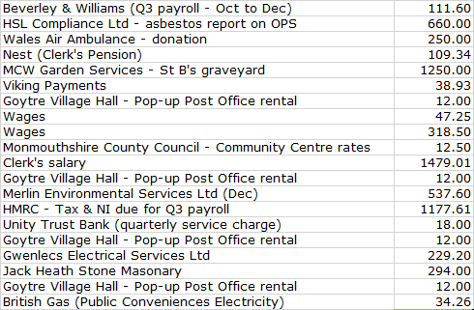  - Review of accounts and cashflow  The Clerk presented the meeting with a copy of the December 2023 cashflow.  It was noted that the final precept payment of 2023/24 has now been received. There were three equal payments, resulting in receipts of £41,001.  The Clerk confirmed that the Cashflow accounts had been verified to the closing balances in the UTB statements at the end of Oct/Nov/Dec 2023, during the Finance Committee meeting on 9th January. Councillor Daniel had signed to confirm in accordance with section 2.2 of the Community Council Financial Regulations (Wales).  There was no further comment or observation.  - 2024/2025 budget – latest draft – update as required  The Clerk presented the latest version of the 2024/25 budget (distributed prior to the meeting). Since December it has been updated to reflect the small change to the Clerk’s salary / PAYE & NI / the OPS rental income and the precept for 2024/25. The remaining items to be decided include:  - Confirmation of the donations budget  - Funding for improvements to the recreation park (KIV some £1886 is still held in our interest-bearing account, remaining from the Geography Fund donation earlier this year). Therefore, in reality, the budget deficit currently indicated is £4109 less £1886 = £2223.  The Clerk has requested an update from Johnathan Wassal at MCC on the progress of the funding for the park equipment. A response is still awaited.  Councillors decided to defer finalising the budget until the February or March meetings.  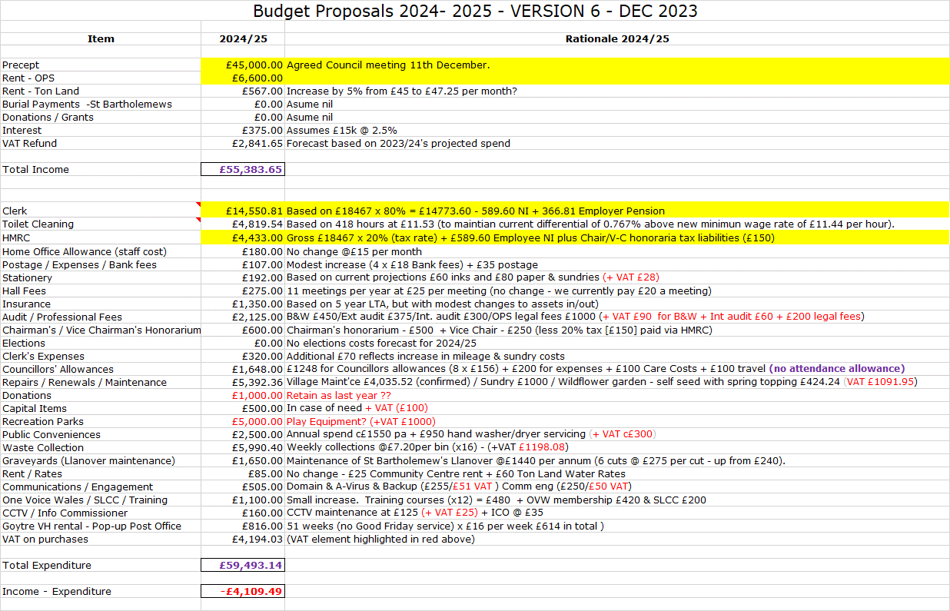  - Finance Committee update including Risk Review from their meeting on 9th January  The following key issues were recorded at the meeting.  Precept not paid by MCC  Full Council confirmed precept for 2024/25 at December 2023 meeting. Clerk/RFO has submitted to MCC who have acknowledged receipt. Final budget to be confirmed by Full Council before the end of March. Final payment of 2023/24 precept monies received in Dec 2023.  Loss of Money  Loss of Income from Olde Pounde Shop. Tenant has asked us to revisit proposed rent increase. Lease expires 28th Sept 2024, and will need to be renewed, with fees of £1000 budgeted to cover. Insurance with Zurich to be renewed 2nd Feb 2024 which includes Business Interruption insurance - max £6600 over 12-month period. The Clerk was asked to check under what circumstances we would be able to claim a ‘loss’ under this cover.  Legal Powers – Illegal Payment or Activity  With the resignation of Councillor Morgan, and the co-option of Lewis Carter, the Community Council will no longer meet the eligibility criteria of having a minimum of 2/3rds of Councillors either elected or elected unopposed. We will therefore be unable to re-adopt the General Power of Competence at the May 2024 ASM. In future, we will have to rely on our specific statutory powers and duties, supplemented by s137 as required.  Salaries / Wages - Wrong Salary Paid  Increase of wages budget formally agreed at Dec. 2023 full Council. Updated wage details to be forwarded to Beverley & Williams for payment from April 2024 onwards. Standing orders for the wages will be updated to reflect 2024/25 salaries. Employees to be advised of pay rise.  Councillors Allowances – proper deduction of Tax  The Clerk requested Councillors complete any required documentation at the Dec 2023 meeting, should they wish to claim their annual allowance. Following HMRC guidance, the allowance will now be paid tax free for those who are able to claim the £156 payment within the annual working from home allowance of £312. Only the Bank details from Councillor Grayland are now awaited (or confirmation that he does not wish to claim the allowance for this year).  Training of Councillors  Code of Conduct course to be identified for Councillor Carter to attend as soon as possible. Full review of GFCC training plan to take place later on tonight’s agenda.  Training of Clerk / Staff  Email to be sent to both cleaners in February, asking for confirmation of adequate safety supplies / materials safety guidance/training issues. Receipt of satisfactory confirmation to be recorded.  Insurance  Insurance to be reviewed later this evening and renewed by 2nd February 2024 at the latest.  Risk Assessment / Health & Safety  Electrical safety checks for the Public Conveniences and Community Centre undertaken on 16th October 2023. Public Conveniences certificate received; Community Centre certificate still outstanding.  Asbestos Monitoring Survey undertaken by HSL Ltd from Hereford. Full report awaited, although initial reaction is ‘no concerns’. May be some asbestos in bitumen coating under a sink unit, but not a danger. HSL suggest painting over the bitumen to protect it from damage / flaking. No other action, but CC will need informing if the unit is ever to be removed. Test results of outside samples awaited.  Data Protection Legislation  Document retention timescales signed off at November 2023 meeting.  Acceptance of the Risk Assessment undertaken by the Finance Committee was proposed by Councillor Daniel, seconded by Councillor Morrey and carried unanimously.  - St Bartholomew’s burial fees with effect from 01-01-24  It was proposed that the burial and associated fees be changed in line with the recent increases agreed by the Church in Wales.  The amendment to change our fees to match those off the CIW was proposed by Councillor Dodd, seconded by Councillor Carter and carried unanimously. | Clerk  Clerk  Clerk  Clerk
8 | Insurance Review & Renewal  The Clerk presented the renewal document, together with a copy of the register of assets. It was agreed that the policy provided adequate cover, with the acceptance and payment of the renewal premium of £1,266.97 (including tax), being proposed by Councillor Dodd, seconded by Councillor Robins, and carried unanimously. | Clerk
9 | Community Engagement – Survey results & conclusions for 2024/25 precept - Councillors Janet Robins/Jan Butler/Nigel Morrey.  Unfortunately, Councillor Butler could not attend this evening’s meeting due to illness, and so was unable to update us on the next steps, following the survey results. Clerk to put on the agenda for February.  The Clerk confirmed that he had had no follow-up queries or comments from residents following the publication of the survey results.  Councillor Morrey asked if the Clerk could chase up MCC to see what, and when, their plans were for an engagement event (hopefully) in the near future, to agree on a way forward to spend the s106 monies. | Clerk  Clerk
10 | Planning.  - To accept the responses of the Planning Committee meeting held on 8th January.  The following applications were listed for consideration during the meeting:  - 23/22449/FUL (APCBB/BBNPA) - Permanent mooring of canal boat for part residential and part A1 and A3 use.  Canal Tuck Shop, Monmouthshire Brecon Canal, Pencroesoped Llanover NP7 9EL  Outcome: It is noted the application form, as documented, indicates, under ‘Description of Proposal and Existing Use,’ that the Canal & River Trust in Wales (CRT) has agreed to the
proposal. However, the response from the CRT dated 5/1/2024 states that the CRT is unable to make a substantive response in the absence of answers to listed questions. GFCC
is similarly unable to form a conclusion on the proposal without these questions, i.e. on Deliveries, Waste Disposal, Waste Storage, Grey Water, Water Supply, Power, Seating, Litter, and Parking, answered. The application further states that ‘Hours of Opening’ are not relevant. GFCC would comment that the opening hours of the business are relevant and should be stated. The application form under, ‘Neighbour and Community Consultation,’ is unclear as to who has actually been consulted on the proposal. The response ‘Local Walkers and Homeless Living on the Mountains’ seems not to do justice to those residents actually living in the locale.

It seems likely that MCC Environmental Health will also require more detail on the management of the business, before it might approve registration.

In summary the proposal lacks sufficient detail for GFCC to form a conclusion on the proposal.

- DM/2023/01752 – (MCC) - An application for the erection of a storage barn (B8) to be used in association with the neighbouring commercial units (retrospective).
Green Court Offices, Sheep Cot Road, Llanover, Monmouthshire, NP7 9BX

Outcome: It was commented that an original boundary hedgerow appears to have been removed? If so, and if not already re-instated, the hedgerow should be re-instated using an appropriate rural mix of shrub and tree species. Otherwise, there were no concerns with the planning application.

Acceptance of the minutes of the meeting was proposed by Councillor Dodd, seconded by Councillor Morrey, and carried unanimously.
- Any other updates
There are currently no other updates of outstanding applications waiting to be considered.
11 | Olde Pounde Shop Rent Review  - Rent Review – closed session.  A proposal to put forward a revised rental increase was proposed by Councillor Daniel and seconded by Councillor Barnes. A counter proposal to retain the original increase was proposed by Councillor Morrey. However, there were no seconders, and therefore the counter-proposal fell.  A vote was then taken on Councillor Daniel’s proposal, which was passed with five Councillors in favour, and one against. The Clerk to update the shop tenant.  - Asbestos – duty to check for, and assess condition under the Control of Asbestos Regulations 2012.  As reported under the risk assessment above, the CC has a duty to check for, assess and manage asbestos in any buildings it owns. Given the age of its construction, it is thought likely that asbestos will be contained somewhere in the fabric of the Olde Pounde Shop building, and we have a duty to assess its likely location, and the condition of any relevant building materials. An asbestos monitoring survey, undertaken by HSL Ltd from Hereford has been undertaken. As reported above, there are no initial concerns and we still await the test results of the samples taken. There may be some asbestos in a bitumen coating under a sink unit. Although it is not a danger, HSL have suggested painting over the bitumen to protect it from damage / flaking. No other action is necessary, but we will need informing if the unit is ever to be removed, so it can be disposed of safely.  The Clerk will update Councillors once the full report has been received. | Clerk  Clerk
12 | County Council update – County Councillor Jan Butler.  Unfortunately, Councillor Butler was unable to attend this evening’s meeting due to illness.
13 | Welsh future spending purposes for dormant assets funding in Wales  Welsh Government is currently consulting on future spending purposes for dormant assets funding in Wales, with responses invited no later than 28 February 2024.  The consultation seeks feedback on which areas the Dormant Assets Scheme should fund. These include:  - children and young people  - climate change  - financial inclusion  - community action  They are also interested in receiving suggestions for other social or environmental priorities.  After discussion, the following priorities were agreed: (‘1’ being the highest).  1. children and young people  2. community action  3. climate change  4. financial inclusion  These was proposed by Councillor Morrey, seconded by Councillor Barnes, and passed unanimously.  Clerk to reply via One Voice Wales, who are preparing a response to the consultation. | Clerk
14 | SLCC Practitioners Conference – Clerk’s attendance at £360 plus VAT  It has been recommended by clerk colleagues, that the Clerk attend the conference in Kenilworth on 31st Jan and 1st Feb. The cost is £360 +VAT. The Clerk has always attended local events, but has never been to the national SLCC conference, partly because of the distance / expense.  Since the item was placed on the agenda, rooms to attend the two-day event have sold out. However, it is still possible to attend either day as a day delegate at a cost of £140. The Clerk would like to attend the second day which has agenda items including the use of AI, Procurement, Employment - Pay Rates & Holiday Entitlement.  After discussion, it was agreed that the Clerk should attend as requested, and this was proposed by Councillor Morrey, seconded by Councillor Robins, and passed unanimously. | Clerk
15 | Goytre Recreation Park.  - Sports recreation hub  Councillor Butler has emailed Mike Moran and Nigel Leaworthy, asking for an update on MCC’s proposed engagement event to discuss the use of the s106 monies in Goytre Park. Clerk also to chase at the request of Councillor Morrey.  - Playground equipment update  The Clerk is awaiting an update from Johnathan Wassal at MCC | Clerk
16 | Training Plan Review  The Clerk presented the Council’s latest training plan for review. Courses for 2024 have already been booked by Councillors Morrey and Butler. The Clerk is also encouraging a range of modules be attended by Councillor Carter (newly appointed) and Councillor Grayland, who, apart from the Code of Conduct training, has not attended any courses.  The training represents excellent value for money, and the clerk strongly encourages all Councillors to review their attendance on all relevant modules.  ‘Acceptance and approval’ of the current training plan was proposed by Councillor Daniel, seconded by Councillor Morrey, and passed unanimously. | Clerk
17 | Village Committees’ Reports – questions based on previously distributed updates.  - Goytre Village Hall  - Good Christmas events.  - Activities still well presented and attended.  - Waiting for the outside wall to be repaired after vehicle ran into it. Nothing too serious.  - Llanover Village Hall  - No report submitted  - Goytre School Governors  - All back to school for the new term. No meetings as yet.  - Goytre Community Centre  No report submitted  - Other Reports  - There are no other reports
18 | Donation requests.  The Clerk reminded everyone that this year’s donations budget has been exhausted. He therefore suggested that we now formally transfer the honoraria budgets which both the Chair and Vice Chair have said they will not be claiming this year. These total £750, including the tax on the HMRC budget line. This would increase the donations budget from £1000 to £1750, with £1250 already spent to date. The transfer of the budget, as suggested, was proposed by Councillor Robins, seconded by Councillor Daniel and carried unanimously.  In the meantime, the following donation requests have been received.  - Goytre Fawr Primary  A request has been received from the Head Teacher, Mr Mike Gough, for a donation of £250 to support sending 25 pupils to perform at the Urdd Eisteddfod. The school’s Welsh language and music specialist Mr. Small, is taking the school choir whom he has been working. It is rare for an English medium School Choir (but singing in Welsh) to perform at the Urdd. The funding will cover Urdd membership and transport at £10 per head.  Support for the request was proposed by Councillor Morrey, seconded by Councillor Robins and carried unanimously.  - Kids Cancer Charity  We have received a request for an unspecified donation to help with their work to improve the quality of life for children affected by cancer and their families. Support services include play therapy, befriending and support groups and UK & Disneyland Paris / Florida breaks.  Referrals are via hospital oncology departments, social services, schools and other organisation and charities. The cost of providing these services is more than £300,000 per annum. The charity is currently supporting three families in the NP4 area. Councillors felt that although this was a very worthy cause, it was likely that the majority of NP4 cases would fall outside of the ward, and given the many calls on our limited donations budget, a contribution should not be made on this occasion, and this was formally proposed by Councillor Barnes, seconded by Councillor Morrey and carried unanimously. | Clerk  Clerk  Clerk
19 | Communications  No communications have been received.  - Adoption of social media policy.  Given the recommendation that the CC has a much greater presence on the village Facebook pages, the Clerk has forwarded a suggested social media policy for adoption, based on the OVW template.  Councillors wondered whether section 4 (re authorisation of posts) required further clarification / flexibility, so as not to overload the Clerk with ‘authorisation requests’. Authorisations could perhaps be given by the Chair / Vice Chair as well. It was also questioned whether re-posts of items from MCC would require authorisation (although these typically come from the Clerk). The policy to be revisited to consider appropriate updates, and will be reviewed again at the February meeting.  - Thank you letters re public conveniences and Wales Air Ambulance  The Clerk has received a letter from a Mr and Mrs Davies from Cardiff, who wanted to express their thanks for the provision of the public conveniences in the village. It appears they use the facilities on longer journeys, and this enables them to travel further than would otherwise be the case. The Clerk has acknowledged their letter and thanked them for taking the time to write. He has also passed on their thanks to our cleaners, who work hard 364 days a year to keep the toilets safe and clean, for both locals and visitors to the village alike.  Wales Air Ambulance have also written to thank Councillors for the donation of £250, agreed at the last meeting.  - Web Site Gold status renewal  The renewal (to avoid Google advertising when visiting the site) is now due at £39.95 for the year. Renewal was proposed by Councillor Dodd, seconded by Councillor Morrey, and passed unanimously | Clerk  Clerk
20 | Advertising - Usk and Raglan Diary contributions March/April 2024.  The closing date for submissions for the March / April edition is the 26thJanuary.  It was recommended that the following item be sent to the diary for inclusion in the next edition:  - Dates of the meetings up until the Annual Statutory Meeting in May, together with contact details for the Clerk for anybody wanting the link to join virtually. | Clerk
21 | Date of next meeting and close.  The next meeting is to be held on Monday 19th February at 19.45. The venue to be Llanover Village Hall, and by teleconference via: https://meet.jit.si/GoetreFawrCommunityCouncil | All/  Clerk

Chairman: …………………………… Date:…………………

