CYNGOR CYMUNED

GOETRE FAWR

COMMUNITY COUNCIL
MINUTES OF THE MEETING HELD AT LLANOVER VILLAGE HALL & BY TELECONFERENCE ON MONDAY 18th MARCH 2024 @ 19.45

Present: Community Councillors Owen Dodd, Andy Barnes, Peter Daniel,
Janet Robins, Lewis Carter and Community / County Councillor Jan Butler.

Guests None.
In Attendance: Jonathan Lazenby (Clerk).

Apologies: Community Councillors Nigel Morrey and Scott Grayland.
Absent without Apology: None
 |  | ACTION
1 | Apologies for Absence.  As above. | Clerk
2 | Declarations of Interest.  As the Chair of the Council (Councillor Owen Dodd), was joining remotely, he asked that Councillor Andy Barnes (Vice Chair) preside over the meeting. Councillor Barnes commenced by asking the members present whether they had any declarations of ‘interest’ to make. Councillor Barnes reminded members that they should notify the meeting of any additional interests which become apparent during the progress of the meeting. No further declarations from the members were forthcoming. | All / Clerk
3 | Chairman’s Remarks.  Councillor Barnes took the opportunity to welcome everyone to the meeting.
4 | Approval of the Minutes of the Meeting held on 19th February 2024.  The minutes were proposed as a true and correct record by Councillor Barnes, seconded by Councillor Daniel and carried unanimously. | Clerk
5 | Matters Arising from the minutes of 19th February.  - Item 5 (v) - The last of the Councillor Allowances for 2023/34 (to Councillor Grayland) has now been paid.  - Item 6 (i) – Loose stonework on bridge 76. Councillor Butler advised that the work is underway and is scheduled to be completed by 26th March. Councillor Butler will ask if the potholes can be repaired while the road is closed.  - Item 6 (ii) – Capel Ed Lane full re-surface. Councillor Butler will continue to monitor. It currently just misses the threshold for a full new road surface.  - Item 6 (iii) - Update on the replacement of the missing speed cushions on Star Road. Councillor Butler advised that the new cushions are now in the depot, but MCC are awaiting the delivery of the concrete, which will be used to afix them.  - Item 7 (d) – EH Accountancy have signed and returned their appointment letter to undertake our internal audit for 2023/24.  - Item 7 (e) – Our SLCC membership has now been renewed.  - Item 9 – Councillor Butler advised that she has nearly completed the notes on Community Planning, which will be distributed to everyone in due course.  - Item 11 (ii) – The Asbestos warning signs have now been placed on the underside of the sink unit in the Olde Pounde Shop.  - Item 13 - Councillor Butler advised that the Severn Wye project had undertaken an energy assessment of the Community Centre, and there is a meeting tomorrow to consider the findings. | Cllr. Butler  Cllr. Butler
6 | Approval of the Minutes of the Extraordinary Meeting on 13th March 2024.  The minutes were proposed as a true and correct record by Councillor Barnes, seconded by Councillor Daniel, and carried unanimously. Matters Arising will be picked up under item 9 below. | Clerk
7 | Maintenance. (including items previously reported, but not yet addressed).  - Councillor Butler raised a new item as residents of ‘The Acres’ have complained that the pond is not being maintained. Councillor Butler thought that this was the responsibility of the developers, but will check. | Cllr. Butler
8 | Llanover Residents - Biodiversity Enhancements Survey - Councillor Carter  Councillor Carter advised that he had sent out an email earlier this afternoon with a revised version of the survey to be used to consult with the residents of Rhyd-y-Meirch. The new version has been broadened to consult on both biodiversity and the wider amenity of the area, particularly as there is so very little public land in the village. There are only some 18 (16 private / 2 MHA) properties on the estate, with the central green managed by MCC, and the verge of the approach road by MHA. Councillor Butler felt that we needed to be careful so as not to elevate expectations beyond what we can deliver. It was thought that MHA may be able to help fund the improvements to the verge area. It is intended to deliver paper copies of the survey to each property, with completed forms returned to the village hall. Councillor Carter asked for everyone to look at the form and provide feedback / suggestions, and advise if they thought it was likely to set expectations overly high. Councillor Robins said that she was to undergo her ‘Bee Friendly’ training on Wednesday, following which she may be able to contribute something to the survey.  It was agreed that, subject to some potential fine tuning to the survey, Councillor Carter should proceed with the survey, and this was proposed by Councillor Daniel, seconded by Councillor Barnes, and carried unanimously. | Cllr. Carter
9 | Goytre Recreation Park  Following the Extraordinary Meeting on 13th March, the Clerk has written to Mike Moran to ask if the purchase of some park benches would count as a ‘spade in the ground’ and potentially secure the availability of the s106 funding beyond Oct, if necessary. Mike M’s response did not specifically cover this point, and so the Clerk has sent a further email for clarification.  The Clerk is to arrange a ‘Teams’ meeting with Mike M / Nigel L / Johnathan W, to look at equipment options for the on-line survey and subsequent face to face meeting, (which needs to be mentioned as part of the on-line consultation). The CC also needs to post a note on our Facebook page to advise residents that the MUGA isn’t progressing – Councillor Dodd to prepare later this week. | Clerk  Cllr Dodd.
10 | Finance.  - Payments made since the previous meeting.  £  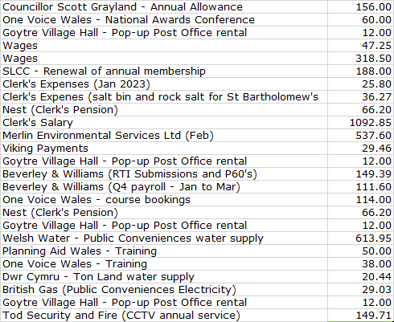  - Review of accounts and cashflow  The Clerk presented the meeting with a copy of the February 2024 cashflow.  He noted that there were two pension payments to NEST in February. However, this was because the January payment wasn’t collected until 1st February, and he confirmed that no additional payments had been made.  There were no other comments or observations.  - Finalisation of 2024/25 budget lines.  The Clerk presented the latest version of the 2024/25 budget (version 8 - February 2024, distributed prior to the meeting). This has been updated to include the projected graveyard income, and also now contains a reminder note of the remaining funding still held from the MCC Micro-Geography grant.  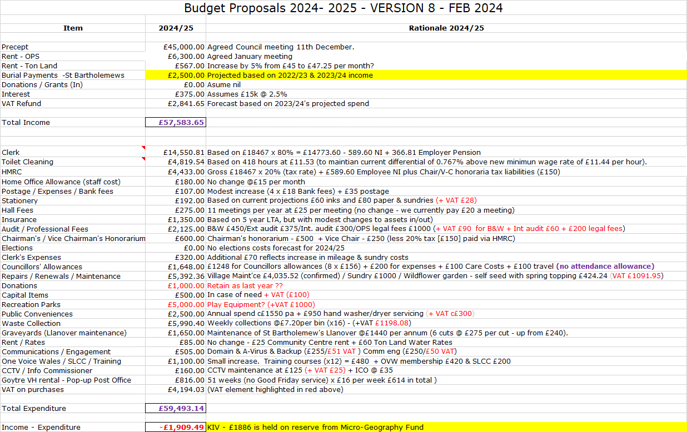  The budget lines still to be decided include:  - Confirmation of the donations budget  - Funding for improvements to the recreation park or other community improvements. As noted on the table above, some £1886 is still held on our interest-bearing account, from the Micro-Geography fund donation earlier this year.  Following further discussion, it was agreed that the final budget additions / amendments should be:  Budget line: Donations to remain at £1000, although recognising that there may need to be some flexibility of the amount later during the financial year.  Budget line: Play equipment to be changed to ‘capital equipment’ to provide more options over the potential spend, particularly if the s106 funding covers all the required park improvements.  This was proposed by Councillor Daniel, seconded by Councillor Carter, and carried unanimously.  - Renewal of One Voice Membership (£420)  The renewal of our OVW membership is due on 1st April. The total cost for 2024/25 will be £420 (last year it was £399). OVW are an invaluable source of both legal and financial advice to the sector, together with best practice, and have a wealth of templates which we are able to utilise. Renewal was proposed by Councillor Barnes, seconded by Councillor Robins, and carried unanimously.  - Confirmation of 2024/25 wage rates  It was confirmed, that as per the budget proposals, the wage rates should be formally increased to £11.53 per hour, with notification to be sent to all relevant parties by the Clerk. This was proposed by Councillor Daniel, seconded by Councillor Robins, and carried unanimously.  - Renewal of Ton Land Lease  The lease on the land is due for renewal on 1st April. The current lessee has indicated that they wish to continue for a further 12 months. It was agreed that the land should be offered up at an annual cost of £567 (as per the budget plan above, and payable in quarterly instalments of £141.75). This was proposed by Councillor Robins, seconded by Councillor Barnes, and carried unanimously.  - Merlin Environmental contract renewal (dog waste bins)  A renewal contract for 2024/25 has been received for signature. The price  is as previously indicated (and budgeted for) at £7.20 per bin, on a weekly  collection basis. Renewal of the contract was proposed by Councillor  Daniel, seconded by Councillor Dodd, and carried unanimously. | Clerk  Clerk  Clerk  Clerk  Clerk
11 | Planning – APCBB / BBNPA 24/22712/CL  To upgrade the existing pole (53L5735S3/1P1), transformer and stay wire - network maintenance and reinforcement works to maintain a reliable electricity supply to the area. Vine Tree Cottage, Mamhilad, Penperlleni Monmouthshire NP4 8RG  It was agreed by Councillors that because of the nature of the work to be undertaken, the planning committee would not be able to comment meaningfully on the application. This was formally proposed by Councillor Barnes, seconded by Councillor Dodd, and carried unanimously. Clerk to advise APCBB / BBNPA. | Clerk
12 | Community Engagement – Latest update re Community Plan - Councillors Jan Butler / Lewis Carter / Nigel Morrey  As mentioned in Matters Arising, Councillor Butler is hoping to circulate the notes from the Community Planning meeting tomorrow (following her attendance on the OVW course).  A meeting is to be arranged between Councillors Butler, Carter, and Morrey to progress the plan. It was agreed that Councillor Carter would provide the previous Llanover Community plans from 2014 and 2019 to feed into the mix. | Cllrs.  Butler,  Carter,  Morrey
13 | Charge Place Wales - EV car sharing – Councillor Owen Dodd  Councillor Dodd brought this to the meeting as a potential initiative for the village, although at this stage it was unclear what level of involvement would be required from the Community Council. The Clerk said he believed at least 14 members were required to make the scheme viable. Councillor Robins advised she had seen a presentation on the scheme in her role as climate champion, that gave more details, and which she would circulate to Council Members. She believed that the scheme may be being taken forward in Usk. | Cllr. Robins
14 | County Council update – County Councillor Jan Butler.  Councillor Butler provided the following updates.  - Councillor Butler advised that following the petition for an improvement to improve the access & exit at the Secret Garden Nursery on the A4042, the works to improve the safety of this ‘junction’ will be going forward at some point in the future. She has received a letter from Lee Waters in the Senedd, but at this stage can’t share the details. However, she has asked that the letter / information be shared with MCC.  - The Community Centre Committee is meeting tomorrow.
15 | Goytre Public Conveniences – proposed installation of sanitary bins (update)  Following the item on last month’s agenda, the Clerk has still not received any feedback from MCC on potential suppliers / pricing. However, in the meantime, the clerk has independently obtained the following quotes, both from well-known service providers (all plus VAT): Copies of the quotes from each company were circulated to Councillors at the meeting.  - Supplier 1 - 3-year contract  2 x ladies bins - £38.22  1 x gents bin – £19.11  Total cost pa. £57.33 The cost doubles to £114.66 if we want the disposable bags as well.  - Supplier 2  2 x ladies bins - £38.22  1 x gents bin – £39.13  Total cost pa. £77.35  If we want to add sanitary bags with supplier 2, we would have a one off cost of £18.24, plus an additional £100 per annum, so £18.24 upfront and then £177.35 per annum.  It was agreed that the contract offered by supplier 1 was the most attractive quote, although one bin in the ladies was considered sufficient (with a sign on the door to advise which cubicle housed the bin). It was agreed that to start with, sanitary bags would not be added to our order.  The Clerk calculated that the cost of just a single bin in each toilet would under £40 (£38.22?) per annum with supplier 1. It was proposed to proceed with this option by Councillor Butler, seconded by Councillor Robins, and carried unanimously. | Clerk
16 | St Bartholomew’s Graveyard  - Upkeep of graveyard and proposal to discourage the use of plastic flowers.  We have had another comment that the graveyard is in a poor condition. The Clerk commented that the maintenance regime is the same as it has been over recent years, and so there is no obvious reason for any deterioration (if this is the case). The undulating nature of the grassy area means that the graveyard has to be strimmed, which does not always leave as neat a finish as we would like. Plus, the grass needs to be at a certain length before it can be cut effectively by a strimmer. The Clerk has spoken with the ’gardener’ to see if he can make any suggestions for improvement. Apart from an additional cut each year, there were no obvious solutions. His suggestion of treating the path with ‘Roundup’ to remove the moss was not supported by Councillors. It was agreed that we should add an additional (seventh cut) each year, which the Clerk thought could be largely covered by the existing budget.  A suggestion has also been made from a parishioner that we discourage the use of plastic flowers. They can sometimes look unattractive when past their prime, and may not be as environmentally friendly as real flowers, (although this may be dependent on how they were grown / where they were transported from). However, when the Clerk visited the graveyard recently, he was surprised at just how ‘popular’ they appear to be. The Clerk estimates that a good 2/3 (maybe more) were either plastic flowers or a combination of real / plastic. In fairness, some of the displays did look very attractive.  Having spoken with Sue Ingle-Gillis (Ministry Team Leader) it appears that this is an issue in many cemeteries. Although the guidance from CIW is clear (only silk or real flowers), it is acknowledged that many families place plastic flowers, possibly because of their longevity – important if the family lives away and cannot visit regularly. After discussion the Clerk and Sue concluded that sensitivity and pastoral care must take priority. The Clerk has therefore prepared a small ‘environmental’ notice, which it is hoped will encourage visitors to use real flowers, rather than to try and impose an outright restriction. The notice was shared with the meeting, and it was agreed that the Clerk should arrange for a small number to be printed, so that these could be discreetly placed around the graveyard.  This was proposed by Councillor Butler, seconded by Councillor Robins, and carried unanimously.  - Proposal to join The Institute of Cemetery & Crematorium Management (ICCM)- £95  Given the legal complexities of managing a graveyard, the Clerk recommended that we join the ICCM, at an annual cost of £95 for the 2024/25 financial year. This was agreed and proposed by Councillor Barnes, seconded by Councillor Robins, and carried unanimously. | Clerk  Clerk
17 | Village Committees’ Reports – questions based on previously distributed updates.  - Goytre Village Hall  - Alyson Hunt has taken over as booking secretary and Treasurer following Sarah Fodden’s resignation. She has brought herself up to speed with the regular bookings and is looking to introduce an online booking system. A move to the Unity Trust Bank is also being looked at.  - Mike Jones has the completed forms for the alcohol licence for the VH. Alyson Hunt will send him the current booking form which is also required.  - AGM is scheduled for Tuesday 30th April.  - Llanover Village Hall  - Bookings remain good.  - GFCC bookings need renewing (Clerk - now renewed until April 2025).  - Coffee Morning are engaging with Aneurin Bevan NHS Community Engagement for a discussion on services available.  - Councillor Carter is supporting the village hall with requesting an energy efficiency audit from BBNPA.  - Llanover Village Fete scheduled for 22nd June.  - Goytre School Governors  - No report submitted.  - Goytre Community Centre  - No report submitted.  - Other Reports  - The Clerk recently attended a meeting on the ESAG - The Event Safety Advisory Group. The Group aims to help organisers with the planning, and management of an event, and to encourage cooperation and coordination between all relevant agencies.  - The group is a non-statutory body and so does not have legal powers or responsibilities, and is not empowered to approve or prohibit events from taking place. However, individual enforcing authorities may choose to take their own enforcement action if they have concerns.  - The group can consider all types of events. e.g. public or private; ticketed or non-ticketed; free or for payment; traditional or innovative; annual, monthly or exceptional; voluntary or charitable etc.  - The overall aim of the ESAG is to assist organisers to deliver a safe event although their involvement does not absolve the organiser of this responsibility.  - Typically, plans should be with the ESAG approx. 3 months prior to the event, and longer for large events.  - The main information ESAGs need from organisers will include the type of event / where it will take place / when it will take place, (date and time) / who will be attending (and likely numbers) / what facilities will be needed e.g. toilets, first aid, drinking water and refreshments.  - Also, whether the event is for specific groups, such as children, teenagers, older people or people with disabilities? Are specific facilities required for these groups?  - What is needed to manage crowds safely? Is the site an appropriate size for the proposed attendance numbers?  - Typical issues organisers will need to consider and provide information on include (an event notification form is available on the MCC website to help):  - An event safety plan  - A traffic management plan  - A risk assessment  - A fire risk assessment  - Child safety policy  - Event site layout plans  - List of stewards  - List of food traders and non-food traders  - Public liability Insurance  - Plans / drawings of temporary structures  - In addition, organisers need to consider what they can do to reduce the risk and mitigate against the impact of a terrorist attack. As such, they are encouraged to undertake the on-line ACT Awareness e-Learning course (see link below).  https://www.monmouthshire.gov.uk/app/uploads/2022/03/Event-Planning-and-Counter-Terrorism-Considerations-2.pdf  - The ESAG web site for MCC is https://www.monmouthshire.gov.uk/licensing/safety-advisory-group/
18 | Donation requests.  - Gwent Federation of Women’s Institutes (unspecified amount) towards fund raising of £1000 for a new projector.  As a member of the local WI, Councillor Butler declared a personal interest. The Clerk confirmed that in his opinion this was not prejudicial (and the likely amount granted would be less than the £500 prejudicial limit).  GFWI appear to have approached all the relevant Town and Community Councils to appeal for monies for a new projector. The trustees would normally work to raise these funds themselves, but are currently concentrating on running events to cover an £8000 income shortfall. After discussion it was agreed to make a donation of £50. This was proposed by Councillor Robins and seconded by Councillor Carter, and carried unanimously.  - Hedgehog Highway - £150 The donation is for a box of 50 hedgehog highway surrounds, and information leaflets. The former would be placed in holes cut in fences to allow access for hedgehogs between gardens. Councillors were unsure that there would be sufficient take up amongst residents, given the need to cut holes in fences. It was agreed to defer a final decision until Councillor Robins has spoken with the Community Garden Committee, to ascertain their view. Clerk to place on the April agenda. | Clerk  Clerk
19 | Communications  - Communications Received  No communications have been received since the last meeting  - GFCC Facebook page – latest posts / responses  - A resident has advised that there is an old blue food recycling bin at the bottom of Midfield (near to Capel Ed Lane), which is being used to collect bagged dog waste. It has already been reported to MCC. Councillors to monitor.  - An old BT telephone box at Pencroesoped, (privately purchased some time ago, and which used to be maintained by local residents), is now being considered for use as a book share store. However, it is in poor condition and needs ‘restoring’ again. The Clerk believes he may have details of the proper paint to use and will see if he can find the information.  At this point Councillor Dodd left the meeting | All  Clerk
20 | Honoraria – Gift for proof Reader – Closed session  It was agreed to purchase a gift in recognition of services freely given, with Councillor Butler to arrange / deliver. | Cllr. Butler
21 | Advertising - Usk and Raglan Diary contributions May/June 2024.  The closing date for submissions for the May / June edition will be towards the end of March.  It was agreed that the following should be submitted for the next edition of The Diary.  - The URL for the new Community Council Facebook page | Clerk
22 | Date of next meeting and close.  The next meeting is to be held on Monday 22nd April at 19.45. The venue to be Llanover Village Hall, or by teleconference using: https://meet.jit.si/GoetreFawrCommunityCouncil | All/  Clerk

Chairman: …………………………………….…………… Date:…………………….

