CYNGOR CYMUNED

GOETRE FAWR

COMMUNITY COUNCIL
MINUTES OF THE ORDINARY MEETING HELD AT LLANOVER VILLAGE HALL AND BY TELECONFERENCE ON MONDAY 10th NOVEMBER 2025

Present: Community Councillors Nigel Morrey, Lewis Carter, Andy Barnes, Janet Robins,
Martin Stevens, Owen Dodd and Community / County Councillor Jan Butler.

In Attendance: Jonathan Lazenby (Clerk).

Apologies: Community Councillor Peter Daniel.
Absent without Apology: None.
Guests: Nicola Awni - Project Lead for the Gwent Federation of WIs.
Members of the Public: None.
 |  | ACTION
1 | Apologies for Absence.  As above. | Clerk
2 | Declarations of Interest.  The Chair, Councillor Morrey, commenced the meeting by asking the members present whether they had any declarations of ‘interest’ to make, which includes previous declarations already made. The Clerk noted that Councillors Butler, Dodd and Carter, as trustees and a member of the Community Centre Management Committee had a potential prejudicial interest in some of the budget discussions and the Community Centre agenda item during tonight’s meeting. No other declarations were forthcoming. | Clerk
3 | Chairman’s Remarks.  The Chair welcomed everyone to the meeting.
4 | Approval of the closed session minutes from the meeting held on 8th September 2025.  Approval of the above minutes was unfortunately left off the agenda of 13th October, and so are being approved at today’s meeting.  The minutes were proposed as a true and correct record by Councillor Stevens, seconded by Councillor Carter and carried by a majority vote (Councillor Dodd did not vote as he had lost his internet connection by this stage of the September meeting).  Approval of the minutes of the meeting held on 13th October 2025.  The minutes were proposed as a true and correct record by Councillor Robins, seconded by Councillor Stevens, and carried by a majority vote (Councillors Dodd and Butler did not vote as they were not in attendance at the October meeting).  Approval of the closed session minutes from the meeting held on 13th October 2025.  The minutes were proposed as a true and correct record by Councillor Stevens, seconded by Councillor Carter, and carried by a majority vote (Councillors Dodd and Butler did not vote as they were not in attendance at the October meeting). | Clerk  Clerk  Clerk
5 | Matters Arising.  - Item 5 (i) – The LED light above the Public Conveniences. The Clerk confirmed that the new unit has been fitted by Gwenlec Electrical, at a cost of £100 plus VAT (in accordance with the agreed budget from 8th September).  - Item 5(ii) – The handout document from Nicola Awni regarding the Waterloo Project, has been received and will be posted on the Facebook site.  - Item 5 (iii) – Aderyn. Emergency / temporary accommodation request.  The Clerk has advised Jason Jones, Hospital Director, Aderyn Hospital, that the Village Hall can be used in case of emergency. However, Councillor Butler expressed concern that this had not been passed by the Village Hall Committee. The Clerk advised that Councillor Daniel (the Chair of the Goytre Village Hall) had confirmed this at our October meeting (unfortunately he was not in attendance this evening). The Clerk suggested that Councillor Butler refer this issue back to the Village Hall Committee.  - Item 6 (i) – As requested, a flood advice page has been set up on the Council web site.  - Item 6 (ii) – Councillor Dodd asked what was happening regarding the request to increase the height of the fencing by the Social Club to stop stray balls from entering the seating area. The Clerk has already chased MCC regarding this and will follow up again.  - Item 17 – A signed contract has been received for the new cleaner with a start date of 1st December. The existing cleaner has given notice as of 30th November. | Cllr. Carter  Cllr Butler  Clerk
6 | Not in My Name Waterloo Project - Signing of Pledge Board, supporting the ending of men’s violence against women.  Nicola Awni, Project Lead for the Gwent Federation of WIs thanked the Council for inviting her back and for supporting this long-standing WI campaign. Nicola unveiled a Pledge Board in support of the campaign, which was signed on behalf of every Councillor and the Clerk. A series of photographs were then taken which the Clerk will use in a submission to the Jan/Feb edition of the Diary.  Again, every Councillor was invited to the ‘Light a Candle’ service at 10.15 am on 26th November at St Mary’s Church in Usk. There will also be a ‘procession’ from the Sessions House in Usk to the church, commencing at 9.45 am. The service itself will include four speakers, all who work with young men who need ‘guidance.’
7 | Maintenance. (including items previously reported, but not yet addressed).  - Defibrillator Pad – Llanover Village Hall (£56 plus VAT)  A new defibrillator pad is required for the unit at LVH, as the current one ‘expires’ on 30th November. The Clerk has been unable to access a free pad via the NHS, and so we will need to purchase a new one at a cost of £56 plus VAT. This was agreed and proposed by Councillor Morrey, seconded by Councillor Dodd, and carried unanimously.  - Councillor Butler queried when we might be able to hold Council meetings at the Community Centre. It was agreed that this could take place from January, subject to Centre availability which Councillor Butler will confirm. | Clerk  Clerk/Cllr Butler
8 | Finance.  - Payments made since the October meeting.  £  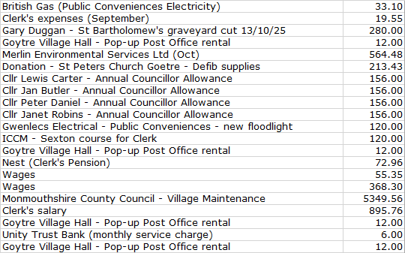  Most are regular monthly outgoings except for the payments of four Councillor Allowances, and the annual maintenance bill from MCC for the village cleaning services (including the bus stops in Llanover). This amount was agreed in the 2025/26 budget. There were no further comments or observations.  - Review of cashflow as at 31st October 2025.  The Clerk presented the meeting with a copy of the October 2025 cashflow.  As requested at the last meeting, £3500 has been transferred across from the current account to the savings account to accrue funds to cover the election costs from August this year.  There was no further comment or observation.  - Electricity & water supply contracts review.  The Clerk has received some quotes for the renewal of our electricity contract. Quotes for our water supply which were expected had not yet been received. Our current electricity contract runs until next September, and so has just become eligible for renewal. Normally, at this time of year, it is expected that prices would rise due to increased demand (and so not a good time to renew). However, interestingly this has not happened – in fact they have reduced slightly, as shown below:  - Current contract - standing charge 45p per day, usage rate 30.18p kWh.  - Renewal contract - standing charge 45p per day and 29p per kWh.  This would result in a projected saving of £10.50 and so our broker wondered if we wanted to take advantage and fix our prices for a further three years. However, the Clerk and Councillors took the view that there was still scope for prices to fall next spring /summer, and so it was felt that we should hold off for the time being and see if better deals become available next year. This was proposed by Councillor Stevens, seconded by Councillor Morrey, and carried by a majority vote, with Councillor Butler abstaining.  - Renewal of Community Mapping (Parish On-line).  We have received our annual renewal invoice of £120 + VAT (Discounted from £150). The Clerk advised that although he does not use the map extensively, it is the only mapping resource which the Council has of the ward, and he would be wary of ‘losing’ it as a reference. Indeed, it may prove particularly useful during the 2027 elections. His recommendation was, therefore, that it should be retained. However, Councillors felt that renewal should be based on our ability to add the ward boundaries to the mapping, and also to make it available to Councillors, and if possible, residents. This was then proposed by Councillor Morrey, seconded by Councillor Dodd and carried by a majority vote. Councillor Barnes abstained as he did not feel we should put any conditions on the renewal.  Councillor Dodd found a link which seemed to indicate there was a £100 switching fund available to Councils adopting the parish-on-line email Service. The Clerk to investigate.  - Goytre Fawr Public conveniences – initial cost estimates for update of interior.  The Clerk has contacted three companies to date, although only one, has, as yet, responded. A site meeting was held with them last week to review all the different elements of the refurbishment, which will be itemised separately so we can see which elements are affordable / a priority for us. However, we suspect a major refurb is likely to be £10k to £20K. We are still waiting for the quotation. The Clerk has investigated possible funding with MCC, but all the funds for 2025/26 have now been allocated. Hopefully, the UK Government SPF Fund will be replenished for 2026/27.  - 2026/27 budget – Review of second draft with suggested amends from 13th Oct.  The second draft of the budget, following the review at the October meeting is shown below, with the suggested changes highlighted in yellow, and explanatory notes under the ‘rationale’ column.  This shows a potential increase in the precept of £7k to £56k (every £1000 in precept equates to 83p per annum per household at Band D level). The Chair noted that no-one was objecting to the proposed increase at this stage. Councillor Dodd advised that there will be three bank holidays on a Friday next year (so only 49 payments for the hire of the village hall for the Post Office), and Councillor Butler thought it likely that the hourly rate would be increased to £8.  Otherwise, there were no changes at this stage.  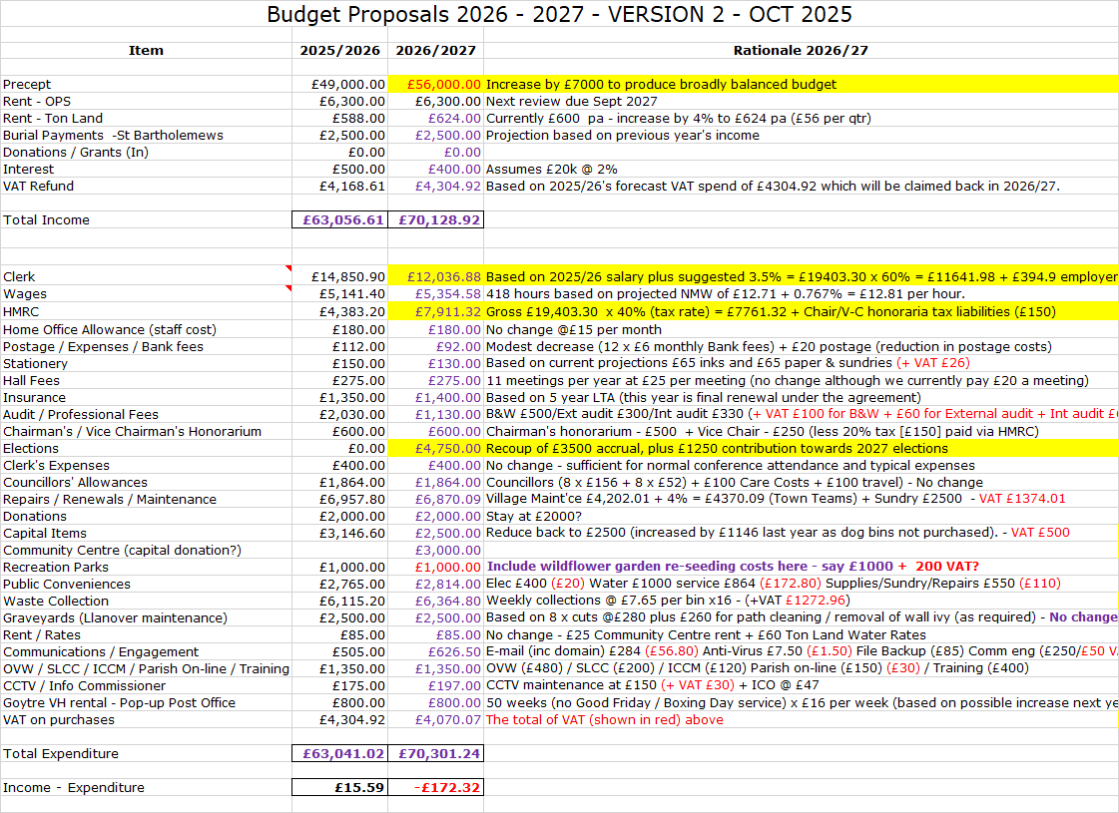 | Clerk  Clerk  Clerk
9 | Planning.  - Acceptance of the Planning Meeting minutes of 14th October & 4th November.  The meeting on 14th October was convened to consider the following application.  25/24052/FUL - (APCBB/BBNPA) - Proposed Sun Room Extension and Highway Access Alterations. Road Farm, Saron Road, Goytre Monmouthshire NP4 8SD.  The review concluded with no issues, or concerns, being raised regarding the proposal to alter the entrance to the access drive, or the proposal to build a sun room extension.  The meeting on 4th November was convened to consider the following applications:  25/24113/FUL - (APCBB/BBNPA) - Proposed conversion of redundant agricultural barns to Holiday Let Accommodation. Barn Adjoining Upper House, Saron Road, Penperlleni Pontypool. It was commented that access to the property concerned appears quite restricted. Otherwise, the review concluded with no issues, or concerns, being raised regarding the proposal.  DM/2025/01370 – (MCC) - Change of use of the building from office use (Class B1) to cosmetic laser services (Sui Generis).  Studio A Treowen House, Llanover Business Centre, A4042 T Llanover to Pencroesoped, Llanover, NP7 9HA. The review concluded with no issues, or concerns, being raised regarding the proposal.  Proposed Woodland Creation for Llanover Estate.  The Woodland Creation Planning Scheme Plan v3.1 (WPR) ref. WPR00139 was reviewed alongside the three planting design diagrams provided centred on grid refences: SO278102, SO302093, & SO297086, all in an area between Llanover and Llanellen.  The review commented that each of the location maps include a legend breakdown of the tree species to be used, presumably for the entire project. The legends do not appear to relate to the individual maps on which they are included. The information in the scheme document does not clearly set out the objective(s) of the woodland creation. For example, is the scheme entirely commercial, to further biodiversity, ecological, climate change mitigation or other? A summary would be helpful.  Overall, however, the review concluded with no issues, or concerns, being raised regarding the proposal.  Acceptance of the minutes was then proposed by  Councillor Stevens, seconded by Councillor Dodd and  carried unanimously.  - Any other updates.  There are no other updates at this time.
10 | Community Centre – Latest update.  An email from the Chair of the Centre Committee was received on 5th November, outlining the committee’s requirements for the renewal of the lease. These are:  - The Community Centre Committee is unable to commit to a full repairing lease.  - In view of their financial position, they could only agree to an annual rent of c£100.  - MCC should be requested to fund a full building survey.  - The Committee consider the minimum lease period should be 15 years as this will facilitate applying for grants from organisations like the National Lottery or the UK Shared Prosperity Fund.  Councillor Lewis shared the business plan with Councillors yesterday. At the moment it is not supported by any financials. The only figures received so far are the 2024/2025 (unaudited) accounts. These show (if grants are excluded) a significant deficit between revenue income and expenditure. However, there are no figures as yet for year to date (1st April onwards). It was agreed that further accounting information needed to be provided to support any re-negotiation.  In addition, the Centre is in urgent need of maintenance, with roof repairs at circa £6k (plus VAT? – as quoted in August 2024). Repairs to the plasterwork also needs to be undertaken where water has ingressed because the silicon sealant around the windows has perished/failed, with water/moisture going down through the walls as far as the Damp Proof Course. Quotes have yet to be obtained, but a total cost in the region of £10k to £12k for all the work would not be unexpected.
11 | Upgrade of CCTV.  Disappointingly, Walker Fire have still not provided a quote for the Community Council to consider. Although it is believed that some of the old Tod Security team may still work out of Mamhilad House, the admin centre of the new company is somewhere in the South West of England. They are not familiar with any of our installations, and despite the Clerk providing them with details of the recommended camera (previously advised by Tod Security but not subsequently installed), no response has been received. The Clerk therefore, asked if we can explore, perhaps via social media alternative suppliers. Tod Security were very active in the area and the Clerk would be interested to hear if other local residents have switched, and if so to who.  Councillor Carter to post a query on Facebook.  In the meantime, the Clerk will make one last attempt to get a price from Walker Fire. | Cllr Carter  Clerk
12 | Adoption of new email system.  The transfer process is now well under way. Parish On-line have registered our domain and are ready to import emails from our existing suppliers. The Clerk has provided Councillors with an email containing a link to a ‘getting started’ video, and a list of FAQs to help them prepare. The changeover date has provisionally been set for this Wednesday, 12th November. The Clerk will provide Councillors with log-in details on Wednesday, and this will contain the link to download both PC and Mobile apps. However, Councillors must not try to log-in until Thursday morning, as this is likely to cause duplicate accounts. | Clerk / All
13 | Biodiversity Report – Councillor Robins.  Since the meeting on 13th October, Councillor Robins has made a number of significant updates to the report which she distributed to all Councillors a few days ago. Everyone in the meeting expressed their thanks for her work. During the following discussion a number of members made further suggestions for changes. Councillor Robins asked them to forward these by email so she could ensure that they were all included in the final version for sign-off at the December meeting. The report will then be forwarded to One Voice Wales / Welsh Govt.  Councillor Robins, together with Councillor Carter and the Clerk will also begin working on the replacement biodiversity plan. This can be either a three-year plan (reviewed annually) or an annual plan for just 2026, with subsequent plans produced for 2027 and 2028. | Cllrs. Robins, Carter &  Clerk
14 | County Council update - County Councillor Jan Butler.  Councillor Butler provided the following update.  - RLDP.  This has now been debated by MCC, passed and submitted to Welsh Govt.  - Goytre crossing.  This has been delayed until after Christmas, as the work will take seven weeks and SWTRA didn’t want to interfere with the traffic in the lead up to Christmas.  - Llanover crossing petition.  The Petitions Committee have met and taken this off the petitions list, as it has cross-party support. In the meantime, Councillors Butler and Carter will keep on ‘pushing’ while we wait for the stage 1 assessment report.  - Highfield ‘works’  MCC are installing some new dropped kerbs.  - Mon and Brec canal.  This is still a live issue.  - Longhouse barn to Newtown Road footpath.  This is still being investigated. Unfortunately, however, it seems that some of the records have been lost, although it does appear that one of the adjacent properties owns some of the path.
15 | Village Committee Reports – questions based on previously distributed updates.  The following updates were also made available in the meeting for review and discussion.  - Goytre Village Hall.  - Nothing new to report.  - Bookings are fine.  - Still looking for grants to update certain areas that need to meet regulations.  - Llanover Village Hall.  - No Report received.  - Goytre School Governors.  - Next meeting on the 12th November.  - Update from a survey has shown serious damp areas which will need to be addressed.  - School attendance around 95%.  - Red and yellow cards are no longer used.  - Goytre Community Centre.  - No separate report received (but see item 10 above).  - Other Reports.  - There were no other reports.
16 | Donations  Wales Air Ambulance (unspecified amount).  We have received the annual appeal letter from Wales Air Ambulance (email previously circulated to Councillors). The Clerk also passed a separate letter around during the meeting. Over the years, the helicopter has been used on several occasions in the locality, and traditionally Councillors have been keen to support this charity. As a result, GFCC has donated £250 in every year in each of the past 5 or 6 years. Councillors were keen to support again and another donation of £250 was proposed by Councillor Dodd, seconded by Councillor Morrey and carried unanimously. | Clerk
17 | Communications.  GFCC Facebook page – latest posts / responses.  There have been no communications of note.
18 | Advertising – Usk and Raglan Diary Contributions Jan/Feb 2026.  The closing date for articles to be submitted for the Jan/Feb 2026 issue will be Friday 21st November.  It was agreed that we should prepare a short article together with a photograph of Councillors signing the ‘End Men’s Violence Against Women’ Pledge Board. | All  Clerk
19 | Date of next meeting and close.  The next meeting is to be held on Monday 8th December at 19.45. The venue to be Llanover Village Hall, and by teleconference using: https://meet.jit.si/GoetreFawrCommunityCouncil | All/  Clerk
Chairman: …………………………… Date:………………

