CYNGOR CYMUNED

GOETRE FAWR

COMMUNITY COUNCIL
MINUTES OF THE MEETING HELD AT LLANOVER VILLAGE HALL & BY TELECONFERENCE ON MONDAY 13th JANUARY 2025 @ 19.45

Present: Community Councillors Nigel Morrey, Lewis Carter, Andy Barnes,
Peter Daniel, Janet Robins and Community / County Councillor Jan Butler.

In Attendance: Jonathan Lazenby (Clerk).

Apologies: Community Councillor Owen Dodd,
Absent without Apology: Community Councillor Scott Grayland
 |  | ACTION
1 | Apologies for Absence.  As above. | Clerk
2 | Declarations of Interest.  The Chair commenced the meeting by asking the members present whether they had any declarations of ‘interest’ to make, which includes previous declarations already made. No declarations from the members were forthcoming. | Clerk
3 | Chairman’s Remarks.  Councillor Morrey welcomed everyone to this first meeting of 2025. He, and the rest of the council joined in wishing Councillor Dodd a speedy recovery, following his recent operation and it was agreed that we should send a card and some biscuits/chocolates for Councillor Dodd and his family. This was proposed by Councillor Daniel, seconded by Councillor Butler and carried unanimously. The Clerk to organise. | Clerk
4 | Minutes.  Approval of the Minutes of the meeting held on 9th December 2024.  The minutes were proposed as a true and correct record by Councillor Daniel, seconded by Councillor Barnes, and carried unanimously. | Clerk
5 | Matters Arising.  - Item 6 (ii) – Goytre Village Hall defibrillator battery / WEL Medical batteries.  The Clerk advised that he has not had a chance to check the batteries, but will undertake the necessary visits / review over the next few weeks.  - Item 6 (iii) – St Bartholomew’s Path lighting. The Clerk is hoping that the work will be carried out this month and has left a message for the electrician to confirm a date.  - Item 7 (iii) – Setting of 2025/2026 Precept. The Clerk confirmed that our precept request for 2025/2026 has now been advised to and acknowledged by MCC.
6 | Maintenance. (including items previously reported, but not yet addressed).  - Councillor Daniel mentioned that one of the street lights in Highfield Square is not working. He will take a note of the post number and advise the Clerk, who will then report it to MCC.  - Councillor Carter mentioned that the leaves had been swept on the A4042 through the village this morning. They had been cleared from both sides of the road and the village looked much better as a result.  - The sink hole in Goytre Park appears to have been filled in (although some ‘debris’ appears to have been placed in the hole). It is not clear if the work is now complete as the barriers are still in place. Councillor Butler will check on the situation. | Cllr Daniel /  Clerk  Cllr Butler
7 | Finance.  - Payments made since the December meeting.  £  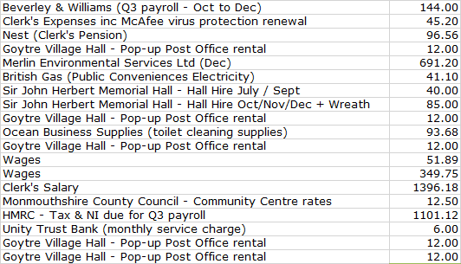  - Review of accounts / cashflow as at 31st December.  The Clerk presented the meeting with a copy of the December 2024 cashflow.  He confirmed that it had been verified to the closing balances in the UTB statements at the end of Oct/Nov/Dec 2024, during the Finance Committee meeting on 7th January. Councillor Carter has signed the cashflow to confirm this, in accordance with section 2.6 of the Community Council Financial Regulations (Wales). There was no further comment or observation.  - 2025/26 budget – Latest updates.  Following the December meeting the Clerk has updated the budget to produce the latest version (v6) – see below. As usual, any changes from v5 are shown in block yellow.  The changes are:  - The precept has been formally confirmed at £49,000.  - The Repairs / Renewals / Maintenance budget line has increased by £1000 (sundry maintenance has increased from £2000 to £3000 within this overall figure).  - The VAT line has increased by £200 to reflect the likelihood that the increased maintenance budget will attract £200 of VAT (£1000 x 20%) – This reduces the forecast surplus from £793 to £593.  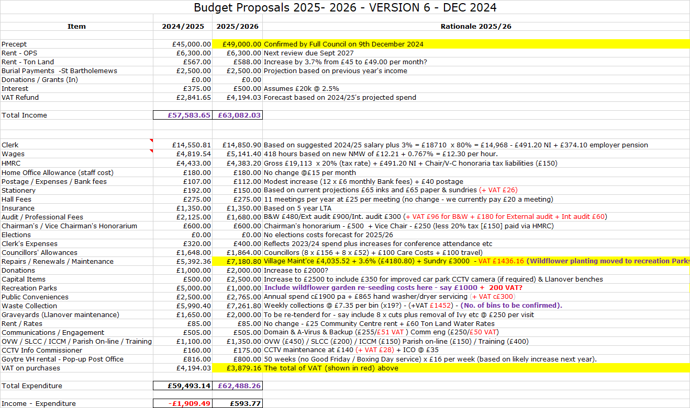  At the Finance meeting on 7th January, Councillor Morrey thought it would be prudent to incorporate a figure of £350 plus VAT (under professional fees), to pay Linnell’s to undertake a review of our property valuations for building insurance replacement purposes (see also insurance agenda item ‘v’ below). The review was last undertaken in February 2023, (when the fee was £300 plus VAT), and is due in early 2026 if councillors feel it prudent to maintain a three-yearly cycle of reviews. This would reduce the surplus by £420 to £173, (so producing a more or less balanced budget). It was agreed that this should be put in the budget, so that councillors can take a view early next year, as to whether another professional valuation is required, or to extend the review cycle, to say, five years.  The above was proposed by Councillor Morrey, seconded by Councillor Daniel and carried unanimously. Clerk to update the budget forecast.  - Tender for St Bartholomew’s graveyard.  The Clerk has launched the tender process. It was agreed that Council should put together a small review committee who would meet (by teleconference) to consider the applications submitted, with Councillors Morrey, Carter and Daniel, together with the Clerk, forming this committee. The following timetable was proposed:  - Friday 31st January – The closing date for tender submissions  - By Friday 7st February - Review committee to have met by teleconference, to consider submissions and request further information / clarification as required.  - By Friday 14th February - Review committee to have met to consider further information submitted and make final recommendations to full council (meeting on 17th Feb).  The above was proposed by Councillor Morrey, seconded by Councillor Carter and carried unanimously.  - Renewal of annual insurance.  Our insurance premium renewal is due on 2nd February. We are currently on a 5-year long-term agreement. The price has increased from £1266.97 last year to £1324.75. The Clerk has produced the following schedule of insurable amounts, which councillors felt was sufficient, and no increases outside of those applied automatically were necessary.  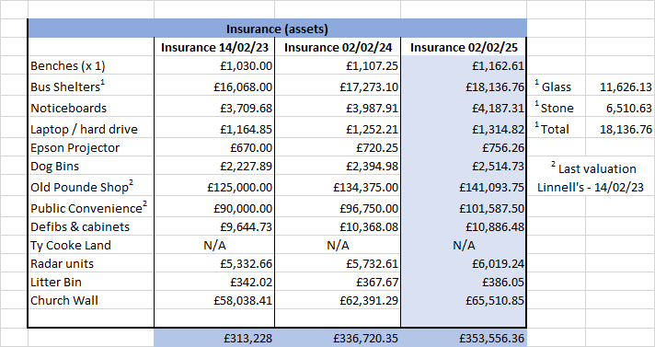  Renewal of the policy was then proposed by Councillor Morrey, seconded by Councillor Daniel and carried unanimously.  - Finance Committee update including Risk & Health and Safety Review, from their meeting on 7th January.  The following points from the Risk Assessment, discussed at the Finance meeting, had previously been distributed by the Clerk for the benefit of full council:  - Precept.  - Full Budget process in place. Clerk/RFO has prepared an annual budget for 2025/26. Precept (£49000) was signed off at December 2024 full council. Final payment of 2024/25 precept received December.  - Loss of Income from the Olde Pounde Shop  New 15-year lease (from Sept 2024) still to be signed  - Reserves – Earmarked – ensure adequacy.  Previous earmarked funds of £1886 - representing remaining monies from Micro-Geography Fund, now allocated and will be spent on the adult exercise equipment for Goytre recreation park. Invoice awaited from MCC.  - Salaries / Wages – wrong rate applied.  Clerk’s salary increase for 2024/25 agreed at Nov 2024 Full Council and backdated to April 2024. B&W (payroll providers) advised. Projected 2025/26 salary now estimated based on this new figure, to provide greater budget accuracy.  - Training of Councillors – ensure all Councillors have attended Code of Conduct Training.  Councillor Carter attended Code of Conduct course on 30th October. All Councillors have now attended.  - Training of Clerk / Staff – Ensure all staff receive appropriate training.  Email sent to both cleaners in January asking for confirmation of adequate safety supplies / materials safety guidance / training issues. Confirmation received 7th Jan 2025.  Training Plan reviewed and updated on 16th December.  - Assets - Loss & Damage.  - Review sums insured annually. Insurance renewal now received and to be reviewed by full council at January meeting and renewed on 2nd February 2025.  - Risk to third party properties or individuals - Employer’s liability cover notice to be displayed in February following renewal of insurance. Clerk to place on stockroom door, notice boards and web site once received.  - Maintenance. The side door of the OPS also requires repair / replacement. Three cost estimates received based on uPVC/Softwood/hardwood. However, responsibility falls to tenant, who is going to investigate a repair / replacement of storm guards at the base of each door and bottom of the door frame.  - Disability Discrimination Issues  Failure to identify and implement adaptations - Councillor Robins felt that this issue had now been addressed. This was due to the installation of new play equipment in the park, much of which was disability inclusive. As a result, the likelihood score should be reduced from 2 to 1 (which would reduce the classification from medium to low). This was agreed by those at the meeting, with the comments amended to reflect this: “The previous lack of disability inclusive play facilities in Goytre Park has been addressed with the installation of new equipment and a picnic table.”  The Health & Safety Checklist update  - Staff Health & Safety.  Email confirmation required from both cleaners confirming the adequacy of safety supplies / materials safety guidance / training issues was received on 6th January. The Employer’s liability cover notice will be posted on the stock room door, noticeboards and web site in February, following renewal of our insurance.  - St Bartholomew’s Churchyard.  Non-compliant wiring has been discovered between the church and the footpath and lychgate lighting. Gwenlec Electrics to replace as soon as possible, with full armoured cabling throughout. As reported above, the Clerk is looking for a firm date for this work to be undertaken.  Acceptance of both the Risk & Health & Safety Assessments on behalf of full council was proposed by Councillor Carter, seconded by Councillor Daniel and carried unanimously.  - St Bartholomew’s burial fees wef 01-01-25.  The Clerk has obtained the 2025 burial fees for the CIW, which, apart from the cost of a plain wooden cross (no change), show small increases across the board. The Clerk recommended that our fees be changed in line with these increases, with our separate admin charge – increased from £22 to £25. The changes were proposed by Councillor Morrey seconded by Councillor Carter and carried unanimously.  - Renewal of IDrive back up @ $79.50.  Our iCloud back up fee has renewed automatically based on the above net fee, (reduced from $99.50). The total cost was $95.40 (including US taxes), which equates to £77.20. For good order, the Clerk asked that the renewal of the service and associated fee be confirmed by Council. Confirmation was proposed by Councillor Daniel, seconded by Councillor Butler and carried unanimously.  - Timing of precept payments (as now, or a single payment each year).  As usual, MCC are consulting with all Town & Community Councils to establish whether they would like to receive next year’s precept as a single payment in April, or, as now, three equal payments in April, August and Dec. Payment will be made based on the majority decision (it is not possible for MCC to run two different payment systems). The Clerk has no strong preferences either way, but was quite comfortable with the status quo. Retention of the existing payment schedule was proposed by Councillor Morrey, seconded by Councillor Carter and carried unanimously. | Clerk  Clerk  Clerk  Clerk  Clerk  Clerk  Clerk
8 | Planning  - To accept the responses of the Planning Committee meeting held on 16th December.  The following applications were considered:  - DM/2024/01418 - Erection of a building to be a hydrotherapy unit for a disabled person at Brook Farm House, Old Abergavenny Road, Pencroesoped, Llanover, Monmouthshire, NP4 0JG.  - DM/2024/01223 - Retrospective application for retention of timber fence adjacent to highway and off-road parking, at 80 Newtown Road, Penperlleni, Goytre NP4 0AZ.  - DM/2024/01486 - Proposed rear two storey extension to create larger bedroom and rear single storey extension, to create larger kitchen and living space. 92 Newtown Road, Penperlleni, Goytre, Monmouthshire, NP4 0AZ.  All three application reviews concluded without comment. Acceptance of the minutes of the meeting was proposed by Councillor Barnes, seconded by Councillor Morrey and carried unanimously.  It was noted that the fence under (c) above appeared to have been reduced in height, but still looked higher then anticipated, perhaps because the 1.2m agreed level was measured from the property side, which is at a higher level than the pavement. The Clerk to query with MCC Planning.  - Any other updates.  A meeting has been arranged for this Wednesday to discuss MCC application DM/2024/01549 - Twyn Cecil, Llan Lane, Penperlleni, Goytre, Monmouthshire, NP15 1QD - Proposed dwelling and associated works: amended design to extant planning permissions ref DC/2013/00703 and DM/2021/00323. | Clerk
9 | County Council update (including update on recent flooding and proposed actions) – County Councillor Jan Butler.  - Following the last meeting, Councillor Butler put her motion to MCC’s full council meeting on 12th December, although unfortunately, the maintenance element (which included the drains and ditches), was amended, which meant it was watered down. However, it was thoroughly debated and overall the proposal was agreed. The debate will be posted on YouTube. It was also reported in ‘The Beacon’ (19th Dec edition), which Councillor Butler will post on her Facebook page.  - Councillor Butler mentioned that a number of T&CC’s are looking at obtaining a supply of sandbags to go into store in case of need, and it was queried whether GFCC could obtain a supply for storage at the back of the Community Centre. The Clerk to explore with MCC.  - Longhouse Barn – The Flooding Team have revisited and identified a couple of tree roots which had infiltrated the underground culvert and have addressed these. This drainage system was largely unknown to the residents who have planted trees in their front gardens, and their roots have then impacted on the pipework. MCC are also talking about putting in additional pipework.  - Parklands – Councillor Butler is keeping this under review, given its high-water table. There has been talk of a recent sewage problem, but Councillor Butler has not heard anything official. | Clerk  Cllr Butler
10 | Green Corridor Project - update  The trees have been planted in Goytre park (including the dog walking area) and at St Bartholomew’s Church. The online survey is now also live and closes this Friday 17th Jan.
11 | Goytre recreation Park – update  The Clerk has asked Johnathan Wassal at MCC to see if he can obtain a delivery / installation date for the new Adult Exercise equipment. Clerk to follow up. | Clerk
12 | Llanover Village.  - Installation of dog bins – update.  Councillor Carter has put a note out asking for the views of residents in Rhyd-y-Meirch. So far, only two people have responded, but the overall feeling seems to be against their installation. Councillor Carter is to go and ‘knock on a few doors’ to ascertain what the strength of feeling is, but overall, dog fouling doesn’t appear to be a big area of concern for residents.  - Residents Survey – update.  This is still on hold.  - Friends of St Bartholomew’s – update.  Two residents have expressed an interest and Councillor Carter is to meet with them shortly.  - Permission for new noticeboard at St Bartholomew’s  We have been approached by the Rev’d Sue Fletcher-Davies, as the Church wishes to replace its existing noticeboard with something more modern (the existing board is in a poor condition). As it is installed on our land (by the front wall), legally the church needs our permission. Our solicitor has advised that a simple letter (or email) of authority will be sufficient. Agreement to the installation of a replacement board was proposed by Councillor Butler, seconded by Councillor Morrey and carried unanimously. | Cllr. Carter  Cllr. Carter  Clerk
13 | Donation Requests.  Monmouthshire Citizens Advice donation request 2025/26.  We have received the annual appeal letter and a very informative annual report from Monmouthshire Citizens Advice. The report highlights the need for the organisation to increase its income from donations to covers its costs. This is due to the increasing number and complexity of queries which they receive. The organisation regularly provides advice via the Well Being café at Goytre Village Hall. For information, last year we gave a donation of £300. This year, a donation of £350 was proposed by Councillor Morrey, seconded by Councillor Butler and carried unanimously. | Clerk
14 | Village Committees’ Reports – questions based on previously distributed updates.  - Goytre Village Hall.  - No updates to report  - Llanover Village Hall.  - Llanover village hall committee don’t meet until after our meeting this evening. However:-  - Hall appears to be in a good financial and bookings position going into the new year.  - Meetings taking place with GAVO and Lottery Representative looking at potential sources of funding to make structural improvements to the hall (damp issue) etc.  - Goytre School Governors.  - No updates to report.  - Goytre Community Centre.  - No updates to report.  - Other Reports.  - There are no other reports.
15 | Communications.  - GFCC Facebook page – latest posts / responses.  There was nothing specific to report. Councillor Carter has now set up a Facebook ‘group’ for the CC page. which should make it much easier for people to find via normal internet searches.  - Upgrade to web site.  The Gold status on our web site (which enables it to be provided without adverts) is due to expire on 26th Jan, and needs to be renewed, at a cost of £39.95.  However, the web site it is based on, is an old design, with some elements dating back to 2006. The operators have advised that it’s a dated design, not properly mobile friendly and not as flexible as modern systems. We are therefore, encouraged to update to ‘Spanglefish 3’, at a cost of £79 per annum (so twice what we pay now). However, the upgrade includes an SSL ('secure sockets layer') certificate. This guarantees the authenticity of our website, and also encrypts communication between computers, so that if anyone intercepts the SSL-certified communication whilst it’s in transit, it will be illegible and meaningless.  The upgrade was proposed by Councillor Daniel, seconded by Councillor Carter and carried unanimously.  The Clerk said that he would provide a copy of the site statistics to councillors for information. | Clerk  Clerk
16 | Dates of Council meetings – May 2025 to May 2026 amendment to Oct meeting date.  The Clerk has realised that the agreed meeting date for Oct 2025 (6th), does not provide sufficient time for the Finance Committee to meet after the end of September, to consider the Quarter 3 accounts and risk assessment, before full council meets on the 6th.  The Clerk therefore recommended a new date of 13th and this was proposed by Councillor Morrey, seconded by Councillor Robins and carried unanimously. Clerk to update the calendar. | Clerk

17 | Advertising – Usk & Raglan Diary Contributions March/April 2025.  The closing date for contributions is Friday 24th January. There are currently no articles for consideration.  The Clerk felt that it was a good idea for articles to be submitted as early as possible, as his feeling was that those forwarded close to the deadline, (perhaps understandably), tended to get squeezed into the remaining available space. Therefore, particularly larger articles, accompanied by several photos, might have to be ‘compressed’ to fit in to the latest edition. | All
18 | Date of next meeting and close.  The next meeting is to be held on Monday 17th February 2025 at 19.45, at Llanover Village Hall, and by teleconference using: https://meet.jit.si/GoetreFawrCommunityCouncil  Councillor Morrey gave his apologies in advance. | All/  Clerk

Chairman: …………………………………….…………… Date:…………………….

