CYNGOR CYMUNED

GOETRE FAWR

COMMUNITY COUNCIL
MINUTES OF THE MEETING HELD AT LLANOVER VILLAGE HALL & BY TELECONFERENCE ON MONDAY 24th MARCH 2025 @ 19.45

Present: Community Councillors Nigel Morrey, Lewis Carter, Andy Barnes, Peter Daniel, Janet Robins and Community / County Councillor Jan Butler.

In Attendance: Jonathan Lazenby (Clerk).

Apologies: None
Absent without Apology: Community Councillors Scott
Grayland, Owen Dodd.
 |  | ACTION
1 | Apologies for Absence.  As above. | Clerk
2 | Declarations of Interest.  The Chair, Councillor Morrey, commenced the meeting by asking the members present whether they had any declarations of ‘interest’ to make, which includes previous declarations already made. No declarations from the members were forthcoming.
3 | Vice Chairman’s Remarks.  The Chair welcomed everyone to the meeting, following which he advised the members present that he has now resigned as a member of the Community Centre Management Committee, as a Trustee of the Charity, and as the Treasurer of the Committee. Clerk to update the register of members’ interests. | Clerk
4 | Minutes.  - Approval of the Minutes of the meeting held on 17th February 2025.  The minutes were proposed as a true and correct record by Councillor Daniel, seconded by Councillor Carter, and carried by all those Councillors who were in attendance in February. (Councillors Morrey and Butler were not in attendance at the February meeting and so did not vote).  - Approval of the closed session minutes held on 17th February 2025  The minutes were proposed as a true and correct record by Councillor Daniel, seconded by Councillor Carter, and carried by all those Councillors who were in attendance in February. (Councillors Morrey and Butler were not in attendance at the February meeting and so did not vote). | Clerk  Clerk
5 | Matters Arising.  - Item 5 (ii) – The electrical cabling work at St Bartholomew’s Churchyard is still to commence. The Clerk is continuing to chase so that it is completed before the financial year end.  - Item 6 (i) – Additional leaf/litter sweep through Llanover village on the A4042. The Clerk has requested MCC to undertake the work.  - Item 7 (iv) – Appointment of EH Accountancy in Abergavenny as Auditors. The Clerk confirmed that they have signed and returned the standard letter of engagement.  - Item 7 (v) – Our membership of SLCC has been renewed for a further 12 months w.e.f. 1st March.  - Item 7 (vii) – Our contract with Merlin Environmental (for the dog waste collection), has been renewed for a further 12 months w.e.f. 1st April.  - Item 13 – St Bartholomew’s maintenance contract. A risk assessment has now been received and the contract signed by Mr Duggan. The first cut of the grass took place on Monday 17th March.
6 | Maintenance. (including items previously reported, but not yet addressed).  - The Clerk advised that he has had to call out 24/7 Plumbing to repair a leak in the ladies’ toilets. Apparently, the fix took some time due to the inaccessibility of the cistern in the ‘boxing’ behind the toilets. However, the handle flush has now broken and so 24/7 will need to attend again. Clerk to ask their advice on changing the boxing design to see if we can facilitate better access to undertake future repair work.  - Councillor Butler mentioned that residents of Penwern Lane had complained that the village maintenance team had only been completing a sweep of half of the lane. The Clerk was surprised that their sweeping activities would have extended this far anyway, but will investigate further. | Clerk  Clerk
7 | Finance.  - Payments made since the February meeting.  £  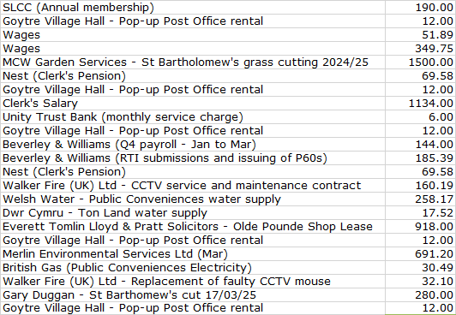  - Review of accounts / cashflow as at 28th February.  The Clerk presented the meeting with a copy of the February 2025 cashflow.  There were no comments or observations.  - Cleaning of Llanover bus shelters  MCC has confirmed that the village maintenance team will undertake this on a monthly basis at a cost of £277 plus VAT. This needs to be added to the existing maintenance cost for 2025/26 of £4180.80 – total £4457.80. The VAT line will also increase by £55.40 (£277 x 20%). The proposal to expand the cleaning duties to the three (Estate owned) covered bus shelters, with associated costs as outlined, was proposed by Councillor Morrey, seconded by Councillor Robins and carried unanimously. The Clerk will show the impact of this on our projected budget under the next item.  - 2025/26 budget – Latest updates and finalisation of budget lines. .  Following the February meeting, the Clerk has updated the 2025/26 projection to show an increase in the St Bartholomew’s maintenance budget from £2000 to £2500. This will cover 8 cuts per year (£2240) with an additional £260 available to cover footpath weeding and the removal of ivy from the wall (which eats away at the pointing). This additional work can be undertaken at a cost of £20 per hour per person. The Clerk will request this as and when required, (within the available budget). To cover the additional £500, the Clerk has reallocated £500 from ‘sundry maintenance’ (reducing from £3,000 to £2500), under the Repairs/Renewals/Maintenance line – reducing this to £6680 in total. The graveyard maintenance line goes up by £500 to £2500 accordingly. As a result, the VAT budget line reduces by £100, as VAT is not payable on the additional £500 budget for the St B’s contract.  The changes are shown below in the next iteration of the budget, version (v8) As usual, any changes from v7 are shown in block yellow.  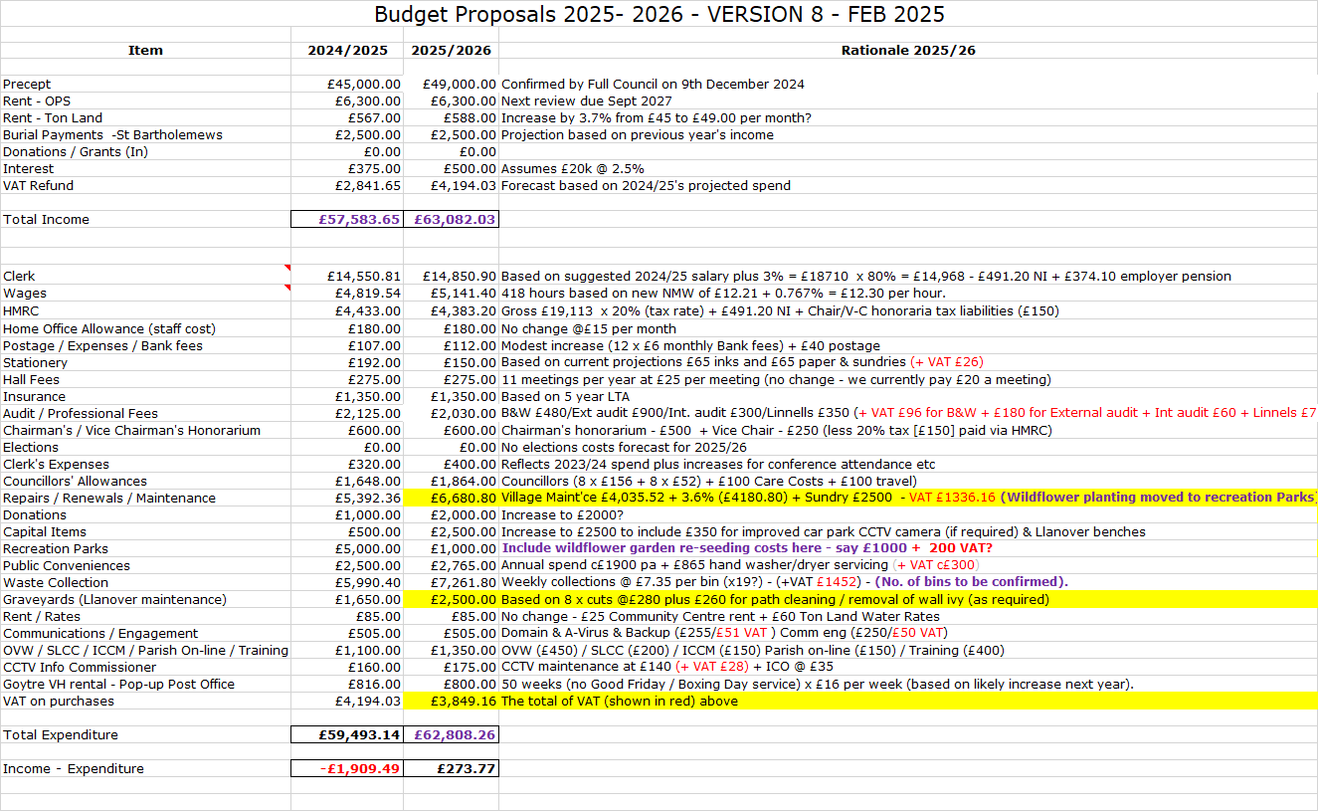  However, in anticipation of agreement under item 7(iii) above, the Clerk has prepared a further updated projection version (v9), which is shown below and which incorporates the additional £277 plus VAT.  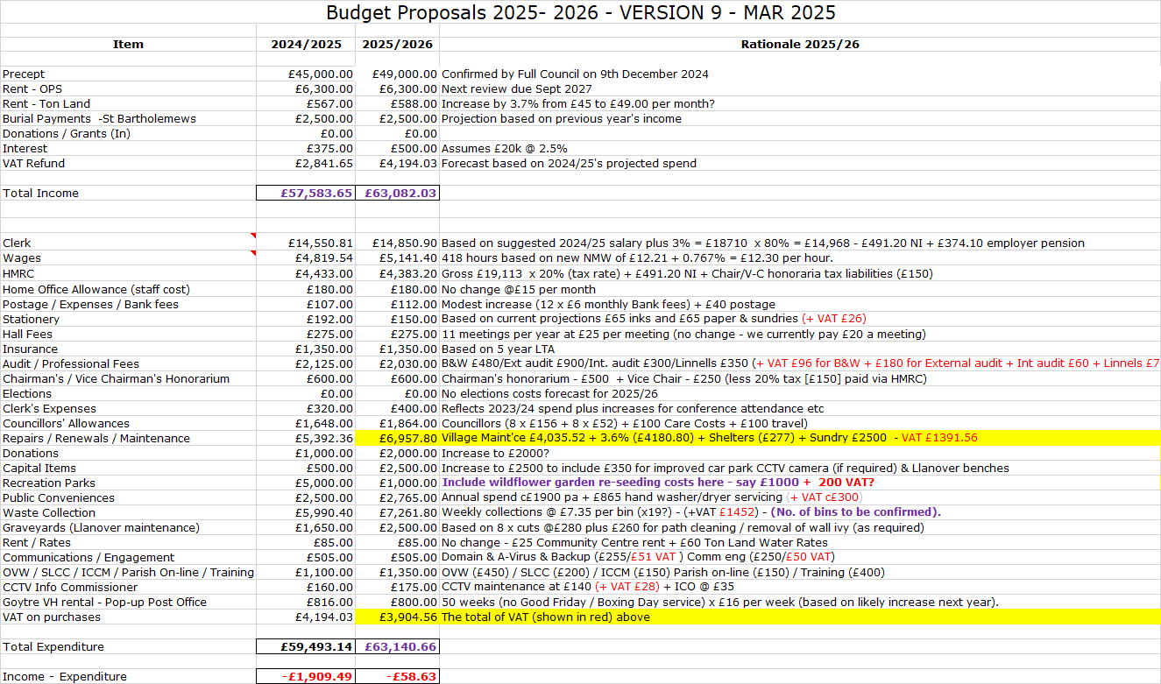  This leaves just one further potential adjustment.  At present we have allocated £1146.60 (plus VAT), to cover the cost of three dog waste bins for Llanover, which it now appears are unlikely to come to fruition. Rather than leave the ‘waste collection’ budget line as is, the Clerk recommends that the excess funding should be moved elsewhere. He suggested that the expenditure could be added back to the sundry maintenance figure, although Councillor Carter was keen that we should be able utilise this money for the benefit of Llanover, (perhaps with the installation of some benches). However, it was argued by other Councillors that while this was an understandable approach, ultimately it should be used for whatever was the greatest need.  Councillor Barnes proposed that the funding should be moved to Capital items, and this was seconded by Councillor Daniel and carried unanimously. Clerk to update the projection and present this to the April meeting.  - Town Teams (potential new maintenance contract with MCC)  We have been approached by MCC to see if we would like to change our current village maintenance scheme to one known as ‘Town Teams’. MCC are setting up a new team which will undertake work for Raglan & Usk TC’s over four days a week, and so have a day a week available for a third Council. The existing MCC maintenance team mainly undertakes leaf sweeping, litter collection and a bit of roadside weeding. However, the Town Team would cover a much broader range of scheduled and reactive services.  At present we have contracted to pay £4,180 for 12 monthly visits of the maintenance team in 2025/26, plus the £277 above (all plus VAT). The monthly cost of the service (with weekly visits) is £17,632 plus VAT (way beyond our budget), but on a like for like basis as our existing contract (a day a month), the new service would cost £4408 plus VAT, so almost identical to what we pay under the current arrangement. We would have to make an initial contribution to their equipment capital costs, but our share for a day a month is just £75.  Longer term, it may be possible to extend our contract to two days a month to include the maintenance of St Bartholomew’s if the existing contractor did not wish to extend the existing contract, and this could largely be covered by other maintenance budgets.  Councillors agreed that it would make sense test the new service on a trial basis, subject to Nigel Leaworthy at MCC being able to make the service viable based on our relatively small uptake of the service. No adjustments to budgets (likely minimal in any event) are required at this stage. This was proposed by Councillor Barnes, seconded by Councillor Daniel and carried unanimously. Clerk to advise Nigel Leaworthy of our intentions.  - Renewal of annual OVW membership (£440 – last year £420).  The renewal of our membership is due on 1st April. This has been calculated on 1025 chargeable dwellings @ £0.43p per dwelling and is based on the Valuation List, not the Electoral Register. Renewal of our membership was proposed by Councillor Morrey, seconded by Councillor Robins, and carried unanimously.  - The lease on the Olde Pounde Shop – update.  The lease has now been completed and the Clerk holds the counterpart document (the lease signed by the tenant), which we will retain in our deeds box.  - Signing of the renewal of the Ton Land lease, 12 months from 1st April.  The short-term lease on Ton Land is now due for renewal. As per section 23 of our Standing Orders the Clerk requested that the CC pass a resolution to do this, with then any two councillors to sign on our behalf, with the Clerk of the Council (as Proper Officer), witnessing their signatures. A formal resolution to execute the lease was proposed by Councillor Morrey, seconded by Councillor Daniel, and carried unanimously. The lease was then signed by Councillors Morrey and Daniel, with the Clerk signing as witness to both signatures.  The Clerk will now forward the document to the tenant to sign.  - Confirmation of 2025/26 wage rates  It was agreed, that as per the budget proposals, the wage rates should be formally increased to £12.30 per hour, with notification to be sent to all relevant parties by the Clerk. This was proposed by Councillor Morrey, seconded by Councillor Peter, and carried unanimously. | Clerk  Clerk  Clerk  Clerk  Clerk  Clerk
8 | Planning  - To accept the responses of the Planning Committee meeting held on 3rd March.  The following application was considered:  - DM/2025/00160 (MCC) - Change of Use from B1 (Office) to A2 (Financial and Professional Services). Studio C Treowen House, Llanover Business Centre, A4042 T Llanover To Pencroesoped, Llanover, Monmouthshire, NP7 9HA  - 24/23004/FUL – (APCBB / BBNPA) - Proposed livestock and agricultural storage building. Ty To Maen, Ancient Road, Llanover NP7 9ES  No issues or concerns were raised with either of the applications.  Acceptance of the minutes of the meeting was proposed by Councillor Daniel, seconded by Councillor Morrey and carried unanimously.  - Any other updates.  An appeal has been lodged following the refusal of application DM/2024/00398 for 1 Pen Y Wern Cottage, Pen-y-wern Road, Penperlleni, Goytre, NP4 0AB.  The original application was due to be considered by GFCC last April, but the meeting had to be abandoned due to being inquorate. So, as it stands, the CC has no stated position on the application. However, the application was refused by MCC as it is outside the village development boundary of Penperlleni and doesn't meet the criteria of the adopted local plan. There are also concerns regarding the potential release of phosphorus, thereby affecting the river Usk.  Separately, a 5-year extension to planning permission DM/2020/00806 (new outbuilding to form two stables with associated storage and home office with storage over) - Blackberry Barn, Tredomen, Penperlleni, Monmouthshire, NP4 0AF, has also been received.  Therefore, a meeting of the Planning committee has been scheduled for tomorrow evening (25th March at 6.30pm), to consider whether the Community Council wishes to raise any points which we feel are relevant to the appeal under DM/2024/00398, and whether we have any objections to a further extension to the planning permission originally granted under DM/2020/00806. | Cllr. Barnes
9 | County Council update - County Councillor Jan Butler.  - At the last County Council meeting it was agreed that there would be no changes to the 20 mph speed limits in the county. However, Welsh Govt. has insisted that all the 20 mph repeater signs be taken down (in our area this includes on School Lane/Newtown Road/Plough Lane), which has caused some confusion amongst residents. In addition, there are still some red 20 mph signs painted on the road, which might suggest that people are now passing out of a 30 mph zone, which is not the case, as the whole village is 20 mph. Councillor Butler has asked that these be erased. Councillor Butler commented that although a widespread consultation was undertaken by Welsh Govt., frustratingly, councils are unable to see the results.  - The Monmouth & Brecon Canal has become an issue with proposals to charge for the water abstraction from the River Usk. Some 80% of the water in the canal is taken from the River Usk above Brecon, although most of the water goes back into the Usk further downstream, and so is not lost. However, a change made to legislation in the 1990’s (and which hasn’t been as issue until now), allows for charging for the abstraction of water, which the NRW is planning to implement. This would cost the C&RT in the region of £600k to £1m a year. Meetings are taking place to see what can be done. Peter Fox has held a meeting with the Canal & River Trust Director and Councillor Butler is due to meet with the Inland Waterways Association. It was agreed that the Clerk would compose a letter to send to the Deputy First Minister (cc’ing the Chair of NRW), which the Chair will sign. | Clerk
10 | Goytre Community Centre  Councillor Carter reported that, as advised earlier, Councillor Morrey has resigned from the Committee, as Treasurer and as a Trustee. One of the members of public has also resigned from the committee. The proposed meeting (for residents) on 4th March (as per section 17 of the Trust deed), was not held, but will now take place on Tuesday 8th April. The proposed meeting will be widely advertised from tomorrow. | Cllr Butler
11 | Green Corridor Project - update  The planting at Goytre Park and other designated spots in the village has now been largely been completed with just Rhyd-y-Meirch and St Bartholomew’s of the major works left to complete. Rhyd-y-Meirch is scheduled to be planted, with some help from the pupils of Goytre Fawr Primary tomorrow, at 10.00 am.  A few residents have queried that in some cases the planting did not match the original plans that were shared. MCC has suggested that this may be a reflection of the groundworks that became apparent once the work had commenced. However, the Clerk has spoken with Jane Clarke who will check on each individual site and compare them with the original plans. In addition, some of the green space furniture, (benches etc) is still to be delivered.  Queries outstanding include:  - The extent of the wildflower planting on the Highfield verge (perhaps blocked by a parked car?). Plus, as yet, there is no sign of the ‘grasscrete’ to enable parking when the grass is waterlogged.  - The top verge on Newtown Road has not been planted with wildflowers, and the hedge has been moved forward to the road side.  - The residents who live opposite the public footpath across the railway line on Newtown Road are concerned as they were not aware of the consultation and are worried that the planted hedge (on an area that they have traditionally maintained), may spoil their view.  - It is not clear if the ‘bog garden’ in Goytre park is to go ahead. | Clerk
12 | Goytre recreation Park – update  MCC have now completed the re-cementing of two of the pieces of the adult gym equipment. However, last week we were presented with an incorrect invoice for £7,161.40 plus VAT (total £8,593.68), for the new equipment. Mistakenly, this failed to take into account the remaining section 106 monies of £2,371, held on our behalf, which would reduce our contribution to £4,790 plus VAT (£5,748). This latter sum has been fully accounted for in the budget for 2024/25. Johnathan Wassal at MCC has requested a new invoice to be issued before the end of the month. | Clerk
13 | Llanover Village - updates  - Installation of dog bins – update.  Councillor Carter advised that this issue can now be taken off the agenda.  - Llanover bus stops – lease proposal from Llanover Estates  See also item 7 (iii) above. Llanover Estates are still looking for either ourselves or MCC to take on the lease of the three covered bus stops in Llanover. Their view is that they shouldn’t be held liable for the use of what is effectively a public service. In the meantime, Councillor Butler is exploring options with MCC. | Cllr Butler  Clerk
14 | Donation Requests.  - SSAFA Wales Community Council appeal 2025 (unspecified amount)  We have been approached to make a donation to the Wales region of SSAFA – the Armed Forces Charity. The Charity provides practical, emotional and financial support to forces men and women and their families, particularly to those facing difficult times and in need of a helping hand. The Clerk noted that the CC made a donation of £50 in May 2023. After discussion, a similar donation (under section 137) was proposed by Councillor Morrey, seconded by Councillor Carter and carried unanimously.  - Marie-Curie Cancer Care - (unspecified amount)  We are asked to support Marie Curie’s Great Daffodil Appeal this year. The Charity’s aim is to ensure a better end of life, by providing care and support services in local communities across Wales. We are advised that any monies donated will support local Marie Curie services in our area, so that patients in our community will directly benefit from any gift. The Clerk noted that the CC made a donation of £100 in February 2023 and councillors again agreed that they wished to support with a donation under section 137. A donation of £100 was proposed by Councillor Morrey, seconded by Councillor Carter and carried unanimously.  - Gwent Young Farmers (unspecified amount)  We have received a ‘round robin’ request from Gwent Young Farmers. Councillors will be aware that this is a youth organisation in Monmouthshire for young people aged between 10 -28 (anyone can join – not just farmers). They are looking to raise funds to provide a wider range of activities going forward. The Clerk noted that the CC made a donation of £50 in April 2023.  On this occasion Councillor Barnes proposed that we should not make a donation and this was seconded by Councillor Morrey. However, Councillor Butler proposed that we should make a donation, but there was no seconder for this, and so the motion fell. The original proposal was then carried by a majority vote with only Councillor Butler voting against it.  - Goytre Fawr Primary School – Urdd Eisteddfod (amount unknown at time of posting)  A letter has been received from the school requesting support for attendance at this year’s Urdd Eisteddfod. No specific figure is mentioned, but it appears they are looking for a contribution (full or in part) to the cost of membership (at £10 per pupil) for the 40 pupils in the Choir. The competition is being held in Port Talbot and the Clerk suspects that they may also require help with transport costs at a future date. The Clerk noted that last year two separate donations of £250 were made.  It was proposed by Councillor Morrey that the CC should make a donation of £250 with an indication to the school that they should approach us if further support was required. This was then seconded by Councillor Robins and carried unanimously. | Clerk  Clerk  Clerk  Clerk
15 | Village Committees’ Reports – questions based on previously distributed updates.  - Goytre Village Hall.  - Health & safety, electrical and fire inspections held. Good overall, but needs some changes to ensure insurance is covered correctly.  - Events are still going well with lots of activities taking place.  - Looking for grants to upgrade audio equipment.  - AGM due in April.  - Llanover Village Hall.  - Financial position and bookings remain strong.  - Grant application submitted to fix damp, decorate hall and install hearing loop.  - VE/VJ day celebration planned (10th May @14:00).  - Potential future GFCC grant application pending for contributions towards a new Marquee to replace a broken one for Llanover Village Fête.  - Goytre School Governors.  - Michael Gough, head teacher is retiring this academic year. Adverts are going out and interviews will take place soon, as they require a replacement to take over in September.  - Parents evening went well and statistics are showing good progress.  - Have held a fund-raising event in the village hall towards the Urdd event.  - Goytre Community Centre.  - The Public Engagement meeting will take place on April 8th at 7pm with AGM to follow. Public notice will go out on Tuesday 25th (see also item 10 above).  - Other Reports.  - There were no other reports
16 | Communications.  - GFCC Facebook page – latest posts / responses.  There was nothing specific to report.  - Web hosting renewal £71.88 plus VAT  The Clerk advised that the fee for the hosting of Community Council’s domain is now due for the next twelve months at a cost of £71.88 plus VAT (£53.88 plus VAT last year – although we upgraded in June 2024 to increase our email storage capacity).  This was proposed by Councillor Morrey, seconded by Councillor Daniel and carried unanimously. | Clerk
17 | Advertising – Usk & Raglan Diary Contributions May/June 2025.  The closing date for contributions will be the end of this week. Currently there are no articles for consideration. It was suggested that next month we submit an article covering the Green Corridor Project, including, in particular, the planting at Rhyd-y-Meirch, supported by the pupils from Goytre Fawr Primary. | Clerk
18 | Date of next meeting and close.  The next meeting is to be held on Monday 28th April 2025 at 19.45, at Llanover Village Hall, and by teleconference using: https://meet.jit.si/GoetreFawrCommunityCouncil | All/  Clerk

Chairman: ………………………… Date:…………………….

