CYNGOR CYMUNED

GOETRE FAWR

COMMUNITY COUNCIL
MINUTES OF THE MEETING HELD AT LLANOVER VILLAGE HALL & BY TELECONFERENCE ON MONDAY 28th APRIL 2025 @ 19.45

Present: Community Councillors Nigel Morrey, Lewis Carter, Andy Barnes,
Peter Daniel and Owen Dodd.

In Attendance: Jonathan Lazenby (Clerk).

Apologies: Councillors Janet Robins and Community / County Councillor Jan Butler.
Absent without Apology: Community Councillors Scott Grayland.
 |  | ACTION
1 | Apologies for Absence.  As above. | Clerk
2 | Declarations of Interest.  The Chair, Councillor Morrey, commenced the meeting by asking the members present whether they had any declarations of ‘interest’ to make, which includes previous declarations already made. No declarations from the members were forthcoming.
3 | Chairman’s Remarks.  The Chair welcomed everyone to the meeting, and noted that next month (19th May) we will hold the Annual Statutory Meeting in addition to our ordinary meeting. He also took the opportunity to thank Councillor Lewis and the Clerk for their efforts over the weekend to help restore St Bartholomew’s graveyard, after the ‘break-in’ by a herd of some 400 cows.
4 | Minutes.  Approval of the Minutes of the meeting held on 24th March 2025.  The minutes were proposed as a true and correct record by Councillor Daniel, seconded by Councillor Barnes, and carried by all those Councillors who were present at the March meeting, (Councillor Dodd was not in attendance and so did not vote). | Clerk
5 | Matters Arising.  - Item 5 (ii) – The electrical cabling work at St Bartholomew’s Churchyard has now been completed and a certificate of compliance issued.  - Item 6 (i) – Jeff Jones at 24/7 Plumbing has advised that enhancing the size of the access hatch may help with future cistern repairs etc.  - Item 6 (ii) – Johnathan Wassal (JW) at MCC has advised that any cleaning of Penwern Lane would be the responsibility of Highways, as it is outside of his cleaning teams’ responsibility (they are limited to the 20 mph zone).
6 | Maintenance. (including items previously reported, but not yet addressed).  - It appears that the repairs to the toilet have not been completed. The Clerk is chasing 24/7 Plumbing to try and ascertain the state of play. It may be that the ‘boxing’ surrounding the cisterns will have to be removed (and subsequently replaced), if it is preventing access and completion of the necessary repairs.  - It has been reported that small dogs are managing to ‘escape’ from the dog exercise area into the main park via the tractor access gate. The Clerk to speak to JW at MCC, to see if some chicken wire or plastic fencing can be attached to the gate to fill in the gaps. | Clerk  Clerk

7 | Finance.  - Payments made since the March meeting.  Payments from 2024/25 tax Year £  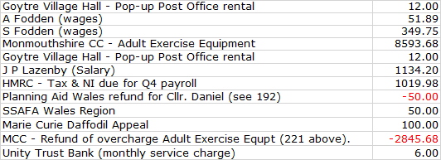  Payments from 2025/26 tax Year £  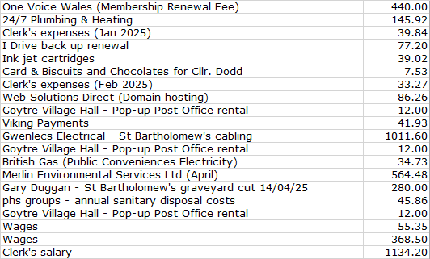  - VAT Claim update.  The Clerk confirmed that a claim for £4168.61, being the total VAT paid by the CC during 2024/25, was submitted on 2nd April and refunded in full on 7th April.  - 2025/26 budget – Latest updates and finalisation of budget lines.  Following the March meeting, the Clerk has updated the 2025/26 projection to version 11. This shows an adjustment to transfer the surplus bin collection provision of £1146.60 (plus VAT), to Capital items, as agreed at March’s meeting. This was following the recognition that the three bins we had planned for Llanover, will not now happen. However, in doing so, the Clerk identified that we had not made any provision for VAT for the existing capital items budget of £2500. Therefore, to compensate, instead of transferring the full £1146.60, the Clerk only transferred £646.60, and used the balance to make provision to cover the £500 VAT shortfall for this budget line.  In addition, the VAT refund reported under item (ii), has now been inserted into the relevant income line. We had forecast £4194.03, so were only c£25 out. As usual, all amendments from the previous versions (9 & 10) are shown in yellow.  Version 11 is shown below.  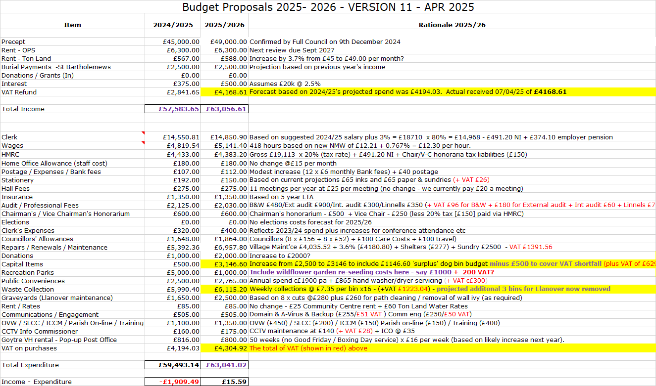  This ‘final budget was proposed by Councillor Morrey, seconded by Councillor Daniel, and carried unanimously.  - Review & Acceptance of 2024/25 Cashflow and end of year accounts / Bank Reconciliation.  The end of year Cashflow, Accounts & Bank Reconciliation have been circulated to members in advance and were also reviewed during the meeting. The Clerk confirmed that the Cashflow balances had been verified to the closing balances in the Unity Trust Bank statements, at the end of Jan/Feb/Mar 2025, during the Finance Committee meeting on 9th April, with Councillor Daniel signing to confirm in accordance with section 2.6 of the Community Council Financial Regulations (Wales). There was no further comment or observation.  The ‘Balance Sheet,’ together with the ‘Bank Reconciliation’ for the year were also reviewed. The figures on each were cross-checked against the Cashflow account, which itself had been verified to the balances in the bank as at 31.03.25.  Acceptance of all three documents, as an accurate record of the transactions and closing financial position as at 31.3.25, was proposed by Councillor Morrey and seconded by Councillor Carter. All Councillors voted in favour. Clerk to confirm the signing of the ‘accounts’ with EH Accountancy.  - Reserves & Budget.  The Clerk advised that our year end reserves had increased to £23,205.94, up from £22,788.07, at the end of the last financial year, a modest increase of £417.24. This reflects the balance budget that was set, although individual over and underspends can be seen in the Cashflow referred to above. Based on this, the Clerk felt the existing budget level of reserves (at 47% of the precept for 2025/26 and just under 37% of the forecast gross expenditure for 2025/26), was appropriate, and at present, no changes are required for the forthcoming year.  - External Audit 2024/2025.  The external audit papers have now been received for 2024/25, which the Clerk has already started to prepare. This year we will again be subject to the Full Transactional Audit. Wales Audit have confirmed the following dates:  - 16th June: Latest date for publishing the Audit Notice on our noticeboards  and web site.  - 30th June: Latest date for approving the Annual Return.  - 1st July to 28th July (inclusive): Period for public to inspect the accounts and supporting documents.  - 8th August: Latest submission date for the Annual Return. This is about a month later than normal, due to the requirement to submit a greater number of papers and accounting / governance records.  - 15th September: The date from which Electors can exercise their rights under the Public Audit (Wales) Act 2004.  - 18th September: Wales Audit anticipate issuing audit opinions from this date.  All the published dates (except for the final submission date) are within the normal timescales and so should not cause us any issues. In the meantime, the Clerk will follow the usual timescales, with sign-off of the Annual Return no later than 30th June.  - Finance Committee update inc Risk Assessment & Health & Safety reviews.  The following points were highlighted by the Clerk from the Risk  Assessment:  - Precept  Final budget confirmed by Full Council at April 2025 meeting.  - Loss of Income from the Olde Pounde Shop  Rent being received into Unity Trust Bank account. Payments are all up to date. New 15-year lease (from Sept 2024) now signed.  - Reserves – General Adequacy  End of year reserves as at March 2025 were £23,206, (47% of this year’s £49k precept), marginally down from 48% as at 31/03/24. This represents just under 37% of the forecast gross expenditure for 2025/26. Clerk considers this to represent an adequate short-term reserve.  - Reserves – Earmarked  Previous earmarked funds of £1886, representing the remaining monies from Micro-Geography Fund, were transferred from the instant access account and spent on the adult exercise equipment.  - Salaries / Wages  Increase of wages to £12.30 per hour budgeted and formally agreed at March 2025 Full Council. Updated wage details forwarded to Beverley & Williams, for payment from April 2025 onwards. Clerk has updated the standing orders to reflect 2025/26 salaries. Employees advised of pay rise.  - Recovery of VAT payment  The claim for 2024/2025 (£4168.61), was submitted to HMRC on 2nd April and received in full on 7th April.  - Councillors Allowances  The Clerk advised that despite repeated requests, one Councillor had not completed his documentation to claim the allowance (either with or without tax) or decline it. The Clerk is aware that this omission will be identified by Wales Audit during their more in-depth transactional audit. He is currently in discussion with the Democratic and Boundary Commission (to whom we must report the allowance claims), as to the best way to complete our return, so that it is consistent with the figures to be sent to Wales Audit.  - Training of Clerk / Staff  The Training Plan was reviewed and updated on 15th April 2025 and published on the web site.  - Insurance  - Insurance renewal received, reviewed by Full Council at January meeting  and renewed on 2nd February 2025.  - 2025/2026 Employer’s liability cover is in place following renewal of the  Council’s insurance policy which has been posted on the stockroom door,  notice boards and the web site.  - Health & Safety  - Survey of Trees on Ton Land undertaken by MCC June 2022. Report received and remedial action undertaken. No other concerns as to vitality of trees. Diarised for re-inspection summer 2025.  - St Bartholomew’s: Non-compliant wiring for the lighting was discovered between the church, footpath and lychgate. Gwenlec Electrics have now replaced this with armoured cabling throughout. Electrical compliance certificate issued.  - Community & Town Councils Duty under Section 6 of the Environment Wales Act 2016 (Bio diversity plan)  An updated plan is due at the end of this year and should reflect the Green Corridor initiatives, which are taking place across the ward. These include wildflower beds and trees in Goytre Park (and Dog walking area), the green at Rhydymeirch, St Bartholomew’s graveyard, as well as other small selected sites.  The Health & Safety Checklist  - The four Oak Trees on Ton Land need to be safety assessed this year – Clerk to arrange.  - The non-compliant wiring for the lighting in St Bartholomew’s graveyard has been replaced with full armoured cabling throughout, and is now fully compliant with current electrical standards.  The Risk Assessments & Health and Safety updates were accepted by the meeting and formally proposed by Councillor Daniel, seconded by Councillor Morrey, and carried unanimously.  (l) Renewal of ICCM Membership £105.  The renewal of our annual membership of the Institute of Cemetery and Crematorium Management, at a cost of £105 is now due. The Clerk advised that they provide invaluable advice and guidance on what is a complex area of rules and regulations, and he strongly recommended that the Council renews its membership. This was agreed and then proposed by Councillor Morrey, seconded by Councillor Carter, and carried unanimously. | Clerk  Clerk  Clerk  Clerk  Clerk
8 | Planning.  - To accept the responses of the Planning Committee meeting held on 25th March.  The following application was considered:  Application: DM/2024/00398. Appeal against refusal of the proposed conversion of outbuilding to 2 No. holiday lettings.  1 Pen Y Wern Cottage, Pen-y-Wern Road, Penperlleni, Monmouthshire NP4 0AB.  The review concluded with no comments being made regarding the appeal against refusal of the proposal, or grounds for the refusal.  Application Number: DM/2025/00305. Modification or Removal of Condition 1 relating to planning DM/2020/00806 (new outbuilding to form two stables with associated storage and home office with storage over).  Condition 1 - This development shall be begun within 5 years from the date of this permission. Application seeks to extend the development commencement date.  Blackberry Barn, Tredomen, A4042T Goytre To Penperlleni, Goytre, NP4 0AF  The review concluded with no issues, or concerns, being raised regarding the application to extend the time condition on the previous approval of the proposal.  - Any other updates.  - The following application has been received from MCC. DM/2025/00512 Change of Use from Class B1 Business to Class D1 – Non-residential institution (Children's Creche / Day Care.) at Hall House, Llanover Business Centre, A4042 Llanover To Pencroesoped, Llanover, Monmouthshire. A meeting of the Planning Committee will be arranged in due course to consider the application.  - Councillor Dodd noted that the stile by the large house being developed next to the football ground had still not been changed to a Lychgate. This was a condition of the development (which doesn’t appear to be progressing at the moment). Clerk to check back on the files and try and establish the current position with MCC Planning.
9 | County Council update - County Councillor Jan Butler.  Councillor Butler provided the following written updates in her absence.  - Goytre A4042 Pedestrian Crossing Status..  Both Peter Fox and Laura Jones have been working behind the scenes on this, but have no answers as yet as to what is causing the delay. It was budgeted for in the 24/25 budget and the preparatory work is complete. Cllr Butler suspects this is a scheduling delay but is pressing Richard Jones, Manager at SWTRA for a date that work will begin.  Peter Fox put in a request for information on accidents on the A4042 and this came back as 21 between Llanover and Llanellen in the last year, including a recent fatality. Cllr Butler has asked for the figures from the Mamhilad roundabout to Llanover, and for a progress update on the improvements to access the Secret Garden. Is also separately pressing for signage around The Cedars.  The GoSafe volunteer group is still able to do some speed monitoring and Cllr Butler intends to restart this asap at the end of School Lane with the intention of getting some press coverage. If anyone wishes to write directly to WG to press for the crossing, then they should direct their comments to Ken Skates MS.  - Mon and Brec Canal.  A short-term solution to put water in the canal to save the summer season has been agreed between CRT/NRW/DWR Cymru.  Following Cllr. Butler’s recent motion to MCC (which was carried unanimously), the administration is working towards a meeting of the key stakeholders to find a long-term solution to the issue. It will be held in Monmouthshire with Huw Irranca Davies, as early as possible in May.  The petition is still open and exceeded 10,000 votes within 10 days. It will be considered for a full debate in the Senedd. Significantly, there are now signatures from every Senedd area. MS’s should be in no doubt as to how much the residents of Wales care about the future security of the Mon and Brec.  There is no date as yet, but Cllr. Butler has asked to have a voice at the meeting once it has been arranged.  Cllr Butler feels there is a much wider issue regarding climate change and flood management of water in the Usk catchment in which the canal may have a pivotal role.  It was agreed that we should publish the Deputy First Minister’s response to the Chair’s letter onto the CC Facebook page. | Cllr. Butler  Cllr Butler.  Cllr Lewis
10 | Goytre Community Centre - Update on current situation.  The Community Centre Meeting was held on 8th April. The result of the vote of those in attendance was 22 to keep the Centre open and 3 against.  There then followed the AGM where Owen Dodd was re-elected as Chairman and Jan Butler as Secretary. Deb Williams continues as a user member. Lewis Carter continues as a Community Council member. Alyson Hunt was elected as the new Treasurer with Deb Fury and Wayne Hunt as new members.  The next Committee Meeting will be Tuesday 6th May at 7:30 pm. A further four members can be co-opted, should anyone be considering joining the Committee.  Councillor Dodd said that the projected income should be enough to continue with the building cost until March next year. They are installing some audio-visual equipment, which should create opportunities for more people to use the facility.
11 | Green Corridor Project – Goytre & Llanover Biodiversity Enhancements.  Jane Clarke is still waiting to hear back from the Grounds Maintenance team for clarification on the planting at St Bartholomew’s North churchyard. Further details will be provided as they become available.  In the meantime, the following items are still to be delivered:  Goytre Park: 3 x benches, bug hotel, Spring bulbs (to be delivered in Autumn)  St Bartholomew’s North Churchyard: 1 x bench, small bug hotel, stone hibernacula (small rain-garden may not happen, waiting for confirmation from Grounds Team), Spring bulbs (again to be delivered in the Autumn).  Jane visited Goytre Park last week and was pleased to see the red campion coming through on the wildflower turf. She has forwarded a photograph which the Clerk has shared with Councillors.  Councillor Carter mentioned that there had been some comment on the FB page re the planting of hedges etc on the bank of Goytre Park. There was concern that the planting might prevent the children from using the slope. However, Councillors felt there were still plenty of gaps to roll down and for sledging etc.
12 | Goytre Recreation Park – update.  As some Councillors may be aware, despite promises to the contrary, the CC was debited with the incorrect sum for the finalisation of the work in the park, failing to take into account the remaining section 106 monies of £2,371. We were therefore charged £8,593.68 instead of £5,748 (both figures inclusive of VAT). This would have had a significant impact on our end of year reserves and VAT claim. Numerous frantic calls on the 31st March finally resulted in us being re-credited late in the afternoon, with our final end-of-year figures able to reflect the ‘true’ financial situation.  However, the work is now complete. The Clerk has enquired as to the cost of adding a set of nets to the basketball hoops. JW at MCC has confirmed that these can be fitted free of charge and has ordered some ‘chain nets’ which are more robust and last longer.  The goal areas seem to be extremely popular. The Clerk wondered whether he should enquire as to the possibility of extending the artificial area to alleviate some of the wear and tear on the grassy area, especially in the winter months. However, Councillors felt that we should wait another season to see how the pitch fairs over the next winter. It was noted that some children have been seen climbing on the goal ends and sitting on the basketball hoops. Clerk to contact JW to see if we should put a no climbing sign (or similar), on each goal end. | Clerk
13 | Planning and Environmental Decisions Wales (PEDW) – Briefing on the work of this organisation – Councillor Barnes.  Councillor Barnes recently attended this training session which was run jointly by One Voice Wales and Planning Aid Wales (PAW), with 83 attendees. This agenda item is to share some of the output with other members of the Community Council.  Councillor Barnes advised the members that PAW effectively ‘front ends’ Welsh Government (WG) on Strategic Planning. Their work is split into three geographical areas: South Wales / East Wales / North Wales, with PAW working on the strategic plans of each area, which includes infrastructure, jobs, education etc. This then filters down to the more locally based planning.  The meeting also looked at PEDW - Planning & Environment Decisions Wales. This organisation responds to appeals against planning refusals. It is mainly concerned with larger projects (like solar and wind farms), but also consider the ‘standard’ household planning refusals. They essentially arbitrate between WG and the applicant, and advise that c30% of appeals are eventually successful. As example The Canals and River Trust recently appealed against the decision regarding the water abstraction issue, but were not successful. PEDW also issues TANs – Technical Advice Notes. These provide detailed planning advice, which local planning authorities take into account when they are preparing development plans.
14 | GFCC – Annual Report – Allocation of Reviewers.  It is now a requirement (under the Local Government & Elections (Wales) Act 2021), that all Councils publish an Annual Report, as soon as is practical after the end of the financial year. As this year the Council is subject to the full triennial transactional audit, the Clerk (who normally undertakes the review), has asked if it would be possible to allocate some of the review to Councillors as detailed below:  - Chair’s Forward – Cllr Morrey  - Introduction to the ward – Clerk  - Councillors (No change – but Clerk will check)  - Councillors’ attendance – Clerk will update  - Community Council’s Vision - (No change – but Clerk will check)  - The review against the Future generations Act: A More Prosperous Wales / A Resilient Wales / A Healthier Wales / A More Equal Wales / A Wales of Cohesive Communities / A Wales of vibrant culture and thriving Welsh language / A globally responsible Wales – All Councillors  - Donations / Annual accounting Statement - Clerk  This was agreed and the Clerk will forward last year’s Report for review, with Councillors requested to respond before the June meeting. | Clerk / All
15 | Llanover Village – updates.  - Llanover bus stops – lease proposal from Llanover Estates  There is no further update on the lease proposal. In the interim, Cllr. Carter asked if the Clerk would check when the bus stops are due to be cleaned, as this doesn’t appear to have happened yet.  - Separately, the Clerk was asked if he could ascertain the cost of having the bus stops in Goytre professionally cleaned. Clerk to investigate. | Clerk  Clerk
16 | Donation Requests.  - National Eisteddfod  We have been approached to make a donation to the 2025 Llangollen International Eisteddfod, (the organisation normally writes as part of its annual fundraising to all Local Authorities, Town and Community Councils). Traditionally, the Community Council has reserved its donations to support the attendance of local school children, and indeed, at the March meeting agreed a donation of £250 to enable them to attend this year’s Urdd. Councillors agreed that they wished to continue with this ‘policy’ and that the CC should not make a separate donation to the National Eisteddfod on this occasion. This was formally proposed by Councillor Morrey, seconded by Councillor Daniel and carried unanimously. | Clerk
17 | Village Committees’ Reports – questions based on previously distributed updates.  - Goytre Village Hall.  - Little to report really, all is going well.  - AGM next month.  - Llanover Village Hall.  - Work has taken place on the porch with moss being removed. The structure is confirmed as OK.  - The Hall has been awarded a grant approaching £15k. This will be used to fix the rising damp in the kitchen area and to re-decorate the hall.  - Goytre School Governors.  - New headteacher as from next academic year will be Mr Alex Mill from Merthyr Tydfil  - A new deputy headteacher will be selected next month.  - Goytre Community Centre.  - See Item 10 above.  - Other Reports.  - There were no other reports.
18 | Communications.  - GFCC Facebook page – latest posts / responses.  There was nothing specific to report.
19 | Advertising – Usk & Raglan Diary Contributions May/June 2025.  The Clerk suggested that we submit an article covering the Green Corridor Project. In particular, the planting at Rhyd-y-Meirch, which was supported by the pupils from Goytre Fawr Primary (photographic permissions are held). The Clerk asked Councillor Lewis if he could supply a short amount of copy to go with the photos. | Cllr. Carter  Clerk
20 | Date of next meeting and close.  The next meeting is to be held on Monday 19th May. This will commence with the Annual Statutory meeting at 19.45, followed by the ‘ordinary’ May meeting at approximately 20.30.  The venue to be Llanover Village Hall, and by teleconference using: https://meet.jit.si/GoetreFawrCommunityCouncil  Councillor Morrey gave his apologies, as he has to present to a conference in Leeds first thing the following morning. | All/  Clerk

Chairman: …………………………………….…………… Date:…………………….

