|  |
| --- |
| **Environment (Wales) Act 2016 Part 1 – Section 6**  **The Biodiversity and Resilience of Ecosystems Duty Report 2022** |
| **Name of Town or Community Council: Goetre Fawr Community Council** |
| **Introduction and Context**  This paper provides an update on the report prepared at the end of 2019.  Goetre Fawr is a small Community Council (CC) in Monmouthshire in South Wales, with a precept of £37,000 (financial year 2022/23). There are just over 1700 residents on the electoral role in the villages of Penperlleni and Llanover, and hamlets of Mamhilad and Nantyderry. Since the last report, electoral boundary changes have seen the village of Little Mill transfer into the Community Council Area of Llanbadoc. Similarly, the ward of Llanover has transferred to become part of Goetre Fawr which includes the Llanover Estate and a historic garden.  The majority of the Community Council’s influence on biodiversity will be through decisions taken at Council and Planning meetings, to ensure the promotion and protection of the eco-system within the Community. The CC has worked closely with Monmouthshire County Council (MCC) to identify biodiversity opportunities on public and community spaces. Unfortunately, the impact of Covid and various lockdowns meant that the potential for a partnership with the Canal & Riverside Trust was not taken forward. However, this remains a future opportunity as The Brecon and Monmouthshire Canal runs through the ward and is a major wildlife asset. The opportunity has recently been taken to appoint a Councillor(s) with specific responsibilities for overseeing the CC’s actions to support biodiversity following the departure of the previous incumbent at the May 2022 elections.  In addition, the CC owns a small paddock (c1 acre), on which horses have traditionally been grazed and which is land-managed in accordance with best practices. However, recent requests from residents to consider the use as allotments are being reviewed by the Community Council. The use as a community farm has also been considered, although at only 1 acre, the plot was considered too small by the charity involved. |

|  |  |  |
| --- | --- | --- |
| **Action Report** | | |
| Action carried out to: |  | Monitored by: |
| -embed biodiversity into decision making & procurement | 1. The impact on biodiversity is now considered as part of the review of all planning applications and in particular the awarding of CC contracts. 2. The previous biodiversity representative did not stand for re-election in May 2022, which has provided the opportunity for a new Councillor, (and Chair of the Community Garden), to oversee this important issue. 3. Amongst other initiatives, the newly appointed Councillor will explore GFCC obtaining bee friendly accreditation through MCC. | Clerk, Full Council / Planning Committee  Biodiversity representative. To include:   * General Actions / commitments * Responses to planning applications * Specific biodiversity initiatives / actions. |
| -raise awareness of biodiversity & its importance | 1. Work with influential groups e.g., Community Garden, Llanover Garden, school, Nantyderry Nursery, to promote biodiversity / ecological sustainability 2. Promote initiatives via the villages Facebook site. 3. Continue with and re-inforce existing initiatives and awareness campaigns | Full Council / Biodiversity representative – feedback received from Council members and residents |
| -safeguard principal species and habitats | 1. Ensure hedgerows are protected, especially as part of any planning applications, with restoration of any hedges / trees removed or damaged during construction 2. Ensure hedgerows are managed in the winter months when the woody growth is dormant. Avoid work during the bird nesting season (March to August). 3. Create habitat piles - dead wood and piles of leaves are good for a range of species 4. Look for opportunities to erect bat and bird boxes or to build a bug hotel (provide boxes for local organisations to erect) 5. Liaise with the Canal & Riverside Trust to explore opportunities - the canal is a haven for wildlife | Planning Committee / Full Council Biodiversity representative  Record any specific activity / sites or species protected |
| -restore & create habitats and resilient ecological networks  -restore & create habitats and resilient ecological networks – continued. | 1. Continue to manage the Goytre Wildflower area and orchard / bee friendly trees. This is an area specifically created in Goytre park to enhance local biodiversity. Clerk / Biodiversity representative to review if the flowering season can be extended by including spring flowering bulbs, shrubs etc. 2. Arrange for bulb planting alongside hedges, verges and under the trees in the park 3. Continue to support different mowing regimes with MCC (no mow May), to allow low growing species like daisies, clover and selfheal to flower and increase the number of flower-visiting insects, helping pollinators. 4. Identify any areas of grassland where the landowner can be asked to let the grass grow long and manage like a hay meadow. 5. Continue with the messaging that ‘tidiness is not a priority’ for biodiversity projects (nature isn’t neat), and that sometimes just leaving a small area (in the park or Community Garden) to go wild can be beneficial. | Full Council  Biodiversity representative  Identify areas of habitat which have been created / increased / protected.  Look for areas to improve |
| -tackle negative factors: for e.g., reduce pollution, use nature-based solutions, address invasive species | 1. Review the use of pesticides in the village to tackle weeds, particularly along the dog exercise area and roadside verges 2. Identify and remove invasive species such as Japanese Knotweed, Himalayan Balsam etc 3. Ensure any composts used by the CC are peat free 4. Support the groups who carry out regular litter picking to keep the lanes free and support wildlife. | Full Council (liaise with MCC as necessary)  Invasive species addressed  Usage of pesticides  Certificates/letters for regular litter pickers |
| -use improve and share evidence | 1. Liaise with the Community Garden team / other volunteers to share best practice / ideas for householders re the planting of flower and vegetable beds / containers & hanging baskets etc to encourage the use of pollinator-friendly shrubs, annuals and perennial plants. 2. Encourage the school / GASC to undertake projects on wild flowers / wildlife that lives in the park etc (provide ‘sponsorship’ if required). | Full Council Biodiversity representative  Use of Community Garden and other local ‘expertise’  Activity from local residents / community groups / School |
| -support capacity and/or other organisations | 1. Continue to actively manage and enhance the wildflower and grass meadow area in Goytre Park 2. Support requests from local organisations for bulb planting (e.g., Seed Bombs requested by Llanover Village Hall). This could include bulb planting alongside hedges, verges and under the trees 3. Plant the park tubs and Olde Pounde Shop trough with pollinator friendly flowers / shrubs 4. Encourage landowners to avoid hedge cutting between April and August, and to adopt more bio-friendly mowing regimes (no mow May), again to allow low growing species like daisies, clover and selfheal to flower, and increase the number of flower-visiting insects, helping pollinators. 5. Identify any areas of grassland where the landowner can be asked to let the grass grow long and manage like a hay meadow. | Full Council / Biodiversity representative /  Regular postings on social media – village Facebook sites.  Encouragement of the adoption of biodiversity best practice by Village Halls and Goytre Fawr Primary School.  Support with donations if appropriate.  Identify areas of habitat which have been created / increased / protected |

**Photographs**

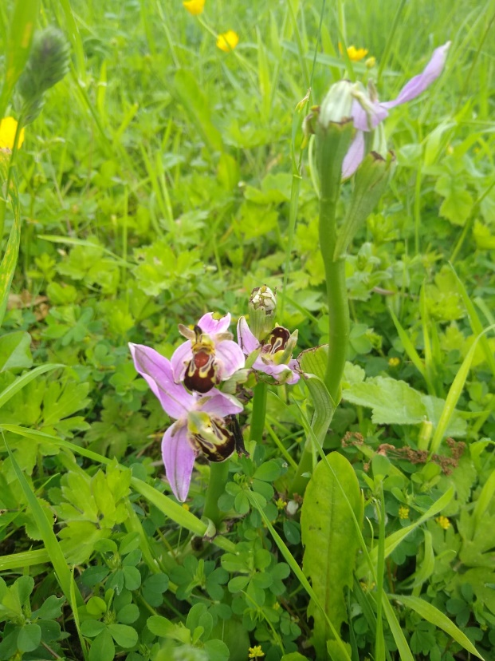

To the right is a picture of a Bee Orchid, a rare species which appeared in the Local **Community Garden** when the grass was left unmown.

The Photographs below (used with the kind permission of local resident Mr David Owen), are from the Wildflower Garden in **Goytre Park**, which is the centre piece of the Community Council’s efforts to enhance local biodiversity. The scheme includes pollinating flowers, fruit and pollinator friendly trees, together with a grassland walkway created around the boundary of the garden.

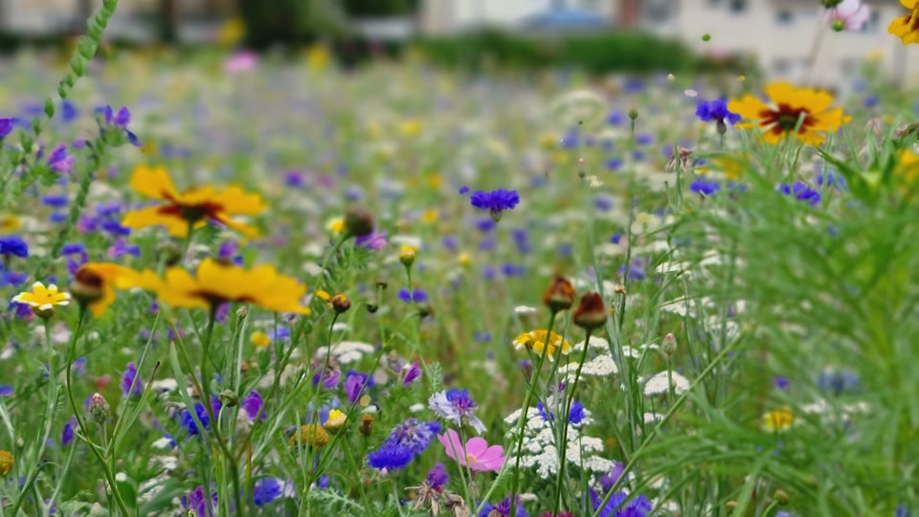

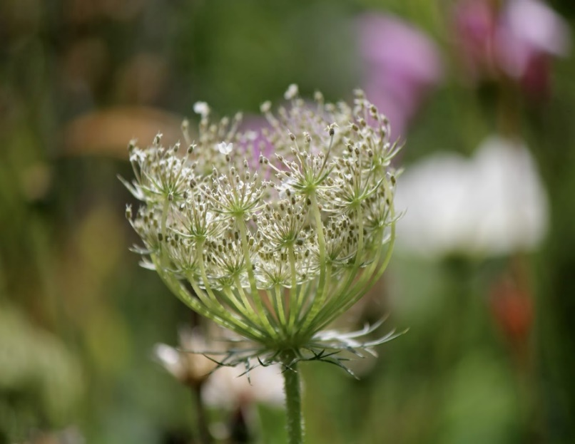 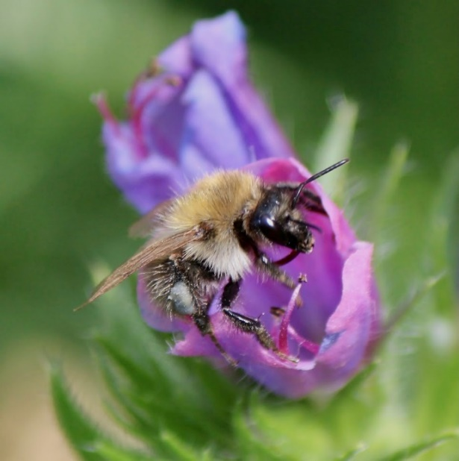

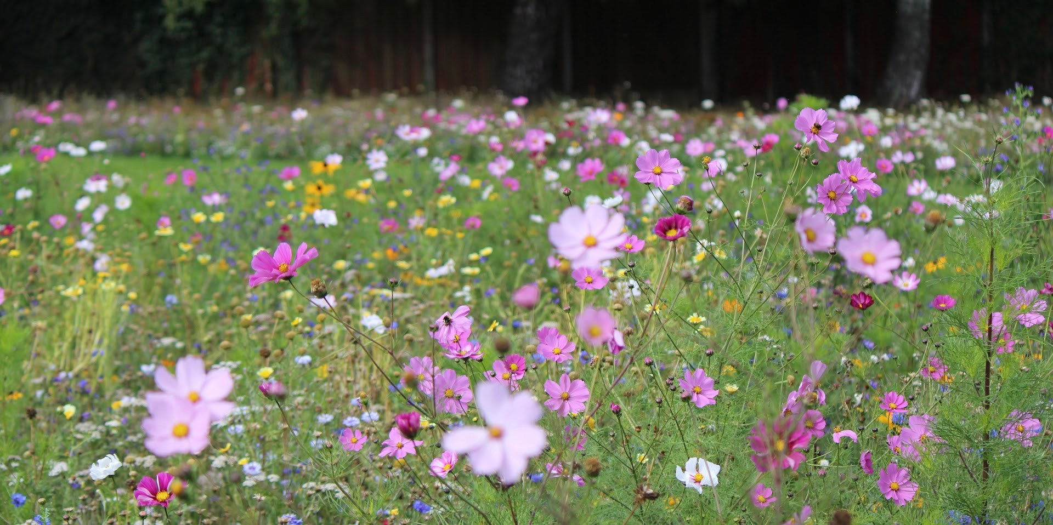

|  |
| --- |
| **Review of s6 duty** |
| **What worked well? What have the barriers been? What will you change?**  **What’s worked well?**   1. Since the 2019 plan was instigated the Community Council has created a significant wildflower area with native and pollinator friendly species. A dozen fruit and pollinator friendly trees were also planted, with a grassland walkway created around the boundary of the garden. The installation of two benches, paid for by a Community Councillor in memory of her late husband, have created a wildlife space for families to enjoy. The Clerk / Biodiversity representative are now to explore whether it is possible to extend the flowering season by planting some spring flowering bulbs / shrubs.   A planter including pollinator friendly species has been put outside the Olde Pounde shop.   1. All planning applications are now considered by a dedicated Planning Committee. Previously, they were considered by full Council, which meat that time limitations prevented the proper consideration of the wider environmental impact of any applications being put before Council. The new committee, formed in 2020, has enabled a much more detailed examination of planning proposals, with recommendations for bio-diversity actions as part of any approval, being made as appropriate.   Typically, the committee will examine the impact on any proposals on:   * + The prevention of the removal of hedgerows and trees (with any unavoidable damage caused by construction equipment etc made good).   + The impact on local drainage / watercourses.   + Enhancement of bio-diversity as part of any application.  1. No mow May. This is now practiced on all Council -owned managed/land. The local community garden adopted this practice and noted the appearance of ta wide range of wild flowers as a result; Bee orchid, Early Purple Orchid, Dandelion, Buttercup, Daisy, Ragged Robin, Clover, Lesser Celandine, Speedwell, Self-Heal, Speedwell, Deadnettle, Herb Robert, Greater Stichwart etc. This practice is likely to be extended more widely in the garden.     **What’s not worked so well?**   * The Community Council’s experienced biodiversity champion did not stand for re-election in May 2022. (However, a Councillor with a wide breadth of Biodiversity knowledge [from her active involvement in the successful local Community Garden], has been appointed to the vacant position). * The reduction in Councillors from 12 to 8 has meant a 33% reduction in the Council’s resources – meaning that Councillors have less time to allocate on a wide range of Council priorities. * The formation of a partnership with the Canal & Riverside Trust, to explore biodiversity opportunities along the Brecon and Monmouthshire Canal did not happen. This is to be revisited as a matter of priority. * The impact of Covid meant that the attention of the Community Councillors was diverted from some key priorities.   **How and when will the s6 duty be monitored and the s6 plan?**  The duty will be monitored through the appointed Community Council Biodiversity representative, reporting back to the council on the success or otherwise of any actions - taken through regular assessments, and more formal quarterly, six monthly and annual updates. |