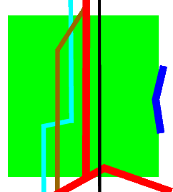

CYNGOR CYMUNED

GOETRE FAWR

COMMUNITY COUNCIL

**Community Youth Representatives**

Be a Voice for Young People in Goetre Fawr!

Are you a young person aged 16 to 25 living in Goytre, Mamhilad/Goytre Wharf, Nantyderry, or Llanover?

Do you care about your community and want to make a real difference for young people?

Goetre Fawr Community Council is looking for two enthusiastic Community Youth Representatives to join us! This is a fantastic voluntary opportunity to ensure the views, issues, and opinions of local young people are heard and considered in local decisions.

What you'll do:

 * Attend Community Council meetings.

 * Take part in discussions and contribute your insights.

 * Help shape decisions that directly impact our community.

 * Please note: While you will be an active participant in discussions and provide valuable input, you will not have voting rights on council decisions.

This is your chance to gain valuable experience, develop your leadership skills, and have a tangible impact on making Goetre Fawr an even better place to live.

Anyone wishing to apply or find out more information on how to become involved is encouraged to contact The Clerk at ‘theclerk@goytre.gov.uk’, or by telephoning 07510 345337

The closing date for applications is Sunday 5th October 2025

Please note that for young people under the age of 18, parental consent will be required.