CYNGOR CYMUNED GOETRE FAWR COMMUNITY COUNCIL

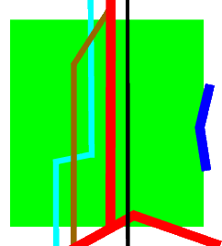

ANNUAL REPORT – CIVIC YEAR 2025 /2026

CHAIR’S FOREWORD

The Council has had an active year and there has been good progress on a number of Community based projects. I would like to personally thank the Community Councillors for their dedication, commitment and contribution. Each year we face an ever-increasing workload and many more challenges to manage but, as a local Council, we continue to provide best value to the Community with the limited funds that we have available to us and ensure that the increases to our budget (referred to as the “precept”) reflect the needs of our residents and the projects that we support.

As always, the Council has to rely heavily on the commitment of our Councillors (many of whom represent many other community and charity-based organisations) to provide the insight from the wider members of the public, ensuring that we continue to deliver in line with the needs and wishes of the Community.

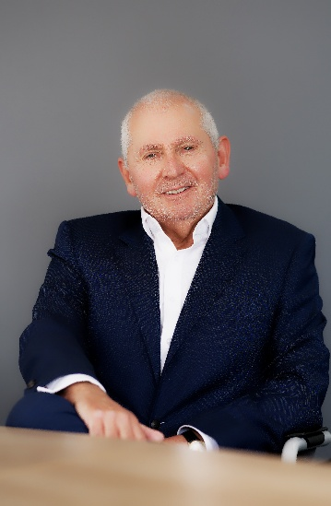

We are very fortunate to continue to be supported and guided by our Clerk, Jonathan Lazenby and I would personally thank him for the support he provides me as Chair and the wider Community Councillors. He works tirelessly to support the Council and again we have had excellent feedback following our recent audit.

Goetre Fawr Community Council
As you read this annual report, you will get a greater appreciation of the level of activity that our Community Council both supports and funds. The Council delivered a wide range of new initiatives in 2025/2026, notably the refurbishment of the Goytre Recreation Park (using our s106 funding) and the biodiversity initiatives in many locations around Goytre village. At the same time there has been significantly increased engagement with Llanover Village, led by Councillor Lewis Carter, and we hope to move forward with more Llanover-based projects during the 2026/2027 financial year.
I hope this report will improve your understanding of the Community Council’s activities and we would welcome your feedback and ideas. You are all, of course, all welcome to join us at our “hybrid” monthly Community Council meetings (time and dates published on notice boards and on our website).

Introduction to the ward
Goetre Fawr Community Counci is an electoral ward in the County of Monmouthshire. In May 2022 the ward was subject to significant changes as part of the Monmouthshire County Council electoral and boundary review. As a result, the ward of Mamhilad was split, with the village of Little Mill transferring to Llanbadoc Community Council, and the remainder becoming part of a new ward called Goetre Wharf. Redefined boundaries were created for Goytre and Nantyderry and the ward of Llanover (previously part of the larger Llanover Community Council) became part of the new Goetre Fawr Community Council. The ward therefore, now consists of the villages and hamlets of Penperlleni (Goytre), Mamhilad, Nantyderry and Llanover in four electoral wards, being Goytre (four councilllors), Goetre Wharf (covering Mamhilad) with two councillors, and Nantyderry and Llanover, each with one councillor.
Currently the council serves a population of around 1800 residents on the electoral register, and is funded by Monmouthshire County Council (MCC), through a tax known as the precept. For 2025/26 this amounted to £49,000, which is equivalent to £40.80 per year for a band D property, and is approximately 1.76% of the equivalent council tax bill. The council employs a part-time clerk, as well as two members of staff who maintain the public conveniences in Goytre.

The Clerk can be contacted by email at theclerk@goytre.gov.uk

The community council’s web site is www.goytre.gov.uk

The main activities of the council include the running and maintenance of the following:

Goytre Ward
- Public Conveniences
- Wildflower beds and meadow grass area in Goytre Park.
- Two bus shelters
- Seven dog fouling collection bins
- Monthly village cleaning and maintenance services
- Meeting the room cost for the weekly Post Office service in the village hall
- Purchase and maintenance of two defibrillators
- Installation and management of the traffic speed indicators on School Lane and Plough Road
Goetre Wharf Ward
- Seven dog fouling waste bins
- Purchase and maintenance of three defibrillators

Llanover Ward
- Maintenance of one defibrillator
- Monthly village cleaning and maintenance services
- Successfully spearheaded a campaign for the installation (with ongoing maintenance by MCC), of a wildflower area and orchard trees in Rhyd-y-Meirch, together with seating
- Management of St Bartholomew’s graveyard
Nanytderry Ward
- Two dog fouling waste bins

We also undertake the following:

The scrutinisation (via our Planning Committee), of planning applications submitted by MCC and APCBB, which meets as required to consider building developments and property extensions in the area.

Making donations to the local community and supporting agencies e.g. Typically these include (but by no means exclusively), the Village Halls , Goytre Fawr Primary school, Wales Air Ambulance and Monmouthshire Citizens Advice.

Advocating on behalf of residents where services fall under the remit of other agencies or providers for example

Welsh Government re the A4042, in particular the pedestrian crossing which is now being installed in Goytre village

The Aneurin Bevan Health Board regarding Goytre Surgery

MCC regarding the maintenance of the playground equipment in Goytre recreation park

MCC for the implentation of the Green Spaces project which saw a range of biodiversity initiatives during 2025, with the planiting of hedges and wildflowers acrss the ward

Regular reporting of issues requiring intervention by MCC – pot holes / other repairs, playground equipment etc

Councillors

The role of a councillor is a responsible one. Goetre Fawr Community Council has eight councillors, of which six have been elected / elected unopposed, with a further two co-opted by the council. Each one of them has an active interest in the local community and they are dedicated to improving the quality of life and well-being of our residents. The Clerk, as part of his role, ‘summons’ the councillors to each council meeting, as the councillors have a legal duty to attend.
The councillors, as part of their inauguration, must agree to act within a Code of Conduct set out by the Public Ombudsman for Wales. They must sign a declaration of acceptance of office which states they agree to work within this code and will declare any ‘personal interests’ in the work of the council. The role of a town & community councillor is a demanding one. Only a modest allowance of £156 a year is made (which a number of our councillors decline to receive), together with expenses for specified items in connection with their role. No salary is paid.
As the voice of the local community, councillors have an opportunity to influence bodies such as Welsh Government and their Principal Authority (Monmouthshire County Council). Each councillor, together with any political affiliation and the ward that they represent, is shown on the following page.


Councillor Owen Dodd
Goetre Wharf
owen.dodd@goytre.gov.uk
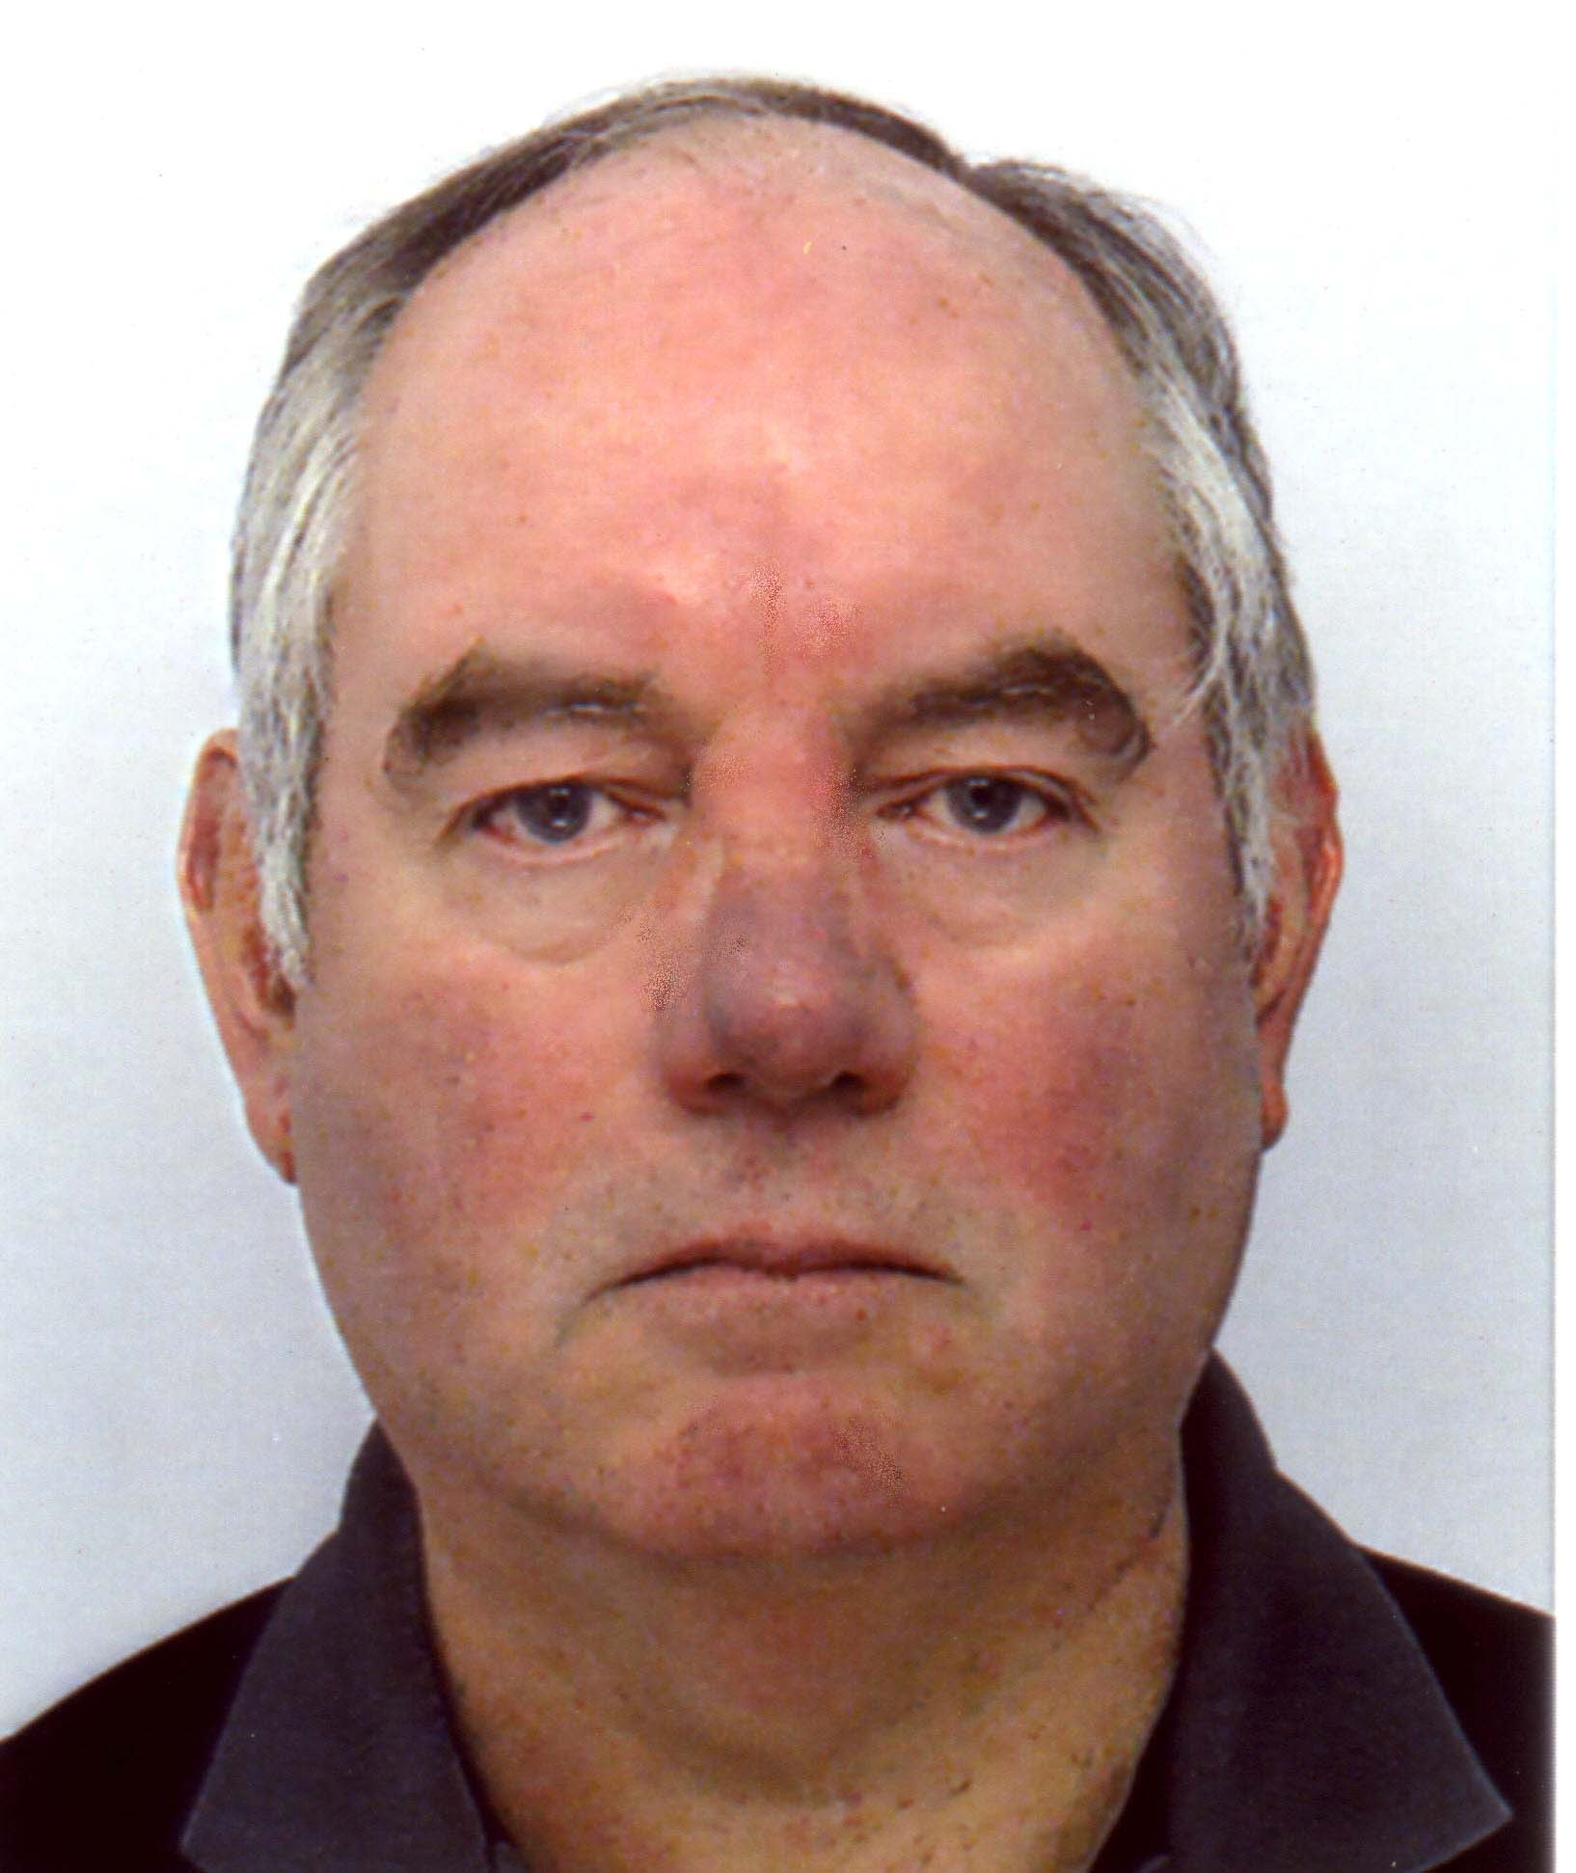
Councillor Andy Barnes (Planning Committee Chair)
Goetre Wharf
andy.barnes@goytre.gov.uk
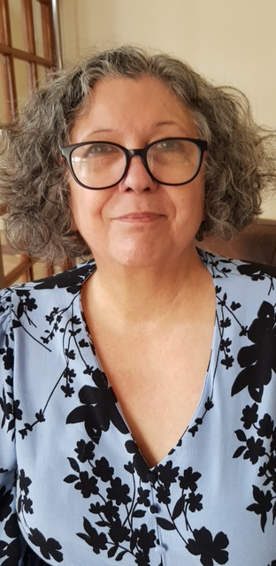
Councillor Janet Robins
(Welsh Labour)
Goytre janet.robins@goytre.gov.uk
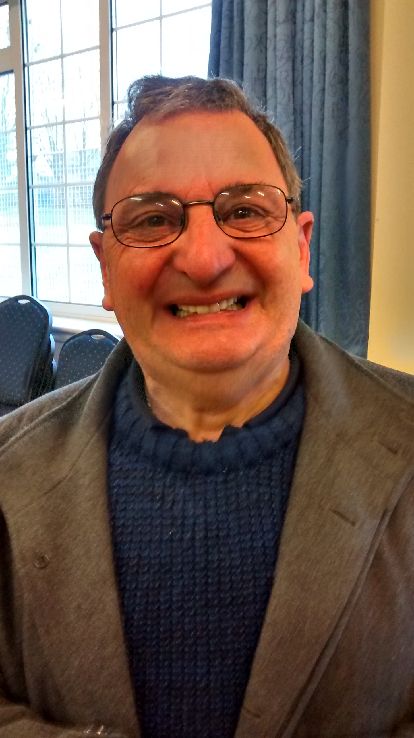
Councillor Peter Daniel
Goytre
peter.daniel@goytre.gov.uk

Councillor Lewis Carter
(Vice-Chair 2025/2026) Llanover
lewis.carter@goytre.gov.uk

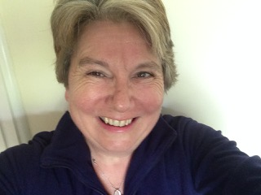
Councillor Jan Butler (Conservative)
Nantyderry
jan.butler@goytre.gov.uk
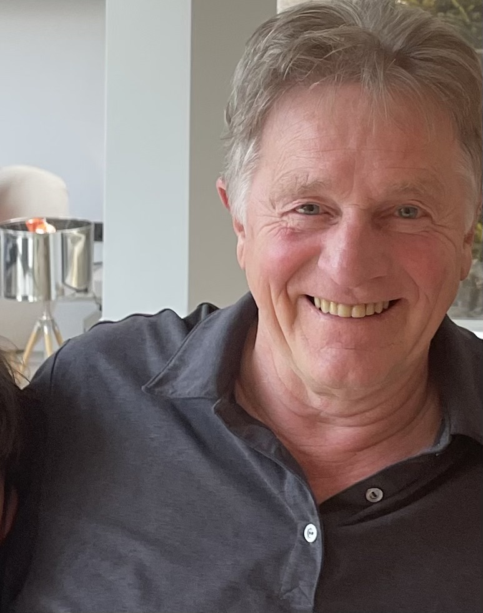
Councillor Martin Stevens (Reform)
Goytre
scott.grayland@goytre.gov.uk

Councillor Nigel Morrey
(Chair 2025/2026)
Goytre
nigel.morrey@goye.gov.uk

Councillor Attendance
The following table shows the attendance of councillors at Full Council, Planning Committee and Finance Committee meetings for 2025/26
Full Council Meetings (all Councillors ‘summoned’)
Date of meeting | In attendance | Absent with apology | Absent without apology
April 2025 | Owen Dodd  Andy Barnes  Nigel Morrey  Peter Daniel  Lewis Carter | Jan Butler  Janet Robins | Scott Grayland
May (inc. Annual Statutory Meeting) | Nigel Morrey  Lewis Carter  Owen Dodd  Andy Barnes  Jan Butler  Peter Daniel | None | Scott Grayland  Jan Butler
June | Nigel Morrey  Lewis Carter  Owen Dodd  Andy Barnes  Janet Robins  Peter Daniel | None | Jan Butler
July | Nigel Morrey  Lewis Carter  Owen Dodd  Jan Butler  Janet Robins  Peter Daniel | Jan Butler | None
August | No meeting held
September | Nigel Morrey  Lewis Carter  Andy Barnes  Janet Robins  Peter Daniel  Owen Dodd  Jan Butler  Martin Stevens | None | None
October | Nigel Morrey  Lewis Carter  Andy Barnes  Janet Robins  Peter Daniel  Martin Stevens | Owen Dodd  Jan Butler | None
November | Nigel Morrey  Lewis Carter  Andy Barnes  Janet Robins  Owen Dodd  Jan Butler  Martin Stevens | Peter Daniel | None

December | Nigel Morrey  Lewis Carter  Andy Barnes  Janet Robins  Peter Daniel  Martin Stevens | Owen Dodd  Jan Butler | None
January | Nigel Morrey  Lewis Carter  Andy Barnes  Janet Robins  Peter Daniel  Owen Dodd  Jan Butler  Martin Stevens | None | None
February | Lewis Carter  Andy Barnes  Janet Robins  Peter Daniel  Owen Dodd  Jan Butler  Martin Stevens | Nigel Morrey | None
March | Nigel Morrey  Lewis Carter  Janet Robins  Peter Daniel  Jan Butler  Martin Stevens | Andy Barnes | Owen Dodd

Planning Meetings (all Councillors ‘invited’)
Date | In attendance
14th May 2025 | Nigel Morrey  Janet Robins  Peter Daniel  Andy Barnes
17th June | Nigel Morrey  Peter Daniel  Andy Barnes
5th August | Andy Barnes  Abandoned - inquorate
3rd September | Andy Barnes,  Janet Robbins  Peter Daniel  Jan Butler
23rd September | Owen Dodd  Jan Butler  Peter Daniel  Martin Stevens  Nigel Morrey  Jan Butler
14th October | Andy Barnes  Martin Stevens  Peter Daniel
4th November | Andy Barnes  Peter Daniel  Martin Stevens  Jan Butler  Owen Dodd
15th December | Andy Barnes  Martin Stevens  Janet Robins
29th December | Andy Barnes  Martin Stevens  Abandoned - inquorate
9th February | Andy Barnes  Martin Stevens  Abandoned - inquorate

Finance Meetings (quarterly)
Members: Nigel Morrey, Lewis Carter, Peter Daniel and Janet Robins
Date | In attendance | Apologies
9th April 2025 | Nigel Morrey  Lewis Carter  Peter Daniel | Janet Robins
8th July | Nigel Morrey  Lewis Carter  Janet Robins | Peter Daniel
7th October | Lewis Carter  Janet Robins  Peter Daniel | Nigel Morrey
6th January 2026 | Nigel Morrey  Lewis Carter  Janet Robins  Peter Daniel | None

The Community Council’s Vision
As the first tier in local government, Goetre Fawr Community Council aims to provide a voice for the community, representing the area at both county and national level. We work closely with Monmouthshire County Council, the Police, the South Wales Trunk Road Agency (SWTRA), Welsh Government and other authorities to take account of the needs of our community, and when making decisions that affect our residents. The council uses the powers and resources available to it to proactively and quickly react to the needs of the community and provide appropriate levels of relevant services to our residents.
In May 2022, the newly formed community council, having satisfied the relevant criteria, resolved to adopt the recently introduced General Power of Competence. This replaced the previous ‘Power of Well-Being’ (now repealed by Welsh Government), with a broader range of powers available, which enable relevant authorities to do anything that an individual may generally lawfully do. The intention of the new legislation from Welsh Government [The Local Government and Elections (Wales) Act 2021] is to engender a culture of change, so that local authorities move away from a position under which they are required to ask whether they have a power to undertake a particular activity, to one in which it is assumed they can do something unless there is a statutory limitation or restriction preventing it.
The aim is to enable Community and Town councils to be more dymanic in the range of services and support that they can provide for their commmunities.

THE WELL-BEING OF FUTURE GENERATIONS

THE SEVEN NATIONAL GOALS

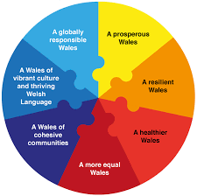

Although technically not covered by the Well-Being of Future Generations Act, the community council continues to focus on activities which both support and complement these national priorities, and which also support the principal authority (Monmouthshire County Council). These priorities have been used to provide the structure for this report and actions taken by the community council are detailed on the next few pages.

Well-Being of Future Generations Act – key priorities and actions taken
A Prosperous Wales
An innovative, productive and low carbon society which recognises the limits of the Global environment and, therefore, uses resources efficiently and proportionately, and which develops a skilled and well-educated population in an economy which generates wealth and provides employment opportunities, allowing people to take advantage of the wealth generated through securing decent work.
• The council makes budget provision for community improvement activities.
• The council maintains an up-to-date website and Facebook page, both of which are open to the community for information exchange and regularly posts relevant news items. These include local news items, employment and engagement opportunities, and consultations from other statutory organisations e.g. Aneurin Bevan Health Board.
- The Community Council actively supports the local Citizens Advice team to provide support and guidance to local residents, which is especially important during the current ‘Cost of Living Crisis’

A Resilient Wales
A nation which maintains and enhances a biodiverse natural environment with healthy functioning ecosystems that support social, economic and ecological resilience and the capacity to adapt to change.
- The community council continues to meet monthly and actively encourages public attendance at the meetings. The meetings can be accessed remotely via a teleconference platform (now a legal requirement), but are also held on a face-to-face basis in Llanover Village Hall for those without digital access / an adequate broadband connection, or for those who simply prefer ‘physical’ face-to-face meetings.
- The council provides for green spaces across the community and allows these areas to grow in a way that supports biodiversity.
- The council continues to provide a range of plants across the ward which both support pollinators and provide a haven for wildlife. Over the past twelve months it has worked closely with MCC following an engagement exercise with local residents to significantly enhance the biodiversity in the area. This has included extensive wildflower and hedgerow planting in Goytre Park, as well as a number of verges and smaller green spaces in Goytre. Wildflower planting has also taken part on the local green in Rhyd Y Meirch and plans are also in hand to create a wildflower area on the north side of St Bartholomew’s churchyard.
- A dedicated individual, Councillor Janet Robins, continues to oversee the community council’s environmental and biodiversity policies and actions.

A Healthier Wales
A society in which people’s physical and mental well-being is maximised and in which choices and behaviours that benefit future health are understood
- The community council supports the maintenance of the Goytre Park play area (Goytre Ward). A bid for funding for the building of the Multi-use Games Area (MUGA) was agreed in 2019. Unfortunately, progress was delayed due to the Covid pandemic, and it became apparent that the costs of the scheme were now beyond the s106 budget. As a result, and following another community engagement exercise, it was agreed to install the following items:
          - Two goal / basket ball ends on the lower grassy area (sports pitch)
          - A new climbing frame, rotating swing and trampoline to refresh the existing children’s play equipment
          - A wheelchair accessible picnic table
- The community council recognises the importance of children’s health and therefore continues to implement the Public Health (Wales) Act 2017 by ensuring the play areas in the ward remain smoke free areas (as required by the Act). This is supported with appropriate county council signage.
- The community council also recommended that Goytre park be formally confirmed as a dog exclusion area as part of the introduction of MCC’s Public Spaces Protection Order across the county, and this has now been implemented together with appropriate signage.
- In the past, the community council has provided substantial funding to upgrade the facilities in Goytre Village Hall and refurbish the Goytre Community Centre. The community council is custodian trustee of the community centre, which it leases from the county council and which was (until the recent closure of Goytre After School Club), used extensively to support local parents by providing before and after school activities. With the re-drawing of the electoral boundaries, Llanover village hall now falls within community council‘s area, and grant funding has been provided to their events committee to encourage social events to bring the two areas of the village together on a regular basis.
- The community council works with Monmouthshire County Council to maintain and improve both the urban and countryside footpaths in the area.
- The community council manages the provision of six defibrillators in the community (which are monitored and checked on a monthly basis), and recorded on the national defibrillator data base (‘The Circuit’). In addition, the community council periodically arranges for CPR and defibrillator training for residents.
- The community council has supported the installation of, and collection from 16 dog waste bins across the Goytre, Goetre Wharf and Nantyderry wards. The previous Llanover Community Council did not adopt the ‘Show dog fouling the red card’ scheme and so currently has no bins. The local community councillor undertook a consultation exercise with local residents to see if this should change, but overall there was only limited ‘enthusiasm’ to install bins on the limited areas of Country Council owned land which were available. However, the existing scheme continues in the other three wards, and despite significant price rises, the community council has continued to fund the weekly collection of waste from these bins (previously weekly in summer and fortnightly for lesser used bins in winter). This year the net cost (excluding VAT which the community council reclaims) increased to £6115 (from £5990) due to the cost increases of waste disposal. The budgeted cost for 2026/27 is £6364 (net of VAT).

A More Equal Wales
A society that enables people to fulfil their potential no matter what their background or circumstances
- The community council continues to seek solutions to the issues of road safety and access problems in order to ensure all residents are able to utilise all community services safely. Community / County Councillor Jan Butler has been persistent in leading a campaign to press SWTRA / Welsh Government to install a pedestrian crossing between the main bus stops on the A4042 in Penperlleni. It was announced that the crossing would go ahead, with construction due to start during the 2024/25 financial year but the scheme was delayed due to land ownership issues. The scheme commenced in early 2026, with completion on target for early in the 2026/2027 financial year.
- In a similar vein, Councillor Carter is leading a campaign, meeting with SWTRA, Welsh Govt., MS Peter Fox and the area’s MP, for the installation of a pedestrian crossing in Llanover, together with a speed limit reduction through the village. A stage 1 assessment has already taken place with a report back on initial findings stating that the crossing was not justified. The community council is planning to challenge this decision during the 2026/2027 financial year.
- The community council continues to fund the provision of the room for the weekly Post Office to ensure that those without private transport have easy access to postal services.
- Gwent Police continue to provide us with monthly reports, bringing to our attention, issues affecting the community, to help implement actions to address any problems. Similarly, Gwent police is notified of any concerns.
- Councillors are determined to ensure that all residents are kept safe. The elimination of anti-social behaviour, scams and burglary are a key priority.
- The community council regularly posts on the council, Penperlleni and Goytre Facebook pages, as well as other local forums to promote local community services and encourage residents to become actively involved in local consultations

A Wales of Cohesive Communities
Attractive, viable, safe and well-connected communities
- As already outlined above, the community council has successfully lobbied for the installation of a pedestrian crossing across the A4042 Trunk Road in the village of Penperlleni. This will greatly improve the safety and access for pedestrians looking to access northbound bus services on the A4042 towards Abergavenny, north Monmouthshire and train services to South and North Wales.
- The community council campaigned long and hard for the installation of a pedestrian crossing at the junction of School Lane and Star Road, which has significantly enhanced the safety of parents and children making their way to Goytre Fawr Primary School.
- Regular review of public (street) lighting provision and lighting up times.
- In years gone by, the community council published a quarterly newsletter. With the reduction in councillor numbers from 12 to 8 in 2022, it was no longer possible to resource such an undertaking going forward. However, local news and activities are now actively promoted on the community council Facebook page (launched in 203/24), which provides a much more up to date bulletin of community council activities, as well as providing an opportunity for residents to feedback to, and ask questions of, the council.
- The community council’s web site continues to be updated to ensure that it is compliant with all the latest ‘access’ regulations.
- The community council is a ‘sight-loss friendly’ organisation and as such provides all communications in a minimum font size of ‘14’, with separate large font documents (agendas and minutes etc) where these are required to comply with our commitments.

A Wales of vibrant culture and thriving Welsh language
A Society that promotes and protects culture, heritage and Welsh Language
- The council provides a short local history on its web site and, with appropriate use of the Welsh Language in headings and emails. This helps to ensure that all residents are aware of the importance of the Welsh language, even in a predominantly English-speaking area.
In 2019 the community council successfully applied for funding for the installation of a Multi-use Sports Area (MUGA). However, as outlined above, due to the effects of high inflation, the costs of such a project could not be met from the available funding. As a result, the community council worked with Monmouthshire County Council to install new play equipment for the children’s play area, three pieces of adult exercise equipment, as well as enhancing the sports field equipment with two basketball / goal ends. It is hoped that this will greatly enhance the outdoor activities available to the young people of the village and provide improved ‘disability inclusive’ facilities, ensuring improved access for everyone within the community.

A globally responsible Wales
A nation which, when doing anything to improve the economic, social, environmental and cultural well-being of Wales, takes account of whether doing such a thing may make a positive contribution to global well-being
- The community council is committed to implementing long-term well-being goals and objectives in all its activities and services. It regularly consults with the county council, the police, Welsh Government and One Voice Wales to ensure long-term well-being goals are embedded in our services for the sustained benefit of our residents.
- The maintenance of green spaces across the community receives the highest priority in all community council actions. We are also committed to taking action to support the current environment emergency, and have a council member who is a committed member of two county council climate action groups.

DONATIONS

The community council also provides donations to support outside organisations which provide support and services to our local community. During 2025/26 the following organisations received support from the community council:
- Cerebral Palsy Cymru - £50
- Goytre Fawr Primary School (Donation - Urdd Eisteddfod) - £250
- Llanover Coffee Morning - Trip donation - £250
- Donation - St Peters Church Goetre – Defibrillator batteries - £213.43
- Wales Air Ambulance - £250
- Monmouthshire Citizens Advice - £400

FINANCES
The following shows the Accounting Statements for 2024/25 and 2025/26

 | Year ending |  | Notes and guidance
 | 31 March  2025  (£) | 31 March  2026  (£) | Please round all figures to nearest £.  Do not leave any boxes blank and report £0 or nil balances. All figures must agree to the underlying financial records for the relevant year.
Statement of income and expenditure/receipts and payments
- Balances brought forward | 22788 | 23206 | Total balances and reserves at the beginning of the year as recorded in the financial records. Must agree to line 7 of the previous year.
- (+) Income from local taxation/levy | 45000 | 49000 | Total amount of income received/receivable in the year from local taxation (precept) or levy/contribution from principal bodies.
- (+) Total other receipts | 14035 | 12979 | Total income or receipts recorded in the cashbook minus amounts included in line 2. Includes support, discretionary and revenue grants.
- (-) Staff costs | 23493 | 24473 | Total expenditure or payments made to and on behalf of all employees. Include salaries and wages, taxable allowances, PAYE and NI (employees and employers), pension contributions and termination costs. Exclude reimbursement of out-of-pocket expenses.
- (-) Loan  interest/capital repayments | 0 | 0 | Total expenditure or payments of capital and interest made during the year on external borrowing (if any).
- (-) Total other payments | 35124 | 28072 | Total expenditure or payments as recorded in the cashbook minus staff costs (line 4) and loan interest/capital repayments (line 5).
- (=) Balances carried forward | 23206 | 32640 | Total balances and reserves at the end of the year. Must equal (1+2+3) – (4+5+6).
Statement of balances0
- (+) Debtors | 0 | 0 | Income and expenditure accounts only: Enter the value of debts owed to the body at the year-end.
- (+) Total cash and investments | 23206 | 32640 | All accounts: The sum of all current and deposit bank accounts, cash holdings and investments held at 31 March. This must  agree with the reconciled cashbook balance as per the bank reconciliation.
- (-) Creditors | 0 | 0 | Income and expenditure accounts only: Enter the value of monies owed by the body (except borrowing) at the year-end.
- (=) Balances carried forward | 23206 | 32640 | Total balances should equal line 7 above: Enter the total of (8+9-10).
- Total fixed assets and long-term assets | 63785 | 58185 | The asset and investment register value of all fixed assets and any other long-term assets held as at 31 March.
- Total borrowing | 0 | 0 | The outstanding capital balance as at 31 March of all loans from third parties (including PWLB).

