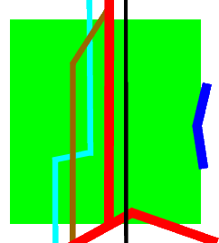

CYNGOR CYMUNED

GOETRE FAWR

COMMUNITY COUNCIL

GRAZING RIGHTS
Level pasture land, approximately 1.08 acres (0.436 ha) in size.
Located near Ty Cooke Farm in Mamhilad, the field is enclosed by hedges, and is bordered by countryside lanes on two sides and agricultural land on the remainder. There is good access via a field gate from the lane. There is a water supply (water rates to be covered by the lessee), with a drinking trough, but no shelter.
The rights to graze on the land are being offered on a lease for 12 months (364 days) at £50 per month, payable quarterly in advance (£150 per quarter).
Please note that any fence repairs which may be necessary to provide a secure environment for any livestock, will be the responsibility of the successful lessee.
The lessee is responsible for keeping all fences and gates in good repair, as well as keeping the land free of noxious weeds and moles. The lessee should also arrange to trim the boundary hedges on an annual basis.
The Clerk will be pleased to arrange for a site visit for any interested parties, if required. Expressions of interest should be submitted to the Clerk by 23.59 on Friday 12th June.
The land is available from 1st July 2026.
For further information please contact:
The Clerk, Goetre Fawr Community Council
theclerk@goytre.gov.uk

