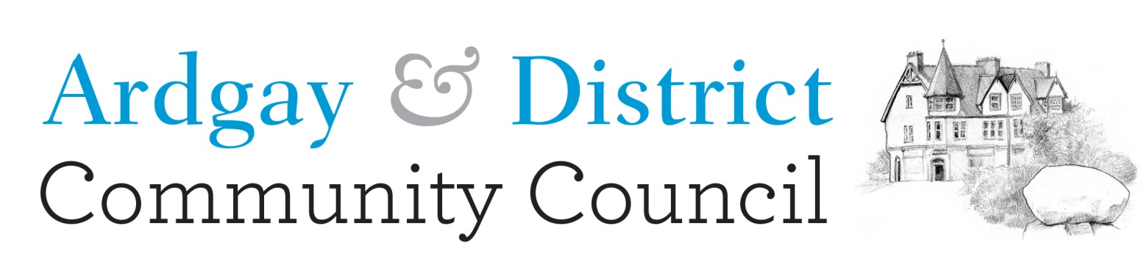

DRAFT Minutes of Ordinary meeting
18th May 2026, Culrain Hall.

Chair’s welcome
Present: Les Waugh, Robert Sawyer, Kerry Hawthorn, Eilidh Forbes, Robert Henderson, Tommy Gordon, Cllr Hugh Robertson.
Apologies: Anne Henderson
Minutes of previous meeting: Approved EF, Seconded LW
Matters Arising: Mistake in the minutes of previous meeting on page 4, first paragraph, now corrected.
Treasurer’s Report: attached
Secretary’s Update: Update regarding approach to the Diocese RE the church bell. The discussion is ongoing.
No response received from Highland Council regarding the dog waste bin, which needs to be removed (since it is no longer maintained by HC). This was noted by Cllr Hugh Robertson, who will bring this up with the Highland Council. The request is to have this replaced with a general waste bin, which the HC would empty routinely.
Local Updates:
KoS Development Trust update: noted the launch of their 5-year Strategic Update, and their appreciation that this event was attended by the Chair & Vice Chair of the A&DCC. No other updates to note.
Culrain Hall: New door funded by North Highland Initiate and Highland Council. Police investigation into the theft of cash box from the hall. Scalextric event on Sat 16th was well attended: 50 in total, with around 30 juniors. Thanks to David Baker & Alan West for providing the track, cars and their time to run the event.
Sat 30th May Plant & Garden Fete, with sausage roll baking competition, games, Bee themed hat competition, raffle, cakes and refreshments. Main fundraising effort of the year – please attend.
Ardgay Hall: New online booking platform is now available on their website. Roof repairs are almost complete and the scaffolding will hopefully be removed soon. Car Boot sale 13th June. Ardgay Stones remain in the back store, which is taking up room. Following advice from a Stone Mason, RS suggested they may deteriorate if they were moved outside, so perhaps they could be moved to the KOS Heritage Society. Valerie to follow up with the KoSHS. Question whether our Resilience plan is up to date and is all aware of the plan. The CC will follow up on this.
Highland Council Update: Cllr Hugh Robertson & Cllr Michael Baird.
MB updated that officers from HC would like members of CCs to come together regarding the roads at a meeting their Drummuie office, Golspie. Date to be confirmed. New tarring on A837. The blue bins not being uplifted in Ardgay last week was due to a breakdown in equipment. This was caught up the following week.
Note of speeding on the roads. Police said they will do spot checks.
RS reported he has received a complaint RE the state of the road up Strathcarron. MoP also noted she received a puncture on the Gledfield road, which she reported but HC refused her claim [, due to the road being graded within the last year.]. Cllr Hugh Robertson will bring this up with the HC.
Suggestion to request an FOI to confirm whether all the monies paid by FLS towards road repairs from logging is being fully reinvested in road maintenance. KH to follow up on this.
Planning & Licensing: Nothing relevant on the HC list. Consultation on Short Term Let scheme is open until the 23rd June, which is open to all. The new legislation is currently only applicable to new STLs.
MB updated the Carnaig and Fanellan substations’ public enquiry will take priority, but HC will look at the pylon line application on 12th and 13th Sept.
Windfarms: No applications (for the first time in our current CC history!). MoP Updated that Inveroykle WF application has been delayed due to a query on whether this should include the overhead power line as part of their application for the project. Developer should have replied by 8th May but they may have requested an extension. HC have until October to respond to this application. MoP expressed their opinion that all planning applications & their Environmental Impact Assessments should include all integral parts of the development: the windfarm installation & operations, the grid connection and all transport considerations.

Scheme of Establishment & Insurance Provision:
An initial meeting has ben held with other Sutherland CCs and a further meeting is to follow.
Sutherland CCs are concerned by the short comings in the Scheme of Establishment, ADCC are not the first CC to have issues as a result.
There is also much concern regarding the personal liability of individual volunteers and the lack of support for CCs to obtain adequate insurance provision.
Concern is being expressed regarding the need for action from Highland Council on this topic from other CCs across the Highland area. There is currently a drive for a Highland Wide response.
Meeting with MP Jamie Stone and MSP David Green. David Green is due to have a meeting with CEO at HC and will discuss issues raised. Both are concerned about the negative impact on grassroots politics and are keen to support where possible.
Correspondence: Chair/Vice Chair met with two members of the community regarding their concerns, inc., the lack of availability of minutes (which A&DCC apologise for) and to ask why no community consultation was taken before using CC funds to pay for the Judicial Review. It was explained that the actions taken were done on guidance from and with approval of the Highland Council. The CC at that time (dissolved). It was also expected that any fees would be covered by a subsequent claim against the CC’s public liability insurance, which was later found to not cover it.
Letter of Thanks received from Kyle Action Christmas Lights for the CC’s ongoing support.
Any Other Business: Letter sent to Highland Council requesting their support towards to the costs of the Judicial Review, on the basis that the CC acted on their advice and within their Scheme of Establishment. No acknowledgement of receipt of the letter has been received as yet.
Next meeting: AGM & next business meeting to be held Mon 22nd June 2026 at Ardgay Hall, 1900.

Closed Session:
CnC application from KoS Gala for £660 towards £1320 cost of running the Gala weekend was approved.
Secretary, Ardgay & District Community Council
Secretary@ardgayanddistrictcommunitycouncil.org.uk

Ardgay & District Community Council Treasurer’s Report
As of 18 May 2026, the balance at the bank was: £36,633.67
This notionally comprises:
• Restricted funds: £35,321.00
• Unrestricted funds:
o CC Admin fund: £982.62
o Windfarm Admin fund: £330.05
Expenditure since last report (20th Apr):
• Zurich Public Liability Insurance £97.20
• Ardgay Hall hire (Apr) £21.00

Income since last report (20th Apr):
• Crowdfunding for Judicial Review (net of costs) £14,733.71
• X2 Donations towards to the Judicial Review costs £120.00
Expenditure not yet in statement:
• Nil
Income not yet in statement:
• Nil
-------------------------------------------------------------------------------------
The balances of the restricted funds are:
• BnO: £44,254.38
• CnC: £43,672.34
• BTWF Community Projects: £1,158.37
• Judicial review fees (£53,764.09) (Not yet allocated)
Key:
BnO = Beinn nan Oighrean Wind Farm
BTWF = Beinn Tharsuinn Wind Farm
CnC = Coire na Cloiche Wind Farm
KoSDT = Kyle of Sutherland Development Trust
A&DCC = Ardgay & District Community Council
CC = Community Council

