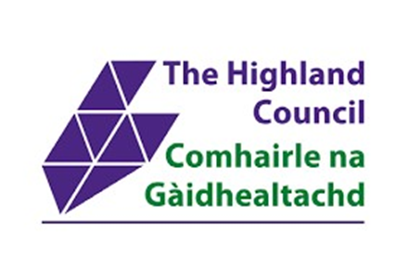

Community Briefing – 03.07.26

Dear Colleagues and Partners,
Welcome to the fortnightly Community Briefing delivered in collaboration with the Highland Community Planning Partnership and Highland Council, containing information about funding, training, support, resources, and news for Highland wide and local communities.
If you have anything you want included in a future Briefing, please e-mail: communitybriefing@highland.gov.uk **please note this is a new, dedicated e-mail address**
To join the mailing list, complete this short form: https://forms.office.com/e/rSS3hXbGTa or scan the QR Code:
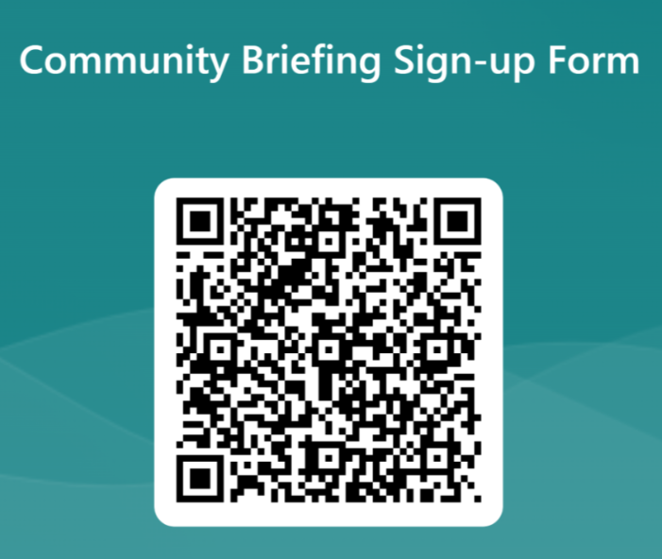

FUNDING | NEWS
- Funding is available to help community organisations turn their ideas into action and make a real difference locally. The Highland Local Action Group encourages community organisations to apply to small grants pot - Highland Council  Priority 1: Community Asset Improvements. This supports projects that make community-run assets stronger, warmer and more sustainable. Priority 2: Tackling Inequality for Children, Young People and Families. This supports short-term, community-led projects that reduce barriers caused by poverty and isolation. Applications up to £10,000. E-mail for further info: clldsmallgrants@highland.gov.uk  - Childcare Support Fund: how to apply: this grant funds short-term, flexible childcare through registered childcare providers, to support low-income families living in, or at risk of, poverty at key times when childcare costs create financial pressure or are a barrier to employment, training or learning.  Deadline for applications is July 9th, full eligibility criteria and a link to apply can be found here.  - Placemaking Support for Island Communities:  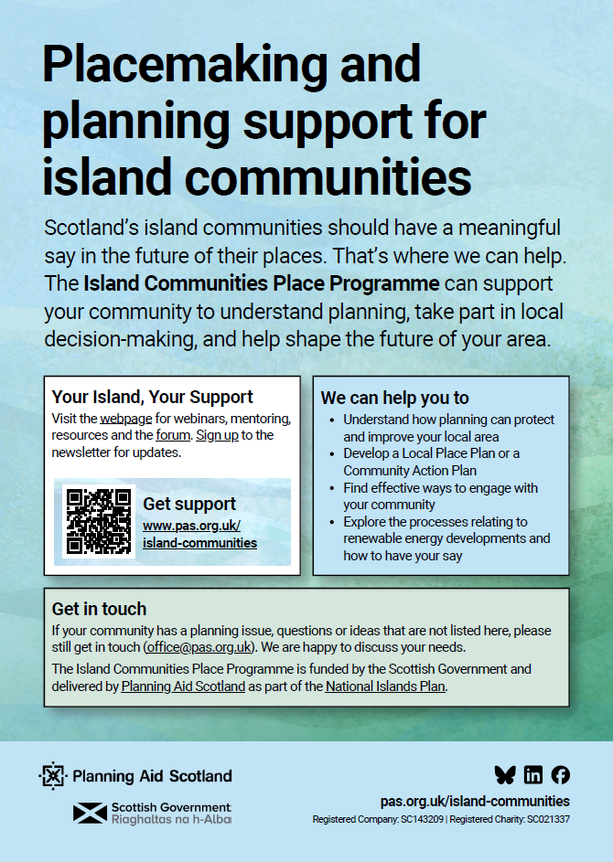  - Highland Coastal Communities Funding (HCCF) allocation across the local area committees. HCCF funding is allocated to Highland Council from the Scottish Government. This year the Council received an allocation of £3,886,450.43. The Highland Council administers HCCF funding as part of the Community Regeneration Fund (CRF), bringing together multiple funding programmes and delivering them via a streamlined process together under one clear, practical approach. Community groups encouraged to submit project proposals for a share of £3m in Community Regeneration Funding - Highland Council For the 2026/27 funding allocation, the CRF team will not be issuing an open call for new projects. Instead, BeConnected will be used as the primary starting point for identifying potential projects. The CRF team are piloting BeConnected, an online interactive map that allows community groups to upload their projects, allowing decision makers to see the grassroots activity happening across Highland. Visit BeConnected here: BeConnected Highland  - Funding Support from Highlands and Islands Enterprise: Please click here for a range of funding support available via HIE. For more information, click here.  - Funding Scotland - Find funding for your charity, community group or social enterprise using our free online search engine. From small grants to funding for big capital projects, we can help you track down the funding you need to make a difference in your community. Click here: Funding Scotland  - Corra Foundation – Corra is a Scottish grant-making charity that works to strengthen and amplify people’s voices and their power to make change. Click here for further info: Home - Corra Foundation  - Highland Third Sector Interface is pleased to announce the launch of Communities Mental Health & Wellbeing Fund for Adults (Micro Grants) in July 2026 for delivering projects between 2026 and 2027.  The Communities Mental Health and Wellbeing Fund (CMHWF) for Adults was established in October 2021 and to date, it has distributed around £66 million to community initiatives supporting mental health and wellbeing across Scotland.  Funding for a fifth and sixth year was announced in March 2025 and a further £15 million per year made available to third sector organisations. The Fund has a strong focus on prevention and early intervention - it aims to support grassroots community groups in tackling mental health inequalities and addressing priority issues of social isolation and loneliness; suicide prevention; and tackling poverty and inequality.  Due to the Fairer Funding pilot, a significant portion of the fund is ringfenced for multi-year projects currently being delivered in Highland. However, we have £100,000 available to distribute in Micro Grants of up to £10,000 for activity up to 12 months.  Applications open 7 July 2026, and funded projects should begin as soon as grants are awarded (by 31 March 2027 at the latest).  To find out more, please register to attend the CMHWF Information Briefing Session 7 July 11am – 12pm - Click here to register  - The National Lottery is investing an extra £2.2 million to help communities across Scotland deliver Glasgow 2026 Commonwealth Games-inspired activities. Through Awards for All Scotland, groups can apply for up to £10,000 to boost participation in arts and sport, strengthen communities, support wellbeing, celebrate diversity, and create a lasting local legacy. To find out more, click here.  - National Lottery Awards for All Scotland: The National Lottery funds projects that bring people together and help communities across Scotland thrive. Social connections and community activities are at the heart of healthier, happier lives, that’s why they support community-led projects. For more information, including application guidance, please click here.  - The National Lottery Community Fund (Scotland) - Strengthening Organisations: This funding is for organisations in Scotland, that we currently fund. We want to support organisations to try out new ideas and ways of working. Or to develop their organisation and improve their current work. Deadline: Ongoing  - Service Pupil Support programme: The Service Pupil Support programme sits with MOD’s dedicated Armed Forces Families Fund. The MOD has partnered with the Armed Forces Covenant Fund Trust to administer the AF3 Fund. Under this programme, the Trust will award grants for projects which support service children along their educational pathway. Closing date: 30 September 2026  - Warmer Homes Scotland:  Need help to make your home warmer?  If you need help to reduce your heating bills and make your home cosier, you could receive support worth £10,000 or more from the Scottish Government. You could be eligible for energy-saving home improvements like heating and insulation to help make your home warmer, cosier and cheaper to heat.  - CARES funding is now open for applications for the 2026/27 funding year. CARES supports a wide range of community energy projects - from community ownership of renewable technologies to installing renewable systems in community buildings, as well as community benefits and shared ownership opportunities. Applications are now open, and we encourage you to apply as soon as possible. We will process, assess and queue applications. However, due to the Scottish Election in May, we cannot issue grant offers or confirm overall scheme funding until a new Government is in place and approves new awards. Read on to find out more about these funds and if they could support your community energy project.  - Robertson Trust Offer for Small Grant Holders: The Supporting Resilience Fund offers £2,000–£10,000 to Small Grant Holders to invest in work that strengthens their organisation from the inside.  This funding is for organisational and staff resilience rather than programme delivery. It is intended to support internal development, creating space to address pressures that are often difficult to fund but are essential for long-term sustainability.  What could the fund support?  The fund can support a wide range of activity aimed at strengthening your organisation’s foundations, including:  *Leadership, governance and strategic planning  *Financial planning, systems and infrastructure  *Organisational development and sustainability planning  *Staff and volunteer wellbeing, particularly in high-pressure or trauma-informed environments.  For more information, including how to apply for the fund, click here.  - HTSI produce a monthly Funding Bulletin for their members, which details current funding opportunities in Highland. They can provide workshops for staff or volunteers in Highland’s third sector, to address some of the challenges they’re aware of when it comes to applying for funds. They also distribute funds to third sector organisations on behalf of agencies in the public sector, find out more information here: HTSI Funding.  - S4GI Community Benefit Fund: S4GI partner Cellnex UK has grants of up to £2,000 available to support initiatives focused on digital projects, community wellbeing, learning & development and more. The fund will prioritise projects located near any of the 55 S4GI mobile masts.  Communities and organisations interested in applying can find further information about eligibility criteria and a link to the application process on Cellnex’s website. | - The Highland Council is piloting BeConnected, a new digital platform to support community organisations and groups in accessing funding, in-kind support, and opportunities to collaborate across the region. Click here to view the BeConnected website: BeConnected Highland  - The Highland Council has just launched its new on-line engagement portal available at Citizen engagement platform | The Highland Council. This will supplement but not replace other methods of engagement and allows a much more interactive experience with the facility for creation of ideas, using mapping to drop ‘pins’, voting etc. One of the most helpful features is that registered users can select the geographic and/or sectoral areas they are interested in and will then receive notifications when there is new activity under these themes or when there are updates. There is no requirement to register on the site, but more functions are available to those who choose to do so.  - Lochardil and Drummond Community Council have published a greenspace and paths which has been made available for download:  Lochardil And Drummond Community Council: Lochardil and Drummond Community Council releases new local paths map  - Feedback sought on proposal to dispose of Fort Augustus Police Station - Police Scotland is asking members of the public to give their views on a proposal to dispose of Fort Augustus Police Station and co-locate with a partner in the village. As part of Police Scotland’s estates transformation, local estate reviews have been carried out across the country to ensure efficient use of the estate. This has included identifying underutilised buildings and reinvesting in facilities which best meet operational need. The proposal at Fort Augustus is to dispose of the large police station on Fort William Road and share space with another public sector / emergency services partner instead.  The consultation on the proposed disposal of Fort Augustus Police Station will close on Monday, 13 July 2026. The consultation has been published here Estate Transformation: Local Area Consultations - Police Scotland - Citizen Space  - Planet Youth June Newsletter: As ever, a fantastic newsletter, packed with a wide range of information on activity occurring across Highland. The June edition includes updates on Planet Youth Community Action Groups; Highland Data infographics; LGBTQ+ Health Inequalities; Training and resources. To read the newsletter in full, click here.  - Social Security Scotland June Newsletter: News on financial support for families over the summer, financial aid for bereaved parents and support for local communities. To read the newsletter in full, click here.  - Have Your Say on Food in Your Community:  Please scan the QR-code below to complete an ongoing survey about food in your area. The survey will close soon so please have your say now.    - People’s Emergency Briefing screening - implications for business in Nairn. Invitation to attend a local screening of the People’s Emergency Briefing film on the risks to our country from ongoing damage to nature and to our climate. The film features footage from last November’s National Emergency Briefing, which brought together leading UK experts in climate science, food security, health, economics, national security and nature.    - Directories: The Highland Community Planning Partnership website now has a page dedicated to Directories, here you will find links to ALISS, Highland Directory of Services and Highland Mental Wellbeing. Click here to find out more.  - NHS Highland Director of Public Health report for 2025 launched. "From the rugged landscapes of Argyll and Bute to the growing urban centre of Inverness, Highland has a rich and diverse landscape, people and culture. Every child born in our region deserves more than just a healthy start; they deserve a foundation that allows them to thrive for a lifetime. Childhood experiences set us on the path beyond our early years. Those experiences shape children’s brain development, emotional resilience and long-term physical health. They also impact numerous factors in our lifetime across areas such as school performance; employment and economic stability; living conditions; and our emotional and social connectedness." Download a copy of the report here: Director of Public Health annual report | NHS Highland  - Highland Equalities & LGBTQ+ Young People’s Networks: Are you a young person living in the Highlands? If so, you might be interested in shaping the new Highland Equalities and LGBTQ+ Networks. This is an opportunity to share your ‘voice’, work alongside other young people and adults, and help influence positive change for everyone across Highland. There is no deadline to register your interest, however Derek Sawyer will begin meeting with interested young people following the summer break, around August/September. If you’d like to get involved or find out more, please contact: Derek Sawyer, Strategic Lead for Equalities, at derek.sawyer@highland.gov.uk  - Highland Senior Citizens Network: A website with recent news including the health benefits of social connection, local activities including creative sessions, games, rewilding, veterans’ advocacy, youth mentoring, intergenerational events, and community lunch clubs. Updates on carers’ research, dementia support, fire safety visits, vitamin D guidance, flu vaccination, energy‑saving tips and more.  - Highland Repair Directory: The Highlands and Islands Climate Hub are pleased to welcome the Highland Repair Directory to their list of projects supporting communities in Highland. The Repair Directory is an online resource which makes it easier for people to share or repair items, instead of sending them to landfill and replacing with new. For more information, click here.  - Free Period Products are available in Highland to everyone who needs them. They can be accessed at community locations, through a home delivery service and are also available to pupils in schools. For more information and how to access products, click here.
TRAINING/EVENTS | EMPLOYABILITY/VOLUNTEERING
- Ewen's Room Trail Therapy - is an innovative intervention programme that seeks to use mountain biking in combination with more traditional therapy techniques to support those with a diagnosed and undiagnosed mental health difficulties.  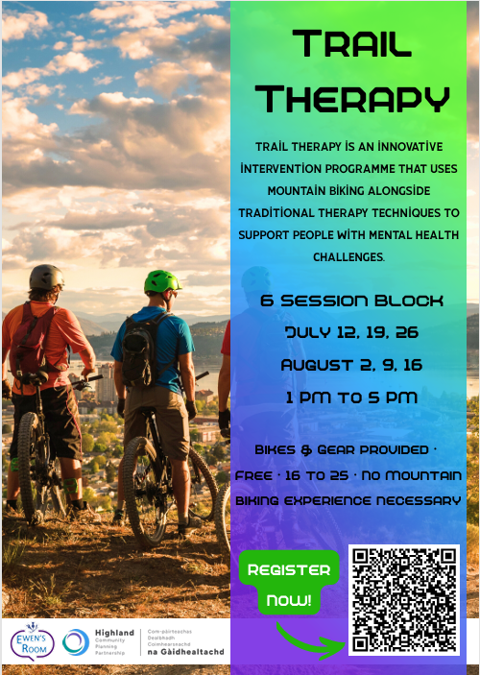  Currently taking sign-ups for our summer block in Fort William which will be specifically for children and young people aged 13 to 20. Sign-ups are only open for another 2 weeks - so it's worth registering interest now! All sign-ups are treated with the strictest confidence, and we only have 6 slots available for this block.  Sessions will take place on July 12th, 19th, 26th & August 2nd, 9th and 16th from 1 PM to 5 PM, at locations in and around Fort William. We provide bikes and helmets (if needed) though personal bikes can be brought along as long as they are safe and suitable.  Expressions of interest/ referrals can be made via: Fort William Trail Therapy Referral Form – Fill in form  - School’s Out: School’s Out is High Life Highland’s holiday activity programme, running every Easter, summer and October half-term across the Highlands. With over 1,000 activities to choose from, there’s something for every age, from babies and toddlers right through to teens.  Activities take place at leisure centres, schools, libraries and community venues right across the Highlands. Both free and paid options are available, so families can enjoy the programme whatever their budget.  To see the full list of activities, click here.  - Gairloch Breakfast Morning:  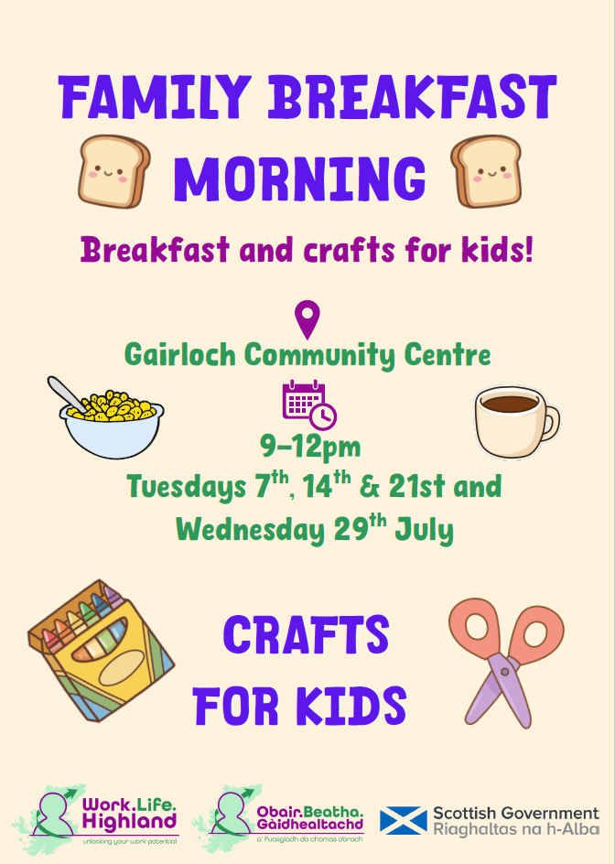  - Free Child Protection Training:  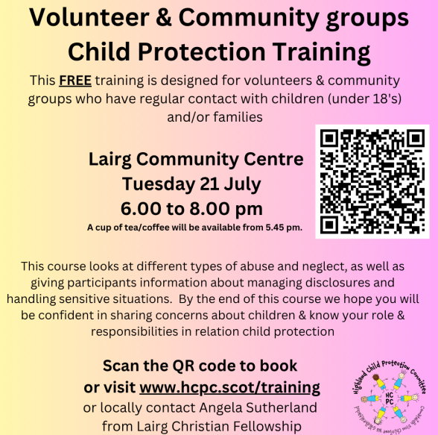  - What’s on South Highlands – July 2026: As usual, a jam-packed programme of activities on offer throughout the month of July – ranging from a Carers Support Group, Reminiscence Grop, Seagull Cruise and much more. Please see attached document for a full list of activities.  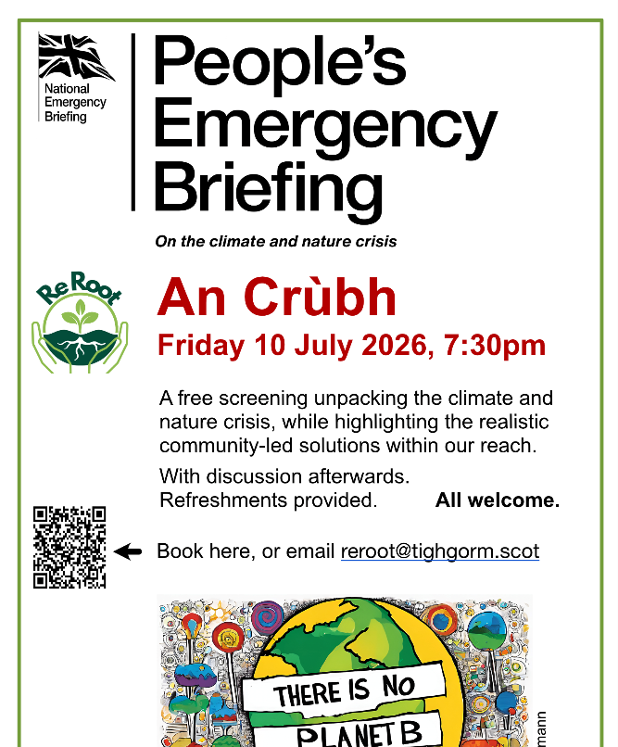  - Summer of Sport Step Count Challenge:  In a summer packed with sport, we are introducing this 4-week team walking challenge. It runs from Monday 6 July until Sunday 2 August and welcomes teams of up to 5 people. And thanks to Summer of Sport funding, we’re able to offer it for free!  You don’t have to be sporty to take part. The challenge is about small, realistic changes that add up to healthier habits. It’s open to everyone aged 16+. You can join at any point and log steps for a few days, a fortnight or the full 4 weeks – the choice is yours! How to take part:  Find out more on our website  Sign up or log in to register your team of up to 5 for free today  For anyone who doesn’t have access to a device to track or upload steps, please get in touch with scc@walkingscotland.org.uk for support.  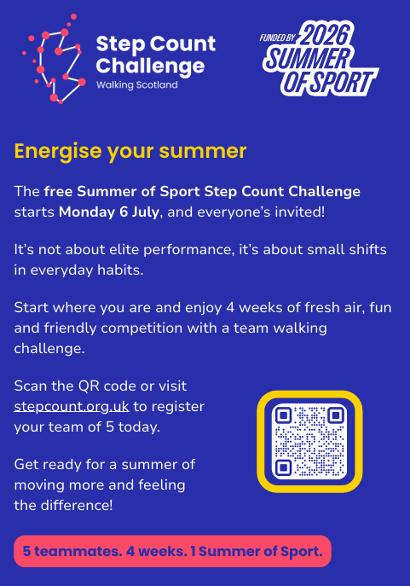  - Walk A Mile In Our Shoes - Saturday 4th July at 11am in Inverness - Join in with groups from the Scottish Mental Health Arts Festival Highland for the annual Walk a Mile in Inverness to raise awareness of mental health issues and challenge stigma. "Reflections" is this year's theme for the 20th anniversary of the festival - so why not use the walk to reflect on what mental health means to you. Everyone welcome.  The route starts at the Fisherman's Hut (corner of Bught Park and Ballifeary House care home) and goes along the river and Ness Walk, crossing the Ness Bridge, up Bridge Street and the High Street to Falcon Square. We are aiming to start the walk at 11am and be led by a local piper, so please try to arrive a few minutes early.  No need to book. Just turn up! Feel free to bring any placards or banners with positive messages about mental health awareness. If you have any queries, please contact the SMHAF HIghland team on smhafhighland@gmail.com  - Festival website: Home - Scottish Mental Health Arts Festival Highland  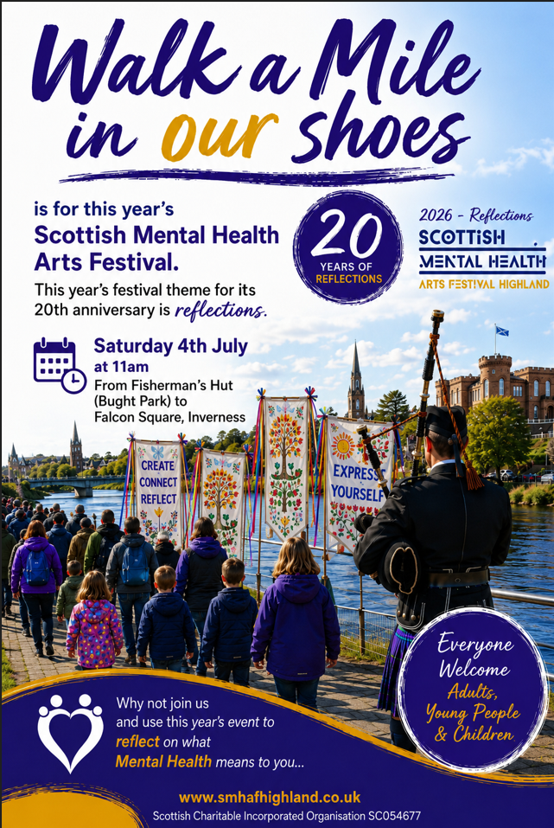  - Community Pop Up Hubs:  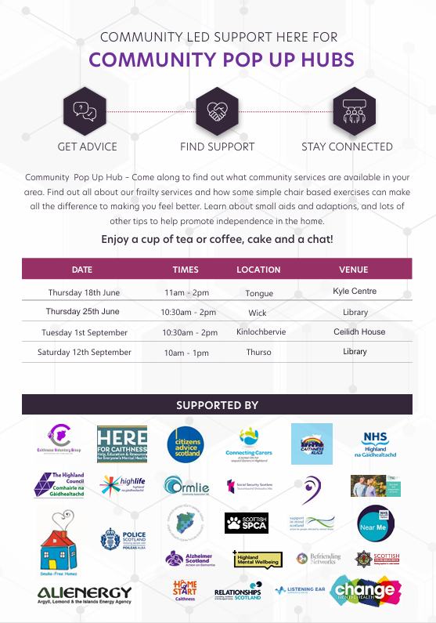  - Alcohol Brief Interventions: This course is for anyone who might benefit from being able to discuss alcohol with service users, to help them make an informed choice about their alcohol use. Before attending, please complete the Drugs and alcohol : alcohol brief intervention eLearning module. The aim is to support the embedding and ongoing delivery of Alcohol Brief Interventions (ABIs). Places for the online training are available on 26th of August - Drugs and alcohol : alcohol brief interventions (ABI) | Turas | Learn |   - Scottish Youth Parliament Elections 2026 in HIGHLAND - Do you know of a young person interested in becoming a Member of the Scottish Youth Parliament (MSYP) for Highland? Are you a young person interested in becoming a MSYP?  The Scottish Youth Parliament (SYP) represents Scotland’s young people. SYP has democratically elected members, aged 14-25 who listen to and recognise the issues that are most important to young people, ensuring that their voices are heard by decision makers. SYP encourage all of Scotland’s young people to play their part in achieving their vision and provide a national platform for their participation in democracy.  In Highland, there is the opportunity for 6 young people who are 14-25 years old to stand as MSYPs: 2 in Inverness and Nairn; 2 in Skye, Lochaber and Badenoch; 2 in Caithness, Sutherland and Ross  Find out more information here: Highlands - SYP 2026 Elections  - Highland Thrive CIC - Advice and advocacy - Community development and regeneration - consultancy and support - Education and training - Employability and employment - Information  Highland Thrive is a community focused social enterprise working across the Highlands of Scotland to design and deliver practical, locally responsive solutions that strengthen people, organisations and communities.  Phone number: 07376488197  Email address: info@highlandthrive.org  Website: Highland Thrive CIC – Unlocking potential across the Highlands  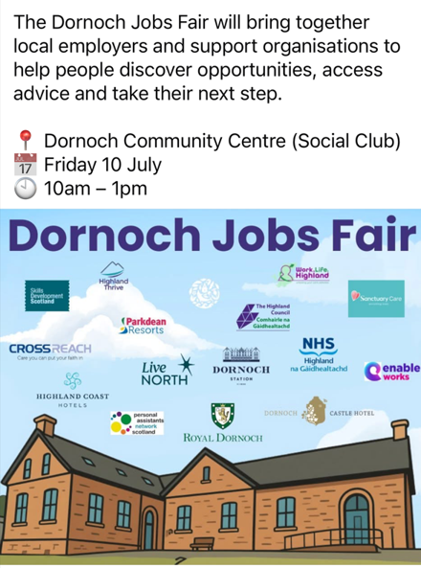  - Connecting Carers: A Highland based Chairty that provides support to unpaid carers (Carers) – people who look after a loved one, friend, or neighbour due to illness, disability, mental health conditions, or age-related needs. Please see attached flyer and poster for further information.  - KoSDT Community Support Officer:  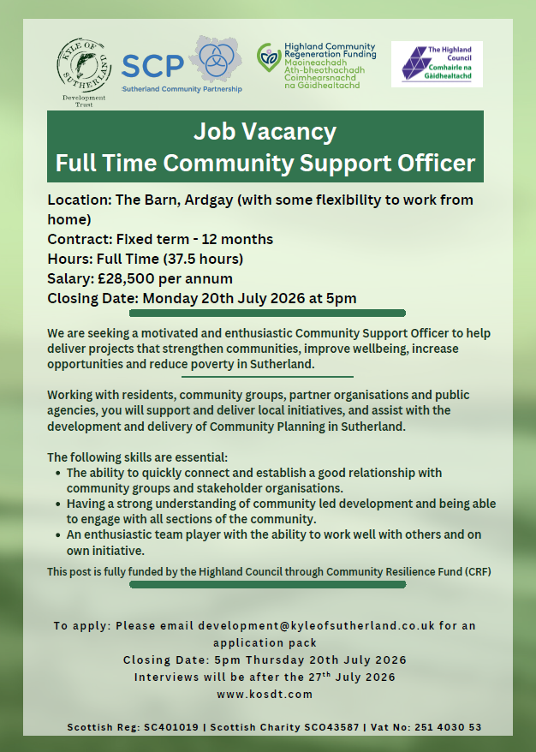  - Childminding Academy: Work.Life.Highland has partnered with SCMA to run childminding training for a Third year. SCMA has funding from Scottish Government for 15 places in Highland which we successfully filled last year. They have continued to partner with SCMA to allow their clients who wish to pursue a career in Childminding through the Childminding Academy.  SCMA provide:  One-year public liability insurance  Info sessions to support with CI applications and regular drop-in sessions to answer candidates’ specific questions,  Funding for startup business cost of £750. (after being officially registered),  Online childminding business courses,  Tailored group, and individual support from SCMA, promotion of business via SCMA find a childminder search engine,  Food health, and Hygiene certificate.  How can Work Life Highland Support?  Dedicated Key worker to help with accessing funding and providing mentoring support  Funding assistance for the following;  PVG membership  Disclosure Scotland  Care Inspectorate registration fee  GP Health declaration fee, ICO – GDPR Insurance  Paediatric First Aid  Launch Pad funding while being supported by our childminding key worker.  For more information, please contact mairi.annan@highland.gov.uk  - Highland Adult Learning Development Group have published their first bulletin. Use this link to access the bulletin: HALDG Newsletter or scan the QR code:    - Volunteer Academy: The Highland Volunteering Academy is dedicated to sparking and nurturing a movement of engagement through volunteering, tailored to the challenges and opportunities of the 21st century with our evolving and diverse communities. Find out what volunteering opportunities are available here.  - MyJobScotland: for public and third sector vacancies.  - totaljobs: for private sector vacancies.  - HTSI Fellowship Programme: Designed to advance volunteer practices through targeted learning and collaboration, through grants to undertake study and learning visits. HTSI now f/our live Fellowships open for application. Full details and application instructions can be found on the Volunteer Academy website.
MENTAL HEALTH & WELLBEING | COMMUNITY SAFETY & RESILIENCE
- Highland Mental Wellbeing – this website is a list of services, information and training around the subject of mental health and wellbeing. It also provides information about training and resources for community/service volunteers or paid staff, in a ‘helping’ or supporting role.    - What’s Growing At Flip of the Coin – July 2026: Please find attached a fantastic update on all of the activity happening at Flip of the Coin, based in Alness.  - Prevent Suicide Highland App - This easy-to-use app helps should you ever find yourself in distress, feeling hopeless or suicidal in the future. The app is available on Google Play for Android devices and the Apple App Store for iPhone and iPad.    - Think Health Think Nature - Taking time to enjoy local outdoor green space could bring you huge health benefits – getting outdoors is good for your physical, mental, and social well-being. Regardless of age and ability, there really is something for everyone.  - Being with Babies Outdoors Toolkit: Babies Outdoors launched their free toolkit in March 2026 via an online webinar which is now available to view on YouTube. Partnering with the Open University the toolkit will support you to explore the benefits to babies and more. Click HERE for more information.  - Screen time guidance for under 5s: Juggling family life and raising children in a digital world can be challenging. Find out more about how to support healthy screen habits for children under 5 by clicking here.  - Suicide Intervention and Prevention Programme: This course is available to those who work within the Highland area only. Various dates available.  Who this is for: staff who have patient, client, service user, or public contact and who have had no previous suicide awareness training or last training was more than three years ago.  Course delivery: Please note this course is delivered over two separate 2 hour sessions and you are required to attend both to complete the course. The sessions are usually run a week apart so please check the calendar below to make sure you can attend both Week 1 and Week 2 before booking your place.  Bookable course: Turas | My Turas | Home  - Mental health and wellbeing: self-harm awareness - understanding and supporting people who self-harm (various dates available).  Who this course is for: This session is aimed at anyone who works with or provides support to people who self-harm or at risk of self-harm. 3hr online session  Bookable course: Turas | My Turas | Home | - Consultation for Digitisation of Herbert Protocol Forms:  Police Scotland is currently seeking the views of the public in relation to a proposed digitalisation of information that helps trace missing people living with dementia. As part of the Herbert Protocol, families/carers can obtain, print and complete a pro-forma document from the Police Scotland website that is handed to investigating officers whenever someone with dementia goes missing.  The form records a range of useful information which will allow police to respond swiftly during the crucial first hour - rather than spend it gathering information. At present, families and carers are responsible for owning, updating and providing this document to police.  Engagement and feedback following missing person inquiries has highlighted the additional stress and pressure associated with keeping this document safe and easily accessible for whenever it may be required. As such, the National Missing Persons Unit are beginning a period of consultation with professionals, carers and the Dementia community to explore next steps of this process.  We are now asking for the public to engage with our consultation survey and provide all relevant feedback and viewpoints in relation to the potential digitalisation of the Herbert Protocol form.  You can take the survey here.  The closing date is Sunday, 2 August 2026.  - Counter Terrorism Security Advisors are being asked quite regularly about cyber threats and frauds and do cover some of this subject in our ACT Awareness face to face workshops. There is also more of a threat now from cyber-attacks in relation to hostile state threats. Our colleagues in our Cybercrime Unit have just released the attached document which focuses on actions you can take in the event of experiencing an online scam or cyber-attack and partners may find this information useful. Please see the attached document for more information.  - New Ready Scotland Website Launched:  The new Ready Scotland website is now live, with a host of great information ranging from how to create an emergency plan, how to stay safe in storms, as well as a plethora of learning material. You can access the new website in full here.  - Home Energy Scotland: Home Energy Scotland’s advisors are true energy saving heroes. They can help you discover practical solutions to reduce your energy consumption, save money, and create a warmer, more comfortable home this year. Whether it’s through energy efficiency tips, grants, or tailored support, their advisors are dedicated to helping you to take control of your energy costs.  Don’t let rising bills catch you off guard. Reach out to Home Energy Scotland today for expert advice that puts you and your home first. Call Home Energy Scotland’s free helpline at 0808 808 2282 or visit homeenergyscotland.org  - Home fire safety visits: Find out what is a Home Fire Safety Visit, who can get one, and how to arrange a visit. Click here to find out more.  - ALIenergy: Support people who live in the Highlands from all tenures who are struggling with fuel poverty with Energy Advice and support. They can help clients with: Energy bills: how you pay for your energy, how much you pay and how often; Advise on changes to the way you deal with your energy payments that may result in saving you money; Advise on heating controls and the way you use your heating to ensure you are using it efficiently and cost effectively; Fuel vouchers for people who have a PPM and have no funds to top up. In some cases, if eligible, they can apply to funded schemes to help with paying for your energy, replacement of white goods, alleviation of fuel debt. (subject to funds being available). Further information is available on their website: ALIenergy.  - Met Office Weather Warnings: Information from the Met Office on weather related matters.

