**Minutes of the Garve & District Community Council ordinary meeting**

**held on Tuesday 1 May 2018 in Achnasheen Village Hall**

**Community Council members present:** Kenny Maclean (Chairman), Jennifer Haslam (Secretary), Eliza Leslie Melville (Treasurer), Bob Moir and co-opted members Joe Stewart and Moragh Wylie.

**Also present:** Val MacIver (Platform PR) and Martin Macphee (Eneco).

**Apologies:** Community Council member Caroline Gamble, Cllr Dr Ian Cockburn and Fiona Milligan (Infinergy).

**The Chairman opened the meeting** at 7.00pm and welcomed everyone. Community Council members were saddened to learn that Bertha Hogg, a long-time resident of the Strathbran Estate near Achanalt passed away a few weeks ago, our thoughts are with Danny and the family.

**Declarations of Interest** – Eliza Leslie Melville and Moragh Wylie both declared an interest in the planning application. Community Council members confirmed that they had read the draft minutes, the consultation and the planning application due to be discussed tonight before the start of this meeting.

**Approval of minutes** of the last ordinary meeting held on Tuesday 3 April 2018 in Garve Village Hall were proposed by Kenny Maclean and seconded by Joe Stewart. Minutes are available at Garve Post Office, Achnasheen Village notice board, on our website, via email or on request to the Secretary.

**Matters arising – Eneco** – Martin Macphee updated the meeting that the two failing components will be repaired off site in Hull in July. Martin Macphee was thanked for attending and for his update.

**EDF** - Val MacIver updated the meeting that the site is running well, no other news at this time but will email us as and when there is anything to report. Val MacIver was thanked for attending and for her updates.

**Infinergy** - [www.lxxwindfarm.co.uk](http://www.lxxwindfarm.co.uk) – no further news.

**Coriolis Energy** - Trevor Hunter, Project Manager at Coriolis Energy has written to say that they are looking into the possibility of a windfarm at Kirkan on the Strathvaich Estate. They expect to be submitting a request for an EIA Scoping Opinion within the next month or so. They also hope to be hosting some public exhibition days in the local area so they can share details of their current plans with the community. **Dates in mid-June are TBC**. They would like to attend some Community Council meetings to discuss both their windfarm scheme and community benefit proposals. Community Council members felt local exhibitions and a willingness to attend our meetings should be welcomed.

**Highland Council updates** – **The bin and stand** went missing from the Aultguish layby.  On further investigations, our Chairman found both down the embankment. They are now both back in place.

**Gorstan side road** - The source of the flooding will have to be addressed first.

The **ruts in the verges** beside the A832 at Grudie and the potholes in the **Lochluichart Church layby** have been filled in.

**School Road in Achnasheen** - was reported as being full of potholes in October 2017.  It seems The Highland Council reporting system has closed the case as the work has supposedly been done – it hasn’t!  Work on patching the road down to the Railway Station was done in November 2017 and it appears the School Road was meant to have been done at the same time.  The case is now very much open again!

**Streetlights** on Matheson Road/Stirling Drive, Garve. Bob Moir noted that apart from the speed signs outside Garve Village Hall, all other lights are now working. A **dip in the road** in Stirling Drive will be pointed out to Iain Moncrieff the next time he visits the area along **with the drain covers**.

We are grateful for all the work carried out over recent weeks, especially when we note press reports which tell us that there are now **only eleven workmen** fixing council roads between the Black Isle and Achnasheen.

The Highland Council notes that **residents should report issues directly to them** by calling The Highland Council’s Call Centre on 01349 886606, by visiting Ross House, Dingwall or via [www.highland.gov.uk/report](http://www.highland.gov.uk/report) In all cases, you will be given a reference number. The Highland Council also appreciate photos showing the actual problem. All road issues we have reported will be attached to the end of these minutes.

**BEAR update** - Resurfacing work has taken place south of Inchbae and below Lochview, east of Garve.  Resurfacing work at Loch Glascarnoch started today.

Bob Moir noted the work to install the **new streetlights** on Station Road, Garve by BEAR has been very untidy, especially the way the verges have been left. It was felt by Community Council members that the verges and pavements should be fully reinstated as soon as possible. Also, why replace the lampposts? Photos will be sent to BEAR for comment.

A member of the community has asked when will the **flowers beside the A835 trunk road** east of Garve be removed as the site is looking untidy. Robbie Bain, Ward Manager advised us on Tuesday 24 April 2018 that … *“Providing a resolution to this is more complicated than I had realised. There is a protocol in place which requires Police Family Liaison Officers to get in touch with the family of the deceased before any action is taken to remove flowers etc, laid as a memorial.  I notice that due to the lack of a verge at this spot, the flowers have actually been laid through the fence, so are technically on the railway.  You will appreciate that the rules governing work on the railway are considerably more complex than the equivalent on the road network”*. Following discussions with the family, The Highland Council, BEAR and Network Rail, the flowers were removed yesterday. We thank Robbie for his help and advice on this matter. The family also wish to pass on their thanks for the tributes left. The member of the community who raised the issue has been kept informed.

A cyclist was injured on Friday 13 April 2018 **after falling at the level crossing in Garve**. Police and ambulance personnel are understood to have attended the scene. The patient was taken to Raigmore Hospital where their condition was understood not to be serious. Due to the emergency services presence, there was some disruption to train services. Once again, we remind all cyclists that there is signage advising you to dismount as does The Highway Code (rule 82 & 306).

**The picnic bench** that needed moving in Achnasheen has now been moved by John Grant, our thanks to him.

**Dog Fouling** - It is an offence not to clean up immediately after your dog in any open space where the public have access. It can lead to a Fixed Penalty Notice of £80 which increases if it is not paid. If you have information regarding irresponsible dog owners, please let The Highland Council know. In particular, they would need times, locations, and a description of the owner and type of dog. Photos also help. Report any issues straight away via [www.highland.gov.uk/info/1330/street_care_and_cleaning/473/dog_fouling](http://www.highland.gov.uk/info/1330/street_care_and_cleaning/473/dog_fouling) or by calling 01349 886606. Anonymous reports are not acted on. On Thursday 5 April 2018, the dog warden and our Chairman walked around Garve and Achnasheen.  One dog was found loose in Garve with no sign of the owner.  After some door to door enquires, the owners were spoken to by the dog warden.  Other dog walkers were out walking their dogs, some without leads but their dogs were under control so that was fine with the dog warden.  No sign of any dog fouling anywhere.  Signs warning people of the £80 fine have been put up in Garve and Achnasheen. The dog warden also spotted some other issues that she will report to the relevant Highland Council departments such as blocked drains and damaged fences.

**Police report** – It has been noted that cars are being parked on pavements in Garve. This is deemed an obstruction and has been reported accordingly.

Press reports inform us that road policing officers in the Highlands have once again highlighted the dangers of speeding, not wearing a seatbelt or using a mobile phone while driving. It follows a number of offences detected during the month of April - which included a dedicated operation across Scotland. During the month of April in the Highlands and Islands, 33 drivers were detected in relation to seatbelt offences, while 34 were detected using a mobile phone while driving.

Police Scotland is to undertake a campaign specifically focusing on Doorstep Crime within local communities.  The initiative will commence on Monday 21 May 2018 until Monday 28 May 2018.  Areas of prevention, intelligence, engagement, enforcement and reassurance will be covered during this period.  This campaign is being carried out in partnership with key organisations in the public, private and Third Sectors. More details will be made available on [www.scotland.police.uk](http://www.scotland.police.uk) Community Council members noted there has been a number of bogus calls recently regarding computers, double glazing and Inland Revenue ... be aware!These represent a rise from 23 and 27 respectively in the same period in 2017.

A total of 493 drivers were detected in connection with speeding offences in April - a rise from 412 in the same period last year.

These offences coincided with a national road safety campaign run by Police Scotland between April 16-22 aimed at raising awareness of the dangers of excess speed, seatbelt offences and using a mobile phone.

These represent a rise from 23 and 27 respectively in the same period in 2017.

A total of 493 drivers were detected in connection with speeding offences in April - a rise from 412 in the same period last year.

These offences coincided with a national road safety campaign run by Police Scotland between April 16-22 aimed at raising awareness of the dangers of excess speed, seatbelt offences and using a mobile phone.

**Treasurers report** – The bank balance on Wednesday 11 April 2018 was £1,352.12. Expenses in the last month have been £10 for April meeting Hall hire. Awaiting bill from our auditor. The administration grant for 2018/2019 will be £445.20 minus £86 insurance and minus £35 data protection.

The Secretary has spent a total of £203.91 on items for hampers which were available at the Garve Hotel. A total of £616.50 has been raised by the raffling of these hampers but the Secretary’s expenses are yet to be deducted. Further donations for the hampers have been received from Carol Grant (goods), our Chairman (sweets), Bob Moir (£20) and Bertha Logie (£2). Donations of hamper baskets from Jean Bailey and Jeanette Dickinson were also very welcome. Thanks to the Garve Hotel, especially the £85 worth of goods for the hampers they supplied which they do not want refunded. There are still some items to be raffled and anyone who wishes to donate to our hampers can do so at the Garve Hotel reception, hamper baskets would be particularly welcome. A round of applause for our Secretary and the Garve Hotel for all their help and support to the Community Council.

LCT ceilidh application – LCT Directors meeting today so a decision expected shortly. Donations for the raffle and tombola to the Secretary please.

**Correspondences** – All correspondences are sent to members via email. Correspondences received by Email - ePlanning – new planning applications at 6 April 2018; Dena Ross & Robbie Bain – Flowers at roadside; ePlanning – new planning applications at 13 April 2018; Carol Smith, Secretary, LCT – application review change of meeting date; James Mackessack-Leitch, Scottish Land Commission - Call for Evidence; Trevor Hunter, Project Manager, Coriolis Energy – update; ePlanning – new planning applications at 20 April 2018; ePlanning – new planning applications at 27 April 2018; Laura Fisher, Interventions Coordinator, Police Scotland (Highland and Islands Division) – Bogus Tradesmen (sent via HC Policy).

Correspondences received by post – Ken Bowlt, BOWLTS – invite to the West Ross Deer Management Group AGM (our Chairman is unable to attend).

We have also received draft minutes from Torridon & Kinlochewe, Plockton, Lochcarron, Lochalsh, Shieldaig and Gairloch Community Councils. Community Council members find the draft minutes from other Community Councils of interest and use. It appears we all seem to have similar problems from time to time.

**AOB from Community Council members** – Our Chairman noted the roadside litter picking campaign (12-20 May) - [www.keepscotlandbeautiful.org/roadside-litter-campaign](http://www.keepscotlandbeautiful.org/roadside-litter-campaign) It was noted that our Community Council members are already doing their bit, especially in laybys!

Moragh Wylie noted that some public toilets are earmarked for closure. We are not aware of plans to close any in our area but discussions are ongoing elsewhere. The mess around some “closed” buildings was noted. Parking at public toilets also appears to be an issue at times. It was suggested that The Highland Council should publicise the “Highland Comfort Scheme” more so businesses know that funding is available from The Highland Council for businesses to open their toilets to the public. <https://highland.gov.uk/directory/60/highland_comfort_scheme> The Highland Council don’t have to provide public toilets, it’s a non-statutory requirement, perhaps it should be, especially with NC500?

**AOB from members of the public** – no issues raised.

**Screening reports, scoping reports and consultations** – we have received one consultation from the Scottish Land Commission regarding their call for evidence. The Commission has launched an open call for evidence of people’s experiences of concentration of land ownership. They want to understand how living or working in a community where the majority of land is owned by a very small number of individuals or organisations affects people’s lives. The call for evidence ends on Saturday 30 June 2018. To find out more and complete the survey online - [www.landcommission.gov.scot/call-for-evidence](http://www.landcommission.gov.scot/call-for-evidence) To speak to someone in confidence call - 0300 244 4452 or write to - Scottish Land Commission, Longman House, 28 Longman Road, Inverness, IV1 1SF or email - [info@landcommission.gov.scot](mailto:info@landcommission.gov.scot)

All Highland Council consultations are available at <http://consult.highland.gov.uk/portal> All Scottish Government consultations are available at <https://consult.gov.scot/consultation_finder>

**Building warrants, planning issues and licensing issues** - There is one new building warrant currently being shown on The Highland Council website for our area. 18/00597/NDOM6 is the demolition of extension, reinstate area post demolition with as-built material cover, make good wall connecting extension, former Achnasheen Primary School. We note security fencing to keep people away from the building has been put up in recent days.

One previous planning applications have been determined by The Highland Council since our last ordinary meeting. 18/00274/FUL is the installation of 25m telecoms mast at land 790metres north west of Grudie Cottage, Grudie. Permission has now been granted for this mast with no conditions.

One new planning application has been received by The Highland Council since our last ordinary meeting. 18/01529/FUL is the proposed erection of two detached houses, land 80metres north east of Druimeorna, Lochluichart. Eliza Leslie Melville and Moragh Wylie both declared an interest in this application and left the room at 8.25pm. Remaining Community Council members fully supported the application, especially the excellent house design. Moragh Wylie then returned to the meeting at 8.27pm.

**Dates of future meetings**

Tuesday 5 June 2018, AGM followed by an ordinary meeting, 7.00pm, Garve Village Hall. Old minute books will be available to view.

Further meetings TBC at the AGM.

Members of the public are very welcome to attend Community Council meetings and take part in the discussions under the guidance of the Chairman. A copy of the Constitution that every Community Council in the Highlands has to work to is available on the Highland Council website - [www.highland.gov.uk/downloads/file/4456/scheme_of_establishment_for_community_councils](http://www.highland.gov.uk/downloads/file/4456/scheme_of_establishment_for_community_councils)

The Chairman thanked everyone for coming and closed the meeting at 8.30pm.

Signed ……………………………..

Signed ……………………………..

Date ……………………………….

**Outstanding road repairs in our Community Council area …**

*School Road in Achnasheen is full of potholes (FS60324080 reported October 2017 and FS72132337 re-reported 5 April 2018 with two pictures attached).*

*Faulty streetlight in Achnasheen (FS73972741 reported 26 April 2018).*

*Flooding in Achnasheen Village centre – the centre of the village always appears to have water laying around on the grass, in car parks etc. Extra drainage may be required. (FS72141980 reported 5 April 2018).*

*Damage to crash barrier next to boathouse on Loch Chullin (FS69994399 reported 10 March 2018 and FS73366383 re-reported on 19 April 2018 with a picture attached).*

*Damage to crash barrier opposite Grudie Cottage (FS69994339 reported 10 March 2018 and FS73367819 re-reported on 19 April 2018 with a picture attached).*

*Damage to crash barrier to the west of Lochluichart Church (FS69992497 reported 10 March 2018 and FS73369865 re-reported on 19 April 2018 with a picture attached).*

*Side road at Gorstan is full of potholes (FS11911374 reported 17 January 2017, FS60318870 reported October 2017, FS68966075 reported 26 February 2018 noting the water flow across the road) – this and the “big hole” in the layby near Gorstan Junction still await repairs.*

*Speed limit sign light out at Junction of Stirling Drive and Station Road, Garve (Reported November 2017 - FS62027724).*

*We have received reports of damaged drain covers in Stirling Drive, Garve. This has been reported (FS66213050 reported 19 January 2018 and a picture attached).*

*Pothole in Matheson Road (FS68964132 reported 26 February 2018).*

*The road surface is breaking up at the start of The Avenue (FS68964983 reported 26 February 2018).*

*The lack of runoff’s and drains was noted between Strathgarve and Wades Bridge.*

A steam train visited our area on Sunday 22 April 2018. Here the engine takes on water at Achnasheen on its return journey from Kyle of Lochalsh to Inverness.

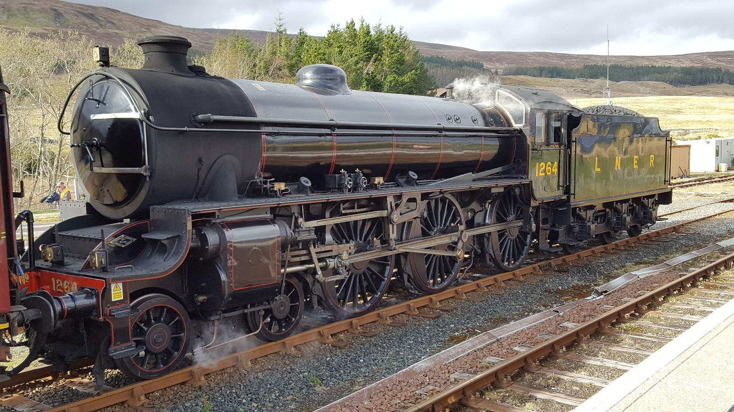

[www.community-council.org.uk/garveanddistrict](http://www.community-council.org.uk/garveanddistrict)

[garveanddistrictcc@yahoo.com](mailto:garveanddistrictcc@yahoo.com)