**Minutes of the Garve & District Community Council ordinary meeting**

**held on Tuesday 4 September 2018 in Achnasheen Village Hall**

**Community Council members present:** Kenny Maclean (Chairman), Jennifer Haslam (Secretary), Eliza Leslie Melville (Treasurer), Bob Moir and Caroline Gamble.

**Also present:** Val MacIver (Platform PR), Sue Tarr (TG&DDC) and one member of the public.

**Apologies:** Co-opted member Joe Stewart, PC Craig Rose and Cllr Dr Ian Cockburn. Apologies were also given on behalf of Grant Folley & Laura Noone (EDF) by Val MacIver.

**The Chairman opened the meeting** at 7.00pm and welcomed everyone. He reminded members of the public that they were very welcome to attend Community Council meetings and take part in the discussions under his guidance. Congratulations to Community Council member Caroline Gamble and her husband George whose grandson Callum was born on Monday 20 August 2018 at 5.44am. The baby weighed 6lb 11oz.

**Declarations of Interest** – none. Community Council members confirmed that they had read all documents due to be discussed tonight before the start of this meeting.

**Approval of minutes** of the last ordinary meeting held on Tuesday 5 June 2018 in Garve Village Hall were proposed by Caroline Gamble and seconded by Eliza Leslie Melville. Minutes are available at Garve Post Office, Achnasheen Village notice board, on our website or via email. A number of updates from these minutes have been noted in the notes of the non-quorate meeting held on Tuesday 7 August 2018 in Garve Village Hall.

**Other matters arising – Eneco –** Martin MacPhee has been in touch to say the Lochluichart windfarm is running well, all turbines are operating and generation levels are above that expected for this time of year. With regard to the **information cabin** at Aultguish, Eneco have had a number of parties’ express interest in the cabin and Eneco are now considering those options. We thank Martin for his update.

**EDF** - Val MacIver updated the meeting that the site is running well. Community Benefit paperwork between EDF and the LCT is now progressing. Val MacIver was thanked for her updates.

**Infinergy** - [www.lxxwindfarm.co.uk](http://www.lxxwindfarm.co.uk) - no further news.

**Proposed Kirkan windfarm** – [www.kirkanwindfarm.co.uk](http://www.kirkanwindfarm.co.uk) – Trevor Hunter from Coriolis Energy has been in touch to say he still hopes to attend a Community Council meeting and in the meantime they have reached ‘design freeze’ on numbers of turbines and their proposed locations, which he hopes goes a long way towards addressing concerns raised by people attending their public exhibitions held in June 2018. We thank Trevor for his update.

**SSE underground cable** – Press reports ([www.bbc.co.uk/news/uk-scotland-highlands-islands-45181499](http://www.bbc.co.uk/news/uk-scotland-highlands-islands-45181499)) inform us that a "final needs" case for a subsea cable linking renewable energy projects in the Western Isles to the National Grid has been submitted to regulator Ofgem. Scottish and Southern Electricity Networks (SSEN) has been planning the link for more than 10 years. The company has proposed a single 600MW subsea circuit from Arnish in Lewis to Dundonnell in Wester Ross. The cable would then be connected to the Beauly substation via underground cables. The cable is planned to be run under The Avenue in Garve. If authorised by Ofgem, the Western Isles Connector could be laid by 2023. However, the project is dependent on two planned large-scale wind farm projects in the Western Isles securing subsidy support from the UK government next year.

Sue Tarr on behalf of **The Garve & District Development Company** updated the meeting that their AGM is planned for November and that their website [garve.org](http://www.garve.org) is up and running. It was noted that the website has bright colours and the text is nice and easy to read! Sue Tarr was thanked for her updates.

**Highland Council updates** – [www.highland.gov.uk](http://www.highland.gov.uk) – we note **verge grass cutting** took place between Gorstan and Grudie Bridge on Thursday 16 August 2018 and the **road sweeper** was again in Achnasheen on Thursday 30 August 2018.

**Achnasheen Village Information Shelter** - Further to the negotiations with the preferred contractor, Claire Bell, the project manager has been unable to bring the shelter in on budget.  Further to discussions between the project manager and the Director of Development & Infrastructure at The Highland Council, it has now been agreed to cancel the competition designed shelters. However, it’s hoped the following can still be achieved … proceed with the provision of public access Wi-Fi; continue with the production and installation of the orientation/interpretative panels and perhaps upgrade the existing village shelter in Achnasheen. Our Chairman met with the project manager on site last Thursday along with Robbie Bain, Ward Manager, Keith Grant from the Wi-Fi team and Gill Ross on behalf of the Achnasheen Village Hall committee as The Highland Council would like to install Wi-Fi in and on the Village Hall. It appears that the existing shelter can be repaired, painted and can house the new information panels along with our own noticeboards.  Costs of repairs need to be worked out but that work has already started.  Gill is happy for the Wi-Fi equipment to be housed in and on the Hall.  A fibre cable is already getting fitted into the Hall so the new faster broadband system could be used to help the Wi-Fi to work. Keith will be looking to arrange a further site visit in late September/early October to go through the installation and siting of two Wi-Fi Access Points for the building. Keith will bring up their installation/supplier company Rapier Systems to help with this task. In the meantime Keith will look into the options of connection speed/availability.

Nominations for **The Highland Council’s Quality Awards** 2018 (employee or team) are due by Monday 24 September 2018. Community Council members agreed that Iain Moncrieff should be nominated.

The Highland Council notes that **residents should report issues directly to them** by calling The Highland Council’s Call Centre on 01349 886606, by visiting Ross House, Dingwall or via [www.highland.gov.uk/report](http://www.highland.gov.uk/report) In all cases, you will be given a reference number. The Highland Council also appreciate photos showing the actual problem. **Streetlight faults** can be reported via <https://www.highland.gov.uk/info/20005/roads_and_pavements/110/street_lighting_and_traffic_signals> You will need to provide the reference number on the streetlight column.

The Highland Council’s **Winter Service Policy** for 2018/19 has been updated and will be published on the Council’s website at [www.highland.gov.uk/gritting](http://www.highland.gov.uk/gritting) There will be more gritting done at weekends. “Winter” in this case starts on the 14 October and continues until 14 April.

A proposal to set a fixed **school holiday** for the first two weeks in April each year from 2019 onwards will go out to consultation by The Highland Council’s Care and Learning Service. The service will consult with Head Teachers, Parent Councils and other relevant educational establishments in Highland. If in any given year, Good Friday and Easter Monday fall outside of the proposed two week break for Highland, schools would still close on Easter Friday and Bank Holiday Monday.

A neighbouring Community Council has come to the understanding that there are plans to demolish the **classroom at Achnasheen** amid concerns over asbestos.  A Council Official has told our Chairman verbally that although there might be asbestos in the building due to the age of the building (thought to have been built in the 1960’s), asbestos has not been confirmed at this stage.  If they do find any when they knock the building down, the asbestos will be dealt with appropriately. The neighbouring Community Council has been updated.

The **dumped lawnmower** at Little Garve has been reported via The Highland Council to Forestry Commission Scotland. It was removed around Monday 20 August 2018. Our thanks to all those involved who have helped to tidy the area up. It appears Little Garve has attracted a lot of rubbish in recent times. Some Community Council members felt the old water pumping station in Little Garve didn’t help matters. Wasn’t Scottish Water going to tidy the area up? Gavin Steel at Scottish Water will be asked for an update.

Sharon Wright, chair of the **Wyvis Natural Playpark** group updated us today that both signs promised by Forestry Commission Scotland directing traffic to the playpark from the Silverbridge end are now in place. We thank Sharon for the update. Caroline Gamble did note that the number of visitors had settled down.

The Secretary asked if a **spring could be put on the gate** at Lochluichart Railway Station. Our Chairman has made enquires and Network Rail no longer put springs on gates to keep them shut as springy gates are not helpful to disabled users.

**Community ceilidh** – was held on Saturday 25 August 2018 in Garve Village Hall. 54/60 tickets were given away. People again appreciated not having to come out on a winters night! Thanks to the Garve Village Hall Committee for all their help, The Captain Stupendous Ceilidh Band and to Out of the Blue Catering who oversaw our catering requirements. A special thank you must go to all those who attended and to those who donated prizes for the raffle and tombola. £101 was raised on the raffle and £84 on the tombola all for our Community Council funds. The cost of putting on the ceilidh came to around £770, similar to last time. Our thanks to LCT for funding the event. Some people have already asked when is the next ceilidh and when can they get tickets. Planning for another ceilidh will begin in the New Year. The LCT feedback form has been viewed by Community Council members and who agreed its contents.

**Police report** - [www.scotland.police.uk](http://www.scotland.police.uk) – no police report received as PC Craig Rose is on annual leave but press reports inform us that the Police are appealing for information following a theft of a backpack leaf blower from a van at Achanalt. The incident happened in the early afternoon of Monday 27 August 2018. Officers are appealing for any witnesses who may have been driving on the A832 and who may have witnessed someone showing interest in a parked-up Turner Hire pickup van.  Anybody who has information or who saw anyone suspicious please call 101, quoting NE5426/18, or call Crimestoppers on 0800 555 111.

These represent a rise from 23 and 27 respectively in the same period in 2017.

A total of 493 drivers were detected in connection with speeding offences in April - a rise from 412 in the same period last year.

These offences coincided with a national road safety campaign run by Police Scotland between April 16-22 aimed at raising awareness of the dangers of excess speed, seatbelt offences and using a mobile phone.

These represent a rise from 23 and 27 respectively in the same period in 2017.

A total of 493 drivers were detected in connection with speeding offences in April - a rise from 412 in the same period last year.

These offences coincided with a national road safety campaign run by Police Scotland between April 16-22 aimed at raising awareness of the dangers of excess speed, seatbelt offences and using a mobile phone.

**Co-option –** Garve & District Community Council currently has one vacancy on the Community Council. A flier advertising the vacancy was emailed/hand delivered to every accessible property in our area on Thursday 28 June 2018 and was also been posted on our website. One name has come forward - Sadie-Michaela Harris from Strathgarve. Voting by elected Community Council members took place by secret ballot with five votes in favour, none against. As Sadie was attending the meeting as a member of the public, she was invited to join the members around the table.

**Treasurers report** - The bank balance on Thursday 16 August 2018 was £2,606.87. Treasurers account was £313.20 minus £16 August Hall hire = £297.20. Community (reserve) fund was £1,223.17 plus £185 ceilidh raffle & tombola minus £84.86 basket items = £1,323.31. Newsletter (flier) fund stands at £695.50. £775 received from LCT to cover community ceilidh costs -£400 band, -£315 Out of the Blue Catering, -£40 Garve Hall hire, -£14.40 crisps and sweets for tables = £5.60. This balance will be returned to LCT.

Anyone who wishes to donate to our baskets can do so directly to our Secretary or at the Garve Hotel reception, hamper baskets would be particularly welcome.

**Correspondences** - All correspondences are sent to members via email. Correspondences received by Email – Martin MacPhee, Eneco – update; Claire McArthur, Depute Clerk to the Licensing Board - Consultation on proposed draft of Gambling Act Statement of Policy 2019-2022; Katrina Taylor, The Highland Council – dumped lawnmower; ePlanning – new planning applications at 10 August 2018; Alison Clark, Acting Head of Policy, The Highland Council - Community Council Scheme Review update; ePlanning – new planning applications at 17 August 2018; ePlanning – new planning applications at 24 August 2018; Shona Gilfillan, NHS Highland - Health & Care Tech Demo; Trevor Hunter,Coriolis Energy - Proposed Kirkan windfarm update; ePlanning – new planning applications at 31 August 2018.

Correspondences received by post – Parkes catalogue advertising flowers.

We have also received draft minutes from Torridon & Kinlochewe, Lochcarron, Plockton and Coigach Community Councils and approved minutes from Aultbea Community Council.

**AOB from Community Council members** – Community Council members noted there are potholes re-appearing at Gorstan Junction, near Strathmore House, Mossford and Grudie Bridge. These can be reported at <https://www.highland.gov.uk/info/20005/roads_and_pavements/96/road_faults>

Caroline Gamble noted that railway lineside tree cutting has taken place east of Garve but what appears to be a dead tree has been left. It was suggested that which trees were cut would depend on the licence/contract in place.

Caroline Gamble and Sadie-Michaela Harris both noted that faster broadband may not come to Strathgarve. Our Chairman suggested they write to the local broadband group for an update.

Bob Moir noted the power will be going off in Garve on Thursday 20 September for a few hours.

While the Ward Manager was in Achnasheen last Thursday, our Chairman took the opportunity to point out to him that the dying tree in the Village centre that was mentioned to him a few years ago, now looks dead as there are no leaves and the bark is falling off the tree trunk! The Ward Manager will look into the matter.

Right of Access over Ledgowan Bridge – we have received verbal reports that the access has been blocked again in a similar way to that which was raised in September 2011. Our Chairman visited the bridge last Thursday and can confirm the verbal reports are true. The matter along with photos has been referred to The Highland Council’s Access Officer to investigate further. If anybody finds similar problems, they are advised to contact the Access Officer directly on 01349 868431 or [philip.waite@highland.gov.uk](mailto:philip.waite@highland.gov.uk)

The Chairman reminded Community Council members that Remembrance Sunday is on Sunday 11 November 2018. The Treasurer will arrange a wreath from the Community Council. It was agreed that The Secretary will lay the wreath. Cllr Dr Ian Cockburn hopes to attend to lay The Highland Council wreath. Service time at the Garve War Memorial TBC.

**AOB from members of the public** – no issues raised.

**Screening reports, scoping reports and consultations** – We received a consultation sent to all Community Councils regarding the proposed Highland Licensing Board Policy Statement 2018-2023. Deadline for comments was Friday 31 August 2018. As our last meeting is not quorate, Community Council members were asked for any comments via email. Community Council members had no comments.

As Sadie-Michaela Harris was only co-opted this evening, she was unable to comment on the following consultation. The Highland Licensing Board are now consulting on a proposed draft of its next Statement of Policy under the Gambling Act 2005 which, when finalised, will become its policy statement for the period 2019-2022. The proposed draft Statement of Policy can be accessed at: [www.highland.gov.uk/downloads/file/19515/draft_policy_statement_2019_to_2022](http://www.highland.gov.uk/downloads/file/19515/draft_policy_statement_2019_to_2022) Comments are to be submitted by Friday 21 September 2018 directly to The Highland Council. Community Council members had no comments.

All Highland Council consultations are available at <http://consult.highland.gov.uk/portal> All Scottish Government consultations are available at <https://consult.gov.scot/consultation_finder>

**Building warrants, planning issues and licensing issues** - One planning application came to our attention at our last meeting. 18/03397/PIP is a planning in principle application for a house, land 1300metres South East of Torriegorrie. As the meeting was not quorate, Community Council members were asked for any comments via email. Community Council members had no comments.

One previous planning application has been determined by The Highland Council since our last ordinary meeting. 18/03028/FUL was the proposed re-instatement of an internal separation wall between Garve Cottage and Rosemount. Permission has been granted with no conditions.

All planning applications can be viewed at <https://www.highland.gov.uk/info/180/planning_-_applications_warrants_and_certificates/143/planning_permission/4>

**Dates of future meetings**

*(Ordinary meetings are usually held on the first Tuesday of every month unless stated otherwise)*

Tuesday 2 October 2018, 7.00pm, Garve Village Hall – apologies noted from Bob Moir

Tuesday 6 November 2018, 7.00pm, Garve Village Hall

Tuesday 4 December 2018, 7.00pm, Garve Village Hall

January 2019 – no meeting

Tuesday 5 February 2019, 7.00pm, Garve Village Hall

Tuesday 5 March 2019, 7.00pm, Garve Village Hall

Tuesday 2 April 2019. 7.00pm, Garve Village Hall

Members of the public are very welcome to attend Community Council meetings and take part in the discussions under the guidance of the Chairman. A copy of the Constitution that every Community Council in the Highlands has to work to is available on the Highland Council website - [www.highland.gov.uk/downloads/file/4456/scheme_of_establishment_for_community_councils](http://www.highland.gov.uk/downloads/file/4456/scheme_of_establishment_for_community_councils)

The Chairman thanked everyone for coming and closed the meeting at 8.00pm.

Signed ……………………………..

Signed ……………………………..

Date ……………………………….

*Another community ceilidh took place on Saturday 25 August 2018 in Garve Village Hall. 54/60 tickets were issued …*

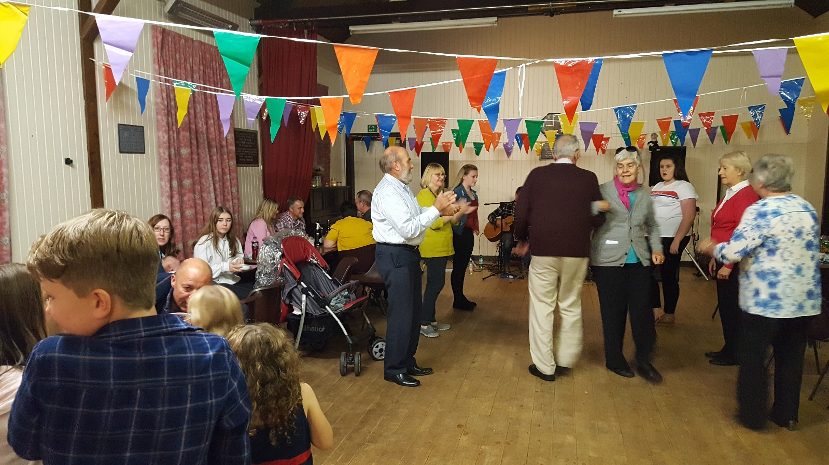

[www.community-council.org.uk/garveanddistrict](http://www.community-council.org.uk/garveanddistrict)

[garveanddistrictcc@yahoo.com](mailto:garveanddistrictcc@yahoo.com)