**Minutes of the Garve & District Community Council ordinary meeting**

**held on Tuesday 6 August 2019 in Garve Village Hall**

**Community Council members present:** Kenny Maclean (Chairman), Jennifer Haslam (Secretary), Bob Moir, Caroline Gamble (from 7.10pm) and co-opted members Joe Stewart and Sadie-Michaela Harris.

**Also present:** Cllr Dr Ian Cockburn, Val MacIver (Platform PR), Nick Sage (Infinergy) and two members of the public.

**Apologies:** Eliza Leslie Melville (Treasurer) and David Lawson (Eneco).

**The Chairman opened the meeting** at 7.00pm and welcomed everyone. He reminded members of the public that they were very welcome to attend Community Council meetings and take part in the discussions under his guidance. Community Council members were sad to learn that long time Achanalt resident Danny Hogg passed away in late June 2019. Achnasheen resident Michael Tierney died in mid-July followed shortly by Chris Hamilton from Achanalt. Our thoughts are with the families. Congratulations to Gemah Graham and her staff at Garve Hotel who recently raised £2,574.70 for Breast Cancer Care.

**Declarations of Interest** – none. Community Council members confirmed that they had read all documents due to be discussed tonight before the start of this meeting.

**Approval of draft minutes** of the last ordinary meeting held on Tuesday 4 June 2019 were proposed without amendment by Bob Moir and seconded by Sadie-Michaela Harris. Minutes are available at Garve Post Office, Achnasheen Village notice board, on our website or via email.

**Matters arising – Eneco** – David Lawson at Eneco writes … “*Lochluichart wind farm is operating well with no major issues.  One turbine underwent a main component exchange at the beginning of July in which the component was transported with police escort to Newcastle for repair.  The component was transported back 7 days later.  There are no further major works scheduled on site. David Lawson is now the site manager for Lochluichart wind farm, a role which was previously held by Martin Macphee.  David has been with Eneco for 5 years as a performance analyst and is looking forward to managing the site.”* We thank David for his update and hope he can attend a Community Council meeting in the future.

**Infinergy** – Nick Sage informed the meeting that following feedback on the planning application from The Highland Council and SNH, the four turbines nearest the A835 would be removed from the scheme. This would reduce the impact on the tourist route and therefore reduce visual impact. Supplementary information (like an amendment) to the planning application would be available shortly for consultees and the public to study and comment on via the planning department. Nick was thanked for his updates.

**EDF** - Val MacIver updated the meeting that the site is running well. No further news at this stage. Val was thanked for her updates. We note the EDF Corriemoillie Education & Training fund panel are undertaking a review of the fund. Sue Tarr confirmed a meeting has taken place, looking at uptake in the different areas, what has been applied for etc … Marion Macdonald will be taking over from Bea Jefferson at Foundation Scotland. Sue was thanked for her updates. The LCT micro grant fund is now open for applications.

Caroline Gamble joined the meeting at 7.10pm.

**SSE update – The Avenue trees** – the two dead/leaning trees were cut down on Wednesday 19 June 2019. Our thanks to all involved. Tree trunks were left for local residents to help themselves to for firewood, which they did so within two weeks of the trees coming down. <http://news.ssen.co.uk/news/all-articles/2019/july/ssen-helps-garve-see-the-woods-through-the-trees>

**Highland Council updates** – [www.highland.gov.uk](http://www.highland.gov.uk) – Several **potholes** developing on the loop road above Little Garve (FS106907725 reported 24 February 2019 with picture and re-reported FS134223281 on 30 July 2019 with picture).

Mess behind **Silverbridge toilets** would have been cleaned up sooner had it not been for staff shortages according to Clifford Smith at The Highland Council. The mess was cleared up on Wednesday 12 June 2019. Our thanks to Katrina, Clifford and their teams.

**Tyres at Gorstan** – no issues raised.

**Dumped rubbish** - on Tuesday 25 June 2019, the Secretary found the bin in “Jocks layby” full with five camping chairs broken up lying beside the bin.  At the Boat House layby, there was a single mattress and five tyres. On Thursday 25 July 2019, the Secretary found a double bed frame, double mattress and drawers in the layby near Lochluichart Church. Everything reported accordingly. Our thanks to Katrina Taylor at The Highland Council and her team. The Secretary wondered whether CCTV or signs in laybys may help prevent dumping? Katrina writes … *“Do you have a local newsletter, it may be the best way forward to highlight the amount of fly tipping in laybys in this area, it is one of the worst in Ross & Cromarty if not the worst and use the pictures?  Both signage and CCTV would more than likely be futile unfortunately as it seems there is a core of people who will dump regardless.”* We thank Katrina for sharing her thoughts and will publish pictures. The Ward Manager has also suggested this item be raised locally. **Bulky uplift information** - <https://www.highland.gov.uk/info/1063/rubbish_-_household_waste/132/dispose_of_large_household_items> **Illegal dumping** can be reported via <https://www.highland.gov.uk/info/1054/rubbish_and_recycling/89/litter_and_fly-tipping> Thoughts of CCTV and signs are still being considered.

**No turning signs at Grudie** – the issue has been noted.

We note the **grass verges** between Gorstan and Achnasheen (and on to Kinlochewe) on the A832 were cut at the end of June. Grass verges along The Avenue and around the corner up to the Wyvis Playpark plus Little Garve grass verges were all cut on Monday 29 July 2019.

**Achnasheen electric vehicle charging point** – still not fully installed. Work began earlier this year. We are advised by The Highland Council that … *“we are communicating with the energy provider; there are some issues with installation they are resolving”.*

**Achnasheen information panels** – Community Council members had no further comments on the latest designs. We now await word when the panels will be installed.

**Resurfacing works** on the A890 south of Achnasheen begun on Monday 10 June 2019, ongoing.

**A890 Stromeferry Bypass** – <https://www.highland.gov.uk/info/1523/transport_and_streets/104/stromeferry_bypass> - although this section of road is out with our area, we take an interest as it affects local residents and tourists alike. A program of works on the rock face is due to start at 10.00pm on Monday 9 September 2019. This will result in the road being CLOSED to all traffic and pedestrians from 10.00pm until 7.00am every night for eight weeks. There will also be a complete weekend closure of the road from 10.00pm on Friday 13 September 2019 until 7.00am on Monday 16 September 2019. During the day, all class of traffic will be convoyed through the site in single file, with the traffic being held by traffic signals at either end of the works.  Delays of up to 20 minutes can be expected. There will be no road/rail diversion this time.

**Community Council Scheme review** – a second and final consultation is currently underway. Community Councils and the public have until Monday 26 August 2019 to respond. The proposals in this second consultation are regarding area boundary’s and do not effect this Community Council area.

The Highland Council notes that **residents should report issues directly to them** by calling The Highland Council’s Call Centre on 01349 886606, by visiting Dingwall Service Point or via [www.highland.gov.uk/report](http://www.highland.gov.uk/report) In all cases, you will be given a reference number. The Highland Council also appreciate photos showing the actual problem. **Streetlight faults** can be reported via <https://www.highland.gov.uk/info/20005/roads_and_pavements/110/street_lighting_and_traffic_signals> You will need to provide the reference number on the streetlight column. **Potholes** can be reported directly via The Highland Council website - <https://www.highland.gov.uk/info/20005/roads_and_pavements/96/road_faults>

**BEAR update –** Regarding **flooding** between Hazelbrae corner and Garve Hotel, works have been taking place since Tuesday 9 July 2019 as noted at our last ordinary meeting. The works are due to continue until late September 2019. The works include extra drains and reinforcing the embankment. The Secretary recently learnt that flooding at Hazelbrae corner is not helped by the fact the off let pipe has been concreted over! The Secretary also wondered if these roadworks shouldn’t be highlighted on TV/Radio traffic reports as well as Traffic Scotland website. Caroline Gamble and co-opted member Joe Stewart both raised the **poor sight lines** coming out of Little Garve junction. The Secretary will raise the issue, also **the loose BT/drain cover** on the road outside Hazelbrae.

**Bridge signs** – no further news from Robbie Bain, Ward Manager. Bailey Bridge in Garve is officially called “Blackwater Bridge”. Bob Moir will make enquiries about getting a sign made.

**Garve Railway Station Footbridge** – From our February 2019 minutes … “***t****he footbridge at Garve Railway Station continues to appear very rusty. We had been informed that work might take place in 2022/23 but have suggested this needs brought forward. Network Rail replied to our query that repair and re-painting of the footbridge is now scheduled to take place in 2020/21”*. We are pleased to see some re-painting work on the handrails took place on Wednesday 26 June 2019.

**2019 Community Ceilidh** will take place later this month. 55/70 tickets have been allocated, a similar number to previous years. Donations for the raffle and tombola would be very welcome.

**Community Defibrillators** - It came to our attention in mid-June that the pads on the local Defibrillators are or were about to become out of date.  It's only the pads that are out of date, not the battery or the Defibrillator itself.  We have been advised by Lucky2BHere who supplied the Defibrillators that the pads can still be used in an emergency.  A £300 donation to cover the costs of replacing the pads in all five Defibrillators in our area has been received from a Mr Stuart Cunningham.  He asks that the donation be made in memory of Ian & Jannette Menzies.  An order has been placed with Lucky2BeHere for new pads.  Those who house the Defibrillators have been kept informed. The Achnasheen Defibrillator has had its new pads fitted, pads for the other Defibrillators are to follow.

**Police report** - [www.scotland.police.uk](http://www.scotland.police.uk) – no report received but speed checks in marked and unmarked cars have continued across our area over the last few months resulting in several speeders being caught. The Secretary was made aware of an accident at the Gorstan Junction on Friday 26 July 2019 and a near miss tonight was noted by co-opted member Joe Stewart. Bob Moir noted speeding motorbikes at the check rail corner yesterday.

**BT** – Proposed Phonebox removal notices have appeared in all four of the Phoneboxes in our area (Garve, Achanalt, Achnasheen and Aultguish) dated Thursday 18 July 2019.  The Phoneboxes are to be removed because *“… phone box has had very little use over a significant period of time.”*  The Community Council was not informed about this proposal as was the case in September 2016.  The deadline for comments is Thursday 29 August 2019 via The Highland Council’s planning department. Documents received via Gail Ross MSP show 110 Phoneboxes are proposed for removal across The Highland Council area (178 were proposed for removal in 2016). All Phoneboxes on the list were used less than 350 times in the last 12 months (was less than 250 times in 2016) however, many on the current list were not used at all. Achnasheen Phonebox was used 15 times in the last 12 months (around 300 times in August 2008), Achanalt Phonebox was used 10 times in the last 12 months (twice in 2016), Garve Phonebox was used twice in the last 12 months (20 times in 2016) and Aultguish was used once in the last 12 months (52 times in 2016). Due to the lack of information, our Chairman has informed all Ward Five Community Councils about this issue. It was also agreed to inform Lucy Beattie at TG&DDC. **It was unanimously agreed** that the Community Council will write to say these Phoneboxes must be retained on the grounds of remoteness, public safety both for local residents and tourists/hillwalkers and due to the poor mobile phone signal in the area.  It was also felt that these Phoneboxes are not vandalised so can’t be costing BT very much in upkeep.

**Treasurers report** - £19.50 meeting expenses for our June AGM & ordinary meeting. Income of £500 from Garve Hotel from fundraising hampers, our thanks to them plus £100 donation. Anyone who wishes to donate to our fundraising hampers can do so directly to The Secretary or at reception of the Garve Hotel.

**Correspondences** - All correspondences are sent to members via email. Correspondences received by email – Patrick Allan, SSE – The Avenue Trees update; Trevor Hunter, Coriolis Energy – Kirkan Community Benefit (advised to contact TG&DCC and LCT); Gavin Steel, Scottish Water – Newsletter update; Clifford Smith, The Highland Council – Silverbridge update; ePlanning – new planning applications at 7 June 2019; Katrina Taylor, The Highland Council – Silverbridge update; ePlanning – new planning applications at 14 June 2019; ePlanning – new planning applications at 25 June 2019; ePlanning – new planning applications at 28 June 2019; ePlanning – new planning applications at 5 July 2019; ePlanning – new planning applications at 12 July 2019; Anna Myeshkova, The Highland Council – Electric Charger update; ePlanning – new planning applications at 19 July 2019; Katrina Taylor, The Highland Council - dumping; ePlanning – new planning applications at 26 July 2019; Gail Ross MSP – proposed Phonebox removals; Phil Waite, The Highland Council - Public Consultation: The Highland Council Amended Core Paths; ePlanning – new planning applications at 2 August 2019; David Lawson, Eneco – update.

We have also received draft minutes from Lochalsh, Contin (x2), Shieldaig, Lochcarron (x2), Torridon & Kinlochewe, Marybank, Scatwell & Strathconon (x3), Coigach, Stromeferry & Achmore and Plockton Community Councils and approved minutes from Gairloch Community Council.

**AOB from Community Council members** – Caroline Gamble and co-opted member Joe Stewart both mentioned there has been another **burst water pipe** in Little Garve. This seems to be occurring on a semi regular basis. The Secretary will write to Gavin Steel at Scottish Water for more information.

Co-opted member Sadie-Michaela Harris noted a suggestion on social media of making a **promotional video** of the area and wondered if this was something the Community Council could do. Sadie replied to the social media post in a personal capacity. Community Council members present felt this was more the remit of the Development Company and we already had a lot on. Sadie also noted a **damaged fence** near Bailey Bridge. The Secretary will pass Sadie’s photos on.

The Chairman noted **Friends of Lochluichart Community** AGM will be held in the Vestry, Community Hall, Lochluichart on Thursday 15 August 2019 from 7.00pm.

**AOB from members of the public** – Sue Tarr informed the meeting that **the local energy group** have received some funding from the Climate Change Fund and will be holding a drop-in session with representatives in attendance covering different energy types on Thursday 29 August 2019, times tbc.

**Screening reports, scoping reports and consultations** – We have received one consultation from The Highland Council - The Highland Council Amended Core Paths. This consultation proposes that the full loop at Silverbridge be given Core Path status. The Consultation also proposes that Little Garve – Aultguish path, Strathvaich track, Strathrannoch track and the Fannich Traverse path all be given Core Path status. More details and maps can be found at <http://consult.highland.gov.uk/portal> Comments by 5.00pm on Friday 18 October 2019. Community Council members raised no objection to the proposed plans.

**Building warrants, planning issues and licensing issues** – No issues since our last ordinary meeting. All planning applications can be viewed at <https://www.highland.gov.uk/info/180/planning_-_applications_warrants_and_certificates/143/planning_permission/4>

**Dates of future meetings**

*(Ordinary meetings are usually held on the first Tuesday of every month unless stated otherwise)*

Tuesday 3 September 2019, 7.00pm, Garve Village Hall

Tuesday 1 October 2019, 7.00pm, Garve Village Hall

Tuesday 5 November 2019, 7.00pm, Garve Village Hall

Tuesday 3 December 2019, 7.00pm, Garve Village Hall

January 2020 – no meeting

Tuesday 4 February 2020, 7.00pm, Garve Village Hall

Tuesday 3 March 2020, 7.00pm, Garve Village Hall

Tuesday 7 April 2020, 7.00pm, Garve Village Hall

Tuesday 5 May 2020, 7.00pm, Garve Village Hall

Tuesday 2 June 2020, **AGM** followed by an ordinary meeting, 7.00pm, Garve Village Hall

Members of the public are very welcome to attend Community Council meetings and take part in the discussions under the guidance of the Chairman. A copy of the Constitution that every Community Council in the Highlands has to work to is available on The Highland Council website - [www.highland.gov.uk/downloads/file/4456/scheme_of_establishment_for_community_councils](http://www.highland.gov.uk/downloads/file/4456/scheme_of_establishment_for_community_councils)

The Chairman thanked everyone for coming and closed the meeting at 8.30pm.

Signed ……………………………..

Signed ……………………………..

Date ……………………………….

*Just some of the dumping that has taken place over the summer in our area …*

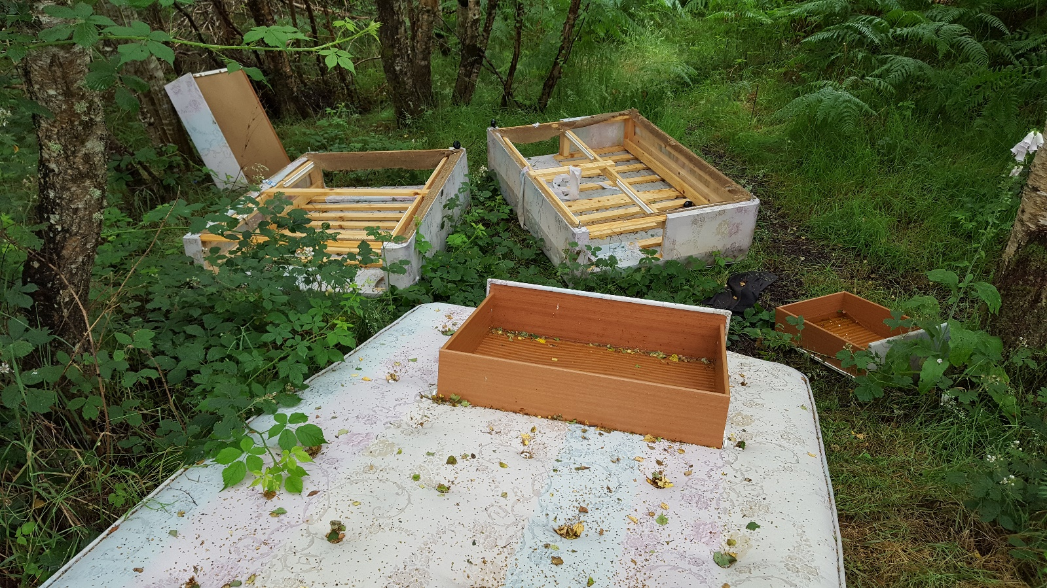

[www.community-council.org.uk/garveanddistrict](http://www.community-council.org.uk/garveanddistrict)

[garveanddistrictcc@yahoo.com](mailto:garveanddistrictcc@yahoo.com)