**DRAFT Minutes of the Garve & District Community Council ordinary meeting**

**held on Thursday 5 December 2019 in Garve Village Hall**

**Community Council members present:** Eliza Leslie Melville, Kenny Maclean, Jennifer Haslam and Caroline Gamble.

**Also present:** Cllr Dr Ian Cockburn and Cllr Mrs Muriel Cockburn (both attended from 7.00pm until 7.10pm).

**Apologies:** Community Council members Bob Moir, Joe Stewart and Sadie-Michaela Harris. Apologies were also received (via text) from Val MacIver (Platform PR).

**As this was the first meeting following the 2019 Community Council Election, Cllr Dr Ian Cockburn opened the meeting** at 7.00pm and welcomed everyone.

**Declarations of Interest** – Eliza Leslie Melville declared an interest in the Infinergy project. Community Council members confirmed that they had read all documents due to be discussed tonight before the start of this meeting. Community Council members also confirmed they had received a copy of the new Constitution (via Kenny) that all Community Councils in the Highlands are now expected to work to.

**Election of Office Bearers** – Jennifer Haslam proposed that Kenny Maclean continue as Chairman, Eliza Leslie Melville seconded and all agreed. Caroline Gamble proposed Jennifer Haslam continue as Secretary, Eliza Leslie Melville seconded and all agreed. Jennifer Haslam proposed Eliza Leslie Melville continue as Treasurer, Caroline Gamble seconded and all agreed. Community Council members also agreed that our Chairman continue to deal with any press enquiries, liaison with other local groups and be the Community Council website administrator. Cllr Cockburn then handed the meeting over to the elected Office Bearers. Our Chairman thanked Cllr Cockburn for getting the ball rolling.

**Adoption of updated Constitution** (following 2018/19 Highland Council public consultation) was proposed by Kenny Maclean and seconded by Eliza Leslie Melville, all agreed. Signed by our Chairman, Treasurer, Caroline Gamble and Cllr Cockburn with a copy to be handed in to Robbie Bain, Ward Manager by Cllr Cockburn. The updates in the constitution relate to financial reports at each meeting, declaring interests at each meeting and promotion of co-opted, associate/youth members, all of which we already adhere to. The Highland Council **child protection policy** for community groups (see page three of the scheme) – we have not seen a copy of this document. Cllr Cockburn will find a copy for us to study before formal adoption takes place.

Cllr Dr Ian Cockburn and Cllr Mrs Muriel Cockburn then left the meeting at 7.10pm and were both thanked for attending.

**Approval of draft minutes** of the last ordinary meeting held on Tuesday 5 November 2019 in Garve Village Hall were proposed without amendment by Caroline Gamble and seconded by Kenny Maclean. Minutes are available at Garve Post Office, Achnasheen Village Noticeboard, on our website or via email.

**Matters arising – EDF** - Val MacIver updated the meeting (via text) that the Corriemoillie windfarm is running well. We send our thanks to Val for her update. Marion McDonald from Foundation Scotland has updated us on the **EDF Corriemoillie Education & Training fund**. At their November 2019 panel meeting, 34 awards were made, all individual bursaries, totalling £43,425. Three individual bursary’s totalling £3,985 were made to residents in this Community Council area. (£1,500 to fund fees related to Diploma in Applied Health & Safety, £1,485 to pay for fees relating to LGV training course and £1,000 to fund travel and other costs relating to BSc Nursing (Adult). The 2020 Application deadlines are Monday 6 January 2020 and Monday 29 June 2020. More details at <https://www.foundationscotland.org.uk/programmes/corriemoille-education-and-training/> We thank Marion for her detailed update which we have posted on our website.

**Highland Council updates** – [www.highland.gov.uk](http://www.highland.gov.uk) – Community Council members were delighted to hear that our nomination of Katrina Taylor for a **Highland Council Quality Award** **(Community)** as agreed at our September 2019 ordinary meeting was successful. Katrina was nominated for her help to us with bins and illegal dumping in our area. Katrina received her award at an awards ceremony which took place on Thursday 14 November 2019 in the Town House, Inverness. Katrina tells us that the awards ceremony was a lovely evening and sends her thanks for the nomination. More details of all the winners are available at - <https://www.highland.gov.uk/news/article/12144/housing_officer_is_council_s_employee_of_the_year> Local newspapers also carried this story which in turn, has helped to highlight the illegal dumping problems we have been suffering.

On Thursday 28 November 2019, the Secretary received a verbal report about potholes. On inspecting the site, she was shocked to see the **car park beside Strathgarve Primary School** and the Recycle Bins was flooded and full of deep potholes, about 6” deep. Photos were taken and passed on to The Highland Council - FS159889272. This will be an ice rink in winter if not fixed. Parents whose children attend the school have been encouraged to report this issue, along with the Parent Council and the School taxi company as the more voices that complain the better. We would also encourage those who use the Recycle Bins to report this issue - <https://www.highland.gov.uk/info/20005/roads_and_pavements/96/road_faults> (best to include photos).

**Achnasheen electric vehicle charging point** – The charger is still not fully installed. Anna Myeshkova at The Highland Council tells us they hope to resolve all outstanding issues shortly so that the charging point can be functional. We thank her for her update. A Lochrosque Estate worker spoke with our Chairman yesterday to confirm that the Estate is not the landowner in question holding up this project. A formal letter from the Estate confirming this is due to be sent to our Secretary in due course.

What appeared to be the beginnings of a **sinkhole** appeared on the Main Road in Achnasheen on Tuesday 19 November 2019. Photos were taken and reported to The Highland Council by our Chairman straight away. FS157989957. Our thanks to everyone at The Highland Council who sent a large team of men out within two hours to investigate. Our Chairman has inspected the temporary repair and is not aware of any further problems since.

In other news from The Highland Council, **Dingwall Swimming Pool** will remain closed until early next year, meaning the facility has been out of action for around six months. A spokesperson for The Highland Council and High Life Highland said … *“Due to ongoing works at Dingwall Leisure Centre, the pool will remain closed and is hopefully scheduled to re-open to the public early in the New Year. We apologise for the closure however, it is important that the swimming pool is a safe and enjoyable environment for users when they return.”* Caroline Gamble noted that the Strathgarve Primary School children’s swimming lessons have been affected by the closure.

The Highland Council notes that **residents should report issues directly to them** by calling The Highland Council’s Call Centre on 01349 886606, by visiting Dingwall Service Point or via [www.highland.gov.uk/report](http://www.highland.gov.uk/report) In all cases, you will be given a reference number. The Highland Council also appreciate photos showing the actual problem. **Streetlight faults** can be reported via <https://www.highland.gov.uk/info/20005/roads_and_pavements/110/street_lighting_and_traffic_signals> You will need to provide the reference number on the streetlight column. **Potholes** can be reported directly via The Highland Council website - <https://www.highland.gov.uk/info/20005/roads_and_pavements/96/road_faults> **Bulky uplift information** - <https://www.highland.gov.uk/info/1063/rubbish_-_household_waste/132/dispose_of_large_household_items> **Illegal dumping** can be reported via <https://www.highland.gov.uk/info/1054/rubbish_and_recycling/89/litter_and_fly-tipping>

**Highland Council winter roads policy** can be viewed at - [www.highland.gov.uk/info/20005/roads_and_pavements/107/winter_road_maintenance](http://www.highland.gov.uk/info/20005/roads_and_pavements/107/winter_road_maintenance) You can now follow where **The Highland Council Gritters** are by going to <https://www.highland.gov.uk/wintervehicletracker> The page does not provide road treatment or gritting information.

**Wondering dogs** – picture needed and then it needs to be sent to - <https://www.highland.gov.uk/info/1211/animal_welfare_and_pest_control/472/dog_control/2> **Dog fouling** – picture needed and then it needs to be sent to - <https://www.highland.gov.uk/info/1330/street_care_and_cleaning/473/dog_fouling> In both cases, anonymous reports will not be accepted.

**BEAR update -** [www.bearscot.com](http://www.bearscot.com) – **Culvert works between Garve Hotel and Hazelbrae** were due to be completed by Friday 15 November 2019 however, water and ice were on the road on the evening of Saturday 30 November 2019. Photos were sent to Calum Farquharson at BEAR who promptly replied as follows … *“I have been advised that works are currently incomplete, which is why there is still surface water on the carriageway. When our operatives excavated the road to upgrade the culvert, they hit bedrock much shallower than we had anticipated. As a result, several changes to the design had to be made and they were unable to complete the works as planned on Friday 15 November. As you correctly pointed out, uncontrolled flow is still coming from the Network Rail embankment and as such, we have increased the length of filter drain which we will be installing along that verge. This filter drain should capture the seepage from the embankment and it will enter our underground drainage network which is being improved as part of the works. The revised drainage works are programmed to resume on Monday 16December and weather permitting, these are expected to take five days to complete. This will be carried out under a single lane closure with temporary traffic lights. An additional week of works will be carried out in January, on the embankment between the carriageway and the small stream that runs parallel. As winter is already upon us, we will prioritise the drainage related works on the carriageway, prior to commencing works on the embankment. I know this issue has been a concern within the community for several months now and that you had expected the situation to have been resolved by now.”* All Community Council members present were grateful for Calum’s prompt and detailed update, for which we send him our thanks. **Trunk road gritters** can be tracked at <http://scotgov.maps.arcgis.com/apps/webappviewer/index.html?id=2de764a9303848ffb9a4cac0bd0b1aab>

**Sunday Services at Kinlochluichart Church** – Reports suggest that at the Church service on Sunday 24 November 2019, 26 people attended, 11 from this area. This is a vast improvement on the figures held for those attending over the last two and a half years. Let’s hope these numbers continue to improve before the May 2020 review. As things stand, the next services to be held in Kinlochluichart will be on Sunday 22 December 2019 at 11.30am (family carol service), Sunday 26 January 2020 at 11.30am, Sunday 23 February 2020 at 11.30am, Sunday 29 March 2020 (Joint Linkage service) at 11.00am and Sunday 26 April 2020 at 11.30am. Signs have been placed on the roadside advertising the services and Tea & Coffee will be served afterwards, everyone of all ages welcome. Notices advertising Church service dates and times have been placed in the Achnasheen Village Noticeboard and at Garve Post Office.

**Remembrance Sunday** – a service took place at the Garve War Memorial on Sunday 10 November 2019. It was a fresh dry day, our Chairman was joined by the Secretary, Community Council member Joe Stewart, Cllr Dr Ian Cockburn and around 45 members of the Community. It was good to see so many of the younger members of the community in attendance.

**BT’s proposed removal** of our four telephone boxes – Following the close of the second phase of consultation by The Highland Council, the Council are going to formally object to all our telephone boxes being removed. This update has been posted on our website.

**Scottish Water** – [www.scottishwater.co.uk](http://www.scottishwater.co.uk) – A Gorstan resident has verbally informed our Secretary that when Little Garve have no water, nor do they. They have been advised to report directly to Scottish Water each time this happens, noting the date, reference number and how long they are without a supply.

Community Council member Sadie-Michaela Harris attended the Community Council liaison meeting for **Dingwall Medical Group** Wednesday 6 November 2019. Sadie emailed her fellow Community Council members to say she thought the meeting was interesting, though in terms of what their initial purpose was, Sadie thought Community Councils could only give limited help such as notifying of events via our meetings and website. Sadie asked if we might have some data with regard of how many patients are in each Community Council area. Sadie noted only 6 of the 11 Community Council’s invited were represented. Sadie explained that all Community Council members are volunteers and the majority have daytime jobs. Other ideas were discussed with regard to things that give greater health benefits to the community – under mental health awareness umbrella and things to reduce rural loneliness. Perhaps another meeting in three months’ time. Our Chairman thanked Sadie for attending and for her update.

Our Chairman along with the Secretary **manned the Community Council stall** at TG&DDC AGM on Friday 22 November 2019. One person from the community raised two issues, street lights out in Garve (which we’ve raised and which are in hand) and could we have an over 60’s dinner? As noted at previous ordinary meetings, poor attendance at the last three such dinners were why the dinners stopped (around 2/3 were not attending in the end). Also, the 2016 Community Needs Survey indicated support for events including ALL AGES as the way forward. It was also noted that there are very few members on the Community Council to be organising such large events now.

**The 2019 Christmas party** will be held in Garve Village Hall on Saturday 21 December 2019 from 6.00pm. BYOB, all welcome!

**2020 Community Ceilidh** – Community Council members are asked to give this matter some thought before the next ordinary meeting on Tuesday 4 February 2020 as if a Ceilidh is to be held, funding would need to be secured from LCT.

**Treasurers report** – The latest bank statement shows a bank balance on Friday 22 November 2019 of £3,052.24. Expenses were last month’s Hall hire £12.50 and £42.95 ink. Data Protection renewal fee of £35 will de deducted by Direct Debit on or around Tuesday 31 December 2019.

**Correspondences** - All correspondences are sent to members via email. Correspondences received by email – ePlanning – new planning applications at 8 November 2019; Katrina Taylor, The Highland Council – Awards update; Paul Arnold, Information Commissioner's Office - Data Protection renewal fee, ICO:00012751999; ePlanning – new planning applications at 15 November 2019; ePlanning – Further consultation on planning application 19/01284/FUL; Marion McDonald, Foundation Scotland – update; ePlanning – new planning applications at 22 November 2019; ePlanning – new planning applications at 29 November 2019; two emails from Calum Farquharson – A835 drains.

We have also received draft minutes from Contin, Shieldaig (x2) and Lochcarron Community Councils and approved minutes from Gairloch Community Council.

**AOB from Community Council members** – The Secretary raised three issues. Following accidents over the last few months and near misses, could The Highland Council erect **“Concealed Entrance” signs at Kinlochluichart Church?** It was noted that trees on private land are not helping site lines at this location. The matter will be raised with Iain Moncrieff from the Road’s Department.

The Secretary noted we have never received a final update to the request about improving the barriers at **“check rail corner”**. The last update was noted at our June 2019 ordinary meeting via Tommy Deans at BEAR which at that time read as follows ... *“I have spoken to our Road Safety Team and Transport Scotland’s Area Manager.  We absolutely appreciate that the removal of the trees and the subsequent exposure of the railway changes the driver experience on the route. Looking at the bend specifically my road safety colleagues tell me that there is no automatic requirement to increase the height of the existing barrier. However, there is a need to assess the start and end points of the barrier to check if any extensions are required.  At the same time a site assessment will be carried out by a barrier expert to look at the suitability of the existing barrier.  The final result may be that no additional work is required but let’s see what is identified during the assessment. It is likely to be July before this will be done but we’ll arrange it as soon as we can.”* We will ask Tommy for an update.

The Secretary also noted the **fence between the railway and the road** between Killin Farm and “check rail corner” is beginning to fall into disrepair again following several accidents in recent times. Caroline Gamble noted she was held up following a recent accident. Our understanding is that there is not enough room for crash barriers at this location. We will ask Network Rail for an update on the fence.

**AOB from members of the public** – no issues raised.

**Screening reports, scoping reports and consultations** – none. All Highland Council consultations are available at <http://consult.highland.gov.uk/portal> All Scottish Government consultations are available at <https://consult.gov.scot/consultation_finder>

**Building warrants, planning issues and licensing issues** - Eliza Leslie Melville declared an interest in the following application and left the room at 8.09pm. From May 2019 minutes … *19/01284/FUL is the proposed erection of 9 turbines (maximum tip height 133m), temporary construction compound, borrow pits, crane pads, access tracks, underground cables between turbines, sub-station, battery storage, maintenance and control buildings with welfare facilities on land between Lochluichart and Loch Glascarnoch. The deadline for comments to the Case Officer is Thursday 23 May 2019. Community Council members raised no objection.* We have now received 80-pages of supplementary information for this planning application. The number of turbines are to be reduced from 9 turbines to 5 turbines (the four nearest the A835 have been removed from the plans following objections from SEPA and SNH amongst others). The deadline for comments to the Case Officer is Friday 20 December 2019. This update has been posted on our website. As the meeting was inquorate for this item, no view could be taken on the supplementary information. Eliza Leslie Melville then returned to the room at 8.12pm. All planning applications can be viewed at <https://www.highland.gov.uk/info/180/planning_-_applications_warrants_and_certificates/143/planning_permission/4>

**Dates of future meetings**

*(Ordinary meetings are usually held on the first Tuesday of every month unless stated otherwise)*

January 2020 – no meeting

Tuesday 4 February 2020, 7.00pm, Garve Village Hall – apologies noted from Bob Moir

Tuesday 3 March 2020, 7.00pm, Garve Village Hall

Tuesday 7 April 2020, 7.00pm, Garve Village Hall

Tuesday 5 May 2020, 7.00pm, Garve Village Hall

Tuesday 2 June 2020, **AGM** followed by an ordinary meeting, 7.00pm, Garve Village Hall

July 2020 – no meeting

Tuesday 4 August 2020, 7.00pm, Garve Village Hall

Tuesday 1 September 2020, 7.00pm, Garve Village Hall

Tuesday 6 October 2020, 7.00pm, Garve Village Hall

Tuesday 3 November 2020, 7.00pm, Garve Village Hall

Tuesday 1 December 2020, 7.00pm, Garve Village Hall

It was agreed that as we have summer and winter breaks, any issue with a deadline will be emailed to Community Council members for their consideration. A special meeting can be called if necessary. As ever, updates between meetings will continue to be posted on our website.

Members of the public are very welcome to attend Community Council meetings and take part in the discussions under the guidance of the Chairman. A copy of the Constitution that every Community Council in the Highlands has to work to is available on The Highland Council website - [www.highland.gov.uk/downloads/file/21179/scheme_of_establishment_final_sept_2019](http://www.highland.gov.uk/downloads/file/21179/scheme_of_establishment_final_sept_2019)

The Chairman thanked everyone for coming, wished everyone a Merry Christmas and a Happy New Year and closed the meeting at 8.15pm.

Signed ……………………………..

Signed ……………………………..

Date ……………………………….

The ladies who attended Jennifer Haslam’s Christmas Wreath Making Demonstration held on Monday 25 November 2019 in Lochluichart Community Hall …

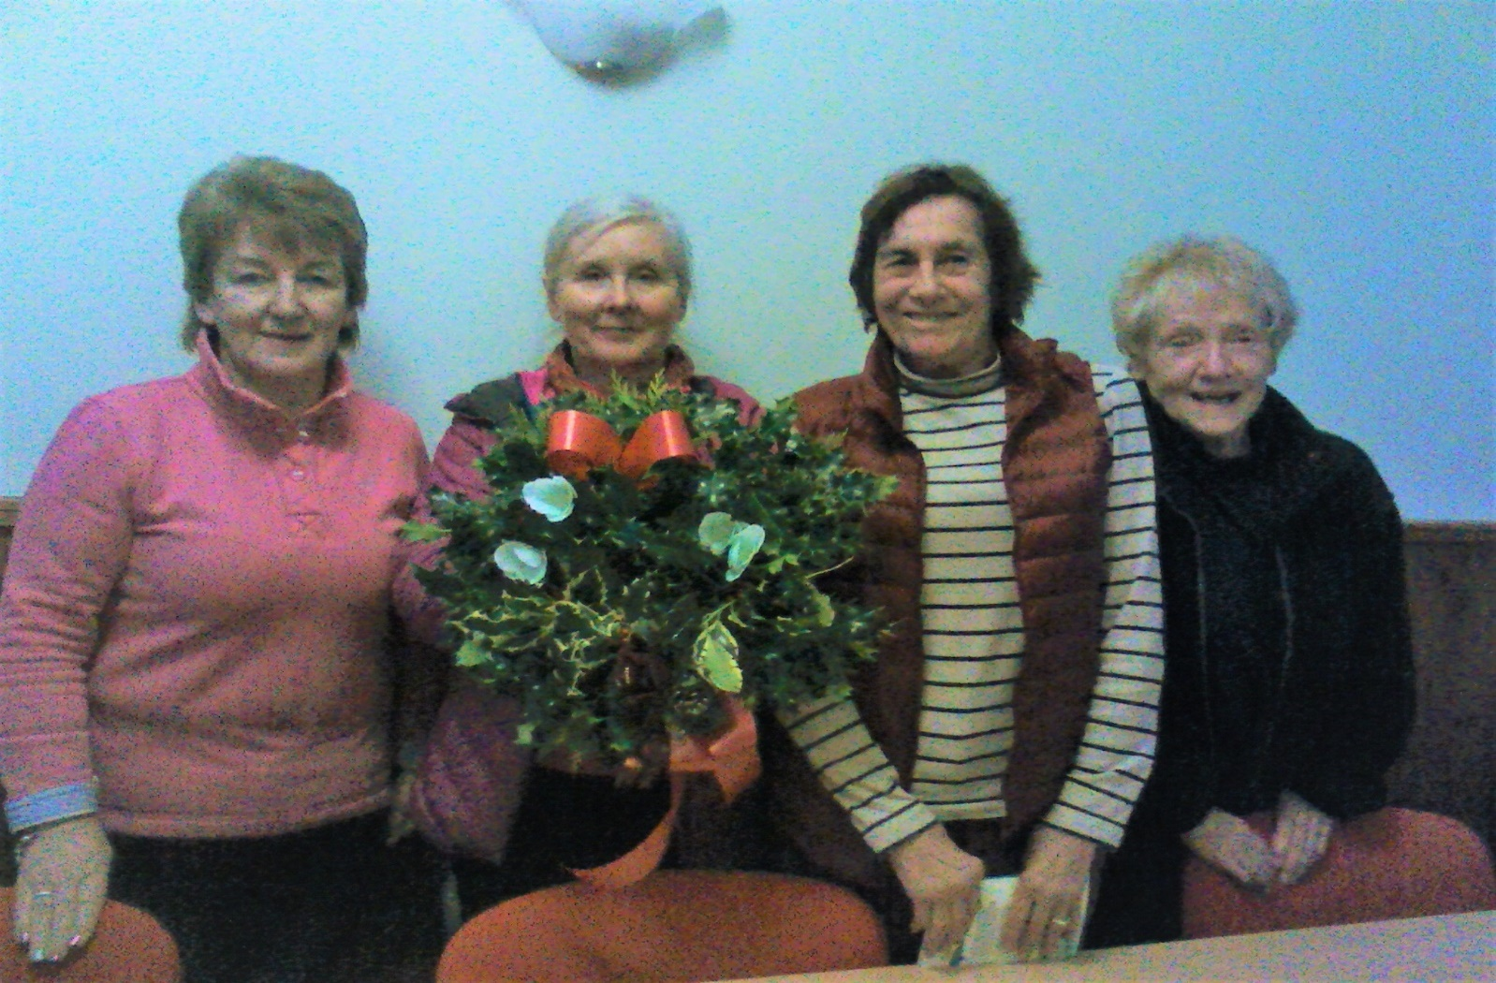

Some of the potholes in the car park outside Strathgarve Primary School and Recycle Bins …

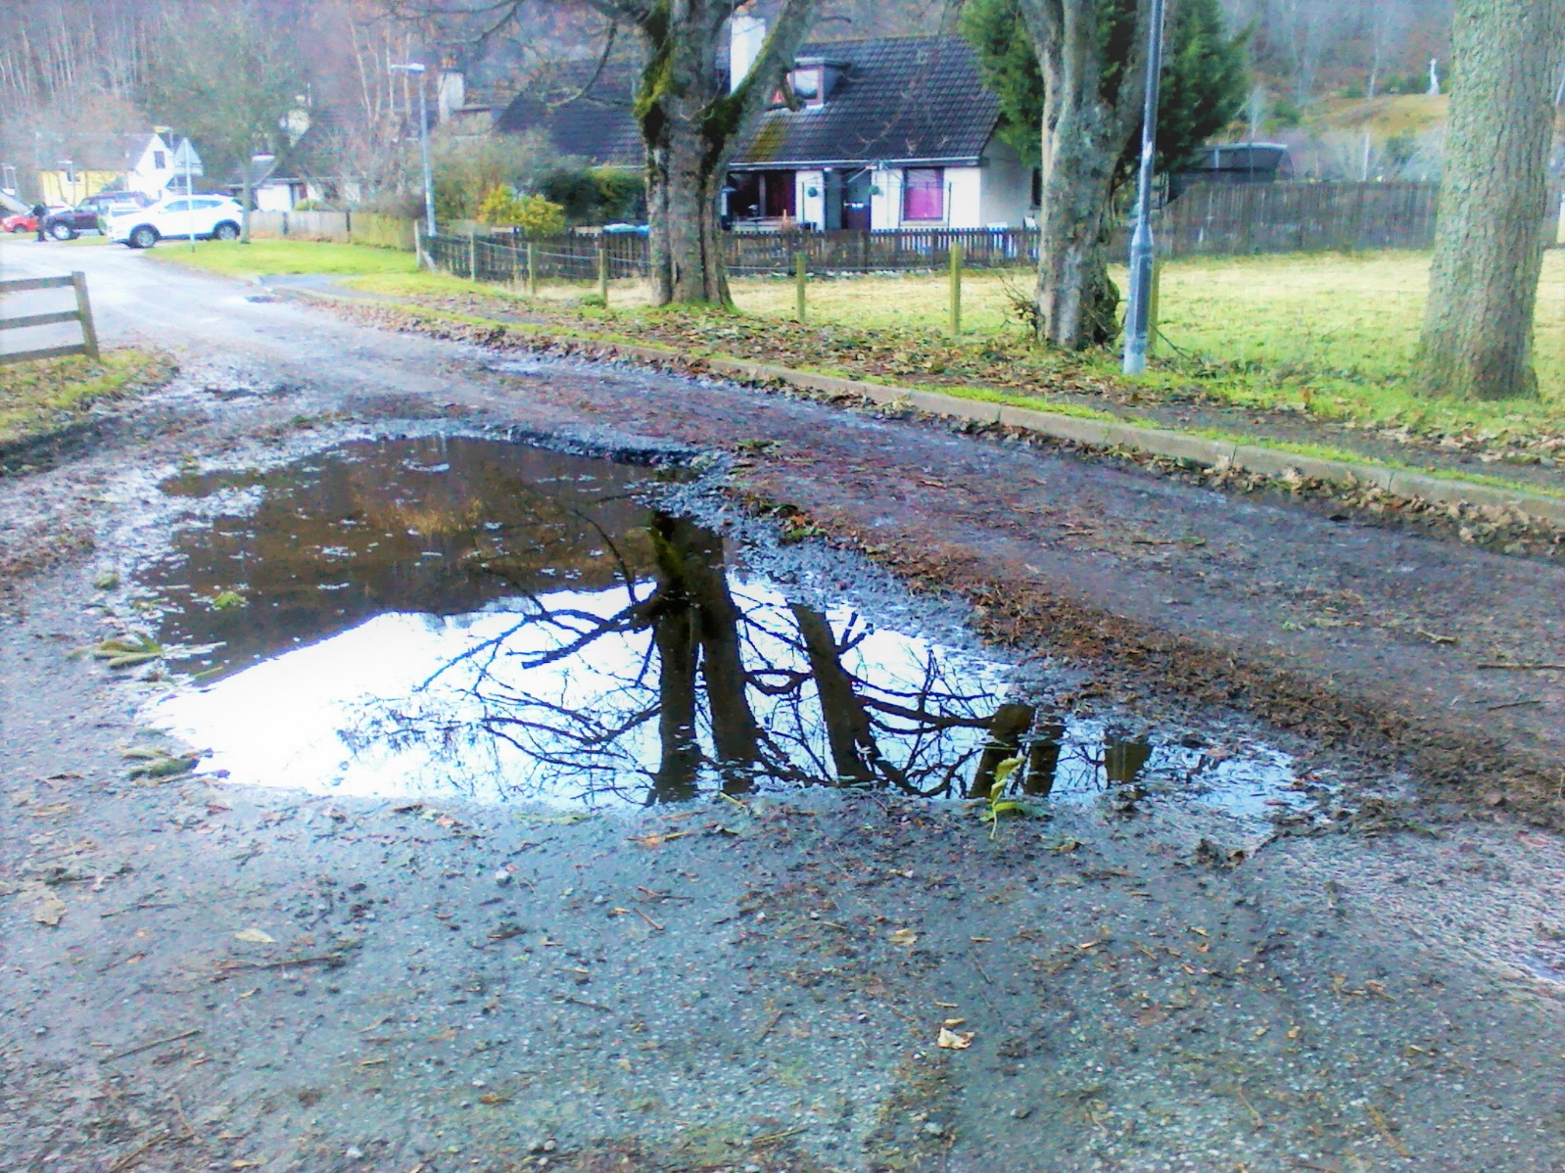

The Garve Christmas lights were turned on at 7.00pm on Saturday 30 November 2019. £244.00 was raised for the Hall and £127.00 was collected towards the PTA funds …

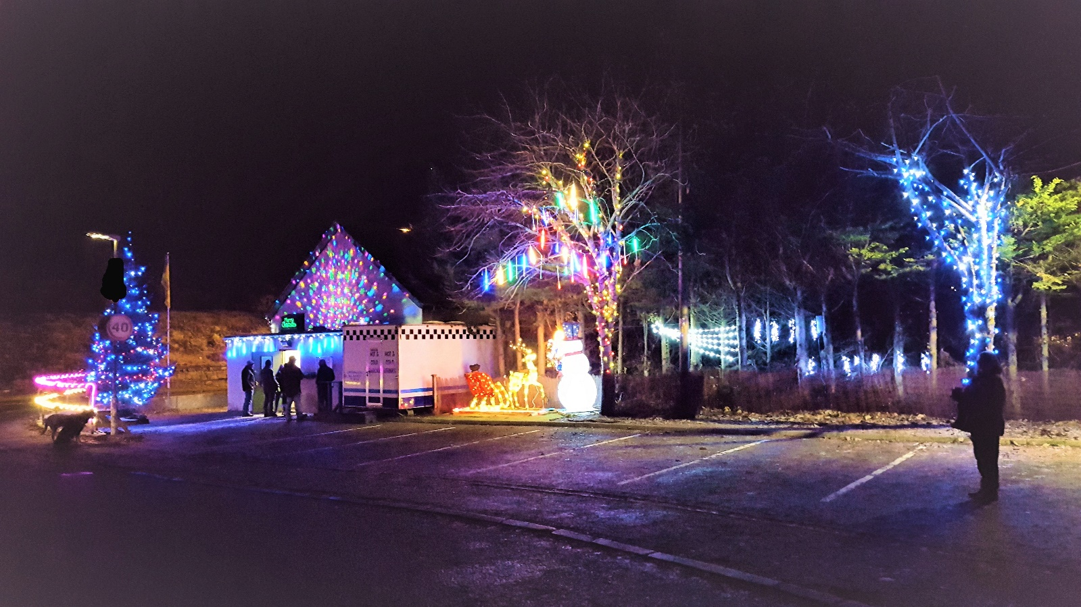

[www.community-council.org.uk/garveanddistrict](http://www.community-council.org.uk/garveanddistrict)

[garveanddistrictcc@yahoo.com](mailto:garveanddistrictcc@yahoo.com)