**Minutes of the Garve & District Community Council ordinary meeting**

**held on Tuesday 3 September 2019 in Garve Village Hall**

**Community Council members present:** Kenny Maclean (Chairman), Jennifer Haslam (Secretary), Eliza Leslie Melville (Treasurer), Bob Moir, Caroline Gamble and co-opted member Sadie-Michaela Harris.

**Also present:** Val MacIver (Platform PR) and one member of the public.

**Apologies:** co-opted member Joe Stewart and Cllr Dr Ian Cockburn.

**The Chairman opened the meeting** at 7.00pm and welcomed everyone. Best wishes to Ilse Jack who has been unwell. The Chairman attended a special meeting of the Marybank, Scatwell & Strathconon Community Council on Tuesday 20 August 2019 along with Euan Fraser & David Lawson of Eneco and Robbie Bain, Ward Manager to discuss Marybank’s share of community benefit funds that are still owed to them by Eneco. We note co-opted member Sadie-Michaela Harris has now been a co-opted member of the Community Council for one year and Jennifer Haslam has been an elected member of the Community Council for ten years.

**Declarations of Interest** – none. Community Council members confirmed that they had read all documents due to be discussed tonight before the start of this meeting.

**Approval of draft minutes** of the last ordinary meeting held on Tuesday 6 August 2019 in Garve Village Hall were proposed without amendment by Bob Moir and seconded by Sadie-Michaela Harris. Minutes are available at Garve Post Office, Achnasheen Village notice board, on our website or via email.

**Matters arising – The Garve & District Energy Group** held a drop-in event on Thursday 29 August 2019 in Garve Village Hall as noted at our last ordinary meeting and as suggested at our June Ordinary meeting. Our Chairman attended along with the Secretary and Bob Moir. Our Chairman thought around 30-40 people attended and received advice from ourselves, TG&DDC, Energy group, Dingwall Men’s Shed, Community Woodlands Association, E-on, Local Energy Scotland amongst others. Our Chairman tried an E-bike and enjoyed the ride! The only point raised with the Community Council was the need for transport into Dingwall & Inverness for 9.00am. As reported at previous Community Council meetings, such transport already exists and has done so for several years. More details are available at [www.scotrail.co.uk](http://www.scotrail.co.uk) and [www.decoaches.co.uk/](http://www.decoaches.co.uk/)

**EDF** - Val MacIver updated the meeting that the site is running well. Val was thanked for her updates.

**Highland Council updates** – [www.highland.gov.uk](http://www.highland.gov.uk) – We note that Cllr Dr Ian Cockburn has confirmed his intention to step down from the Highland Licensing Committee and Highland Licensing Board with effect from Tuesday 1 October 2019.

Photos of the **damaged wooden fence** in Garve have been passed on Iain Moncrieff at The Highland Council.

**A pothole** on the Corriemoillie straight was reported on Thursday 15 August 2019 with a photo. The pothole was filled in within a few days. **Another pothole** appeared beside Garve New Cemetery on Thursday 29 August 2019, reported with photo (FS140580955).

**Illegal dumping** – plasterboard, fish and a mattress were dumped in the layby beside the Boathouse two miles east of Achanalt on the A832 recently.  A golf buggy was dumped in the layby near Lochluichart Church. Everything reported accordingly and cleaned up, our thanks once again to Katrina and her team. Other Community Council’s in the Ward are not reporting dumping to the same degree as we are. The Secretary wondered if cutting back trees in front of the laybys would help prevent illegal dumping as those responsible wouldn’t have somewhere to hide? Community Council members agreed a letter be sent pointing out the cost effectiveness in terms of manpower and time.

**Achnasheen electric vehicle charging point** – still not fully installed, we have requested an update.

**Achnasheen information panels** – we still await word when the panels will be installed.

**Resurfacing works** on the A890 south of Achnasheen begun on Monday 10 June 2019 and were completed within our area by Friday 9 August 2019. Our thanks to Iain Moncrieff and his team. Grass verges were also cut along this stretch of road recently.

**The Highland Council 2019 Quality Awards** – Community Council members unanimously agreed that Katrina Taylor be nominated for her help with bins and illegal dumping in our area.

The Highland Council notes that **residents should report issues directly to them** by calling The Highland Council’s Call Centre on 01349 886606, by visiting Dingwall Service Point or via [www.highland.gov.uk/report](http://www.highland.gov.uk/report) In all cases, you will be given a reference number. The Highland Council also appreciate photos showing the actual problem. **Streetlight faults** can be reported via <https://www.highland.gov.uk/info/20005/roads_and_pavements/110/street_lighting_and_traffic_signals> You will need to provide the reference number on the streetlight column. **Potholes** can be reported directly via The Highland Council website - <https://www.highland.gov.uk/info/20005/roads_and_pavements/96/road_faults> **Bulky uplift information** - <https://www.highland.gov.uk/info/1063/rubbish_-_household_waste/132/dispose_of_large_household_items> **Illegal dumping** can be reported via <https://www.highland.gov.uk/info/1054/rubbish_and_recycling/89/litter_and_fly-tipping>

**BEAR update** – The **loose drain cover** outside Hazelbrae has been repaired by BT. The **sightlines** at Little Garve junction have been cut back by BEAR. Our thanks to all involved. **Flooding** works between Hazelbrae corner and Garve Hotel appeared to have been completed but heavy rain last Saturday showed the drains are still not coping with the amount of water coming off the hills. Photos have been sent onto BEAR of the flooding. Calum Farquharson at BEAR replied … *“It seems as though the Network Rail works have concentrated the discharge from their land onto ours. We had hoped to upgrade our culverts before their works took place, to prevent this from happening. I will be on site today (3 September) to assess the extent of the problem and we will progress our design accordingly, as quickly as possible”*. We thank Calum for his update and await a further update in due course. Caroline Gamble noted that Hazelbrae corner remained flood free! The best way to raise trunk road issues is by sending a picture via [www.bearscot.com](http://www.bearscot.com)

**Scottish Water update** – regarding the **bursts in Little Garve**, Gavin Steel at Scottish Water writes … “*When our local network response team attends a burst or damaged water main, they seek to identify the extent of the issue and carry out immediate repairs which can often succeed in restoring reliable service for a significant period of time.  Where problems recur repeatedly, we will then consider targeted renewal of the network to address this and our investment planning team has confirmed that a section of water main serving Little Garve is currently under consideration. We do understand that customers who have experienced disruption will want to see water main renewal take place as soon as possible and our approach is focused on enabling us to deliver as much improvement as possible with the resources available.  Where poor performance of the network continues, that will result in planned work becoming a greater priority. If the Community Council would be able to characterise the feedback it has received from residents about the main’s performance to date and the impact this has on them, that may help my colleague make a stronger case for this work to be brought forward as soon as possible. In the meantime, residents may be entitled to have some of their water charges refunded if they experience and report 2 or more interruptions in a single year.”* We thank Gavin for his detailed update which we have passed onto all Little Garve residents in full. More details of possible refunds are available at [www.scottishwater.co.uk](http://www.scottishwater.co.uk) Caroline Gamble noted another burst last Saturday during the heavy rain in the field opposite the old pumping station. There have been several bursts in this field over the years. Caroline believes it was the Dornoch team who came out last Saturday before attending a burst in Fortrose! This must be costing Scottish Water a fortune in repairs, manpower from Dornoch and Equipment hire, let alone compensation that residents will now be entitled too. Perhaps the time has come to replace all the pipes in this field? Gavin Steel will be asked for his thoughts on this matter.

**BT proposed Phonebox removals** – we have now received a formal consultation on this issue. Our objections to these proposals have been noted by Alison Clark at The Highland Council. A full list of all 110 Phoneboxes that BT propose to remove from across The Highland Council area is available on The Highland Council website. Members of the public are encouraged to have their say by going to <https://www.surveymonkey.co.uk/r/payphones> by Wednesday 18 September 2019. This update has already been posted on our website. It is perhaps worth noting that The Highland Council do have a veto on this issue on safety grounds.

**Bridge signs** – Bailey Bridge in Garve is officially called “Blackwater Bridge”. Bob Moir made enquiries into a sign for the bridge which will be fitted onto the bridge shortly. Special thanks to Timpson’s in Dingwall who made the sign at a reduced price as it was for the Community Council.

**The 2019 Community Ceilidh** took place on Saturday 17 August 2019 in Garve Village Hall. A total of 55/70 tickets were given away but 22 people did not turn up on the night. This is very disappointing as a reminder email had gone out to ticket holders earlier that week. If there is to be another ceilidh, careful consideration will need to be given as to how free tickets are issued as this years’ non-attendance of some has resulted in over £120.00 (or over 10% budget) in wasted expense such as catering, etc ...

Thanks to the Garve Village Hall Committee for all their help, The Scone Fairies band, who were excellent with their interaction with the kids and to Out of the Blue Catering who oversaw our catering requirements. A special thank you must go to all those who did attend who all seemed to enjoy themselves based on feedback received and to those who donated prizes for the raffle and tombola, more items are always appreciated. £107.00 was raised on the raffle and £54.00 on the tombola all for our Community Council funds. The cost of putting on the ceilidh came to £870.48. Our thanks to LCT for funding the event and Mr Harland for his donation. The LCT feedback form has been viewed by Community Council members who agreed its contents.

**Police report** - [www.scotland.police.uk](http://www.scotland.police.uk) – no formal report received but social media reports an accident south of Garve around 7.00am on Tuesday 13 August 2019. A police spokesman said *“The incident occurred on the A835, just south of Garve and involved a Ford Transit van and a lorry. One person, the driver of the van, has been taken to hospital with serious but not life-threatening injuries. The passenger of the van and lorry driver have also sustained injuries, but these are not as serious. The road reopened at 9.30am after recovery of the vehicles was arranged.”* Social media also suggests a further accident happened in the Garve/Tarvie area on Friday 23 August 2019. Later that same day an accident occurred near Braemore Junction.

These represent a rise from 23 and 27 respectively in the same period in 2017.**Treasurers report** – The bank balance on Thursday 22 August 2019 was £4,454.99. This included the £161.00 raised at the ceilidh but ceilidh expenses were still to be deducted (£500.00 band, £303.00 catering, £50.00 Hall hire, £17.48 nibbles and £361.52 refund to LCT). Other expenses in the last month £15.00 August Hall hire and £40.75 ink. Tonight, a £10.00 donation was handed in at this meeting.

**Correspondences** - All correspondences are sent to members via email. Correspondences received by email – Lesley Hayward & Lauren Salmon, BEAR – updates; Gavin Steel, Scottish Water - Intense rainfall events and flooding; The Highland Council – 2019 Quality Awards (received via HC Policy); ePlanning – new planning applications at 9 August 2019; Eileen Irvine - HSCHT Conference & AGM; ePlanning – new planning applications at 16 August 2019; The Highland Council – BT Phonebox proposals (received via HC Policy); Robbie Bain, The Highland Council - Climate Challenge Fund (passed onto Energy group and Development Company); Robbie Bain, The Highland Council - Community Transport Grants (passed onto the Development Company); ePlanning – new planning applications at 23 August 2019; Clifford Smith, The Highland Council - Corrieshallach Gorge old Toilets; Gavin Steel, Scottish Water – Little Garve update; Calum Farquharson, BEAR – update; ePlanning – new planning applications at 30 August 2019.

Correspondences received by post – J Parker’s garden catalogue.

We have also received draft minutes from Coigach, Lochcarron, Torridon & Kinlochewe (x2), Stromeferry & Achmore, Lochalsh (x2) and Lochbroom (x3) Community Councils and approved minutes from Gairloch Community Council.

**AOB from Community Council members** – A member of the public spoke to our Chairman about the untidy state of the **old toilets at Corrieshallach Gorge**. This building is out with our community council area so the matter was passed onto The Highland Council and Lochbroom Community Council. The Highland Council will look into the matter as it appears that The Highland Council still owns the toilet building.

**AOB from members of the public** – a member of the public wished to thank our Chairman and Secretary for all their hard work they did “behind the scenes” for the **Community Ceilidh**. Our Chairman thanked the member of the public and noted that all the Community Council members do their bit to help.

**Screening reports, scoping reports and consultations** – we have received one consultation from The Highland Council regarding BT’s proposals to remove 110 Phoneboxes from across The Highland Council area. Our objections to these proposals have already been noted by Alison Clark at The Highland Council. A full list of all the phoneboxes that BT propose to remove is available on The Highland Council website. Members of the public are encouraged to have their say by going to <https://www.surveymonkey.co.uk/r/payphones> by Wednesday 18 September 2019.

All Highland Council consultations are available at <http://consult.highland.gov.uk/portal> All Scottish Government consultations are available at <https://consult.gov.scot/consultation_finder>

**Building warrants, planning issues and licensing issues** - There is one new building warrant currently being shown on The Highland Council website for our area. 19/01603/DOM1 is the erection of two [dwellings, associated groundworks and private foul drainage systems](https://wam.highland.gov.uk/wam/scottishBuildingWarrantDetails.do?keyVal=PW6HT2IHJH400&activeTab=summary) on land 80 metres North East of Druimeorna, Lochluichart. This relates to planning application 18/01529/FUL.

All planning applications can be viewed at <https://www.highland.gov.uk/info/180/planning_-_applications_warrants_and_certificates/143/planning_permission/4>

**Dates of future meetings**

*(Ordinary meetings are usually held on the first Tuesday of every month unless stated otherwise)*

Tuesday 1 October 2019, 7.00pm, Garve Village Hall

Tuesday 5 November 2019, 7.00pm, Garve Village Hall

Tuesday 3 December 2019, 7.00pm, Garve Village Hall

January 2020 – no meeting

Tuesday 4 February 2020, 7.00pm, Garve Village Hall

Tuesday 3 March 2020, 7.00pm, Garve Village Hall

Tuesday 7 April 2020, 7.00pm, Garve Village Hall

Tuesday 5 May 2020, 7.00pm, Garve Village Hall

Tuesday 2 June 2020, **AGM** followed by an ordinary meeting, 7.00pm, Garve Village Hall

Members of the public are very welcome to attend Community Council meetings and take part in the discussions under the guidance of the Chairman. A copy of the Constitution that every Community Council in the Highlands has to work to is available on The Highland Council website - [www.highland.gov.uk/downloads/file/4456/scheme_of_establishment_for_community_councils](http://www.highland.gov.uk/downloads/file/4456/scheme_of_establishment_for_community_councils)

The Chairman thanked everyone for coming and closed the meeting at 8.00pm.

Signed ……………………………..

Signed ……………………………..

Date ……………………………….

*The 2019 Community Ceilidh took place on Saturday 17 August in Garve Village Hall …*

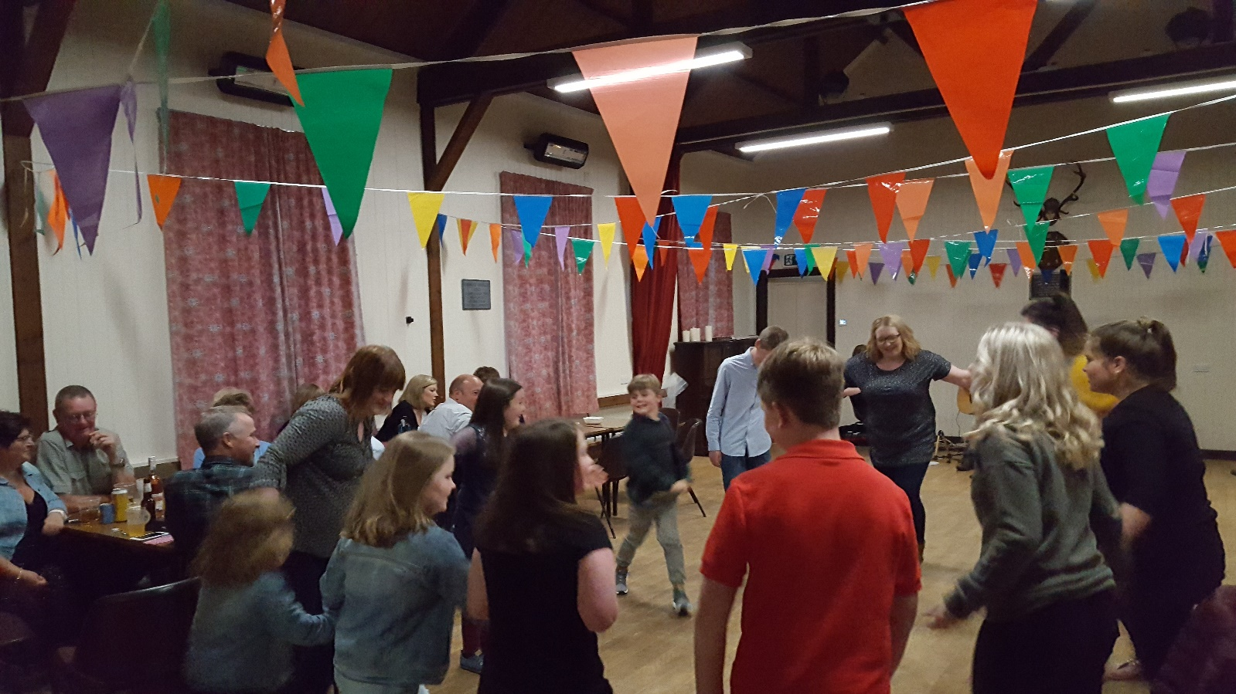

*The Community Council stand at the Energy group drop-in event held on Thursday 29 August 2019 …*

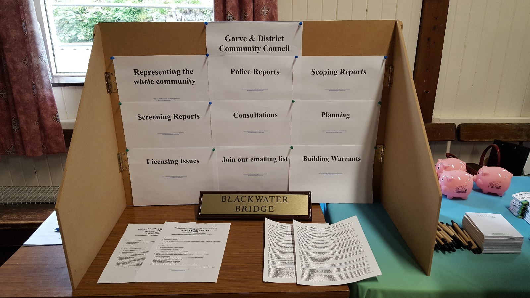

*More illegal dumping in the Achanalt area in recent weeks …*

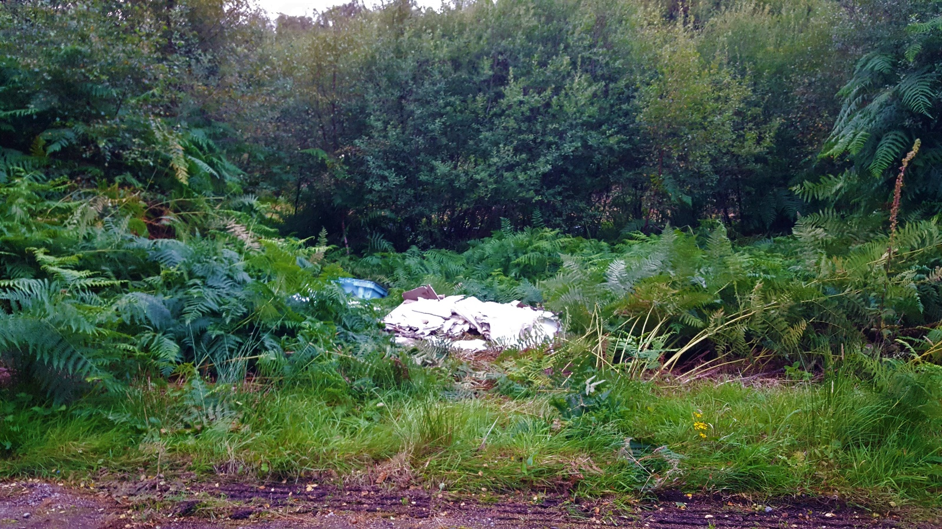

[www.community-council.org.uk/garveanddistrict](http://www.community-council.org.uk/garveanddistrict)

[garveanddistrictcc@yahoo.com](mailto:garveanddistrictcc@yahoo.com)