**Minutes of the Garve & District Community Council ordinary meeting**

**held on Tuesday 1 December 2020 via Zoom webcam**

**Community Council members present on webcam**: Kenny Maclean (Chairman), Caroline Gamble (Treasurer), Bob Moir (from 7.15pm), Sadie-Michaela Harris and co-opted member Hamish Leslie Melville.

**Also present on webcam**: Nick Sage (Infinergy), Fiona Milligan (Infinergy from 7.20pm), Sue Tarr (Chair, TG&DDC), Tina Hartley (Community Engagement and Development Officer, TG&DDC) and one member of the public.

**Present on conference call**: Jennifer Haslam (Secretary).

**Apologies**: Community Council member Joe Stewart and Cllr Dr Ian Cockburn.

The Chairman opened the meeting at 7.00pm and welcomed everyone and explained that this meeting was being held via webcam due to the current Coronavirus situation. He reminded members of the public that they were still very welcome to attend Community Council meetings even on webcam and take part in the discussions under his guidance.

The Community Council website [www.community-council.org.uk/garveanddistrict](http://www.community-council.org.uk/garveanddistrict) continues to be well used, still receiving around 150 “hits” per month. As always, our Chairman, who is the website’s administrator, has no way of knowing who visits, he just sees the numbers. Updates between meetings continue to appear on the bottom of the home page.

Well done to all involved in ensuring Christmas lights were put up in Garve this year. The lights were turned on last weekend and have added a lot of colour to the community. Several households have also put up lights to add to the display in the village. There is a Christmas garden and window competition, more details at [garve.org/christmas-cheer](https://garve.org/christmas-cheer)

**Declarations of Interest** – Co-opted member Hamish Leslie Melville declared an interest in the Infinergy project. Community Council member Sadie-Michaela Harris is a Director of the LCT. Community Council members confirmed that they had read all documents due to be discussed tonight before the start of this meeting.

**Approval of draft minutes** of the last ordinary meeting held on Tuesday 3 November 2020 via webcam were proposed (after a typing error was noted and corrected on page three) by Sadie-Michaela Harris and seconded by Caroline Gamble. Minutes are available at Garve Post Office, Achnasheen Village Noticeboard, on our website or via email. Minutes will be signed by our Chairman and Secretary when they next see each other in person (socially distanced of course).

**Matters arising** – **Infinergy** – Co-opted member Hamish Leslie Melville declared an interest in this project and took no part in the discussions. Infinergy will be holding a live webinar on their website ([www.lxxwindfarm.co.uk](http://www.lxxwindfarm.co.uk)) on Thursday 3 December 2020 to give the community an opportunity to ask any questions about their project to extend the Lochluichart windfarm at 2.00pm and 7.00pm. Infinergy have sent newsletters to every house in the community. As things stand, they are proposing increasing the hub height (76m – 83m) and tip heights (133.3m – 149.9m) but keeping the turbines and infrastructure in the same location. All this will be subject to planning permission. Anyone who can’t attend the webinar can still contact Infinergy directly with any questions they may have. The Highland Council scoping response suggests new bird and bat surveys over perhaps two years may be required following feedback from consultees. Nick Sage from Infinergy confirmed that they won’t be applying for planning permission by the end of this year as they had hoped and discussions regarding the scoping response was ongoing. Nick Sage was thanked for attending and for his updates.

**The EDF Education & Training fund** is still available. The deadline for applications is Monday 11 January 2021. More details are available at [www.foundationscotland.org.uk/programmes/edf-corriemoillie-education-and-training/](http://www.foundationscotland.org.uk/programmes/edf-corriemoillie-education-and-training/)

**SSE** – still no word from SSE regarding possible power supply capacity issues in Achnasheen for the EVC which is still not operational but the Scottish Government has confirmed that they would have no objections to the EVC being moved if the wayleave issue can not be resolved. The Highland Council can not confirm if the unit would stay in Achnasheen or even within the Community Council area if it is moved as there is demand from other communities for these units however, The Highland Council have asked to be put in touch with the Trustees of Garve Public Hall to see if a EVC can be placed there. Still no word on the damaged fence at Grudie Power Station. We did ask for a SSE representative to attend this meeting, no reply received.

**Highland Council updates** – [www.highland.gov.uk](http://www.highland.gov.uk) – The Highland Council has announced that glass recycling is moving from segregated to mixed glass recycling. All glass banks at Recycling Points are now accepting any coloured glass bottles and jars, making recycling much easier for the public. More details at <https://www.highland.gov.uk/news/article/13000/mixed_glass_recycling_for_highland>

**New crash barriers west of “Corran”** – Cllr Dr Ian Cockburn has talked to the road’s engineer after our last meeting and they are going to put a bid in for a barrier. Our thanks to Cllr Cockburn for his update.

The day following our last ordinary meeting, the Secretary discovered a **car bumper and tyres** dumped in the layby before Lochluichart Church. Pictures were taken and forwarded to The Highland Council who tidied up the area the very next day. Our thanks to everyone involved for their prompt response. The Secretary also discovered tyres dumped below “Jock’s” layby at the bottom of Fannich road end. This has also been reported accordingly.

**The Highland Council’s winter service** started on the 14 October 2020 and continues until 14 April 2021. More details including the Winter Service Policy is available at <https://www.highland.gov.uk/info/20005/roads_and_pavements/107/winter_road_maintenance>

The Highland Council notes that **residents should report issues directly** to them by calling The Highland Council’s Call Centre on 01349 886606 or via [www.highland.gov.uk/report](http://www.highland.gov.uk/report) In all cases, you will be given a reference number. The Highland Council also appreciate photos showing the actual problem.

Community Council member Bob Moir joined the meeting at 7.15pm.

**Network Rail** – work on the **Garve railway station footbridge** appears complete and the bridge is looking very smart with its new coat of paint. Today, we learnt that Network Rail are going to install VeloSTRAIL matting at the **Garve Level Crossing** following the number of cyclists falling at the crossing over recent years. Works are scheduled with an anticipated completion by April 2021. Transport Scotland are funding these works, Network Rail will undertake the works on their behalf. It should be noted that it will still be mandatory for cyclists to dismount and walk over the crossing even after these works have been completed (See Highway Code rule 82).

**In other Network Rail news**, the A890 will be closed at the Lair railway bridge at Achnashellach from 10.00pm on Tuesday 15 December 2020 until 6.00am on Wednesday 16 December 2020. Diversion will be via A896 Lochcarron - Shieldaig - Torridon - Kinlochewe and then A832 Kinlochewe – Achnasheen. This is to allow Network Rail to inspect the railway bridge but emergency vehicles will still be able to get through. This update has already appeared on our website.

Fiona Milligan (Infinergy) joined the meeting at 7.20pm.

Various issues were raised about **Little Garve** at our last ordinary meeting (paths, parking, signs and bins). It was suggested a group of private individuals come together to discuss a way forward. Tina Hartley (Community Engagement and Development Officer, TG&DDC) confirmed to this meeting that the issues have been raised on [garve.org](http://www.garve.org) and it is hoped a short-term working group can be formed to look into these various issues. Our thanks to Tina for the update.

**Dumping in Strathgarve Quarry** – Community Council member Sadie-Michaela Harris confirmed the dumped car parts have been removed. There are still some small plastic bits that she will clear up this week. Our thanks to Sadie.

**Remembrance Sunday** –A Wreath was laid on behalf of the community by our Chairman on Remembrance Sunday in line with social distancing measures and Scottish Government advice at the time.

**Treasurers report** – As we are approaching the end of the calendar year, here is a full breakdown of the accounts. At the AGM the audited accounts dated Tuesday 31 March 2020 were approved as follows: Treasurer/Admin Fund - £409.84. Community Fund - £1,538.45. Newsletter Account - £744.50. Outgoings from Treasurer/Admin Fund: June 2020 - Accountancy Fees -£120.00. September 2020 - Expenses (cards, stamps etc) - £15.80. October 2020 - Expenses (cards, stamps etc) - £15.67. Income: July 2020 - Highland Council Grant - £445.20. Balance at Monday 30 November 2020 - £703.57. Outgoings from Community Fund: September 2020 – Robbie gift - £25.00. October 2020 – Plum tree £39.99. Balance at Monday 30 November 2020 - £1,473.46. Newsletter Account remains unchanged - £744.50. Balance as per bank statement November 2020 - £2,921.53. £35.00 for Data Protection will be deducted on or around Thursday 31 December 2020. For the benefit of newer members, our Chairman explained that the Community Fund is like our reserve and the Newsletter Account came from the old “News & Views” newsletter when it folded. Community Council member Bob Moir reminded the meeting that if the Community Council ever folded, The Highland Council would want its funds returned.

**AOB from Community Council members** – Co-opted member Hamish Leslie Melville updated the meeting that the new access ramp and disabled toilet are currently being installed at **Kinlochluichart Church**. There has been a temporary Church roof repair done but a more substantial job will need doing in the future. The building is a Grade II listed building so consultation with the Church of Scotland and Historic Scotland will be required. Hamish also asked if there was an update about the **Garve Hotel** which is currently closed and for sale. The Hotel was a major employer in the area. Tina Hartley (Community Engagement and Development Officer, TG&DDC) was able to update the meeting that they are still interested in buying some of the land but as things stand, the current owners wish to sell the Hotel and land together. Tina will continue to remind the owner and selling agents that there is community interest in some of the land in case their position changes. Tina was thanked for her update.

The Treasurer felt a *“thank you”* was owed to the **local energy group** who have once again provided payments to households in the area for heating/lighting costs. The Treasurer felt the £300 per household would be very welcome in many homes. Fiona Milligan (Infinergy) confirmed that other communities are following this community’s lead on this matter and have been in contact with the local energy group. Thanks to all involved.

**On behalf of Lochcarron Community Council**, our Chairman raised an issue that they have contacted all ward five Community Councils about. With the increase in tourists, rubbish is becoming more of an issue. If bins were removed for a trial period, would that encourage people to take their rubbish home? Members of this Community Council strongly felt it would not.

**AOB from members of the public** – Sue Tarr wished to thank our Chairman for passing on the updates regarding the EDF Education & Training fund so quickly.

**Screening reports, scoping reports and consultations** – we have received notice of two consultations. The first is from the Local Government Boundary Commission on their proposals for councillor numbers and ward boundaries in The Highland Council area. This consultation will last until Tuesday 26 January 2021. A copy of their consultation can be found at the following link - <https://consult.lgbc-scotland.gov.uk/reviews/highland_council_area_public_consultation/> If the proposals are adopted, everything east of Aultguish and east of Achnasheen would fall into a new larger Dingwall ward as from the next Highland Council elections which are currently scheduled for May 2022. Community Council members were not in favour as the distances Highland Councillors have to travel are huge as it is.

The second consultation is from the members of The Highland Council’s Tourism Working Group who previously tasked officers with the production of a Tourism Infrastructure Plan that would provide a simple audit of relevant, publicly provided tourism infrastructure around Highland which in turn will allow gaps in provision to be identified. A draft plan has been received for our comments. It is hoped a finalised plan could be in place soon and some work on filling gaps could then be done in advance of next season (assuming resources are identified).  Responses should be made by Friday 18 December 2020 to [Leona.Joiner@highland.gov.uk](mailto:Leona.Joiner@highland.gov.uk) Community Council members felt Motorhome overnight parking spaces and waste facilities are needed – possibly Silverbridge? This draft plan has been passed onto TG&DDC so recent community survey feedback can also be fed in.

All Highland Council consultations are available at <http://consult.highland.gov.uk/portal> All Scottish Government consultations are available at <https://consult.gov.scot/consultation_finder>

**Building warrants, planning issues and licensing issues –** A question was raised regarding the **Catering Trailer** … should it still be outside Garve Public Hall? Did planning permission not expire on Tuesday 30 June 2020 or has planning permission been extended? If extended, should the Community Council not have been consulted by the planning department? Enquiries will be made. *(Post meeting note – it appears that as the Catering Trailer is now effectively in storage, it is no longer a planning matter).*

Two previous planning applications have been determined by The Highland Council since our last ordinary meeting. 20/03271/FUL was the proposed erection of five detached holiday cabins just north of Ledgowan Lodge Hotel. The Highland Council has now granted permission with three conditions. More details are available on The Highland Council website. 20/04129/FUL was the proposed demolition of house (Shephard’s Cottage), erection of extension and installation of air source heat pump at Ledgowan Lodge. The Highland Council has now granted permission with one condition - for the avoidance of doubt the air source heat pump must be installed in accordance with the Microgeneration Scheme Guidance. The demolition of Shephard’s Cottage has already been completed.

One new planning application has been received by The Highland Council since our last ordinary meeting. 20/04346/OHL is a proposed conversion of the existing 11,000-volt overhead line to 33,000-volt overhead line with no additional apparatus and the installation of a two span 33,000-volt overhead line to connect a mast site above Grudie Power Station. Community Council members were informed by email and raised no objections.

All planning applications can be viewed at [www.highland.gov.uk/info/180/planning_-_applications_warrants_and_certificates/143/planning_permission/4](http://www.highland.gov.uk/info/180/planning_-_applications_warrants_and_certificates/143/planning_permission/4)

**Dates of future meetings**

*(Ordinary meetings are usually held on the first Tuesday of every month unless stated otherwise)*

January 2021 – no meeting

Tuesday 2 February 2021, 7.00pm, venue/webcam tbc

Tuesday 2 March 2021, 7.00pm, venue/webcam tbc

Tuesday 6 April 2021, 7.00pm, venue/webcam tbc

Tuesday 4 May 2021, 7.00pm, venue/webcam tbc

Tuesday 1 June 2021, AGM followed by an ordinary meeting, 7.00pm, venue/webcam tbc

July 2021 – no meeting

Tuesday 3 August 2021, 7.00pm, venue/webcam tbc

Tuesday 7 September 2021, 7.00pm, venue/webcam tbc

Tuesday 5 October 2021, 7.00pm, venue/webcam tbc

Tuesday 2 November 2021, 7.00pm, venue/webcam tbc

Tuesday 7 December 2021, 7.00pm, venue/webcam tbc

Members of the public are very welcome to attend Community Council meetings and take part in the discussions under the guidance of the Chairman. A copy of the Constitution that every Community Council in the Highlands has to work to is available on The Highland Council website - [www.highland.gov.uk/downloads/file/21179/scheme_of_establishment_final_sept_2019](http://www.highland.gov.uk/downloads/file/21179/scheme_of_establishment_final_sept_2019)

The Chairman thanked everyone for attending.  He also thanked Community Council member Sadie-Michaela Harris for hosting the Zoom webcam session and as this was the final scheduled meeting of 2020, wished everyone a Merry Christmas and a Happy New Year. The Chairman closed the meeting at 8.10pm.

Signed ……………………………..

Signed ……………………………..

Date ……………………………….

*A Wreath was laid on behalf of the community by our Chairman on Remembrance Sunday in line with social distancing measures and Scottish Government advice at the time …*

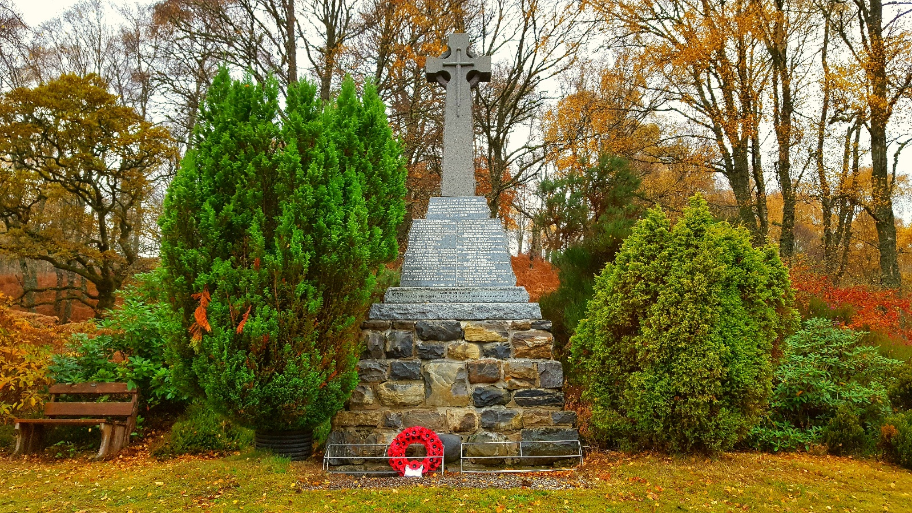

[www.community-council.org.uk/garveanddistrict](http://www.community-council.org.uk/garveanddistrict)

[garveanddistrictcc@yahoo.com](mailto:garveanddistrictcc@yahoo.com)