**Minutes of the Garve & District Community Council ordinary meeting**

**held on Tuesday 2 June 2020 via Zoom webcam**

**Community Council members present on webcam:** Kenny Maclean (Chairman), Caroline Gamble (Treasurer), Eliza Leslie Melville, Sadie-Michaela Harris and co-opted member Hamish Leslie Melville.

**Also present on webcam:** Sue Tarr, Chair, TG&DDC and Tina Hartley, Local Development & Engagement Officer, TG&DCC (7.45pm-7.55pm).

**Present on conference call:** Jennifer Haslam (Secretary).

**Apologies:** Community Council members Bob Moir and Joe Stewart.

**The Chairman opened this meeting at 7.15pm** and welcomed everyone and explained that this meeting was being held via webcam due to the current Coronavirus situation. He reminded members of the public that they were very welcome to attend Community Council meetings even on webcam and take part in the discussions under his guidance. In recent weeks Hamish Leslie Melville has been co-opted onto the Community Council but there is still a vacancy if anyone else is interested as Eliza Leslie Melville retires tonight. The Chairman noted that the Coronavirus situation has been a problem for many in this area but we have put people in contact with the relevant authorities and hope everyone is doing well. Our April and May ordinary meetings were cancelled due to the virus and a lack of business. Since our last ordinary meeting we have lost two residents. Ken Duffield of Achnasheen and Chris Macrae of Gorstan. Ken and his family have owned Ledgowan Hotel in Achnasheen for over 15 years and had become very much part of the place. Chris was a member of the Garve Public Hall committee for over 50 years. Our thoughts are with both families. We learnt last month that the Garve Hotel is to close. Community Council members wished to place on record their thanks to Gemah and all her staff for their help to this community over the years and wish them well for the future. We send Community Council member Bob Moir our best wishes on completing 10 years’ service on the Community Council.

**Declarations of Interest** – none. Community Council members confirmed that they had read all documents due to be discussed tonight before the start of this meeting.

**Approval of draft minutes** of the last ordinary meeting held on Tuesday 3 March 2020 in Garve Public Hall were proposed without amendment by Sadie-Michaela Harris and seconded by Kenny Maclean. Minutes are available on the Achnasheen Village Noticeboard, on our website or via email.

**Matters arising – EDF** - A reminder the **EDF Corriemoillie** **Education & Training fund** deadline for applications is Monday 29 June 2020. Decisions will be made in August 2020. More details at <https://www.foundationscotland.org.uk/programmes/edf-corriemoillie-education-and-training/> This update has already appeared on our website. Sue Tarr updated the meeting that the panel are being very flexible around the Coronavirus situation taking applications at short notice if necessary. Sue was thanked for her update.

**Highland Council updates** – [www.highland.gov.uk](http://www.highland.gov.uk) – we note Mackenzie Sutherland is now acting roads officer for Ward five. Issues around Little Garve, Strathgarve and outside the school will be reported.

**Dumping in laybys** at Grudie (six tyres) and at the Achnasheen recycle bins (glass doors) all noted and reported. **Fly tipping** took place on Forestry land at Strathgarve at the end of March. Murdo Maclennan from Forestry and Land Scotland is aware, our thanks to him and his team. The Highland Council re-opened some of its recycling centres yesterday for some waste. Dingwall recycling centre is open Monday to Friday 9.00am until 3.30pm (closed for lunch 12noon until 1.00pm). This update has already appeared on our website.

**Achnasheen electric vehicle charging point** – The charger is still not fully installed. Anna Myeshkova at The Highland Council tells us they hope to resolve all outstanding issues soon. We thank her for her update. Ewan Bush, the local Energy Officer is now liaising on this matter. It was agreed to formally invite Ewan to a future Community Council meeting.

The Highland Council in partnership with Scottish Water and the Scottish Government, have set up an **Emergency Water Scarcity Scheme for those on private water supplies.**  As part of the scheme, the Council can supply and deliver bottled water at no cost, to domestic private water supply users who are eligible under the scheme. This assistance is in addition to the Council’s current grant funding scheme that can offer a grant of up to £800 to undertake longer term improvements to a private water supply system. If you are served by a private water supply and need assistance under the scheme, please contact the Environmental Health team by email [envhealth@highland.gov.uk](mailto:envhealth@highland.gov.uk) or phoning 01349 886603. This update has already appeared on our website.

The Highland Council notes that **residents should report issues directly to them** by calling The Highland Council’s Call Centre on 01349 886606 or via [www.highland.gov.uk/report](http://www.highland.gov.uk/report) In all cases, you will be given a reference number. The Highland Council also appreciate photos showing the actual problem. **Streetlight faults** can be reported via [www.highland.gov.uk/info/20005/roads_and_pavements/110/street_lighting_and_traffic_signals](http://www.highland.gov.uk/info/20005/roads_and_pavements/110/street_lighting_and_traffic_signals) You will need to provide the reference number on the streetlight column. **Potholes** can be reported directly via The Highland Council website - [www.highland.gov.uk/info/20005/roads_and_pavements/96/road_faults](http://www.highland.gov.uk/info/20005/roads_and_pavements/96/road_faults) **Bulky uplift information** - [www.highland.gov.uk/info/1063/rubbish_-_household_waste/132/dispose_of_large_household_items](http://www.highland.gov.uk/info/1063/rubbish_-_household_waste/132/dispose_of_large_household_items) **Illegal dumping** can be reported via [www.highland.gov.uk/info/1054/rubbish_and_recycling/89/litter_and_fly-tipping](http://www.highland.gov.uk/info/1054/rubbish_and_recycling/89/litter_and_fly-tipping)

**Wondering dogs** – picture needed and then it needs to be sent to - [www.highland.gov.uk/info/1211/animal_welfare_and_pest_control/472/dog_control/2](http://www.highland.gov.uk/info/1211/animal_welfare_and_pest_control/472/dog_control/2) **Dog fouling** – picture needed and then it needs to be sent to - [www.highland.gov.uk/info/1330/street_care_and_cleaning/473/dog_fouling](http://www.highland.gov.uk/info/1330/street_care_and_cleaning/473/dog_fouling) In both cases, anonymous reports will not be accepted.

**Noisy neighbours** - [www.highland.gov.uk/info/1281/pollution/74/reporting_noise](http://www.highland.gov.uk/info/1281/pollution/74/reporting_noise) **BUT** anonymous reports will not be looked into.

The **Dingwall to Stromeferry Railway** will be 150 years old in August 2020. Scotrail have no plans to mark the occasion due to the ongoing Coronavirus situation. **Some work was taking place** on the railway in and around Garve in recent weeks. Community Council is not informed of such works, only neighbouring properties of the railway, but further enquiries can be made by contacting Network Rail directly on 03457 114 141

**2020 Community Ceilidh –** Community Council members unanimously agreed that the Community Ceilidh will be cancelled for this year. There are just too many unknown factors around the Coronavirus situation to plan for a Ceilidh just now.

**Contin bus** – Contin Community Council are having a feasibility study done to see what replacement service could be put on after the cuts to the Number 27. A new service may be of benefit to this area. Ewan Bush, the local Energy Officer is liaising on this matter. Community Council members felt that although parents can choose which school to send their children to, new transport links should not take away from our school. Sue Tarr updated the meeting that Ewan is looking to see what transport requirements there are for both the Garve and Achnasheen communities as well as North of Garve up to Aultguish. Such needs may need to be specially tailored to benefit all our communities. Consulting the community may be done through [garve.org](http://www.garve.org) under the current circumstances. Sue went on to explain that Ewan is employed for the next 2 years and has been looking into warmer homes by working with Home Energy Scotland and potential renewable energy generation projects. Sue was thanked for her updates. In related news, a **number of changes have been made to Westerbus**. We were not informed directly. Details of the changes have been sent to those on our emailing list. Westerbus can be contacted on 01445 712255 or [thewesterbus@btconnect.com](mailto:thewesterbus@btconnect.com) This update has already appeared on our website.

Following **Sue Tarr’s suggestion** of a meeting between G&DCC, LCT and TG&DDC, it has been suggested a public meeting to review the LCT 5-year plan and the community plan may be useful. We await further developments on this issue, subject to Coronavirus restrictions. In related TG&DDC news, further enquiries about the local **Defibrillators** should now be sent to the Development Company, not the Community Council.

**Garve & District Community Council currently has a vacancy on the Community Council.**  The Community Council members consider it to be very important to have as broad a representation of our community as possible, as we cover a wide variety of community issues and to do this well, we need members from all corners of our large area.  We usually meet on the first Tuesday of the month.  If you are aged 16 or over, live in the Community Council area and are on the electoral roll and would like to be considered for co-option onto the Community Council, please email [garveanddistrictcc@yahoo.com](mailto:garveanddistrictcc@yahoo.com) with your name and contact details.  Your nomination will be considered by Community Council members at their next ordinary meeting.

**Treasurers report** - The new and former Treasurer took Community Council members through the latest available figures. The latest bank statement shows a bank balance on Tuesday 31 March 2020 of £2,692.79. This figure breaks down as follows … Treasurers account - £409.84. Reserve - £1,538.45. Newsletter - £744.50. Expenses since the last ordinary meeting were March’s Hall hire £10.00.

**AOB from Community Council members** – On behalf of Community Council member Joe Stewart, our Chairman was asked to raise Joe’s concern’s around the increasing number of vehicles in the Little Garve area last weekend even though the Wyvis Playpark is still closed. Joe reported dozens of cars in the area making it difficult to get out and about. Cars were parked everywhere. The Treasurer and Sadie-Michaela Harris both agreed with Joe’s concerns. The Community Council would remind everyone that there are still lockdown restrictions in place and such guidance should be followed. We will make the Police aware of our concerns.

Tina Hartley, Local Development & Engagement Officer, TG&DCC joined the meeting at 7.45pm.

**AOB from members of the public** – No issues raised.

**Screening reports, scoping reports and consultations** – none. All Highland Council consultations are available at <http://consult.highland.gov.uk/portal> All Scottish Government consultations are available at <https://consult.gov.scot/consultation_finder>

**Building warrants, planning issues and licensing issues** - There are two new building warrants currently being shown on The Highland Council website for our area. 20/00586/DOM1 is to construct new level access path to front entrance of Lochluichart Church and 20/00831/DOM2 is to demolish an old house to the east of Achnasheen.

Two previous planning application have been determined by The Highland Council since our last ordinary meeting. 20/00304/FUL & 20/00310/LBC is to allow an access ramp into Lochluichart Church. Permission has been granted by The Highland Council with one condition - the proposed concrete-steps shall either be in stone (re-using the existing stone steps if possible, or new stone to colour-match) or in cast stone (with sample to be approved in writing by the Planning Authority prior to the commencement of development) in order to safeguard the character and qualities of the listed building.

20/00811/LBC was the proposed re-roofing/re-slating of Lochluichart Church. Permission has been granted with three conditions - the existing slates shall be salvaged where possible. Modern roof-vents will not be acceptable on the main pitches. All rainwater goods shall be made of cast iron or cast aluminium. All conditions are in order to safeguard the character and qualities of the listed building.

Six new planning applications have been received by The Highland Council since our last ordinary meeting. 20/01207/FUL are for earthworks and drainage remedial works on the railway, land 4500metres North East of Glencarron Lodge. Community Council members were informed by email and raised no objections to the application. This update has already been posted on our website. The planning application was granted with no conditions last Wednesday.

20/01593/OHL is the proposed upgrading of the existing 11,000-volt overhead line to 33,000-volt overhead line between Grudie and Fannich. Community Council members were informed by email and raised no objections to the application. This update has already been posted on our website. The planning application was not objected to by the Planning Officer on Tuesday 19 May 2020.

20/01698/FUL are the proposed earthworks on the railway, land 2175metres North East of Achnasheen. 20/01697/FUL are the proposed earthworks on the railway, land 1250metres North East of Achnasheen. Community Council members were informed by email and raised no objections to these applications. This update has already been posted on our website.

20/01795/DEM is the proposed demolition of “Druimdhu” house, one mile east of Achnasheen. Any comments to the Case Officer by tonight. This relates to building warrant 20/00831/DOM2. Community Council members raised no objection to the application.

20/01938/PIP is a renewal of a proposed erection of a house, plot 2, land 1KM South of Achnaclerach. Any comments to the Case Officer by next Wednesday 10 June 2020. Community Council members raised no objections.

All planning applications can be viewed at [www.highland.gov.uk/info/180/planning_-_applications_warrants_and_certificates/143/planning_permission/4](http://www.highland.gov.uk/info/180/planning_-_applications_warrants_and_certificates/143/planning_permission/4)

**Dates of future meetings**

*(Ordinary meetings are usually held on the first Tuesday of every month unless stated otherwise)*

July 2020 – no meeting

Tuesday 4 August 2020, 7.00pm, venue/webcam tbc

Tuesday 1 September 2020, 7.00pm, venue/webcam tbc

Tuesday 6 October 2020, 7.00pm, venue/webcam tbc

Tuesday 3 November 2020, 7.00pm, venue/webcam tbc

Tuesday 1 December 2020, 7.00pm, venue/webcam tbc

January 2021 – no meeting

Tuesday 2 February 2021, 7.00pm, venue/webcam tbc

Tuesday 2 March 2021, 7.00pm, venue/webcam tbc

Tuesday 6 April 2021, 7.00pm, venue/webcam tbc

Tuesday 4 May 2021, 7.00pm, venue/webcam tbc

Tuesday 1 June 2021, **AGM** followed by an ordinary meeting, 7.00pm, venue/webcam tbc

Members of the public are very welcome to attend Community Council meetings and take part in the discussions under the guidance of the Chairman. A copy of the Constitution that every Community Council in the Highlands has to work to is available on The Highland Council website - [www.highland.gov.uk/downloads/file/21179/scheme_of_establishment_final_sept_2019](http://www.highland.gov.uk/downloads/file/21179/scheme_of_establishment_final_sept_2019)

The Chairman thanked everyone for attending. He also thanked Community Council member Sadie-Michaela Harris for hosting the Zoom webcam sessions. The Chairman closed the meeting at 7.55pm.

Signed ……………………………..

Signed ……………………………..

Date ……………………………….

*The Cherry tree and Daffodils beside the steps up to Garve War Memorial …*

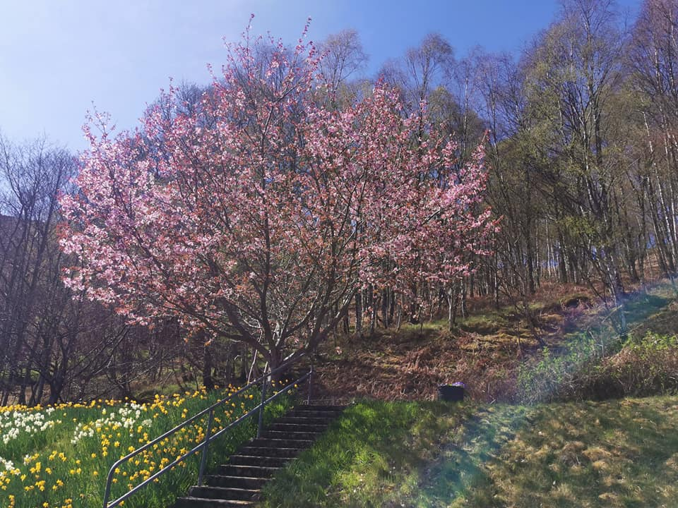

[www.community-council.org.uk/garveanddistrict](http://www.community-council.org.uk/garveanddistrict)

[garveanddistrictcc@yahoo.com](mailto:garveanddistrictcc@yahoo.com)