**Minutes of the Garve & District Community Council ordinary meeting**

**held on Tuesday 3 November 2020 via Zoom webcam**

**Community Council members present on webcam**: Kenny Maclean (Chairman), Caroline Gamble (Treasurer), Bob Moir, Joe Stewart, Sadie-Michaela Harris and co-opted member Hamish Leslie Melville.

**Also present on webcam**: Cllr Dr Ian Cockburn, Sue Tarr (Chair, TG&DDC), Tina Hartley and Yvonne Boa (Community Engagement and Development Officers, TG&DDC), Nick Sage and Fiona Milligan (Infinergy from 7.00pm until 7.30pm) and one member of the public from 7.40pm.

**Present on conference call**: Jennifer Haslam (Secretary).

**Apologies**: PC Kelly Murray.

The Chairman opened the meeting at 7.00pm and welcomed everyone and explained that this meeting was being held via webcam due to the current Coronavirus situation. He reminded members of the public that they were still very welcome to attend Community Council meetings even on webcam and take part in the discussions under his guidance. Best wishes to our Treasurer Caroline Gamble who retires from her day job at the NHS tomorrow.

**Declarations of Interest** – Co-opted member Hamish Leslie Melville declared an interest in the Infinergy project. Community Council member Sadie-Michaela Harris has recently been elected a Director of the LCT. The Secretary has recently retired as a Director of the LCT. Community Council members confirmed that they had read all documents due to be discussed tonight before the start of this meeting.

**Approval of draft minutes** of the last ordinary meeting held on Tuesday 6 October 2020 via webcam were proposed without amendment by Bob Moir and seconded by Caroline Gamble. Minutes are available at Garve Post Office, Achnasheen Village Noticeboard, on our website or via email.

**Matters arising** – We have now purchased a **Plum tree** as a thank you gift to Eliza Leslie Melville for her many years of service to this community. The tree has been planted at the lodge. We send her our best wishes and our thanks to everyone who helped make this possible. Eliza has been in touch thanking us for the Plum tree and to thank all concerned.

**Infinergy** – Co-opted member Hamish Leslie Melville declared an interest in this project and took no part in the discussions.  Nick Sage explained that the scoping report was sent to The Highland Council on Wednesday 14 October 2020.  The new application will incorporate a request for planning permission allowing an operational lifetime of 40 years, compared to the 25 years which the consent granted in July this year achieved.  Infinergy hope to submit a formal planning application by the end of the year.  Due to Coronavirus, all planning documents will only be available online.  In answers to questions from Community Council members, Nick felt it would be in the financial interests of the operator of the project to keep the turbines maintained and fault-free and that planning conditions have been applied in the past to ensure this.  Hub height may change from 76metres to 83metres if the taller (149.9m) turbines are granted permission.  Generating capacity of each turbine would increase from 3.6MW to 4.8MW if planning is granted, so up to 24MW windfarm.

Fiona Milligan then went on to explain that the public consultation would be done online this time due to Scottish Government guidelines.  She noted that in some areas, a better response rate and therefore demographic had been received by developers using this system.  An online feedback form would also be available.  Those who can’t use webcam/internet could request hard copies of the proposals.  It was suggested two online “open” sessions, perhaps on Zoom, one at 2.00pm and another at 7.00pm might be the way forward, perhaps on two different days, open for an hour at a time.  Date TBC but a newsletter would be going to every house in the area in due course with all the details.

Fiona Milligan and Nick Sage were thanked for attending and left the meeting at 7.30pm.

**SSE fence at Grudie** – Morven Smith and Peter Gilmour from SSE have both been in touch to say that they will look into the matter and action. We thank them both for the updates. The Secretary visited the site recently and no work has been carried out on the fence. She has stuck sticks into the fence to try to stop Deer getting through and onto the road. We will ask SSE for a further update.

**Highland Council updates** – [www.highland.gov.uk](http://www.highland.gov.uk) – **Mess behind Silverbridge toilets** has been cleaned up but a **sofa has been dumped!** The sofa has been reported to The Highland Council for uplift which has now taken place. Community Council member Sadie-Michaela Harris **found tyres dumped** in Little Garve which have also since been cleared up. Our thanks to Les Ross and his team for his help in this matter.

Our thanks to co-opted member Hamish Leslie Melville and staff of the Lochluichart Estate who have, in recent weeks, **cuts bushes back** at Gorstan Junction to help signage to be seen and for the safety of road users. The Secretary noted the vast improvement!

**Speeding through Mossford and Lochluichart** – The Police’s Road Policing Unit have been made aware of our concerns regarding the issues in the Mossford/Lochluichart area and they hope they can assist with some periodic enforcement. Cllr Dr Ian Cockburn has raised the issue at the latest area committee but officials are about a year behind in completing traffic order paperwork at present. In the meantime, Highland Council speed cameras will be deployed in the area which was welcomed by Community Council members as a good first step along with the Police’s assistance.

**Achnasheen EVC** is still not operational. The matter has now been passed to various Councillors and officials within The Highland Council and to the Scottish Government who, it is believed, financed the purchase of the charger in the first place. We have also kept Ewan Bush, the Local Energy Officer informed. There appears to be a possible issue about “loads” on the local network if such a machine was installed. Why wasn’t this flagged up earlier? We will seek clarification from SSE.

**The Highland Council’s winter gritting service** started on the 14 October 2020 and continues until 14 April 2021. More details including the Winter Service Policy itself is available at <https://www.highland.gov.uk/info/20005/roads_and_pavements/107/winter_road_maintenance> Today, The Highland Council announced it has invested in 10 new winter gritting vehicles to replace some of the ageing fleet, which are ready to be deployed as soon as they are needed. The winter roads maintenance budget for 2020/21 is £5million which will be used to look after the 6,766km of roads in the Highlands.

**From Torridon & Kinlochewe Community Council minutes** dated Wednesday 23 September 2020 where Highland Council Roads Department Officials were in attendance … *“It is estimated that £180m is needed to cover the backlog of maintenance required on Ward 5 roads. £22M just to maintain the road network in its current state. Yet the HC Roads Department receives only £6m per year and with Covid putting further pressure on funding, the situation appears to be getting worse. There is a desperate need for more manpower, as the Department is currently down to approximately 35% of the required workforce – staff are off sick and vacancies remain unfilled. The problems in Ward 5 are exacerbated by the fact that many of the roads are very old and were not built to deal with current traffic volumes. As roads age, they require surfacing, and yet at current investment levels the Department is only able to resurface 2% of HC roads per year.”* We are lucky in Garve & District to have had so much work done. Our thanks to all involved.

The Highland Council notes that **residents should report issues directly** to them by calling The Highland Council’s Call Centre on 01349 886606 or via [www.highland.gov.uk/report](http://www.highland.gov.uk/report) In all cases, you will be given a reference number. The Highland Council also appreciate photos showing the actual problem.

**BEAR update** – resurfacing works were completed on the A835 at Garve but slightly behind schedule due to the heavy rain. A Community Council member asked about the white lines, should they not be double white lines on the bends? We have been advised that the road markings and studs though this section of works were put back *“like for like”* after confirming they conformed to current roadmaking standards however, to encourage drivers to stick to the 40mph limit, BEAR will be putting in additional 40mph roundels and “slow” markings on the road. The double white lines would not be placed at this section of the carriageway due to the narrow widths of the road which would run the risk of drivers encroaching verges.

**Network Rail update** – work on the Garve Railway Station Footbridge finally started on Wednesday 7 October 2020. Work appears slow but heavy rain probably hasn’t helped. One to watch!

**Dumping in the Quarry at Strathgarve** - cleared? Community Council member Sadie-Michaela Harris will inspect.

**Proposed removal of payphones** – At a full meeting of The Highland Council on Thursday 29 October 2020, it was agreed a response to BT’s proposal to remove 107 of the 348 payphones from across the Highland area including the four in our area be raised. Based upon consultation feedback, The Highland Council will now formally object to 65 payphones being removed including ours. Highland Councillors emphasised the importance of BT’s payphones across the Highlands, not least in times of emergency. Extreme disappointment was also expressed by Highland Councillors that, not only is such an exercise being carried out by BT during a global pandemic, but that it also comes just nine months after the conclusion of a previous consultation on this matter.

Following the lengthy and candid discussion at our last ordinary meeting around **Andy Mudd (ASPE)’s report**, and further emails, the Community Council members have agreed that this project must be put on hold until a face to face workshop can be held.  We appreciate that could be some time away but there are just too many issues that need to be discussed further by everyone involved.  It was also suggested that no more consultancy fees be spent for now. We send our thanks to Tina Hartley, Community Engagement and Development Officer at TG&DDC and Carol Smith, Company Secretary, LCT who have both confirmed that both Board’s agree with our position on this matter. However, we are also grateful to Sheila Mitchell, Secretary of TG&DDC who has been able to clarify the following … *“I can confirm that it is not policy to recruit from just out with the local area although in regard to the post of CEDO, it was the advice of Foundation Scotland and general view of the community at the time that it was preferable; any application which met the essential criteria for the posts would have been considered. At the time when the CEDO role was been recruited for, Tina and Lucy applied as TLC + Associates, the rural consultancy business they have owned and managed since 2013. TLC + Associates were appointed to the post on a self-employed basis, with Tina and Lucy sharing the Garve workload between them. Following Lucy’s decision to move on, Yvonne Boa, as an associate of TLC took on Lucy’s Development Company work. This process is in accordance with the Service Agreement TLC + Associates have with the Development Company.”* This update has already appeared on our website.

**Remembrance Sunday** – Due to the ongoing Coronavirus situation, The Highland Council has advised that this year, we remember and observe the national 2-minute silence at home. The acting minister informs us that … *“I would encourage everyone to pause and reflect on Remembrance Sunday at home and give thanks for the service and sacrifice of all those who have served and continue to serve. I will be preparing a Remembrance Sunday service which will be shared on the following link -* [*https://www.youtube.com/playlist?list=PLVrGUJlUCtK0lwWC2jXzJiUsaBrsZ0Neg*](https://www.youtube.com/playlist?list=PLVrGUJlUCtK0lwWC2jXzJiUsaBrsZ0Neg)*”* Our thanks to James Bissett for his email. It was felt by Community Council members that a Wreath should still be laid at Garve War Memorial on behalf of the community as usual. Community Council members asked our Chairman to attend to this which he will in due course.

**Police report** -

|  |  |
| --- | --- |
| **Ward and Local Policing**  **Plan Priorities.** | **Activities conducted over the reporting period to support those priorities.** |
| 1.Road Safety  2.Anti-Social Behaviour  3.Alcohol/Drug Misuse  4.Crimes/ Crimes of Dishonesty    5. Concern for person  6. Other | During the reporting period, there were a total of **sixteen** Road Traffic matters reported to police. There was **six** Road Traffic Collision (**two** hit deer), **three** complaint of standard of driving. There were **three** reports of dangerous driving, **one** vehicle obstructions, **two** dangerous parking and **one** dangerous overtake.  During the reporting period **one** incident containing an anti-social element were reported to police.  No drug misuse related incident were reported during this period. Appropriate action continues to been taken by Police Scotland who carry out patrols in the area with stop/checks being carried where circumstances allow.  There have been **three** crimes reported to police over the reporting period. These relate to **two** theft (theft of bicycle and theft of road sign) and **one** communications offence. **One** intruder alarm activation during this time period, all was in order. **One** crime of Vandalism.  There have been **two** concern for persons reported to police and **one** dropped 999 call whereby person was traced.  There has been **one** report of unauthorised encampment – with tents and setting fires, **one** planned shoot, **two** incidents involving assisting members of the public and **two** incidents of lost / found property. |
| **Update on Previously Agreed Actions.** | |
| The total number of calls for the area was **49** (previous year **45**), but it should be highlighted that **three** of these calls were duplicates. These figures show an almost like for like versus previous year’s incidents. It should be noted that a large proportion these calls were concern for persons, advice calls, routine calls and administrative calls such as licensing requirements and calls with good intent, these calls were dealt with accordingly by attending officers. Patrols will continue to be carried out within the area where permitted. It is requested that the public should report anything suspicious to police via **101** / emergencies **999** or alternatively contacting **crime stoppers on 0800 555 111**. | |
| **Update on any local community safety issues.** | |
| As highlighted, you are all increasing concerned with the increase in traffic over the past month. I have passed on this information including vehicle behaviour as an on-going concern, whether speeding or manner of driving. This information has been passed to Road Policing Unit. I would still encourage all members of the community to call the police with their concerns, if we don’t know about it, we can’t act upon it. Our time will not be wasted, if the information you pass to us isn’t deemed appropriate of police attendance it can be recorded on an intelligence database. | |
| **Any local / Area Command / Divisional / Police Scotland updates / key messages** | |
| **Beat Doorstep Crime -** From bogus callers to rogue traders, doorstep criminals are cunning, creative, and very skilled at deception. They will use a number of ways to try and gain entry to your home to steal and trick you out of money. Links to the various sections on [Police Scotland website](http://www.scotland.police.uk/whats-happening/news/2015/november/police-scotland-guidance-following-the-attacks-in-paris) | |

**Treasurers report** – Expenses in the last month were Plum tree £39.99, cards £14.15 and stamps £1.52. Bank balance is £2,921.53. The Treasurer can now sign cheques as can the Secretary and our Chairman. Two signatures are required per cheque (as before).

**AOB from Community Council members** – Community Council member Joe Stewart asked about the **Drovers Road** from Little Garve to Aultguish. Has Scottish Forestry objected to its use? Cllr Dr Ian Cockburn confirmed that the path has now been approved to be a core path and Scottish Forestry’s objection was overruled by the local area committee. It was noted the path is overgrown in places. Cllr Cockburn informed us that funding may be available for repairs and upgrading of the path. **Cycle paths** are on the community wish list, perhaps the two issues could be looked at together? Joe also noted that **parking** is still an issue in the Little Garve area - what can be done? There’s also been issues at Ben Wyvis carpark. **Emptying campervan toilets** has also become an issue in Little Garve. Cllr Cockburn confirmed that funding was available on this matter and there are plans to install chemical waste facilities at Highland Council toilets but discussions with SEPA are ongoing as it’s not a “one size fits all” solution. More **bins** would also be needed but who would empty them? It was felt **signage** for the playpark and signage for the Silverbridge toilets needs improving. Improved signage for Garve & District is number 10 on the recent community priority survey out of 16 issues identified. Tina Hartley, Community Engagement and Development Officer at TG&DDC reminded those attending that the updated Community Development Plan is available on garve.org and if people come together with ideas/solutions, both she and Yvonne are happy to help work with the group to try and address these issues.

**AOB from members of the public** – It was noted another car has gone down the embankment west of “Corran” at Gorstan. This is the fourth car in the last few years. Perhaps a crash barrier is required? Cllr Dr Ian Cockburn will make enquiries.

**Screening reports, scoping reports and consultations** – We have received one scoping report - 20/04057/SCOP, Lochluichart Wind Farm Extension II, proposed erection of five wind turbines of up to 149.9m blade tip height and associated infrastructure. This is NOT a planning application. Community Council members had no objections to this report.

We have received one consultation - The Highland Council is inviting the public and interested parties to participate in shaping the guidance on how the Council will promote and determine rural housing applications across the whole of the Highlands. The guidance is being revised to make it clearer and more concise; and to refine the criteria for small scale housing development in the countryside.  Full details of all the changes can be found on the Council’s [Consultation Portal](https://eur02.safelinks.protection.outlook.com/?url=https%3A%2F%2Fconsult.highland.gov.uk%2Fkse%2F&data=04%7C01%7C%7C71e9b3b46c064962023e08d87c1328a9%7C89f0b56e6d164fe89dba176fa940f7c9%7C0%7C0%7C637395769004872006%7CUnknown%7CTWFpbGZsb3d8eyJWIjoiMC4wLjAwMDAiLCJQIjoiV2luMzIiLCJBTiI6Ik1haWwiLCJXVCI6Mn0%3D%7C1000&sdata=cQZfT1SlP4NQ6ol3STD1G%2BALhByvDSLI4ZOJlWC6fvI%3D&reserved=0) and comments should be submitted by Friday 18 December 2020. Community Council members had no comments.

There is also a consultation ongoing regarding social housing allocation - <https://www.smartsurvey.co.uk/s/hhr-20/> Deadline for comments is Monday 30 November 2020. Community Council members had no comments.

All Highland Council consultations are available at <http://consult.highland.gov.uk/portal> All Scottish Government consultations are available at <https://consult.gov.scot/consultation_finder>

**Building warrants, planning issues and licensing issues –** Two previous application have been determined by The Highland Council since our last ordinary meeting. 20/01938/PIP is the proposed erection of house, installation of private drainage and upgrading of access at plot 2, land 1KM South of Achnaclerach. This planning in principle application has been granted with fourteen conditions. More details on The Highland Council website.

20/03190/FUL was for the continuation of rock excavation (Renewal of planning permission 14/03799/FUL) and processing of construction and demolition waste at Achnasheen Quarry. This planning application has been granted with four conditions. More details on The Highland Council website.

There is one new building warrant to note, 20/01746/DOM1 is the proposed bigger opening and new lintel at 5 Mossford.

There is another new building warrant currently being shown on The Highland Council website for our area. 20/01667/DOM3 is to erect an extension for Boot Room and Renewable Energy Plant Room at Ledgowan Lodge. This is tied in with one new planning application for our area. 20/04129/FUL is the proposed demolition of old house, erection of extension and installation of air source heat pump at Ledgowan Lodge. The old house in question is Shepherd's Cottage to the east of the Lodge which has already started to be taken down as a building warrant was granted for that work some time ago. Community Council members raised no objections to this planning application.

All planning applications can be viewed at [www.highland.gov.uk/info/180/planning_-_applications_warrants_and_certificates/143/planning_permission/4](http://www.highland.gov.uk/info/180/planning_-_applications_warrants_and_certificates/143/planning_permission/4)

**Dates of future meetings -** It should be noted 1.2 of standing orders (first Tuesday of each month accept January and July when no meeting shall take place). It was agreed that venue or webcam can be agreed nearer the time of each meeting. The dates of future meetings were proposed by Kenny Maclean and seconded by Jennifer Haslam, all agreed.

Tuesday 1 December 2020, 7.00pm, venue/webcam tbc

January 2021 – no meeting

Tuesday 2 February 2021, 7.00pm, venue/webcam tbc

Tuesday 2 March 2021, 7.00pm, venue/webcam tbc

Tuesday 6 April 2021, 7.00pm, venue/webcam tbc

Tuesday 4 May 2021, 7.00pm, venue/webcam tbc

Tuesday 1 June 2021, AGM followed by an ordinary meeting, 7.00pm, venue/webcam tbc

July 2021 – no meeting

Tuesday 3 August 2021, 7.00pm, venue/webcam tbc

Tuesday 7 September 2021, 7.00pm, venue/webcam tbc

Tuesday 5 October 2021, 7.00pm, venue/webcam tbc

Tuesday 2 November 2021, 7.00pm, venue/webcam tbc

Tuesday 7 December 2021, 7.00pm, venue/webcam tbc

Members of the public are very welcome to attend Community Council meetings and take part in the discussions under the guidance of the Chairman. A copy of the Constitution that every Community Council in the Highlands has to work to is available on The Highland Council website - [www.highland.gov.uk/downloads/file/21179/scheme_of_establishment_final_sept_2019](http://www.highland.gov.uk/downloads/file/21179/scheme_of_establishment_final_sept_2019)

The Chairman thanked everyone for attending.  He also thanked Community Council member Sadie-Michaela Harris for hosting the Zoom webcam session.  The Chairman closed the meeting at 8.35pm.

Signed ……………………………..

Signed ……………………………..

Date ……………………………….

*Eliza’s Plum tree …*

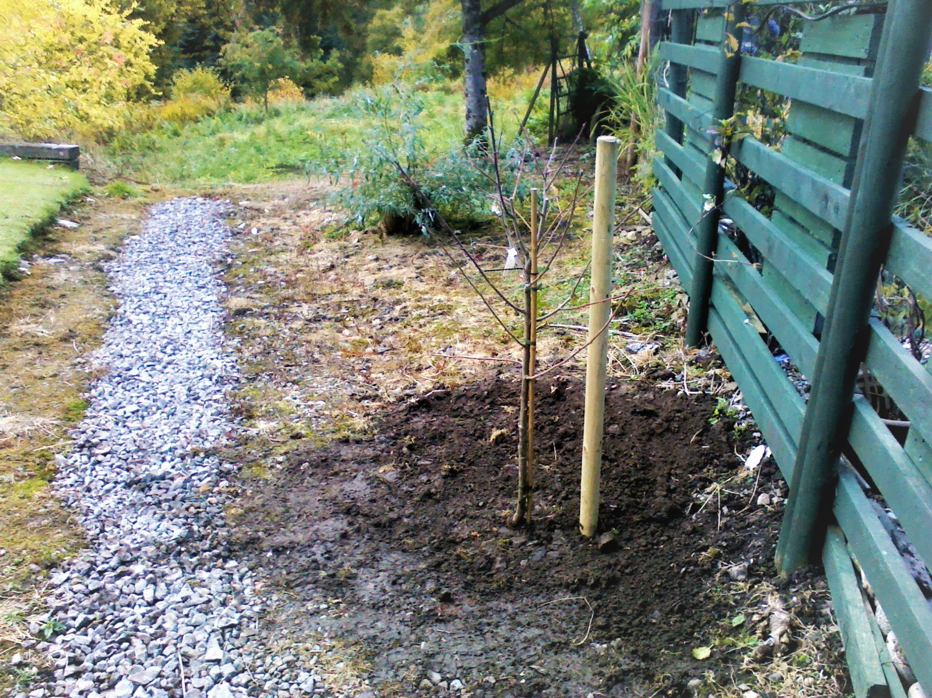

[www.community-council.org.uk/garveanddistrict](http://www.community-council.org.uk/garveanddistrict)

[garveanddistrictcc@yahoo.com](mailto:garveanddistrictcc@yahoo.com)