Minutes of the Garve & District Community Council ordinary meeting
held on Tuesday 5 December 2023 on webcam

Community Council members present on webcam: Kenny Maclean (Chairman & Secretary), Bob Moir (Vice Chairman), Caroline Gamble (Treasurer) and Sadie-Michaela Harris.

Also present on webcam: Peter Kane (PR Consultant for the Kane Partnership from 7.00pm until 7.35pm), Fergus Robb (Holyrood PR from 7.00pm until 7.35pm) and one member of the public.

Apologies: Cllr Liz Kraft, Norma Ross (Chairperson of Contin Community Council) and Community Council member Sadie-Michaels Harris gave verbal apologies on behalf of Andrew Biddlecombe (Chairman of Achnasheen Amenities Association). Next day we received apologies from Ewan Bush (Connecting Communities project officer).

The Chairman opened the meeting at 7.00pm and welcomed everyone. He reminded members of the public that although our meetings are not public meetings, they were still very welcome to attend Community Council meetings even on webcam and take part in the discussions under his guidance (see section 12 of the Constitution). Those who cannot attend our meetings can, as always, write to us by post or email with any issues they wish raised at garveanddistrictcc@yahoo.com Our website www.community-council.org.uk/garveanddistrict/ continues to receive 150-200 visitors per month (out of a community of around 270 people). The Community Council area covers from Garve to Aultguish and from Garve to Achnasheen and is the only organisation that represents the whole community. We are elected by the community every four years or so and usually meet once a month. Draft minutes and a list of current members of the Community Council can be viewed at our website. We are also on social media - www.facebook.com/profile.php?id=61552992414355

Community Council members were shocked to hear of the sudden passing of our former colleague Alex Mackenzie on Saturday 18 November 2023 at his home in Garve. Many will remember Alex ‘Oomlie’ through his work with the railway, the roads department of The Highland Council and his musical and sporting life which took him around the world. He was involved with the Church as well as serving on this Community Council for many years and was still a Trustee of Garve Public Hall. He attended one of their meetings just 48 hours before he died and was reported to have been on good form at the meeting and (we understand) was pleased with the work to refurbish the Hall. Our Treasurer remembered Alex was at the forefront of the Garve community’s quest in getting colour TV from the old mast on the top of the hill down into the village. He was also very green fingered and enjoyed his garden. Alex was one of those unsung heroes every community has … and needs. Our thoughts are with the Mackenzie family at this sad time. The Vice Chairman and Treasurer attended the funeral last Friday and noted how musical the funeral was. It has been a sad few months in Matheson Road following Aileen Ross’s passing. Our thoughts are also with the Ross family.

Declarations of Interest – the Vice Chairman is a Garve Public Hall Trustee and a Friend of Garve War Memorial. The Vice Chairman, Treasurer and Community Council member Sadie-Michaela Harris are all members of the traffic calming group. Community Council members confirmed that they had read all documents due to be discussed tonight before the start of this meeting.

Approval of draft minutes of the ordinary meeting held on Tuesday 7 November 2023 via webcam were proposed without amendment by Bob Moir and seconded by Caroline Gamble, unanimously agreed. Minutes are available at Garve Post Office, Achnasheen Village Noticeboard, on our website or via email. Hard/electronic copies are also available on request. Minutes will be signed by our Chairman and Treasurer in due course via post.

Matters arising – at this point our Chairman planned to take the “Connecting Communities” project update but as Ewan Bush, project officer was not in attendance, he suggested we move on and try again later.

Boralex – https://www.boralex.com – no further news, timescales for construction still tbc.

Kirkan Windfarm – http://www.kirkanwindfarm.co.uk - Trevor Hunter has been in touch to say they are still in the phase of considering options for Kirkan and working through planning conditions. Trevor expects it will be into Spring 2024 before he has any concrete news to give us. We thank Trevor for his update.

Proposed Carn Fearna windfarm – https://projects.statkraft.co.uk/Carn-Fearna/ public exhibitions took place last month and today Seumas Skinner (Community Liaison Manager, Statkraft UK) sent us the following update which we has already appeared on our online channels and our Chairman read out in full at this meeting …

Advertisement
The Carn Fearna exhibitions were promoted via a mailshot to over 1700 properties in a 10KM radius centred on the proposed Carn Fearna site, via adverts in the Ross-shire Journal and Press & Journal and through posters sent to a variety of public locations in the area.
Exhibition
We were pleased to welcome 59 visitors to our exhibitions across four venues. Contin Hall and Strathpeffer Community Hall were the busiest sessions. Based on this, we aim to return to both of these venues next year, along with Garve Public Hall in replacement of Tarvie Café. The majority of visitors were from Garve and the surrounding settlements of Contin, Strathpeffer and Marybank. Feedback on the exhibitions was generally positive, noting that a good amount of information was provided and that there was an appropriate level of staffing. Some attendees were dissatisfied that some information was not available in printed format to take away, and that event timings were too limited. We reduced our provision of printed information across our exhibitions in response to an increasing reference of residents to access digital materials through our project websites. We are very happy to post printed copies of the information on display to anyone who requests it, and at our future public events for this project we will increase the printed materials available. We will consult with the Community Council and other stakeholders on venues and timings for future exhibitions and welcome further feedback on our engagement. Some visitors questioned why an exhibition was not being held in Garve, but were understanding regarding the situation with Garve Public Hall and the failure of the roof at Strathgarve Primary School which prevented this.
Feedback
We have received a number of resident responses via postal feedback forms, feedback forms completed at the exhibition and via our project website. We are in the process of inputting these, and this will be shared with the project team to take into account as they refine the project layout. The closing date for consultation responses is Tuesday 5 December 2023 however we normally include a grace period for replies beyond that date. We will also continue to respond to any queries received via feedback forms after this time.
Next Steps
We intend to respond to questions and comments received on feedback forms by the end of January. This will be by email or post, depending on the contact details provided. We will also publish a report providing details on the feedback received during the consultation period. This will be shared with you as elected representatives, and published on the project website. We would like to express a note of thanks to Contin Hall, Tarvies Café, Strathpeffer Community Hall and Ross County FC for hosting our exhibitions.

Community Council member Sadie-Michaela Harris spent about an hour at the exhibition in Contin on Tuesday 21 November 2023. Sadie noted it was well staffed but requested that PDFs of all visual boards on display on A frames be sent to the Community Council along with all the wildlife surveys which were undertaken and all other documents pertaining (received). Sadie was disappointed that bird survey data amounted to one paper copy of each survey. Sadie noted https://www.nature.scot/doc/recommended-bird-survey-methods-inform-impact-assessment-onshore-windfarms guidance but felt more information could have been presented (noted). Visual viewpoints from the 29 viewpoints so far identified amounted to just 7 montages at the exhibition. It was also felt the timings of the exhibitions were not suitable for those who work (noted). Sadie also noted the National Planning Framework Four document can be viewed at https://www.gov.scot/publications/national-planning-framework-4/documents/ Our Chairman attended the Dingwall exhibition on Thursday 23 November 2023. He could only stay 30 minutes due to other appointments but was surprised how much information was available considering this is still a project at the early stages. He thought Turbine locations will probably need to be adjusted based on further studies and feedback. Statkraft has no plans to use the proposed new powerline to Beauly, they still intend to connect into the existing Corriemoillie substation. Our Chairman also pointed out that those working may have found it difficult to attend. More viewpoints have been suggested including at Blackwater Cottages. Peter Kane (PR Consultant for the Kane Partnership) noted 59 attendees should perhaps be clarified to say 59 signed in, others who did attend did not wish to sign. Peter also explained that timings of the exhibitions also had to fit in with other bookings that the venues had but would be happy to look at this again next time. In Strathpeffer, it was thought the exhibition was on until 7.00pm, it was not but Statkraft staff stayed on for an extra 90 minutes anyway. The dots on maps at the exhibition showing where people came from was more an exercise to see if the mailshot had covered a wide area as hoped. Peter noted all visitors to the exhibitions were polite and welcoming. Re printing of documents - Peter felt they had erred on the side of caution as some people had commented at other exhibitions about the waste of paper being used but will ensure more copies, especially of bird surveys are available next time. It was noted at least two emails had gone “missing” from the Statkraft email system. Statkraft IT did a run through and feel a filter now being removed should resolve this but if anyone has any issues, please get in touch via pkane@kanepartnership.com Peter and Fergus were thanked for their updates.

Proposed Tarvie windfarm – https://tarviewindfarm.com - no further news. Statkraft have contacted them to see what liaison, if any, might be possible, awaiting a reply.

Proposed SSE Fairburn extension – https://www.sserenewables.com/onshore-wind/in-development/fairburn-extension - no further news.

SSEN Spittal – Beauly 400kV project - https://www.ssen-transmission.co.uk/projects/project-map/spittal--loch-buidhe--beauly-400kv-connection and https://www.ssen-transmission.co.uk/globalassets/projects/rocs/slbb/summary-roc---spittal-to-beauly.pdf which shows “D1.3 Community Alternative route” nearer Loch Garve. Community Council member Sadie-Michaela Harris noted SSEN were to send through details of what burying cables would involve versus running them overground as it was agreed that the public really need to know the implications of both, awaiting a reply. An online meeting for Community Councils was held earlier today which our Chairman and Community Council member Sadie Sadie-Michaela Harris attended along with around 12 other Community Councils. Both our Chairman and Sadie felt there were still a lot of questions left unanswered regarding need, undergrounding the cable, construction traffic, community input etc … It was confirmed that D1.3 will need further environmental and technical evaluation before a final possible path can be agreed. A public meeting (not organised by SSEN) was held in Contin last night. We have not heard any feedback but The Vice Chairman passed and noted plenty of cars outside the Hall. (Post meeting note - SSEN have sent us the following links regarding their proposed new Spittal to Beauly powerline. Pathway to 2030 project information: www.ssen-transmission.co.uk/projects/2030-projects/ Spittal – Loch Buidhe – Beauly project webpage: www.ssen-transmission.co.uk/SLBB Frequently Asked Questions: www.ssen-transmission.co.uk/projects/2030-projects/2030-faqs/ Consultation Document: spittal-loch-buidhe-beauly-400kv-ohl_route-selection_consultation-document-aug-2023.pdf (ssen-transmission.co.uk) Information on Project Need: https://www.ssen-transmission.co.uk/projects/2030-projects/2030-need/ Link to webinar on project need which featured SSENT, Ofgem and National Grid ESO: https://vimeo.com/869554483 Summary Report on Consultation: https://www.ssen-transmission.co.uk/globalassets/projects/rocs/slbb/summary-roc---spittal-to-beauly.pdf Spittal – Loch Buidhe – Beauly overhead line: https://www.ssen-transmission.co.uk/globalassets/projects/rocs/slbb/report-on-consultation---spittal-to-loch-buidhe-to-beauly-overhead-line.pdf Spittal substation and HVDC converter station: https://www.ssen-transmission.co.uk/globalassets/projects/rocs/spittal/report-on-consultation---new-spittal-area-400kv-substation-and-hvdc-converter-station.pdf Loch Buidhe substation: https://www.ssen-transmission.co.uk/globalassets/projects/rocs/loch-buidhe/report-on-consultation---new-loch-buidhe-area-400kv-substation.pdf Beauly area 400kV substation and HVDC converter station: https://www.ssen-transmission.co.uk/globalassets/projects/rocs/beauly/report-on-consultation---new-beauly-area-400kv-substation-and-hvdc-converter-station.pdf These links have also been shared on our online channels).

Peter Kane and Fergus Robb were thanked for attending and left the meeting at 7.35pm.

The Highland Council updates – www.highland.gov.uk – Personal Injury Claims – Cllr Kraft updated our Chairman that personal injury claims would not normally be made public because they often have personal sensitive information that would require consent to share, however if there is significant pay outs from a particular department, then they are brought to budget briefings so Cllr’s can look at investing in that department to mitigate. All committees present quarterly financial monitoring reports. These can all be found online and give number of complaints, type of complaints, response times and FOI requests received. Community Council member Sadie-Michaela Harris will do some digging!
Strathgarve Primary School – The Area Education Officer was having meetings w/c 13 November 2023 about the building. He has since confirmed that the estates team are reviewing with the headteacher what may be required in the main building to support the school but all eight children are in the main building and are being educated. Clearly The Highland Council will need to consider carefully the next steps and options for ensuring satisfactory arrangements are in place for all pupils and staff going forward now the demountable unit outside is no longer fit for use. Cllr Kraft has spoken to officials who have confirmed there will be discussions with the parents in due course. We have suggested that knocking through to the old unused schoolhouse may be an option. Also, will the unsightly demountable unit which has come to the end of its useful life be taken down? It would certainly increase the playground area if it was. This update has already appeared on our online channels. It was suggested on social media that windfarm money should pay for the school repairs rather than refurbishing Garve Public Hall. This comment was removed (presumably by the author) after it was pointed out that windfarm money cannot be spent on statutory duties. It should also be noted the school is not available for hire - https://www.highland.gov.uk/directory_record/1464154/strathgarve_primary In related news, Community Council logo – we do not have a logo so have asked the school children at Strathgarve Primary School to design one for us. Our Chairman and Vice Chairman met with teaching staff on Thursday 16 November 2023 to discuss the matter and they are very happy to take up the challenge!

Replanting Trees in The Avenue – full reports since February 2022 are available in the library section of our website, our thanks to the Treasurer for going back through the minutes! A tree planting contractor is still to be appointed and ditches at the far end of The Avenue have been noted as needing cleared out. They have been confirmed as being on the “to do” list of jobs at the roads department, thanks to everyone at The Highland Council and Cllr Liz Kraft for their joined-up approach to this issue. This update has already appeared on our online channels. In slightly related news, Cllr Kraft has informed us of a Tree Preservation Order in the Inchbae area. This was news to us so we are making further enquiries.
Reference Numbers – Community Council member Sadie-Michaela Harris had several reference numbers which she passed onto Cllr Kraft. Cllr Kraft has informed our Chairman that she has passed on all the incident numbers Sadie gave her but has not had a response to any, perhaps some issues have been sorted? Sadie confirmed the numbers were given to her relating to road/bridge issues already covered at this meeting.
Potholes have had temporary repairs at Strathgarve, the road men did have some, but not all, plant equipment locally so they shovelled in the tar as a quick fix for now to help us out, thanks to all for patching us up! Timescales for a proper repair are unknown at this time, especially as the weather has now turned colder so it is gritting time. In related news, road repairs have taken place in Little Garve w/c 13 November 2023 (before the weather turned) which we welcome.
Blackwater Bridge – our Chairman thought the bridge was not so noisy but others felt otherwise so enquiries were made. It appears additional bolts and washers will be ordered as many of the bolts that were taken out to retighten and torque were badly worn, ongoing at this stage but our thanks to all at the roads department and Cllr Kraft for their updates and ongoing works on this vital bridge in our community. This update has already appeared on our online channels.
Wooden fencing and fence post, core path signs and Wyvis Natural Playpark sign and nearest toilet signs are all still outstanding. Cllr Kraft continues to make enquiries along with Trees/bushes needing cut in Stirling Drive.
Grit bins for Strathgarve and Little Garve – were delivered last week and again yesterday, thanks to Cllr Kraft and the local roads team. A grit bin has also been delivered next to the telephone exchange in Garve. The Treasurer requested a grit bin be placed up by Wades Bridge. Refills for grit bins are done at https://www.highland.gov.uk/report (there is an option on the list "grit bins"). (Post meeting note – request for additional grit bin noted).
Silverbridge toilets – these toilets have been closed since early November 2023 but Cllr Kraft has informed our Chairman that they should be able to open soon … watch this space!
Achnasheen Village Hall and Public Toilets – concern has again been raised about the future of the Public Toilets. The Highland Council run survey closed on Monday 20 November 2023 but we await the results. In related news, Achnasheen Amenities Association are planning a Christmas Party on Saturday 16 December 2023. For more details, just email achnasheenamenities@gmail.com by this Friday if you wish to attend or for more details. This update has already appeared at the request of Achnasheen Amenities Association on our online channels and via our emailing list to help inform as many people in the community as possible. They are very grateful for our help in this matter.
Our Chairman has heard there is a rise in inappropriate emails to Highland Council officials and Cllrs. This follows a staff survey where most Highland Council staff feel overworked and are reporting a steep rise in abusive emails. The roads teams are particularly unhappy and have a high level of staff turnover. All this was discussed at a recent full meeting of The Highland Council on Thursday 26 October 2023. We would like to place on record how grateful we are to Cllr Kraft and all officials for their help to us.
The Highland Council notes that residents should report issues directly to them by calling The Highland Council’s Call Centre on 01349 886606 or via www.highland.gov.uk/report In all cases, you will be given a reference number. The Highland Council also appreciates photos showing the actual problem. Winter gritting is done as per The Highland Council roads policy - https://www.highland.gov.uk/info/20005/roads_and_pavements/107/winter_road_maintenance The Vice Chairman noted there were three different vehicles gritting the roads and pavements around Garve when the recent cold snap first arrived which was welcome and appreciated..

Killin Farm Crossing improvements and barriers east of Garve – no further news. We do not know why a fence has been installed at the check rail corner and note the overhanging dead tree at the same corner needs reporting – in hand. Faults on the Trunk Road (A835) should be reported via www.bearscot.com/report-a-defect/ The Treasurer noted the front page of last week’s Ross-Shire Journal which covered the incident in September when a tree fell onto a passing campervan in the same area. We are note bushes were cut back between the Railway and Garve Public Hall on w/c 20 November 2023 and Contin now has a 20mph limit along its trunk road since Thursday 23 November 2023. There are currently no plans to reduce the speed limit on the trunk road through Garve despite our Chairman asking (again!) as low population/number of houses are an issue.

Garve mains water – our Chairman spoke to Gavin Steel at Scottish Water on the telephone on Monday 20 November 2023. The local team and the project team are aware their maps are not correct for Stirling Drive. This is not unusual when maps have been digitised at Scottish Water but notes are being compared. It is still hoped works will start in spring 2024. Strathgarve pipes are newer than Garve pipes so Strathgarve should see improvements once the Garve work has been completed as the water should flow better to all branches including Strathgarve from Garve. In the meantime Gavin asks residents to continue to report any issues directly to Scottish Water to help build up a picture of the knock-on effects of the Garve issues. Our thanks to Gavin who is welcome to attend another Community Council meeting when time allows. Customers of Scottish Water can raise service issues 24 hours a day via Customer Engagement Centre on 0800 077 8778 or on the Scottish Water Facebook page. Customers who may need extra support if their water supply is disrupted, for example due to a disability or a medical condition, can join the Priority Service Register by calling 0800 077 8778 or online at psrscotland.com This update has already appeared on our online channels. Community Council member Sadie-Michaela Harris noted “a logger” (we think to test pressure?) has been placed on the system to take readings and will be removed shortly and results processed.

Garve Public Hall refurbishment – The latest pictures taken by George the Postie are available on our social media page, thanks to George for sharing. KLM Partnership Chartered Surveyors via their social media page have also published this picture giving everyone a sneak peek inside the refurbished main hall …

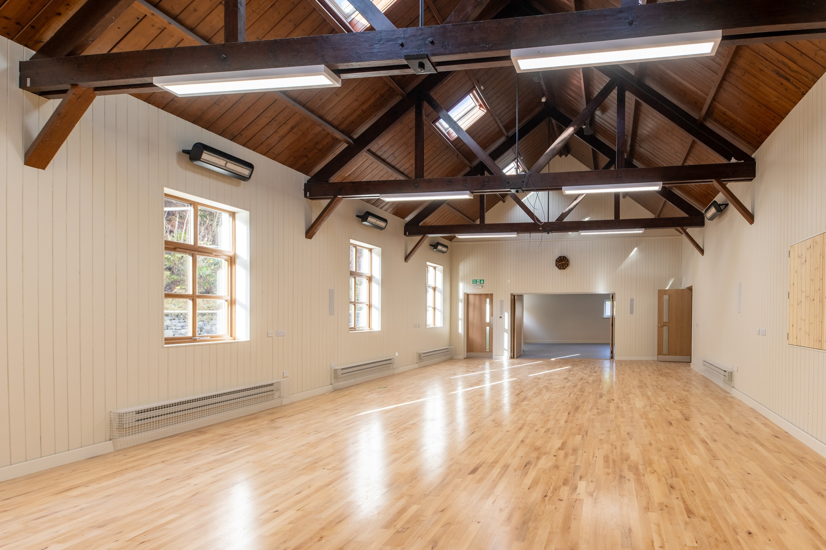

Bob Moir as a Garve Public Hall Trustee updated the meeting that Trustees are now working to get everything set up, spending the last two weekends getting plates, tables, chairs sorted and getting the broadband up and running again. It all takes time and Christmas holidays coming up will not help matters but progress is being made to hopefully re-open the hall in the New Year. A scaled back Christmas tree and lights will be displayed outside the hall this year due to time constraints. In related news, the rusty street light pole outside the hall was reported to The Highland Council on Sunday 26 November 2023 - FS-Case-564845243. The pole was inspected and it was concluded that it is corroded and needs replacing but is still solid enough for now, it will be added to the list of jobs. (Post meeting note – work on the lamp post started on Thursday 7 December 2023). A light out in Achnasheen has also been reported - FS-Case-565741332 on Wednesday 29 November 2023 and was repaired yesterday.

Garve Hotel – Cllr Kraft was updated on Tuesday 14 November 2023 that a building inspector from the planning department has visited the site. The rear of the property has been vandalised; the rest of the site is secure except for some broken windows. The inspector will contact building standards and request they contact the owners to have the building secured. It was noted a property maintenance company was seen on site recently.
Remembrance Sunday – a service took place at the Garve War Memorial on Sunday 12 November 2023. It was a cold misty day but the sun was trying to shine through. Our Chairman was joined by Community Council member Sadie-Michaela Harris, Rev Ronnie Gall, Piper Ali Duff, Cllr Liz Kraft, the Lord & Deputy Lord Lieutenant, the Lord Lieutenant’s Cadet Corporal Calum Sutherland of 1st Battalion The Highlanders Army Cadet Force, Tain Detachment and around 45 members of the community. It was particularly lovely to see Hamish & Harry Leslie Melville in attendance following their sad loss a few months ago, Eliza always attended Remembrance Sunday, even during her long battle with illness. Former Community Council member Joe Stewart laid the Community Council wreath on behalf of the community. The Memorial itself will be 100 years old next year. After the service, our Chairman and Cllr Kraft had a walk around Garve looking at the various issues already noted at this meeting. Our Chairman then sat on Eliza’s memorial bench at Lochluichart to remember our old friend and colleague on his way home.

At 1.00pm on Sunday 12 November 2023, Rev Ronnie Gall, Lord Lieutenant Mrs Joanie Whiteford, Cadet Corporal Calum Sutherland, Cllr Liz Kraft, former Community Council member Joe Stewart and Piper Ali Duff all stand beside the Garve War Memorial before wreaths are laid. (Picture credit - Garve & District War Memorial social media page) …

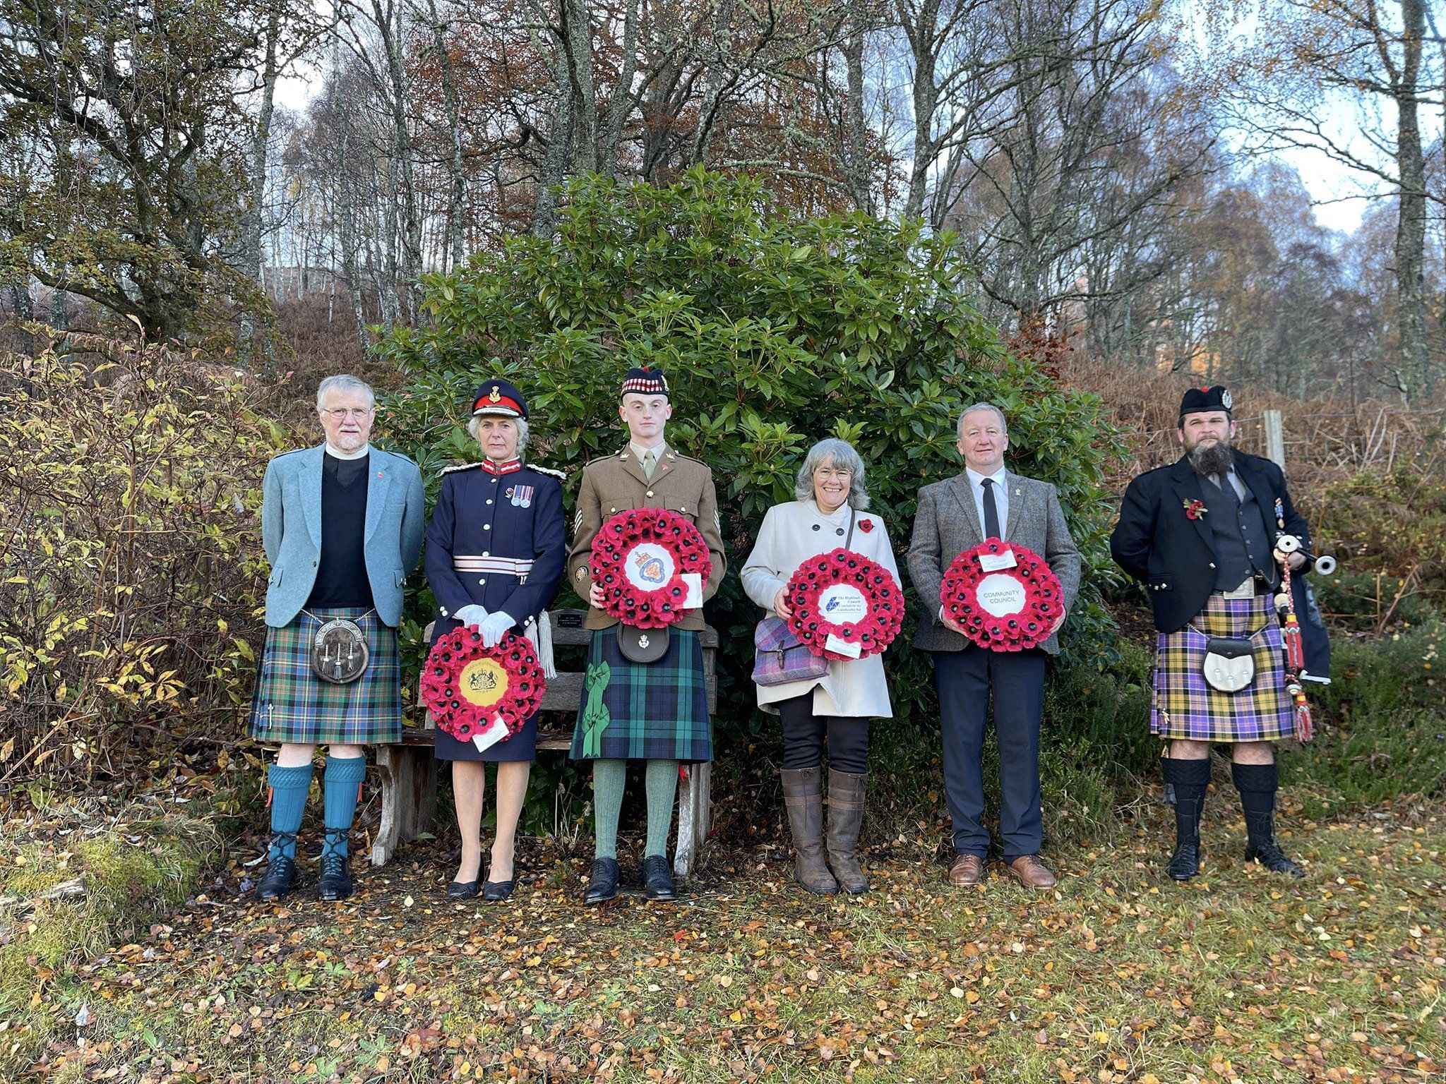

TG&DDC AGM took place online on Tuesday 14 November 2023. Around 16 members attended plus 6 proxy voters. Marcella Melis was elected to the Board and John Fenwick stood down. Quorum was reduced from four to three and accounts adopted. Sue Tarr continues as Chair, Mike Franklin as Treasurer.

Joint working group meeting – discussions are ongoing, no date set yet. It had been suggested that community benefit from new windfarms be discussed but our Chairman thought it might be a bit early at this stage, other Community Council members agreed. This has also been confirmed with discussions our Chairman has had with developers.

The traffic calming group hope to meet in the New Year. In related news, in 2019 the Scottish Parliament passed the Transport (Scotland) Act 2019 which included powers to introduce three new parking prohibitions nationally. These ban parking on pavements, at dropped kerbs and double parking. All the secondary legislation has now been put in place to give local authorities the powers they require to enforce these new parking offences. This means local authorities will be able to issue penalty charge notices from next Monday. More details are available at https://www.transport.gov.scot/our-approach/transport-scotland-act-2019/parking-and-the-transport-scotland-act-2019/
We note Morven MacDonald, Project Officer for the Active Garve & District project will be moving on to pastures new from the New Year. We thank Morven for all her help over her five years in post and wish her well for the future. The local Development Company are recruiting to fill the vacancy - https://garve.org/jointheteam-activategarveanddistrict3 which we have shared through our online channels, Tina Hartley (Community Engagement and Development Officer, TG&DDC) sends us her thanks for doing so.

GD Core land (between Garve Public Hall and Grave Hotel) – The local Development Company has been unable to secure a venue local to Garve for their final face to face event so this will now be rescheduled for the New Year in Garve Public Hall once it is open. In the meantime, anyone with any comments or suggestions for the land can still send them in directly to the company. There is a small sewage system under the community land, ownership of the system and connection is still being investigated. In slightly related news, the local Development Company would like to draw up a local place plan (https://www.highland.gov.uk/info/178/development_plans/1043/local_place_plans) and have asked if we can obtain a public sector geospatial agreement (PSGA) number from Ordnance Survey that they can then use. We are not sure if this arrangement is possible under licensing terms and conditions so are seeking advice from Ordnance Survey directly. (Post meeting note - Ordnance Survey have replied to confirm we cannot pass our PSGA onto a third party as it is against their licensing terms and conditions).

At 8.10pm our Chairman felt we had given Ewan long enough so would need to carry on without him. (Post meeting note – Ewan sends his belated apologies; his calendar reminder did not go off). The “Connecting Communities” project – over the next 12 months, the Connecting Communities project officer Ewan Bush (formally the local energy officer) will be working to set up a community transport service for Garve & District, Contin, Jamestown and Tarvie. Ewan is keen to meet people and groups from the communities to understand how the proposed transport service can best support the community’s needs. There have already been discussions between the local Development Company, Contin Community Council, CJT Projects (Contin, Jamestown and Tarvie Projects), Cllr Liz Kraft and The Highland Council itself. These discussions have concluded that there are benefits to combining resources. A diesel MPV or minibus could be made available. A Highland Council grant could provide funding over a three-year period. The service will be a not-for-profit enterprise helping those with no access to a vehicle or sustainable public transport. Ewan is currently working on various funding applications and has produced a possible three-year business plan to support this project and the provision of an EV charger to enable the switch to an electric vehicle in future years. Ewan would welcome the communities’ thoughts and input. This update has already appeared on our online channels. Apologies have been noted from Norma Ross, Chair of Contin Community Council who informed our Chairman that she is working with Tina Hartley (Community Engagement and Development Officer, TG&DDC) and Ewan on the Connecting Communities project. Ewan has already visited Contin Hall and contacted some Contin residents at the Contin lunch club as part of his information gathering. Norma has asked our Chairman to point out that Contin Community Council is not involved as such in the project. The project is being run by CJT Projects (Contin, Jamestown and Tarvie Projects) who are a Scottish Charitable Incorporated Organisation (SCIO) which has been set up to run projects that the Contin Community Council is not really permitted to do so. CJT Projects has four Directors, two of whom are also Contin Community Council members. The confusion may have arisen from the fact that Norma is Secretary of CJT Projects and Chair of Contin Community Council. We thank Norma for the clarification. Everyone at this meeting had questions, none of which could be answered without Ewan present so hopefully Ewan can join us on another occasion.

We have been approached by The Wester Ross Biosphere as The Scottish Government has invited expressions of interest from community groups and organisations to nominate new areas to be national parks. The Wester Ross Biosphere group are keen to ask communities whether they would like to explore the opportunity - and what this could mean - to be a National Park. Community Council members felt that it could be worth exploring but we have already noticed on social media that comments on the Isle of Skye proposals are scathing so this proposal would need some careful thought. Do we know if Badenoch & Strathspey have benefited favourably over the years from the Cairngorms National Park? What costs, if any, would there be to community groups and residents? As a starting point, we suggested to The Wester Ross Biosphere to ascertain if the majority of Community Councils in Wester Ross are in favour of finding out more before taking it further. Our comments have been noted and we await further updates but they completely agree with us that the whole matter needs careful consideration on many levels.
The poster for the Dingwall Medical Group/Community Council partnership has been supplied to the local newsletter, put up on local noticeboards and is on our social media page, thanks to Community Council member Sadie-Michaela Harris. One person in the community has asked why Dingwall Medical Group? Our Chairman has explained that although most people in our area are registered with the Strathpeffer Medical Practice, some are registered with Dingwall, others in Lochcarron. Sadie stressed that this initiative is being led by Dingwall Medical Group who invited us to be part of their forum. Sadie asserted that we would be keen to work with Strathpeffer Medical Practice if they were to form such a forum and mentioned this as several other Community Councils have also expressed a willingness to work with Strathpeffer Medical Practice in the same way.

The Lochluichart Church Christmas Carol Service will be held on Sunday 17 December 2023 at 11.30am at the church, all welcome. This update has already appeared on our online channels.

Police report - no formal report received but as reported at previous Community Council meetings, anyone who wishes to raise an issue with the Police is asked to call them directly on 101 at the time of the incident and make a witness statement. Video, dashcam or photo evidence is also welcomed, indeed encouraged by the Police. If anyone in the community needs advice or has been scammed, contact Advice Direct Scotland on https://advicedirect.scot/ or 0808 164 6000. This update has already appeared on our online channels. A caravan appears to have been dumped in a layby in the Achanalt area. Police were informed and the caravan was removed later that same day. Local police officers also patrolled around Garve at the same time.

Treasurer’s report - the Treasurer reported our total bank balance is £2,338.16. The breakdown is as follows … Treasurers account £263.11, Reserve £1,613.45, Wreath fund (in memory of Eliza) £461.60. £35.00 due shortly for data protection renewal. There were no questions for the Treasurer.

AOB from Community Council members – The Vice Chairman informed the meeting that the Garve noticeboard appears to have been deliberately vandalised last week. The lock was drilled out and notices scattered everywhere. Some attending felt local children would not do such a thing, was it a vindictive attack? CCTV in the area is being checked and if repeated, steps will be taken. The Vice Chairman also informed the meeting that small pieces of land, thought to belong to private individuals in Garve are discovering The Highland Council are claiming the same land to be theirs. This has been highlighted when buying land for car parking around the Hall and elsewhere. It seems the land register has contradictory paperwork even though individuals have deeds so one to be aware of.
As our Chairman was first elected to this Community Council 20 years ago, Community Council member Sadie-Michaela Harris asked about his memories! He had to admit after all this time it all becomes a bit of a blur so he dug out the minutes of the first meeting he attended as a Community Council member from October 2003 (although he attended meetings as a member of the public before that). Topics included road signage, road markings and crash barriers which were all attended to (eventually!). Concern about litter at the Wades Bridge picnic area was noted and extra patrols by the local Forestry team were arranged. The Treasurer’s account was standing at £2,197.00 in October 2003, today it stands at £263.11, how times and grant funding have changed. Plans were being made for the Senior Citizen’s Christmas Dinner that was well attended, they stopped in 2015 due to continued poor attendance and Community Ceilidhs were held instead. Bob Moir (as a member of the public) raised concerns around traffic issues in Mossford after recent resurfacing works covered the “SLOW” markings on the road, the road marking were repainted (eventually!). Local public toilets were closed due to cold weather (again). The Community TV mast in Garve was repaired following donations and the minute also noted Iris Gordon was about to retire as Postmistress of Garve Post Office after 50 years’ service to the community. The local Cllr at the time was Ewan MacKinnon and our Chairman reported he is still living in Lochcarron and sees him and his wife from time to time, both are keeping well and still have their croft. All minutes from 1994 onwards are available in the library section of our website - http://www.community-council.org.uk/garveanddistrict/library.asp The Vice Chairman recalled the pedestrian signs that were installed in Mossford about that time and how some people thought the signs were of him and his daughter Laura!

AOB from members of the public - no issues raised by those present. Those who cannot attend our meetings can, as always, write to us by post or email with any issues they wish raised at garveanddistrictcc@yahoo.com

Screening reports, scoping reports and consultations – we have received four consultations. The first consultation is from the Children and Young People’s Centre for Justice (CYCJ). CYCJ are contacting all Highland Community Councils to inform them that they have launched their 2023 Stakeholder Survey, and are keen to hear from Community Councils on what they think in relation to children, young people and crime in each Community Council area. The link to the survey has been supplied to all Community Council members to fill in before the deadline of Thursday 21 December 2023. The survey will take about 10-15 minutes to complete, and the results will help CYCJ to plan their work over the next five years.
We have also received a “Have your say – Shaping The Highland Council’s Budget 2024/25”. The Highland Council is facing the same financial challenge as other public sector agencies – increasing costs, increasing service demand and inflation. With less money, they want to focus their resources on key priorities. To help shape the budget, The Highland Council want to understand what people think are those key priorities and where should the money be spent. More details at https://www.highland.gov.uk/budget This update has already appeared on our online channels.
Rent Consultation for 2024/2025 is now open. The Highland Council are inviting all tenants to have their say on the rents for the year 2024/25. Find out more at www.highland.gov.uk/.../263/tenant_participation/2
Complete the survey at www.surveymonkey.co.uk/r/RC23document This update has already appeared on our online channels.
Yesterday we were made aware via social media of The Highland Council’s review of 20mph zones - https://www.highland.gov.uk/news/article/15741/council_launches_highland_20mph_consultation Our Chairman stressed it is important that everyone takes part to say what they like, don’t like and where speed limits should be increased or decreased elsewhere. Comments on truck roads will be passed on by The Highland Council. Deadline for comments is Wednesday 31 January 2024. This update has already appeared on our online channels and Community Council member Sadie-Michaela Harris has passed the details onto everyone on the traffic calming group, thanks to Sadie.
All Highland Council consultations are available at http://consult.highland.gov.uk/portal All Scottish Government consultations are available at https://consult.gov.scot/consultation_finder

Building warrants, planning issues and licensing issues - there are no new building warrants currently being shown on The Highland Council website for our area.
Two previous applications have been determined by The Highland Council since our last ordinary meeting. At our October 2023 ordinary meeting we considered 23/04454/PIP which was the proposed renewal of an erection of house, installation of private drainage & upgrading of access on land at Achnaclerach. This planning in principle renewal application has now been granted permission with fifteen conditions. At last month’s ordinary meeting we considered 23/04945/PNO, the proposed peatland restoration under class 20A on land 4715M NE of Glencarron. The Case Officer has granted prior approval.
There are currently two planning applications awaiting determination by The Highland Council for our area at Fannich and Inchbae.
One new planning application has been received by The Highland Council since our last ordinary meeting. 23/05514/FUL is the proposed erection of a 25m High Lattice Tower with Associated Equipment and Ancillary Development on land 510M NE of Hydro House, Blackbridge. Those who live in the Aultguish, Blackbridge and Inchbae areas that we have email addresses for have been informed and this update has already appeared on our online channels. Anyone with any comments has until Monday 18 December 2023 to submit them directly to the Case Officer. Community Council members are still studying these plans that only came to our attention yesterday so will let our Chairman know of any concerns by the end of the week. (Post meeting note – Community Council members raised no objections to this planning application).
We have received notice of one new pre-planning application as part of the Shared Rural Network Project https://srn.org.uk on land north of A835, west of Loch Glascarnoch, just inside our Community Council area. Cornerstone are in the process of identifying a suitable site in the Loch Droma area for a radio base station that will improve service provision for Vodafone Limited, Virgin Media O2 (VMO2), Hutchison 3G Limited (Three) and EE. The proposal is part of the UK Government backed scheme called Shared Rural Network (SRN). It is a collaboration between Mobile Network Operators (MNO’s) (Vodafone, VMO2, Three and EE) and the UK Government to improve 4G coverage for people living, working and travelling in poorly served rural areas. Community Council members had no comments at this stage on the proposal. We note this is the sixth such proposal in our area this year. The Treasurer noted a number of these masts are getting planning permission in some scenic areas - www.bbc.co.uk/news/articles/cp4pkz5jzw0o Our Chairman wonders if National Planning Framework Four has moved the goalposts? In related news, we have been asked by the Torridon & Kinlochewe Community Council to sign a letter raising concerns about the Shared Rural Network Project and the lack of overall information. Also see www.bbc.co.uk/news/articles/cyj2ww73w17o Most proposed masts are at a pre-planning stage but nobody seems to know how many will be needed or where, we all just learn about them as the planning lists are published each week. Torridon & Kinlochewe Community Council feel greater engagement with communities at an earlier stage would help and 95% geographical coverage should be changed to 95% of population. The Wester Ross Biosphere have also raised similar concerns. Our Chairman has written to the Shared Rural Network Project to ask if they could confirm exactly how many new masts will be built in our area and where they will be located. Their reply received last Friday tells us that the Shared Rural Network is a large and complex programme that requires a significant amount of planning around mast locations. At this stage, they are not able to confirm which specific areas will benefit from the Shared Rural Network as the programme is still carrying out site investigations and locations are subject to change throughout the programme. Locations can be affected by factors such as site suitability, the ability to achieve planning permission, landowner agreements etc … Community Council member have seen a draft letter by Torridon & Kinlochewe Community Council for consideration. After seven days of consideration, Community Council members felt that although more information about the whole project would be useful and indeed welcome, especially around the exact number of masts required, we would prefer to see the program continue with 95% geographical coverage as already planned because the masts work on a daisy chain principle, the signal passes from one to the other, therefore all need to be installed to give coverage and make the system work, especially for hillwalkers/emergency services in the more remote areas. Community Council members concluded we would not be signing the letter.
A possible planning breach can be reported at https://www.highland.gov.uk/info/180/planning_-_applications_warrants_and_certificates/170/planning_enforcement/2
All planning applications can be viewed at www.highland.gov.uk/info/180/planning_-_applications_warrants_and_certificates/143/planning_permission/4
There were no new licensing issues for us to consider this evening.

Dates of future meetings - (Ordinary meetings are usually held on the first Tuesday of every month unless stated otherwise)
January 2024 – no meeting
Tuesday 6 February 2024, 7.00pm, webcam – agreed.

As usual, our Chairman started to draw the meeting to a close by asking all present if anyone had any final questions or thoughts on anything they had heard this evening, a question he often asks throughout the meeting too. Nobody had any final questions or thoughts. Although our meetings are not public meetings, members of the public are still very welcome to attend Community Council meetings and take part in the discussions under the guidance of the Chairman (see section 12 of the Constitution). A copy of our Constitution is available in the library section of our own website and hard/electronic copies are available on request. Those who cannot attend our meetings can, as always, write to us by post or email with any issues they wish raised at garveanddistrictcc@yahoo.com

The Chairman thanked everyone for attending. He also thanked Community Council member Sadie-Michaela Harris for hosting the webcam session and as this was the final scheduled meeting of 2023, wished everyone a Merry Christmas and a Happy New Year and thanked Community Council members for all their hard work over the past twelve months representing the community. The Chairman closed the meeting at 8.50pm.

Signed ……………………………..

Signed ……………………………..

Date ……………………………….

www.community-council.org.uk/garveanddistrict
www.facebook.com/profile.php?id=61552992414355
garveanddistrictcc@yahoo.com

This set of minutes were first published (in draft form) at 1.00pm on Monday 11 December 2023.

