**Minutes of the Garve & District Community Council ordinary meeting**

**held on Tuesday 7 November 2023 on webcam**

**Community Council members present on webcam**: Kenny Maclean, Bob Moir, Caroline Gamble and Sadie-Michaela Harris.

**Also present on webcam**: Cllr Liz Kraft, Scott Vallance (Principal Project Manager, Statkraft UK from 8.00pm until 8.40pm), Tina Hartley (Community Engagement and Development Officer, TG&DDC) and four members of the public.

**Apologies**: none.

As this is the first meeting following the 2023 Community Council elections, Cllr Liz Kraft opened the meeting at 8.00pm and welcomed everyone and noted the uncontested election result of four Community Council members from Wednesday 11 October 2023 and thanked them for standing. Cllr Kraft then took Community Council members through an overview of the rules of how all Community Councils in the Highlands function. This is available in the library section of our website. There are five main sections - the scheme of establishment, membership numbers, constitution, standing orders and code of conduct. All Community Council members were already aware and had no questions.

Cllr Kraft then asked for **nominations for Office Bearers**. Bob Moir proposed Kenny Maclean as Chairman, Sadie-Michaela Harris seconded, unanimously agreed. As Dot Ferguson, Senior Ward Manager at The Highland Council has already allowed a joint Office Bearer role as per 9.3 of the Constitution, Bob Moir proposed Kenny Maclean as Secretary, Sadie-Michaela Harris seconded, unanimously agreed. Sadie-Michaela Harris proposed Caroline Gamble as Treasurer, Bob Moir seconded, unanimously agreed. Sadie-Michaela Harris proposed Bob Moir as Vice Chairman to ensure we have three Office Bearers, Caroline Gamble seconded, unanimously agreed. Sadie-Michaela Harris proposed, and Bob Moir seconded, that our Chairman deal with any press enquiries and be Community Council website administrator, unanimously agreed. It was also unanimously agreed that the three bank signatories will be Kenny Maclean, Bob Moir and Caroline Gamble only and that Community Council member Sadie-Michaela Harris continues to keep us online with our online meetings, our IT expert!

Cllr Kraft then handed the meeting over to our Chairman who noted the next item on the agenda provided by The Highland Council was to discuss **associate membership**. It was noted by Sue Tarr that although on the agenda, associate membership is perhaps not so well known. Our Chairman noted it has been part of the rules since 2011 when the current scheme came into force and has been discussed at previous Community Council meetings. Although the Vice Chairman initially felt associate membership might be beneficial, others felt we needed time to see which projects we might get involved in first. Our Chairman read out the following from the scheme (5.5) … *Associate members, who need not be resident within the Community Council area, may be appointed by a majority vote of a Community Council where there is considered to be a need for individuals with particular skills or knowledge. Associate members shall have no voting rights on the Community Council. Associate members may serve for a fixed period as determined by the Community Council or for the term of office of the Community Council that has appointed them whichever is the shorter.* Our Chairman was asked to confirm that local groups have always been welcome to attend Community Council meetings as and when they have updates and would this remain the case. Our Chairman was very happy to confirm and noted no invitation was needed, all welcome. It was agreed that associate membership is not needed at this time but can be revisited if necessary. Our Chairman also noted that an election has just been held so anyone could have stood to be elected directly onto the Community Council if they wished.

**Dates of future meetings** will be discussed at the end of the meeting.

The final item on the agenda was that the Community Council members may choose to **discuss continuing business** arising from the minutes of the previous Community Council or new items that it wishes to prioritise. It was felt it would be good to have a full ordinary meeting to hear the various issues while we were here. Our Chairman confirmed that we have already agreed to have a **social media page** -

[www.facebook.com/profile.php?id=61552992414355](http://www.facebook.com/profile.php?id=61552992414355) and we hope the local schoolchildren will design a logo for us in due course, discussions are ongoing with the Strathgarve Primary School.

**Eliza’s memorial services –** our Chairman attended Eliza Leslie Melville’s memorial services in London last week and in Strathpeffer yesterday where he delivered the eulogy about her community work. As he noted in his closing remarks yesterday … *Eliza was a remarkable lady who always turned up for the community, whatever the event, whatever the weather, whatever the time of year and however she may have been feeling, she was there, a true pillar of the community, highly respected and greatly missed by many.* It was good to see so many people from the community and former residents in attendance yesterday.

**Congratulations** to Ewen Moir from Garve who has been playing football for Scotland - <https://www.fifetoday.co.uk/sport/football/scotland-qualify-for-2024-euro-amputee-football-championships-4392313?fbclid=IwAR27G7l6KTxDcHb5CHq2Kmfyf0KMDXXWPtqqaHIBHeMaqj-wIQfvahMMTLA>

**Declarations of Interest** – the Vice Chairman is a Garve Public Hall Trustee and a Friend of Garve War Memorial. The Vice Chairman, Treasurer and Community Council member Sadie-Michaela Harris are all members of the traffic calming group. Community Council members confirmed that they had read all documents due to be discussed tonight before the start of this meeting.

**Approval of draft minutes** of the ordinary meeting held on Tuesday 3 October 2023 via webcam. Andrew Biddlecombe, Chairman of the Achnasheen Amenities Association has asked us to note that they are still awaiting a formal response from The Highland Council to their questions around when the survey is to be issued, or to their other prior correspondence seeking further information on the current valuations of the building. As Andrews email to The Highland Council is dated the day after our last meeting, we will include this as a post meeting note. The draft minutes were proposed with amendment by Bob Moir and seconded by Sadie-Michaela Harris, unanimously agreed. Minutes are available at Garve Post Office, Achnasheen Village Noticeboard, on our website or via email. Hard/electronic copies are also available on request. Minutes will be signed by our Chairman and Treasurer in due course via post.

**Matters arising** – **Boralex** – <https://www.boralex.com> Craig Conlin, Construction Site Manager for the Lochluichart Windfarm extension II had tried to contact our Chairman but they have not managed to talk yet. Our Chairman hopes to have a full update for our next ordinary meeting*. (Post meeting note – on Wednesday 8 November 2023, our Chairman and Craig managed to talk on camera phone. Craig continues to liaise with Glyn Robson, Lochluichart Estate Manager who has been very helpful.  Three contractors are still interested in building the windfarm and the preferred bidder process is now being looked at. Construction start date of March 2024 is looking unlikely as Boralex are reviewing all projects.  The windfarm may not be functioning until 2026, tbc.  Turbine supplier still tbc however, site visits and surveys to meet planning conditions continue).*

**Kirkan Windfarm** – <http://www.kirkanwindfarm.co.uk> - no news.

**Proposed Carn Fearna windfarm** – <https://projects.statkraft.co.uk/Carn-Fearna/> following concerns raised at the last ordinary meeting of the Community Council around non replies to emails, Statkraft have checked their two public facing email inboxes [UK-post@statkraft.com](mailto:UK-post@statkraft.com), which is managed by their front of house team in London, and [ukprojects@statkraft.com](mailto:ukprojects@statkraft.com), to ensure there have not been any emails missed. To date (Tuesday 17 October 2023) Statkraft are certain that they have only received two emails and both have had responses. Statkraft are fully committed to communicating with everyone who is keen to hear more about the project and/or Statkraft. As an extra measure, having heard our feedback, Statkraft have also made the contact details for the project team significantly more prominent on their website homepage <https://projects.statkraft.co.uk/Carn-Fearna/> and to alter the footer on all their project pages, where the [UK-post@statkraft.com](mailto:UK-post@statkraft.com) address was previously displayed, to avoid potential confusion. Statkraft seek to be a good neighbour and engage fully with residents, Community Councils and businesses in areas where they have operations and would like to thank this Community Council for helping them in keeping this commitment by bringing this issue to their attention. This update has already been posted on our website. Community Council member Sadie-Michaela Harris confirmed our special meeting from August 2023 covering this topic has been viewed 88 times. Scott Vallance (Principal Project Manager, Statkraft UK) confirmed only two emails received. Scott confirmed the following timetable …

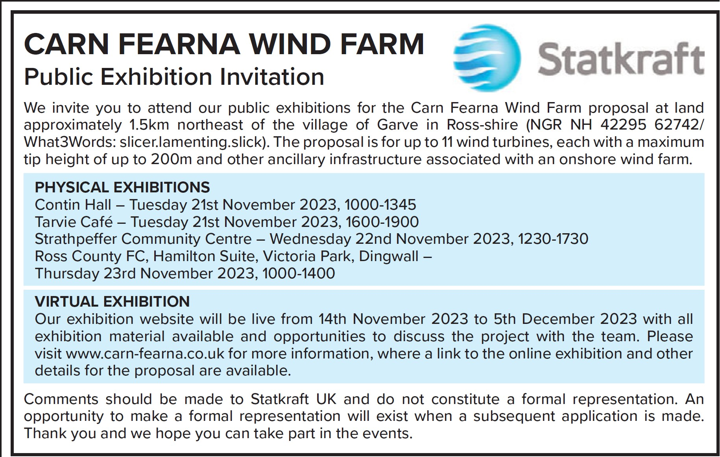

Scott is also happy for anyone to contact him directly about the project - [scott.vallance@statkraft.com](mailto:scott.vallance@statkraft.com)  In answer to a series of questions, Scott confirmed bird survey results would be available at the public exhibitions, the number of turbines had been reduced from 14 to 11, mainly the western side having been removed but before and after maps will be available which also show proposed location positions which have also moved. The changes are due to landscape and visual impact assessments and photomontages will reflect this. 29 viewpoints will be used after consultation with The Highland Council, Nature Scot, RSPB, Forestry, etc ... 7 locations will have photomontages at the exhibitions, the other will be bare wire drawings at this stage. It was noted that in England the moratorium has been lifted for windfarms so why not build where the demand for the electricity is? Not a complete lifting as community support in each area might be needed, more information required. Scott also noted an article from the Financial Times which perhaps emphasises the caution around this whole area of commercial scale onshore wind south of the border: <https://www.ft.com/content/80ed244f-119c-461a-a98b-3ee3e6ece583>. National Planning Framework Four will be the main planning document used in this proposal once it gets to a planning stage. As this project will still be over 50MW, it will be determined by The Scottish Government consent unit rather than The Highland Council but they will have a say like everyone else. Public enquiries only happen once a decision is made about a planning application as a rule, not at this early stage. The Highland Wide Local Development Plan will also be considered in the process. Cllr Kraft confirmed that once the applicant submits to the planning department, lots of documents will be submitted and will be available on the planning website and those on the planning committee do read all the documents. It was again noted that the power generated by this project (if it goes ahead) will go south. It was noted that it is a National Grid decision which is under Westminster control. Our Chairman noted that there has been a growing feeling over the last few years that consultation should be meaningful, not notification as it has felt to be at times so therefore it is very important that people do attend the exhibitions and have their say. *(Post meeting note – our Treasurer found this link -* [*https://www.energymonitor.ai/policy/uk-onshore-wind-britain-passes-the-buck-on-wind-power/?cf-view&cf-closed*](https://www.energymonitor.ai/policy/uk-onshore-wind-britain-passes-the-buck-on-wind-power/?cf-view&cf-closed)*)*

Scott Vallance was thanked for attending and left the meeting at 8.40pm.

**Proposed Tarvie windfarm** – no news.

**Proposed SSE Fairburn extension** – no news.

**SSEN Spittal – Beauly 400kV project** – no news but it is hoped the forum of Community Councils can meet soon now elections are complete for most Community Councils.

**Highland Council updates** – [www.highland.gov.uk](http://www.highland.gov.uk) – **Achnasheen Village Hall and public toilets** – concern has again been expressed about the future of the public toilets. A postal survey of all residents in the Community Council area was sent out by The Highland Council about 10 days ago, the deadline is Monday 20 November 2023. We are aware of at least two individuals who did not receive the survey, a website link has been provided instead. Andrew Biddlecombe, Chairman of the Achnasheen Amenities Association, told us that there were some issues with the online form where only one option could be selected. This has now been corrected and hopes this does not affect the overall results. They are disappointed the Amenities questionnaire is not also online and would encourage everyone to fill in both. If you have filled in The Highland Council survey online, you can post in the Amenities questionnaire. It was noted only one survey per household was received and the public toilets are included in the survey. Kathy Grist, Secretary of the Achnasheen Amenities Association told us that the whist drive has been cancelled but a soup lunch next Wednesday is on instead - <https://garve.org/news-whist-drive-nov-23-cancelled> Andrew and Kathy were thanked for their updates. In related news, **Achnasheen Post Office Outreach Service** which was closed due to ill health reopened on Tuesday 17 October 2023 but was closed today and last Tuesday due to annual leave.  Kinlochewe Post Office remains open Monday - Saturday 9.00am until 11.00am.  Garve Post Office remains open Wednesdays and Thursdays 3.30pm until 5.30pm.

**Strathgarve Primary School** – parents and carers were informed on Friday 20 October 2023 that following a structural engineering survey of the standalone classroom, substantial structural issues have been identified which cannot be easily remediated therefore, the classroom is closed to staff and pupils with immediate effect. Classes will be taken in the main building for now until more is known. We noted at our September 2023 ordinary meeting the temporary closure of the same classroom. The Vice-Chairman noted the classroom has required attention for many years and has been neglected badly. Cllr Kraft confirmed she was aware of the issue and has asked for regular updates (as have we) but does not know what the exact problem is at this stage but has been told the schoolchildren are happy in the main building. Cllr Kraft will ask for more details, especially what the long-term plan is but noted that The Highland Council did apply to the Scottish Government for funding other schools like St Clements in Dingwall but their application was declined.

**Personal Injury Claims** – no news.

**Trip in the bin lorry** – Cllr Kraft thought that a public information animation video was being made which she hoped would help with awareness. Community Council member Sadie-Michaela Harrissaid she hoped it would not be a cartoon, dumbing down output that other organisations seem to favour lately, which she felt were suitable for young children only. Sadie also requested, for the fourth time, to go out on the recycling truck with the team and follow the collection process end to end, Cllr Kraft will chase up.

**Replanting trees in The Avenue** – the contract to plant the trees has (we understand) gone out to tender, awaiting updates but we also note flooding in and around Garve on Saturday 21 October 2023 following heavy rain. 90.40mm fell at Inchbae and 77.00mm fell at Strathgarve. Sue Tarr asked if the historic integrity of The Avenue would be kept? Our Chairman confirmed that is something we have already requested. He also read out the following from the minutes of our last ordinary meeting for information … g*iven the challenging ground conditions, cell grown trees are thought to be the most likely to bring the best results and will be easier to plant than bare-rooted stock. Nursery stock will be sourced from local provenance where available. Estimates for site area, based on an estimated area of 1.1 hectares and a planting density of 2000 stems per hectare, an allowance has been made for 300 trees. Planting should be undertaken in winter/spring 2023/2024 (tbc). 50 x Scots Pine, 50 x Pedunculate Oak, 50 x Downy Birth, 50 x Silver Birch, 25 x Juniper, 25 x Alder, 25 x Aspen and 25 x Hazel. It has also been acknowledged by The Highland Council that successful establishment of the young trees is entirely dependent on a robust maintenance programme therefore, an initial three-year maintenance contract will also be secured with the planting contractor.* It was noted the tendering process is usually advertised online and our Treasurer noted an old photo seen recently of the War Memorial showed in the background how few houses were in Garve and how thick with trees The Avenue was in days gone by. *(Post meeting note - this project is going to be going out to tender by the end of this month along with nine other lots as one combined contract. This will allow planting to commence in the new year. We will be updated once a contractor has been appointed. A full report of all updates since February 2022 is available in the library section of our website, thanks to our Treasurer for putting together for us).*

**Blackwater Bridge inspection report** – the local roads manager had a look and then spoke to the structures manager who confirmed some minor remedial repairs are scheduled following an inspection some time ago which highlighted many of the bolts that hold the plates in place are loose hence the noise when vehicles pass over the bridge. The plan is to replace all the bolts. Community Council member Sadie-Michaela Harris is happy to meet on site if necessary.

We note the **wooden fencing** on the approach to the bridge beside Strathgarve Primary School is also still broken, as is the **broken fence post in Garve** – our Chairman has not received a response from Phil Waite either by email or when he called at his house recently so he has emailed the Seasonal Access Officers directly but they are now finished for the season. We also note the **wooden signs for walks on the Garve circular** are in a poor state of repair. Cllr Kraft noted all this but noted budgets are extremely tight and is not sure if maintenance/repairs of path signs is still even included anymore as this pie chart shows (more details at <https://www.highland.gov.uk/budget>) …

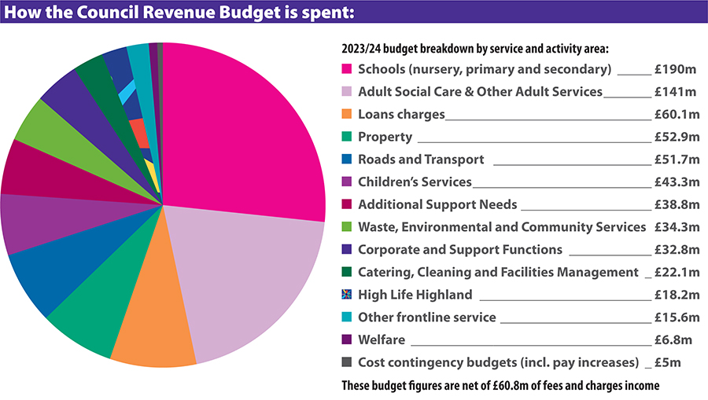

**“nearest toilet signs”** – also, sign for Wyvis Natural Playpark? Cllr Kraft has had no reply to either.

Concern was raised that **replies are not forthcoming** at times either to ourselves or to Cllr Kraft. Are Highland Council employees overworked? Cllr Kraft noted that staff are doing their best but it is a huge inbox to reply to at the best of times. There is a complaints procedure if necessary - <https://www.highland.gov.uk/info/670/consultations_complaints_and_compliments/368/make_a_complaint> but members of the community are truly fed up with submitting repeated reports and seeing no action. Community Council member Sadie-Michaela Harris gave examples of four reference numbers for various issues reported over the last 6-8 months that are still outstanding – FS CASE 496633397 10 March 2023 at 12.03, FS CASE 515513676 15 May 2023 at 18.08, FS CASE 522210354 7 June 2023 at 15.45 and FS CASE 554140217 13 October 2023. Cllr Kraft will chase up and noted the points raised.

**Trees/bushes are overgrowing into Stirling Drive** – no action.

**Various potholes** at Corriemoillie and Dos Mucheran have been filled in and in Matheson Road BUT the other potholes, within a few hundred yards of it just over the bridge have not (FS CASE 560931977)! Cllr Kraft contacted the roads team during our meeting and got a reply to say they will be temporarily filled in this week until the machines are available. Cllr Kraft confirmed that roadworks are prioritised on safety, speed of road etc … European funding has ended and levelling up funding was declined. Weather is also a factor when repairing roads and staff are due holidays before winter pressure begins. However, **resurfacing works** between Mossford and Lochluichart Railway Station (A832) took place w/c Monday 16 October 2023 which we welcome and **various white line issues** have been completed recently. We note the **A890 will be CLOSED** at Achnashellach from 9.00pm until 6.00am Sunday to Thursday nights until 6.00am on Friday 24 November 2023 for resurfacing works.

**Grit bins for Strathgarve and Little Garve** – are on order and should be received by The Highland Council by the end of the week.

The Highland Council notes that **residents should report issues directly to them** by calling The Highland Council’s Call Centre on 01349 886606 or via [www.highland.gov.uk/report](http://www.highland.gov.uk/report) In all cases, you will be given a reference number. The Highland Council also appreciates photos showing the actual problem.

**Killin Farm Railway Crossing** – no news but we note fencing works east of Garve at the Check Rail Corner and patch work on the **A835 beside Loch Glascarnoch** are taking place. **Faults on the Trunk Road (A835)** should be reported via [www.bearscot.com/report-a-defect/](http://www.bearscot.com/report-a-defect/)

**Garve mains water** – [www.scottishwater.co.uk/](http://www.scottishwater.co.uk/) we understand maps are being checked by Scottish Water as part of the planning for the works in 2024 following concerns raised about where the water pipes may be in Stirling Drive, Garve.  Towards the end of October, some Strathgarve residents experienced very low water pressure again, meaning upstairs showers are barely working.  Those that have mentioned it have reported it directly to Scottish Water who would send an operative to attend and investigate who attended last Tuesday and found another leak and were apparently going to get it fixed.  The Treasurer has been advised that the pressure was low again last Friday, it seems to come and go.  We do not think Strathgarve will be included in the Garve works next year but will seek clarification and suggest it would be good to include both areas.

**Garve Public Hall refurbishment** – Bob Moir as a Garve Public Hall Trustee updated this meeting that all works have now been signed off by building control as complete and the keys were handed over to Trustees yesterday. Some snagging issues will be dealt with and Trustees now have the challenge to empty the storage container and put back in the Hall the plaques, dishes, chairs, tables etc … Mrs Bell’s clock has already been reinstated. As things stand, the project remains well ahead of schedule and under budget. Fire safety inspection and insurance updates will all take place before opening to the public. As ever, all enquiries to [garvehall@gmail.com](mailto:garvehall@gmail.com) Our Chairman congratulated both the builders and Trustees on what has been achieved, especially over these last six months and with the future of Achnasheen Village Hall also on the agenda, 2024 could be a very busy year for Halls in our community.

**Remembrance Sunday** is this Sunday. As usual, the Community Council will lay a wreath on behalf of the community. This year, recently retired Community Council member Joe Stewart will do the honours for us. Cllr Kraft will lay a wreath on behalf of The Highland Council and the Lord Lieutenant hopes to join us again. The Minister has confirmed the service at the War Memorial will be at 1.00pm and like last year, he will take the schoolchildren up to the War Memorial a few days prior to explain the importance of why we remember. As ever, all welcome.

The latest **Dingwall Medical Group Liaison Meeting** took place on Monday 23 October 2023. Community Council member Sadie-Michaela Harris attended and reported as follows … *Points discussed included the inability to register with a dentist - not part of the surgery remit, people are not able to get pain relief or antibiotics from their Dr for dental pain.  The surgery recommends asking our community if they have issues and if so as a Community Council we write to our MSP.*

*Also raised were problems when trying to book Winter Vaccine appointments.  Example - one of the Community Councillors present had an appointment booked in Dingwall.  When he arrived for the appointment the venue was closed.  When he tried to book another appointment in Dingwall the operator offered him Thurso or Dundee, but nowhere else showed availability for weeks.  All agreed the new Scottish Government handling of the Winter Vaccination has been mainly shambolic compared to when local surgeries were administering them.  Surgery recommends asking our community if they have issues and if so as a Community Council we write to our MSP.*

*The major spike in patient deaths at the practice in the first quarter of the year - gave great cause for concern.  Mean average for the period in previous years would be 12 and this year it was 30.  This was attributed to a rise in respiratory conditions.  It is thought that this may be due to vaccines not being taken up and those experiencing blood clots.*

*The Surgery has a new Doctor to replace a leaving Doctor and another due to join in the new year.  This means they will have increased the number of Doctors at the practice.  Meanwhile Alness is short of Doctors and have not been able to successfully recruit new ones.  The Dingwall Medical Group practice continues to work with student Doctors.  Notably two this year have made presentations of their in-practice work at a national medical conference, one of whom won an award for his presentation.*

*Poster that was recently sent out to Community Councils can be distributed and shared within the wider community.*

*Dr Mack reminded us that the Minor Injuries unit was temporarily moved from Ross Memorial Hospital to Invergordon Hospital but has never returned.  Everyone agreed Ross Memorial provides vital services for the region.*

*The January meeting will take place via Zoom and Dr Mack will invite Kenny Rogers to attend.*

*Laura the Community Link Worker was there and chatted about wellbeing, she has been involved via social prescribing.  She is interested to know what is available in each area – link to our local activities sent.* Our thanks to Sadie for attending and reporting back. The full minutes are available in the library section of our website.

In related news, we were invited to a public meeting organised by **Dingwall Community Council** about St Clements school and The Ross Memorial Hospital but due to the very short notice (three days!), nobody from this Community Council was able to attend.  We sent apologies and asked to be kept informed of developments. Cllr Kraft believes the meeting did go ahead but has not heard outcomes either. Our Chairman will seek an update for us. *(Post meeting note – only ten members of the public attended and it was felt no real progress was made).*

It will be our turn to chair the next **joint working group** meeting in January 2024. We will ask LCT and TG&DDC for suitable dates and agenda items. The **LCT AGM** took place on Monday 30 October 2023. Pam Morrison and Uisdean Menzies were both re-elected to the board, accounts were adopted and there were no questions from LCT members present. **TG&DDC AGM** is due to take place next week where changes to articles will be considered - <https://garve.org/agm-why-attend-reminder2> New board members are encouraged, all welcome. Community Council member Sadie-Michaela Harris has not received details of the AGM. Tina Hartley (Community Engagement and Development Officer, TG&DDC) will check and resend the email.

**Police report** - no formal report received but as reported at previous Community Council meetings, anyone who wishes to raise an issue with the Police is asked to **call them directly on 101** at the time of the incident and make a witness statement.  Video, dashcam or photo evidence is also welcomed by the Police.

We received reports of a **lorry leaving the road** just outside our area at Blackwater Cottages, Tarvie on Friday 20 October 2023.  The road was closed for a few hours until the lorry was emptied and recovered. There were suggestions that the same lorry was seen passing through Garve earlier at speed - unconfirmed.

**Treasurer’s report** - the Treasurer reported our total bank balance is £2,338.16. The breakdown is as follows … Treasurers account £263.11, Reserve £1,613.45, Wreath fund (in memory of Eliza) £461.60. There were no questions for the Treasurer.

**AOB from Community Council members** – Community Council member Sadie-Michaela Harris noted **Daniel the local Postie** recently walked around Garve and Strathgarve with deliveries after his Postvan broke down. It was very much appreciated and should be noted. We send our thanks to Daniel for his devoted service and our Chairman will inform Daniel’s manager accordingly of our appreciation.

**AOB from members of the public** – Sue Tarr wished to remind everyone again that **TG&DDC AGM is next week**, all welcome, the meeting will be online. Hopefully next year the AGM will be back in Garve Public Hall.

Tina Hartley (Community Engagement and Development Officer, TG&DDC) noted **an online video** from our area that perhaps raised security issues. The Development Company has highlighted the video to the police and asked if the Community Council would do the same – agreed. It was noted the IP address might be traceable.

**Screening reports, scoping reports and consultations** – we have received one consultation from The Wester Ross Biosphere who have launched a Gaelic Community Survey. This survey will not take more than five minutes to complete and the answers you give will be anonymised. The information you provide will help give a greater understanding of how Gaelic is used in Wester Ross. Gaelic Survey: <https://www.surveymonkey.co.uk/r/WRBgaidhlig> English Survey:  <https://www.surveymonkey.co.uk/r/WRBGaelic>

All Highland Council consultations are available at <http://consult.highland.gov.uk/portal> All Scottish Government consultations are available at <https://consult.gov.scot/consultation_finder>

**Building warrants, planning issues and licensing issues** – our Chairman explained after having been asked recently by Tina Hartley (Community Engagement and Development Officer, TG&DDC) that around 20+ years ago, Garve and Achnasheen had what he would call planning *"masterplans"* as did most communities at that time but over the years, The Highland Council moved away from those masterplans, especially for smaller communities like Garve and Achnasheen when they moved to more general local area plans.  Those plans were more policy focused rather than for each individual community.  That has led to today's situation where any planning applications in our area are considered against policies in National Planning Framework Four (2023), Highland Wide Local Development Plan (2012), West Highland And Islands Local Development Plan (2019) and any appropriate supplementary guidance.

**A possible planning breach** in our area came to our attention recently which we passed on to the planning department. Following enquiries made by the planning department, planning permission was indeed required.  We understand discussions between the planning department and the landowner are ongoing.  Another possible planning breach in our area has also been passed on to the planning department but in that case, planning permission is not needed. A possible planning breach can be reported at <https://www.highland.gov.uk/info/180/planning_-_applications_warrants_and_certificates/170/planning_enforcement/2>

**There is one new building warrant** currently being shown on The Highland Council website for our area. 21/01897/NDOM6/A is the renovation and extensions to existing hall - AMENDMENT - Stairs to store omitted and wall cladding at entrance at Garve Public Hall. The Case Officer has already agreed to the amendment.

No new planning applications have been received by The Highland Council since our last ordinary meeting but we note **one new screening report** - 23/04997/SCRE, multiple containerised battery storage units totalling circa 49.4MW export capacity, along with associated infrastructure, control building, switch room, inverter containers, lighting and associated works on land 270M NW of Grudie Cottage. The Case Officer has already determined an Environmental Impact Assessment is not required. It was suggested a presentation or email update for our next ordinary meeting would be useful. *(Post meeting note – the company plans to hold two public consultations in person next year and would be happy to attend a Community Council meeting then and discuss the plans once the project has progressed further).*

**We also note 23/04945/PNO** for peatland restoration under class 20A on land 4715M NE of East Cottage, Glencarron. Although the location is just outside our area, it will probably be accessed from our side of the hill. Community Council members had no comments. This update has already appeared on our website.

**One pre-planning application** – proposed telecommunications installation at Glascarnoch Dam. The Shared Rural Network is a telecommunications programme which sees the UK Government working in partnership with the four UK mobile network operators - EE, O2, Three and Vodafone - to increase mobile connectivity in rural parts of the UK. The programme will make 4G available to 95% of the UK, offering significant improvements to mobile coverage in rural communities. The operator VMO2 has identified a suitable location to host the proposed critical infrastructure. Community Council members had no comments. This update has already appeared on our website.

All planning applications can be viewed at [www.highland.gov.uk/info/180/planning_-_applications_warrants_and_certificates/143/planning_permission/4](http://www.highland.gov.uk/info/180/planning_-_applications_warrants_and_certificates/143/planning_permission/4)

**Dates of future meetings** - *(Ordinary meetings are usually held on the first Tuesday of every month unless stated otherwise)*. It was agreed that we will still aim for the first Tuesday of each month as per 1.2 of standing orders but will confirm nearer the time as there are only four Community Council members and all four will need to be present for a meeting to be quorate.

Tuesday 5 December 2023, 7.00pm, webcam – agreed

January 2024 – no meeting

Tuesday 6 February 2024, 7.00pm, webcam, tbc

Tuesday 5 March 2024, 7.00pm, webcam, tbc

The April 2024 meeting will probably need to be moved to Tuesday 9 April 2024, tbc

As usual, our Chairman started to draw the meeting to a close by asking all present if anyone had any final questions or thoughts on anything they had heard this evening, a question he often asks throughout the meeting too. Nobody had any final questions or thoughts. Although our meetings are not public meetings, members of the public are still very welcome to attend Community Council meetings and take part in the discussions under the guidance of the Chairman (see section 12 of the Constitution). A copy of our Constitution is available in the library section of our own website and hard/electronic copies are available on request. Those who cannot attend our meetings can, as always, write to us by post or email with any issues they wish raised at [garveanddistrictcc@yahoo.com](mailto:garveanddistrictcc@yahoo.com)

The Chairman thanked everyone for attending.  He also thanked Community Council member Sadie-Michaela Harris for hosting the webcam session and to Cllr Liz Kraft for opening the meeting following the elections.  The Chairman closed the meeting at 10.00pm.

Signed ……………………………..

Signed ……………………………..

Date ……………………………….

*Our Chairman Kenny Maclean would like to thank everyone in the community for their help and support over his 20 years as a Community Council member. Here is a picture of Kenny recently inspecting the Blackwater Bridge for himself following reports of loose plates/bolts (photo curtesy of Cllr Liz Kraft) …*

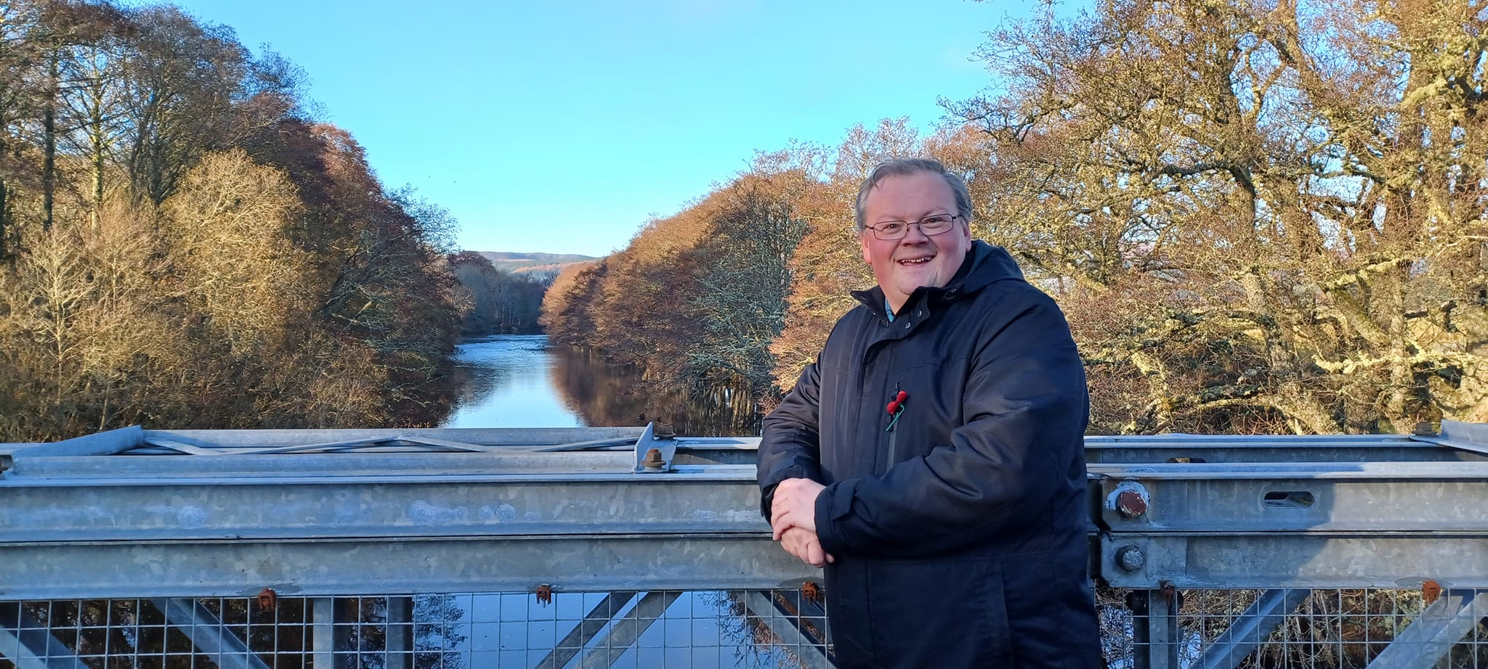

[www.community-council.org.uk/garveanddistrict](http://www.community-council.org.uk/garveanddistrict)

[www.facebook.com/profile.php?id=61552992414355](http://www.facebook.com/profile.php?id=61552992414355)

[garveanddistrictcc@yahoo.com](mailto:garveanddistrictcc@yahoo.com)

This set of minutes were first published (in draft form) at 4.00pm on Tuesday 14 November 2023.