**NOTES of the Garve & District Community Council non-quorate meeting**

**held on Tuesday 2 May 2023 on webcam**

**Community Council members present on webcam**: Kenny Maclean (Chairman and acting Secretary), Sadie-Michaela Harris and co-opted member Hamish Leslie Melville.

**Also present on webcam**: Cllr Liz Kraft and one member of the public.

**Apologies**: Jennifer Haslam (Secretary), Caroline Gamble (Treasurer) and Community Council members Bob Moir and Joe Stewart.

**The Chairman opened the meeting** at 7.00pm and welcomed everyone. He explained that this meeting would not be quorate (at least FOUR Community Council members must attend for a Community Council meeting to be quorate) however, he would give general updates to help keep the community informed. He noted this is our first non-quorate meeting since August 2018.

**Approval of draft minutes** of the last ordinary meeting held on Tuesday 4 April 2023 were deferred.

**Matters arising** – **Highland Council updates** – [www.highland.gov.uk](http://www.highland.gov.uk) – **Personal Injury Claims** – Cllr Kraft is making enquiries.

**Seasonal Access Officers** – Cllr Kraft has been in touch to say funding for Seasonal Access Officers has continued for 2023 but their remit has changed slightly as there is more focus on working with visitor management groups this year and investing in the Stac Pollardh car park.

**Broken fence in Garve** – Phil Waite at The Highland Council has confirmed to Cllr Kraft that it does appear the fence was put in by a council service, possibly Amenities. There is a bit of distance Phil notes from the fence down to the riverbank and therefore poses no immediate risk to the children, it is just untidy. More of a concern to Phil is that properties are dumping their garden waste on to the riverbank, often falling into the river. This has led to the spread of garden species into the countryside and possible pollution of the river. There could be three offences, as dumping garden waste is still fly-tipping. A solution maybe to extend the fence to stop access to the riverbank, but that is more costly. Phil suggests if the Community Council agree to inform the residents to stop fly-tipping, he will speak to Amenities and Phil should be able to get a Seasonal Access Officer to replace the strainer. Our thanks to Cllr Kraft and Phil for the updates. It was noted that the “fly tipping” had probably been going on for years.

**Replanting trees in The Avenue** – The Highland Council’s roads department tell us that they will ask one of their arbo team to work something out and will keep us updated.

**White lining in Garve** – this is on the list along with the white lines on the A832 as you approach the Gorstan Junction from Corriemoillie and the white lines as you leave Little Garve and travel up to the main road.

**Mossford road surface** – Cllr Kraft has confirmed that the money has run out for 2022/23 but more funding will be going into the 2023/24 budget for roads. <https://www.highland.gov.uk/news/article/15269/77m_capital_investment_for_strategic_road_schemes_across_highlands> shows the need for repairs south of Achnasheen if the plans are approved later this week. We asked that both Mossford and the Old School Road in Achnasheen be included in plans and that a full list of all roads requiring attention be provided so we can see where we are on the list, something Officers should be providing ward members on a regular basis. How long is the list for ward five?

**Speed survey on A832** – Police patrols continue to take place both in Garve and the Achanalt/Achnasheen area. This update has already appeared on our website. The Highland Council’s roads department are currently concentrating on 20mph zone work (including Garve Village) as there is a tight deadline set by Transport Scotland/Scottish Government for these funds to be spent - <https://www.highland.gov.uk/news/article/15268/highland_20_mph_speed_limit_programme_benefits_%E2%80%93_help_keep_your_community_safe> Perhaps “Unmarked Police Car” signs might help? Cllr Kraft will ask if such signage still exists.

Our Chairman wished to place on record his thanks to all those who helped him tidy up around the **Achnasheen Recycle Bins** last week after glass sheets were left instead of being taken to the Dingwall Recycling Centre. It was felt some sheets had been deliberately smashed.

**New recycle centre visit** – Cllr Kraft is awaiting news on this and where the blue bin items go.

The Highland Council notes that **residents should report issues directly to them** by calling The Highland Council’s Call Centre on 01349 886606 or via [www.highland.gov.uk/report](http://www.highland.gov.uk/report) In all cases, you will be given a reference number. The Highland Council also appreciates photos showing the actual problem.

**Killin Farm railway crossing works/barriers east of Garve** – no further news.

**Faults on the Trunk Road (A835)** should be reported via [www.bearscot.com/report-a-defect/](http://www.bearscot.com/report-a-defect/) It was noted the left side of the road on the sharp right-hand bend east of Blackwater was bad. This will be reported.

**Garve mains water** – it was noted at this meeting that water pressure continues to drop in Strathgarve and at Killin Farm and bursts to the mains pipes also keep occurring. Everyone is encouraged to report such problems directly to Scottish Water at <https://www.scottishwater.co.uk/Help-and-Resources/Contact-Us/Contacting-Us> or by calling them directly on 08000 778 778 and keep a note of the reference number. Perhaps new pipes are required as was the case in Gorstan and Little Garve?

Work has now started on the **refurbishment of Garve Public Hall**. We understand the contractor is very grateful to neighbouring properties/individuals for their support and assistance so far. It is good to finally see some work on the ground! The Garve Defibrillator has been moved nearer to Garve Post Office so it can remain available to the public if required.

**Future of Achnasheen Hall** – Cllr Kraft informed us that there was a ward business meeting today and the subject of Achnasheen Hall came up. The Highland Council will be conducting their own community consultation into the future use of the building as costs have risen to refurbish the Hall to £100,000. The Highland Council want to know if there is a real need for the Hall before spending such sums. It is hoped the consultation can be carried out sooner rather than later. It was noted that following a survey of Achnasheen and Achanalt residents undertaken by Achnasheen Amenities in October 2021, 31 responses were received from the 49 questionnaires that were sent out (turnout 63%). The responses were: 22 not in favour of buying the hall from The Highland Council, 8 in favour of buying the hall and 1 abstention.

Community Council member Bob Moir and our Chairman attended **an online joint meeting** of the Community Council, LCT and the Development Company on Tuesday 18 April 2023. Topics covered included funding projects in the future, community support grant review (<https://garve.org/csg-review23>) food parcels (not going ahead) and community consultation/engagement. As usual, minutes of the meeting will be made available in due course on our website. Since the meeting, Tina Hartley (Community Engagement and Development Officer, TG&DDC) who was unable to attend the joint meeting has noted that to date applications made by the Development Company for external funds (out with the area) in support of community priorities amounts to £771,688.  Of these applications, the sum of £356,658 has successfully been brought into this community with £415,031 worth of external applications being unsuccessful.  The Development Company has and will always consider external funding opportunities as they arise and how they relate to the community’s priorities as per the community development plan. We thank Tina for her update. Carol Smith, LCT Secretary has also noted since the meeting that across the Lochluichart windfarm and the extension plus the Corriemoillie windfarm there will be funding of £8.6m for the duration of the windfarms. Our thanks to Carol for her update. It was felt be some that to borrow or get advances of future funds would tie the hands of future LCT Directors and that a financial plan based within actual amounts available each year may be required.

**Police report** - no formal report received but as reported at previous Community Council meetings, anyone who wishes to raise an issue with the Police is asked to **call them directly on 101** at the time of the incident and make a witness statement.  Video, dashcam or photo evidence is also welcomed, indeed encouraged by the Police.

We were saddened to hear via press reports of the fatality east of Garve on Saturday 15 April 2023 after a car and motorbike collided around 11.10am. The 65-year-old male rider of the BMW GS motorcycle was pronounced dead at the scene. He has now been identified as Andrew McIntyre from Inverness-shire. The other vehicle involved was a grey Citroen C3. The 53-year-old female driver was treated at the scene by the Scottish Ambulance Service and did not require hospital treatment. The road was closed to allow for an investigation at the scene and fully reopened around 6.20pm. Police are keen to speak to witnesses. Anyone who can help is asked to call 101, quoting 1270 of 15 April. Our thought are with Mr McIntyre’s family. This update has already appeared on our website.

Press reports also tell us that 25 speed-related offences were detected on the NC500 over the weekend of Friday 14 – Sunday 16 April 2023. Just two of them were detected in our area. One driver was detected at 97mph within the 60mph limit on the A832 near Achnasheen while another was detected at 91mph in the same area. The enforcement action was carried out following similar work carried out in previous years.

**Treasurer’s report** – Our Chairman on behalf of the Treasurer confirmed that our total bank balance is £1,508.31. The breakdown of the bank balance figure is treasurers account £-30.14 and reserve £1,538.45. Ann MacRae has agreed to audit our accounts once again, our thanks to her. The Treasurer is taking the paperwork to Ann tomorrow so the audit can begin.

**AOB from Community Council members** – no issues raised by those present.

**AOB from members of the public** – no issues raised by those present.

**Screening reports, scoping reports and consultations** – we have received notice of one consultation from The Highland Council. Their Participation Statement describes how The Highland Council intends carrying out consultation on the new Highland Local Development Plan, including how they get views on where development goes and the policies and guidance that are used to make planning decisions. The survey is **open for responses until 5.00pm on Wednesday 31 May 2023**. To take part in the survey, please visit - <https://forms.office.com/e/Z9RS4T0bJn> This update has already appeared on our website.

All Highland Council consultations are available at <http://consult.highland.gov.uk/portal> All Scottish Government consultations are available at <https://consult.gov.scot/consultation_finder>

**Building warrants, planning issues and licensing issues** - one new planning application has been received by The Highland Council since our last ordinary meeting. 23/01636/OHL is a proposed 33kV electricity wood pole connection at Fannich. The deadline for comments to the Case Officer was Tuesday 18 April 2023. We noted the application on our website. Community Council members viewed this application online and raised no objections.

All planning applications can be viewed at [www.highland.gov.uk/info/180/planning_-_applications_warrants_and_certificates/143/planning_permission/4](http://www.highland.gov.uk/info/180/planning_-_applications_warrants_and_certificates/143/planning_permission/4)

**Dates of future meetings** - *(Ordinary meetings are usually held on the first Tuesday of every month unless stated otherwise)*

Tuesday 6 June 2023, **AGM** followed by an ordinary meeting, 7.00pm, webcam

July 2023 – no meeting

Tuesday 1 August 2023, 7.00pm, webcam

Tuesday 5 September 2023, 7.00pm, webcam

Tuesday 3 October 2023, 7.00pm, webcam

Tuesday 7 November 2023, 7.00pm, webcam

Tuesday 5 December 2023, 7.00pm, webcam

The Chairman thanked everyone for coming and closed the non-quorate meeting at 7.45pm.

*Over the weekend of Friday 14 - Sunday 16 April 2023, police in marked and unmarked vehicles undertook speed related works in our area. Here some of the police officers are seen west of Strathbran (Photo credit Police Scotland) …*

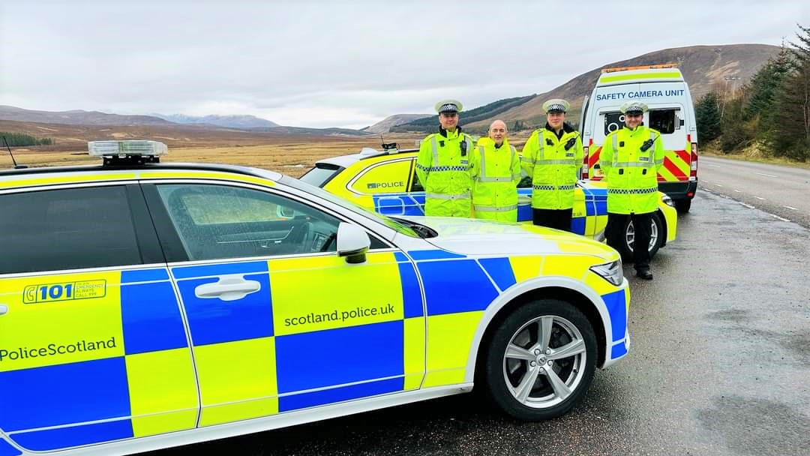

*Some of the initial works around Garve Public Hall, thanks to Bob Moir for the picture …*

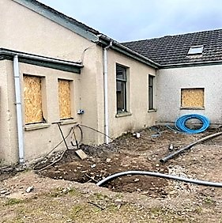

[www.community-council.org.uk/garveanddistrict](http://www.community-council.org.uk/garveanddistrict)

[garveanddistrictcc@yahoo.com](mailto:garveanddistrictcc@yahoo.com)