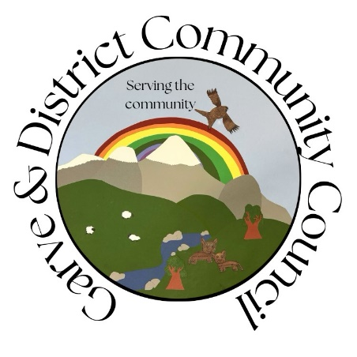

**Minutes of the Garve & District Community Council**

**ordinary meeting held on Tuesday 23 July 2024 on webcam**

**Community Council elected members present on webcam**: Kenny Maclean (Chairman & Secretary), Bob Moir (Vice Chairman), Caroline Gamble (Treasurer) and Sadie-Michaela Harris.

**Also present on webcam**: one member of the public (Sue Tarr).

**Apologies**: Cllr Liz Kraft, Tina Hartley (Community Engagement and Development Officer, TG&DDC and Community Council associate member), Peter Kane (Kane Partnership) and Seumas Skinner (Community Liaison Manager, Statkraft UK). Seumas also sent apologies on behalf of Scott Vallance (Principal Project Manager, Statkraft UK).

The Chairman opened this meeting at 7.15pm following the conclusion of the AGM and welcomed everyone. He explained that as elected members were busy next month, we were holding our August ordinary meeting tonight. He also confirmed that this meeting would be recorded as per the agenda and will be archived and available for viewing for twelve months thereafter - <http://bit.ly/GDCCmeeting23July2024incAGM> He reminded members of the public that although our meetings are not public meetings, they were still very welcome to attend Community Council meetings even on webcam and take part in the discussions under his guidance (see section 12 of the Constitution). Those who cannot attend our meetings can, as always, write to us by post or email with any issues they wish raised at [garveanddistrictcc@yahoo.com](mailto:garveanddistrictcc@yahoo.com) Our website [www.community-council.org.uk/garveanddistrict/](http://www.community-council.org.uk/garveanddistrict/) continues to receive 150-200 visitors per month (out of a community of around 230 people). The Community Council area covers from Garve to Aultguish and from Garve to Achnasheen and is the only organisation that represents the whole community.  We are elected by the community every four years or so and usually meet once a month.  Draft minutes and a list of current members of the Community Council can be viewed at our website. We are also on social media - [www.facebook.com/profile.php?id=61552992414355](http://www.facebook.com/profile.php?id=61552992414355)

We send best wishes to Iain Macleod, Mossford following his car accident. Our Chairman visited him in Hospital about 10 days ago and reports Iain is doing well all things considered. Iain left Hospital last Friday. The Vice Chairman has also seen Iain and found him to be in good form and cracking jokes.

Best wishes to Andrew Biddlecombe, Strathgarve who has been in Hospital following a bike accident.

Best wishes to Norma Ross, Contin Community Council who has been unwell. Norma has been a key driver in community matters in the Contin area for many years and we hope to see her back on her feet soon.

Community Council elected members were very sad to learn that Dr Val MacIver OBE passed away last week after a short stay in Hospital. Val was first elected to the old Council and remained an elected member into the new Highland Council until 1999 before returning to serve a final term in 2003-2007. She then went on to work for Platform PR and though that work became a regular attendee of these meetings mainly for windfarm development but was also happy to point us in the right direction on other matters. Val loved attending these meetings saying they were some of the best run in the Highlands, high praise from someone who had chaired the planning and education committees in her time overseeing windfarms and school closure programs but it was perhaps her involvement in setting up the University of the Highlands & Islands that she was most proud of outside of her family. Our Chairman recalled one Community Council meeting where Val looked uncomfortable in her seat. When he offered her another seat she said she was fine, was needing to spend a penny but did not want to miss a minute of our meeting! Our Chairman called a 5-minute comfort break just for Val. Val had a beady eye for details that mattered and did her homework, she called a spade a spade but Val was a good laugh too and we think of her and her family at this sad time. <https://www.ross-shirejournal.co.uk/news/death-of-trailblazing-highland-politician-who-championed-uhi-356090/> The Vice Chairman remembered Val as a character, smoking with other Community Council elected members outside Achnasheen Village Hall after a meeting while he waited to get them home, a good servant to this community. The Treasurer recalled a lovely lady who was very competent in her roles, she spoke her mind freely and will be sorely missed. The Treasurer also recalled Val on guard down her driveway after a sofa was dumped but Val recognised the sofa and it was soon removed at no cost to Val. Community Council elected member Sadie-Michaela Harris remembered the sharp witty mind of Val and the sofa story.  *(Post meeting note – a memorial service celebrating Val’s life will be held at St Andrews Cathedral, Inverness on Thursday 8 August 2024 at 12.30pm).*

Following the General Election held on Thursday 4 July 2024, we note our new MP is Jamie Stone, our thanks to outgoing MP Ian Blackford for his help over the years. We also note 183 electors are registered to vote at Garve Polling Station and 46 electors at Achnasheen Polling Station.

**Declarations of Interest** – the Vice Chairman is a Garve Public Hall Trustee and a Friend of Garve War Memorial. The Vice Chairman, Treasurer and Community Council elected member Sadie-Michaela Harris are all members of the traffic calming group. Community Council members confirmed that they had read all documents due to be discussed tonight before the start of this meeting.

**Approval of draft minutes** of the ordinary meeting held on Monday 6 May 2024 via webcam were proposed without amendment by Sadie-Michaela Harris and seconded by Caroline Gamble, unanimously agreed. We also note the notes of the non-quorate meeting held on Monday 10 June 2024. Minutes are available at Garve Post Office, Achnasheen Village Noticeboard, on our website or via email. Hard/electronic copies are also available on request. Minutes will be signed by our Chairman and Treasurer in due course via post.

**Matters arising** – **Local Place Plan –** Tina Hartley has supplied the following update … *“June 2024 – As planned, the dedicated Local Place Plan area on garve.org became live and the first post, under the heading of community engagement, went out on 7 June 2024. Since this initial post three other posts have been shared with the community via garve.org and all our social media channels during this month. Work on designing the community survey (postal, digital, word and pdf) completed. Throughout June, engagement continued and all households and businesses in Garve and District had the opportunity to complete a Local Place Plan Community Survey. A paper copy of which was distributed to all households and businesses;*

*a digital copy was available online and both word and fillable pdf copies were made available which could either be returned via email or post. On Saturday, 22 June 2024, a face-to-face engagement event took place at Garve Public Hall where the whole community was invited to attend to share their views on community development moving forward. The event was attended by staff from the Development Company and Lochluichart Community Trust and board/community council volunteers from all three community organisations – The Garve & District Development Company, Garve and District Community Council and Lochluichart Community Trust. Around fifteen members of the community attended the event. To meet our timescale for completion of the process, the closing date for the survey was set for 30 June 2024. From an approximate 230 adults of voting age, (information provided by G&DCC from June 24 poll statistics), seventy-two responses were received. Information about the community survey and engagement event was widely circulated by all three community organisations’ communications channels and we thank G&DCC and LCT for their support. The Company continue to receive Local Place Plan updates from The Highland*

*Council and Garve & District Community Council continue to share any relevant information it receives which is appreciated. Next steps – the draft Local Place Plan is currently being developed in line with*

*legal obligations and will be available for distribution on the 1 August 2024. Comments on the draft plan can be received and noted during the month of August with the final plan being submitted to The Highland Council in September 2024.”* Our thanks to Tina for the update and for her regular contact as she works through the process, our thanks to all who took the time to fill in the survey. 72 responses were received, which is around a 31% turnout. On-going priorities – caring for our community seems to be top followed by traffic calming: -

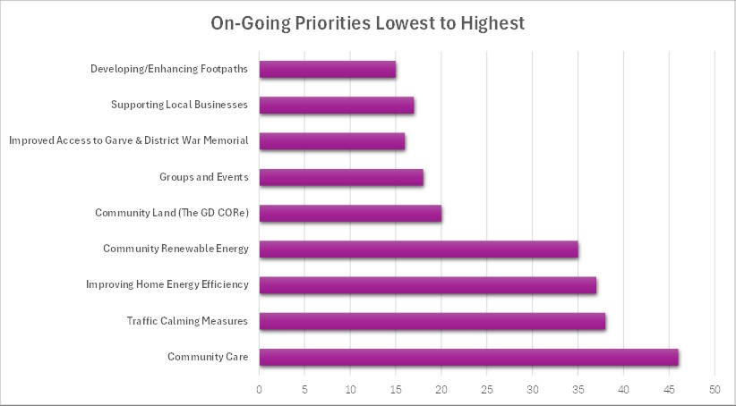

More details at <https://garve.org/local-place-plan-update6> Sue Tarr who attended this meeting was asked if she had anything further to add from a Development Company’s point of view, nothing at this stage. *(Post meeting note – the draft plan can now be viewed at* [*https://garve.org/local-place-plan-update7*](https://garve.org/local-place-plan-update7) *Any comments to the Development Company directly by Saturday 31 August 2024 please).*

**Boralex** – <https://www.boralex.com> – no news but Fiona Milligan was sad to hear the news about Val as was Andy Russell at EDF, Nick Sage at EDP, SSE staff and former HC staff and Councillors.

**Kirkan Windfarm** – <http://www.kirkanwindfarm.co.uk> - as reported previously, they are still in the phase of considering options for Kirkan and working through the various planning conditions. Community Benefit is something Kirkan would like to give the community but those discussions will take place much later once everything else is known. We thank Trevor for his regular updates.

**Proposed Tarvie windfarm** – [www.tarviewindfarm.com](http://www.tarviewindfarm.com) - **Koehler Renewable Energy (KRE) was f**ounded in 2012 and are part of the Koehler Group, an eighth-generation family business in the paper industry. Proposals for a Tarvie windfarm remain early and evolving and have altered since last year. KRE is committed to early and consistent engagement with local communities and hopes to organise a meet the developer event in September (date and location to be confirmed). KRE has been invited to our September ordinary meeting. This update has already appeared on our online channels.

**Proposed SSE Fairburn extension** – <https://www.sserenewables.com/onshore-wind/in-development/fairburn-extension> - no news.

**SSEN Spittal – Beauly 400kV project** - <https://www.ssen-transmission.co.uk/projects/project-map/spittal--loch-buidhe--beauly-400kv-connection> - as previously noted, further public exhibitions took place on Wednesday 12 June 2024 and Thursday 13 June 2024. SSEN have confirmed the attendance figures as per those who signed in were: Contin – 13, Marybank – 42, Garve – 2, Strathpeffer – 61. Our thanks to SSEN for the update however we note the recording of the SSEN meeting with Community Councils online has still not been shared. The meeting took place on Thursday 7 March 2024 – 20 weeks ago! Our Chairman asked about this at the Garve drop in event.  It seems they cannot share the video outside of the company due to security settings but the SSEN representative will again ask their IT department how to change the settings so that it can be shared. Community Council elected members felt it was a poor show no video had been supplied to the Community Councils who were all agreeable to the meeting being recorded, especially as the meeting was held in the middle of the working day so not all Community Council members were free to attend. The Vice Chairman noted that in Aberdeenshire, community groups there are also having similar problems with SSEN.

**SSEN underground cable** from the Western Isles to Beauly – <https://www.ssen-transmission.co.uk/projects/project-map/western-isles/> - as previously reported, SSEN Transmission have started ground investigation works along the underground cable route for the Western Isles HVDC beside the A835. There will be between 3 to 4 squads working along the route at any one time and a shift pattern of 12-day fortnight from 08:00 -18:00 or till daylight hours allow. The duration of time at each location along the route will be dependent on how deep the trial pit/borehole is, but a rough estimation is between half a day and up to three days. **In slightly related news** and as noted at our non-quorate meeting in June 2024, SSE Renewables are proud of their hydro heritage which has been vital to bringing clean energy to the north of Scotland for over 80 years. They recognise the hydro infrastructure plays an important role in communities and want to ensure that they continue to support the local communities for the next generation so are launching a new £10 million community fund which will be open to projects that support the community council areas which proudly host hydro assets. To support the launch of the fund in autumn 2024, SSE Renewable need to undertake work in summer 2024 to understand how this new fund can best support local communities across Scotland. Consultation – SSE Renewables have secured the services of IBP Consultants to complete a consultation with local residents to ensure that the new fund focuses on the themes which are most important to the local area, SSE Renewables would appreciate help in raising awareness of this consultation so that the views of as many residents as possible will be heard. Local Panel – SSE Renewables will establish a panel of community representatives from across Scotland to make independent funding decisions for the new fund. The panel will meet online three times a year and will review applications from all hydro communities across Scotland. SSE Renewables would particularly appreciate any interest from residents aged 18-30 to increase community representation of younger people on the panel. Applications – the fund will open for applications in autumn 2024. The survey is now available online at [www.ibp.eu.com/hydrofund](http://www.ibp.eu.com/hydrofund) and will remain open until Monday 19 August 2024 but we were advised last week that only two individuals from this community have responded to the survey so far.

**Field Corriemoillie** – [www.fieldcorriemoillie.co.uk](http://www.fieldcorriemoillie.co.uk) - Field have submitted a Proposal of Application Notice (PAN) to The Highland Council -  - <https://wam.highland.gov.uk/wam/applicationDetails.do?activeTab=documents&keyVal=SFF8EUIH0KN00>

**Proposed Carn Fearna windfarm** – <https://projects.statkraft.co.uk/Carn-Fearna/> a planning application has been submitted to The Highland Council for a met mast. The deadline for comments has passed but the community was informed at the time via email and our online channels. Concern was expressed by Community Council elected members at the length of time this mast may be on site (three years), its height and the bird deterrents.  We have been informed all this is standard but have asked the Case Officer to also pay particular attention to these details before determining the planning application.  We have also asked if the fixings of the proposed mast to the ground will hold up to the windy conditions and if the metal spikes shown below the measuring equipment in the applicant's photos are necessary. Earlier today, we received an update from Seumas Skinner (Community Liaison Manager, Statkraft UK) to say they are continuing to carry out final refinements based on their surveys and feedback and expect to reach the design freeze state of the project next month. They will be issuing the consultation summary report and responses to those who provided feedback to the previous round of exhibitions within the next month or so. They are working on responses to questions raised by consultees (including the Community Council) to their Met Mast planning application, these will be passed back to The Highland Council and that they hope to be able to attend the next meeting of the Community Council. They also confirmed that they have been invited to attend a Strathpeffer Community Council meeting. Our thanks to Seumas for the updates. Community Council elected member Sadie-Michaela Harris informed the meeting that a data logger for wind has been seen on the ground on top of the hill in the last 10 days or so. Is this related to Statkraft? We will seek clarification. *(Post meeting note - Skinner Seumas believes it is a LIDAR array for wind data tracking. He will get some more details on the use and purpose of the equipment).* In slightly related news, we have received notice of works on the **base station above Garve**. Cornerstone and Virgin Media O2 (VMO2) are undertaking works to the existing radio base station above Garve. The works will include proposed VMO2 1No. 600 Transmission Dish, fixed to new offset bracket, proposed VMO2 equipment to be installed within existing VMO2 equipment cabin and to provide improved technical provisions, greater capacity and coverage in the area. It is intended that the works will take place shortly and they will endeavour to keep any disruption to a minimum. This update has already appeared on our online channels.

**Community Council logo** is now complete, our thanks to the Strathgarve Primary children for designing the logo for us. It is already in use on our social media page and even on our Chairman’s notes for these meetings. The logo will also appear on agendas and minutes in due course. The children were very proud of their design and rightly so! It features trees, hills, red kite, sheep and cows from our area and a rainbow.

**The Highland Council updates** – [www.highland.gov.uk](http://www.highland.gov.uk) – **Replanting Trees in The Avenue** – a full list of the monthly updates since February 2022 is available in the library section of our website.

**Wooden fencing and Wyvis Natural Playpark sign, nearest toilet signs** **and hedge cut back in Stirling Drive, Garve** are all still outstanding. Is the wooden fencing even needed outside the old cemetery in Garve? We will ask Cllr Kraft to seek guidance on the matter, it is an eyesore. The Vice Chairman also noted the speed limit signs (20’s plenty) are still up, no roundels painted in Stirling Drive/Matheson Road, Garve and the bushes are now covering the speed limit signs at the junction outside Garve Public Hall. Cllr Kraft will be made aware.

**Garve Cemetery** – there appears to be problems getting the grass cut in the cemeteries again. The grass in the new cemetery was cut but with a sit-on machine, this meant that the grass close to the headstones was not cut. The grass in the old cemetery has had a very rough cut and some areas have not been cut at all. We raised this issue via Cllr Kraft and the Vice Chairman was able to report the grass was attended to last week in both cemeteries and was now looking good, thanks to all concerned. It was noted that families visit people in both these cemeteries so respect should be shown.

**Garve 20mph zone** – The Highland Council reduced speed limit roll out has been delivered using a Temporary Road Traffic Regulation Order (TTRO) which is valid for a period of 18 months and runs till Friday 31 January 2025. The Highland Council are required to go through the full statutory process for the making of the permanent Traffic Regulation Order (TRO) and it is scheduled that this process will begin in September this year. Early indications would suggest the Garve 20mph zone will be made permanent, tbc.

**The A832 side of the Gorstan Junction** - we have again written to The Highland Council about the A832 side of the Gorstan Junction (FS-CASE-624561804) and they confirmed white lining and rumble strip concerns are noted. Our Chairman has a paintbrush if The Highland Council supplies him with the white road paint … Community Council elected member Sadie-Michaela Harris noted other areas such as Dingwall and Alness have similar problems yet where resurfacing works have taken place, white lining has also been done, but only on the new tar, not the whole stretch of road.

**Strathgarve potholes** – not filled in! **Matheson Road** potholes are getting worse. A pothole in **Achnasheen** has been reported – FS-CASE-624560732 and was filled in a few days later, perhaps a sign that busy roads do take priority. Where is the Hotbox and white lining machine? Cllr Kraft will be asked to make enquiries.

**Dumped mattress** – both appear to have been removed, thanks to all concerned. **Reports of rubbish dumped** on Lochluichart Estate owned land have been passed onto the Estate who confirmed that at a few locations there were some cans and pieces of rubbish left behind by fishermen. It was noted that there would always be a minority of people who take access to the beautiful countryside for granted and are unwilling to take away their rubbish when they leave; however, the Estate will keep tabs on the matter. Our thanks to Glyn Robson, Estate Manager and staff for their help. **A TV and car parts were dumped beside the Achnasheen glass recycle bins**, The Highland Council collected a few days later when they were next passing but such items should be taken directly to Dingwall Recycle Centre - <https://www.highland.gov.uk/directory_record/1096724/dingwall_recycling_centre> The Treasurer noted the old Quarry in Strathgarve was also used as a dump but the locked gate helped stop that.

We note **grass verge cutting** took place on the A832 between Gorstan and Achnasheen in June which we welcome and **surface dressing** works are currently taking place south of Achnasheen on the A890 and west of Achnasheen on the A832 though it is disappointing that no overtaking signs and 20mph signs through the works are being ignored by many causing chipped windscreens and making the work risky for those on the ground. At least three cars have gone off the road during the works.

Some **40mph signs** are missing east of Achnasheen. This has been raised with the appropriate department at The Highland Council (FS Case 631490462, Monday 15 July 2024) and will be investigated, thanks to all.

**Future of Achnasheen Public Toilets and Hall –** we note the **public toilets** were again closed from Friday 14 June 2024 until Wednesday 19 June 2024. The Highland Council confirmed that the toilets were backing up and would not flush. It was noted several buses stop there and their high use on a system originally designed as the Station House would not cope. Cllr Kraft had suggested encouraging buses to be diverted to Silverbridge toilets but that was felt to be only moving the problem to another site. The toilets closed again on Thursday 4 July 2024 and remain closed. The Highland Council confirmed it is unfortunately the same, recurring issue with the drains.  They raised an emergency repair request for the site to be visited and pipes cleared again. The Highland Council survey showed support for retaining public toilets in Achnasheen as has the Local Place Plan so a permanent reliable solution must be found. We await developments with interest but note Kinlochewe public toilets also remain closed following renovation work that they are waiting for the building inspector to sign off before opening but Silverbridge, Lochcarron and Rogie Falls toilets are open. Community Council elected members felt the toilets were not fit for purpose in Achnasheen with buses and motorhome use so further thought needed. **Regarding the future of the Hall,** Achnasheen Amenities Association have still not been updated on what the plan is (nor have we) but they confirmed that their Office Bearers are the same as before - Andrew Biddlecombe as Chairman, Kathy Grist as Secretary and Steve Jones as Treasurer. Our thanks to Steve for the update.

We were concerned to read press reports on Friday 12 July 2024 that **the mobile library service**, which was discussed at our ward five joint Community Council meeting on Wednesday 28 February 2024 appears not to have improved. Press reports suggest library vans have been replaced by hire vehicles carrying books in plastic containers. Cllr Birt has confirmed the review of the service is (as he understands it) complete but has not heard what the next steps are. We also asked Highlife Highland, who provide the service for The Highland Council for comment. They told us they were sorry for the long-term disruption. Highlife Highland delivers the service on behalf of The Highland Council while the Council retains responsibility for the maintenance of the vehicles. Currently, six of the seven mobile libraries, including the one that serves the Garve & District area are no longer road worthy due to age and excessive mileage. These vehicles are long overdue for replacement and this has led to disruption of the service in recent times. Unfortunately, the situation is not helped with the financial challenges both Highlife Highland and The Highland Council are facing. Highlife Highland and The Highland Council are currently working together to review service needs. Future fleet requirements and establishing specifications and costs of replacement vehicles is being considered as part of the overall process. As an interim measure, Highlife Highland is providing an alternative service for customers via a small transit van. All customers are being given the option of a drop-off of books to their communities to ensure that they have access to reading material. Schools are being offered a small and regular delivery of books to their building for pupils to choose from.  Highlife Highland are aware that the alternative service being offered is far from ideal but feel they are doing everything they can to try and ease some of the difficulties that are currently being experienced. We hope for a good outcome and will ask Cllr Kraft to also chase up an update for us. Community Council elected member Sadie-Michaela Harris noted a similar service in Cambridgeshire is still running after 60 years - <https://bbc.in/3YgikKa>

The Highland Council notes that **residents should report issues directly to them** by calling The Highland Council’s Call Centre on 01349 886606 or via [www.highland.gov.uk/report](http://www.highland.gov.uk/report) In all cases, you will be given a reference number. The Highland Council also appreciates photos showing the actual problem.

**A835 Trunk Road issues - Killin Farm railway crossing improvements and barriers east of Garve** appear complete.

We also note the damage to the **crash barrier at the “Check Rail Corner”** which we have continued to ask for updates on from Network Rail (no response), Transport Scotland (see previous minutes) and the MSP (who is chasing up again for us). The Vice Chairman was recently told of an incident at the lights. A local resident was heading back west to Garve and stopped at the lights, they were at the head of the queue. When the lights changed they moved forward, as they turned past the blind corner they met cyclists heading the other way. The cyclists had not “jumped” the lights, the lights had changed while they were in the middle of the works. Would it be possible to open a cycle lane inside the cones? Increasing the time between changes of the lights will only lead to longer queues and (probably) driver frustration. The number of cyclists on the road is increasing as the holiday season is on us. Community Council elected members agreed with the suggestion and have already passed the suggestion onto Transport Scotland and the MSP’s office. The Vice Charman also noted a bike behind the cones/barrier recently so there is room. We have also been made aware of traffic lights stuck on red at both ends and other times both sets of traffic lights stuck on green. Such instances should be reported straight away directly to BEAR **-** [www.bearscot.com/report-a-defect/](http://www.bearscot.com/report-a-defect/) or **0800 028 1414.** The last update from Transport Scotland as noted at our non-quorate June 2024 meeting was *that unfortunately, traffic management is going to be required for some time at this location. The engineering solution that is necessary to make the road safe is complex and extensive site investigation work is necessary before BEAR can progress to the detailed design.* The damage to the barrier occurred in early 2024 and was first reported at our February 2024 ordinary meeting. *(Post meeting note – an update via the MSP’s office informs us that the improved traffic management at the site has continued to be monitored and maintained by BEAR. Transport Scotland have liaised with Network Rail and they have advised that additional vegetation within the railway boundary will be cleared by them in the next few days. This should further improve sight lines within the traffic management (Kevin MacBean at Network Rail has since confirmed that the trees have been cleared and opened the sight line east bound towards the temporary traffic management). For the repair of the safety barrier, Network Rail and BEAR have now agreed with Transport Scotland what the concept will be for the structure that will be required to support the road and the new safety barrier system. Transport Scotland are making arrangements with Network Rail for track access that is required to carry out a dimensional survey of the entire site to assist with the design of the repair solution. Unfortunately, the traffic management will need to remain for some time while these surveys are completed and the repair is designed, procured, and constructed. BEAR have confirmed they had to lengthen the site (distance between traffic lights) due some verge subsidence. This has now been repaired and the site was shortened on the Thursday 25 July 2024, this will allow cyclists more time to get through the site. Setting up a cycle lane would not be possible due to the position of the varioguard. Our thanks to all for the various updates).*

**A835 part of Gorstan Junction** – BEAR have confirmed that their planned maintenance team were in the area recently. Both resurfacing and lining will be part of their scheme so they will refresh the lines during this scheme if necessary. Our thanks to BEAR for the update. We note some white lining was done w/c Monday 8 July 2024.

**Request for a sign** for Inchbae has been passed onto Transport Scotland, no reply received.

**Concrete repairs planned for the Inchbae Bridge - t**raffic lights will be in place from Monday 8 July 2024 for six weeks. BEAR, on behalf of Transport Scotland, is set to start essential concrete repair works on the A835 at Inchbae bridge. Throughout the duration of the works, the A835 at Inchbae will have temporary traffic lights to give safe access to allow BEAR employees to carry out crucial repairs. This update has already been posted on our online channels. Our Chairman visited the site on Sunday and reports work is well underway.

**Traffic calming group** – a meeting of the traffic calming group took place online on Tuesday 25 June 2024. Tina Hartley has kindly supplied us with the following report from the meeting (thanks Tina). Community Council updates highlighted …

***Garve***

* *Agreed that we are unlikely to get any “official” traffic calming measures via Transport Scotland given their recent response to recent queries and they would not give permission for community measures to be installed.*
* *The term “discretionary” was picked up from their correspondence however they feel that discretion has already been used with the reduction from the national speed limit to 40mph.*
* *20’s Plenty signs HAVE NOT been removed just yet.*
* *New 20mph roundels are planned for the village.*
* *Points to be considered for the future:*
  + *Garve Public Hall is getting busier with more events planned and therefore increased traffic exiting the A835 on to Stirling Drive.*
  + *The Primary School use the hall for school events and weekly gym sessions.*
  + *High School pupils are dropped off and must cross the road to get home to the village.*
  + *Railway crossing.*
  + *We have horses at the side of the road.*
  + *Telephone exchange.*
  + *Because of the bend some houses that front the road are unable to easily see traffic when trying to pull out.*
* *Things we could do as a community:*
  + *Property/land owners – can we encourage anyone to install private signs?*
  + *Community gateways – flowerbeds, bespoke planters (in Ullapool we have old rowing boats entering and exiting the village – anything that would represent Garve & District at entry and exit boundary points and on the approach/exit to individual villages/hamlets?  Link to Wester-ross Biosphere?*
* *Pursue the Wester-ross gateway sign – we could amend the wording to say, “please drive carefully and enjoy the scenery.”*

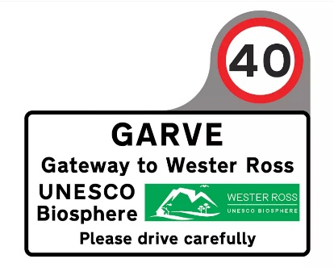

* *Pursue the sign directing visitors away from Stirling Drive and to Wyvis Natural Play Park via the official route (the northern entrance to Little Garve)*
* *Tina looked at Google Map directions from Inverness to the playpark and they now direct people through Little Garve (no longer via Stirling Drive).  I have asked Sharon (Chair of the playpark) if she could update their FB header to show directions image, to put a shout out welcoming visitors now school is out and remind them of the correct directions and to schedule regular posts throughout the Summer to promote the correct route.  I have also offered to admin their page to help.  I have today, amended their link on*[*garve.org*](https://garve.org/wyvis-natural-playpark)*and I will do a reminder post to ask the community to help in getting Google Maps to amend directions to the playpark.*

***Little Garve***

* *Information regarding Wyvis Natural Play Park above is relevant.*
* *Property/landowners – can we encourage anyone to install private signs?*

***Inchbae***

* *A request for a village sign has been made – this could be considered alongside any ideas in general for updating signs (no response received).*

***Gorstan Junction***

* *Acknowledgement that The Highland Council are responsible for the A832 and Transport Scotland for the A835.*
* *Rumble strip on the A832 approach to the junction – Google Maps does show a strip of*[*different (old) road texture*](https://www.google.co.uk/maps/@57.6229747,-4.6995975,3a,75y,267.8h,53.52t/data=!3m6!1e1!3m4!1sOIuEwQUQVLzpE1erUlVb_w!2e0!7i16384!8i8192?coh=205409&entry=ttu)*on the approach to the junction – is that still there? (Yes)*
* *White lines need renewing.*
* *Property/landowners – can we encourage anyone to install private signs?*

***Lochluichart***

* *Gateway measures planned.*
* *Sue feels Lochluichart may meet the requirements for reduced speed limits – Tina and Sue to review.*
* *Footpath to support access to train station.*
* *Slow signs before train station at each end.*
* *Property/landowners – can we encourage anyone to install private signs?*

***Achanalt***

* *Footpath to support access to train station.*
* *Slow signs before train station at each end.*
* *Property/landowners – can we encourage anyone to install private signs?*
* *Double white lines where appropriate.*

***Achnasheen***

* *Gateway measures planned.*

*Pam shared a news article about a new NC500 Director, and it was agreed that the Community Council would invite a representative to a future meeting. (Invite sent by the Community Council on Thursday 27 June 2024 and again 10 days ago, no reply received).* The Community Council would welcome feedback from non-members of the group if there is anything else that needs considered.

**Garve mains water** – no update provided. Community Council elected members were very disappointed though we acknowledge plans may be coming together behind the scenes. The last update at our April 2024 ordinary meeting talked about works in November 2024.

Community Council elected member Sadie-Michaela Harris attended the **MRCPP** on Wednesday 19 June 2024, about 25 people attended from various Community Councils. Presentation by Paul Young, PDF to follow. Anne Gillies also presented; minutes expected to follow. Next meeting Wednesday 25 September 2024. Sadie also attended the **Dingwall Medical Group** meeting on Monday 1 July 2024. The meeting was held in person like the last few and discussions included supporting travelling people and needs of veterans - 74, more than they thought. Dr Mack concerned German Measles on the rise and expects more cases and whooping cough. Vaccines away from surgeries has shown less take up. Healthy eating should be promoted. Invited community transport along to next meeting (Tuesday 27 August 2024) to see how it can help get people to surgery. In previous times, there was talk of coming to Village Halls to do surgery there. Now, gone the other way but children vaccinees still done at surgery.

Garve & District Community Council currently has vacancies on the Community Council.  The Community Council elected members consider it to be very important to have as broad a representation of our community as possible, as we cover a wide variety of community issues and to do this well, we would like members from all corners of our large area.  We usually meet on the first Tuesday of the month.  If you are aged 16 or over, live in the Community Council area and are on the electoral roll and would like to be considered for co-option onto the Community Council, please email [garveanddistrictcc@yahoo.com](mailto:garveanddistrictcc@yahoo.com) with your name and contact details. This update has already appeared on our online channels.

**Police update -** as reported at previous Community Council meetings, anyone who wishes to raise an issue with the police are asked to **call them directly on 101** at the time of the incident and make a witness statement.  Video, dashcam or photo evidence is also welcomed, indeed encouraged by the police. The police can also be contacted on [www.scotland.police.uk/secureforms/contact/](http://www.scotland.police.uk/secureforms/contact/) *(Post meeting note – a accident south of Achnasheen -* [*https://www.ross-shirejournal.co.uk/news/a890-driver-taken-to-hospital-after-three-vehicle-crash-356343/*](https://www.ross-shirejournal.co.uk/news/a890-driver-taken-to-hospital-after-three-vehicle-crash-356343/)*)*

**Treasurer’s report** – the Treasurer noted our total bank balance (checked online) is £1,942.98.  The breakdown is as follows … Treasurer's account £-132.07. Reserve £1,613.45. Wreath fund (in memory of Eliza) £461.60. There were no questions for the Treasurer but the Treasurer will claim £75 for cover gift costs for our now retired auditor.

**AOB from Community Council members** – no issues raised by those present.

**AOB from members of the public** – **Sue Tarr wished to raise an issue** she had raised a few months ago. She was sorry not to have been able to attend one of our meetings before now but had watched the recordings and read the minutes. Our Chairman asked her to tell us when she had felt silenced. Sue felt those were our Chairman’s words, not hers so he asked her to put it into her own words. Sue referred to a chain of emails from the Traffic Calming Group which is made up of residents who meet informally to discuss various problems with traffic in the area. Information had come in from a resident and Sue felt our Chairman’s reply was negative. Her observation on the whole matter was that the Community Council had not been seen to take forward from certain residents their issues about traffic. Social media was used to ask if anyone else felt silenced (no replies received). Our Chairman was glad Sue attended this meeting as that was not his interpretation but was glad Sue had clarified her position. He regretted Sue felt the Community Council had not taken issues forward but confirmed we have been raising the issues raised with various organisations and individuals such as Cllr Kraft and MSP. Who else should we be contacting? Sue went on to say as the Traffic Calming Group has developed, she felt the Community Council had played a very valuable role and have now been getting on board, just frustrating it has not always felt to be that way. Residents are being driven mad by the issues. The Treasurer felt it was the authorities causing the problem as they were unwilling to listen or reply. We can only highlight concerns raised. Sue – felt the Community Council elected members had made their views known at previous meetings and make decisions based on information received. The Development Company works hard to try and de-escalate fights as not everyone gets on with one another all the time, past should be left behind. The Traffic Calming Group now has new problems, with new people attending expressing new worries, promote trust and respect within the community and between residents. The Vice Chairman - 75% of Community Council elected members are in the Traffic Calming Group and do feedback at the Community Council meetings as has happened tonight but it is a fight, fighting authorities such as speed surveys on A835, Community Council do try and our Chairman also attends to support where he can. Community Council elected member Sadie-Michaela Harris mentioned that we write to MSP, BEAR, Cllr Kraft, some more than once, who else? More ideas welcome and have explored many avenues already. Sue – perhaps this is more a Traffic Calming Group issue as we can use all those members as it is their information that helps inform us. Perhaps it does not have to be a fight, more building a case. Just reporting to authorities may not be the only way, perhaps we need to demonstrate why, show all the information we have and perhaps some of the information provided recently may be a way thought but battling is not necessarily the answer, work with all parties involved. The Treasurer – the last meeting of the Traffic Calming Group was light hearted and relaxed. Some authorities remain faceless and do not always take concerns on board. Sue – why not invite officials to Community Council meetings as we did years ago? The Vice Chairman confirmed we do but no NC500 or Scottish Water representative here tonight. Next month we hope to hear from KRE as noted earlier this evening. The Treasurer noted it is easier to join online than in person yet they are not attending. The Vice Chairman felt it is a fight as they will not come outside office hours, is a petition about the roads the way forward? Community Council elected member Sadie-Michaela Harris noted the Lochluichart cameras and the four weeks of traffic data which was shared with Police, MSP etc showing speeds, even that did not come to anything except a lot of expense and time. Pandemic since NC500 has shown some shocking speeds. Our Chairman noted that covid did change everything, even these meetings of the Community Council, rare to meet in hall/venue, officials not replaced and those left only work office hours, very different to the old days, happy to invite but often they do not come or give apologies. The Vice Chairman felt the whole work culture had changed meaning officials do not want another meeting in the evenings, especially if they have been online all day. More ideas welcome from the Traffic Calming Group and they are certainly not falling on deaf ears here at the Community Council.

Sue asked if we were **planning in person meetings** again? The last in person/hybrid meeting was our 2022 AGM but the hybrid did not really work for those online as they could not hear what others in the hall were saying. Our Chairman confirmed we were not against the idea but hall hire costs, travel expenses and technology were issues last time (costing around £60 for a meeting, those who did attend could have all attended online for free). Sue noted a lot of organisations went down an online route for their meetings during covid, what is The Highland Council guidance now? (up to each Community Council). The Vice Chairman noted there are no funds, cannot afford to hire a hall, Trustees could be asked but Hall Trustees have expenses to meet too and very often it is just Community Council elected members present. Even tonight, only one member of public was in attendance. How do we record an in person only meeting? Community Council elected member Sadie-Michaela Harris noted she had other meetings today, prefers online, unnecessary travel should be avoided and do our bit for climate change. Zoom free as Sadie lets us use her account so no subscription costs, petrol expenses or travelling time. Hybrid might work better in the future once conference facilities are installed into Garve Public Hall. When Sadie was away last year she zoomed in from England so our meetings remained quorate. Winter travelling was something the Chairman felt very strongly was a reason to remain online through winter months as it is his car, his time, his insurance, his life at the end of the day. Safely must come first, Community Council elected members fully agreed. New system provided by LCT should work at the top end of the main hall as well as the meeting room of Garve Public Hall. Ten people can sit in the meeting room but what happens if more turn up? Development Company/LCT feedback once they use the new system at their meetings would be welcome. Hire of the meeting room is free to community groups, main hall £12/hour. Booking online at [www.garvepublichall.com/](http://www.garvepublichall.com/) Community printer also available in the meeting room. Sue confirmed the Development Company have started meeting in the hall when they can, do have online meetings too, AGM might have to be in person. Our Chairman noted that those who cannot attend our meetings can, as always, write to us by post or email with any issues they wish raised at [garveanddistrictcc@yahoo.com](mailto:garveanddistrictcc@yahoo.com) *(Post meeting note – if anyone offline wishes to attend our meetings, just write to us at 4 Bignold Place, Achnasheen, IV22 2EG).*

**Screening reports, scoping reports and consultations** – In mid-June 2024, we were made aware of the **possibility of Phonebox removal notices** in the Achnasheen, Achanalt and Garve Phoneboxes. Aultguish Phonebox was checked twice, most recently last Sunday but no notice there. We were disappointed that yet again our Phoneboxes are on the hit list, especially in such a rural community and yet again no information sent directly to the Community Council. We are aware of one Achanalt resident who has objected to the proposal. The last such exercise was in 2019 when Achnasheen was used to make 15 phone calls in a 12-month period, Achanalt 10 phone calls, Aultguish 1 phone call and Garve 2 phone calls. The notice askes those with any comments to contact The Highland Council planning department directly who will collate all responses for each Phonebox. The deadline for comments is Saturday 31 August 2024. Residents who we have email addresses for have already been informed of this consultation by us. Community Council elected members unanimously agreed we must object again as if the mobile signal is down, a fixed line will be needed in emergencies. It was also agreed we put in an objection for Aultguish in case the notice is just missing from that Phonebox.

The Highland Council has launched a **consultation to gather early learning and childcare experiences** to help shape future provision in Highland. Survey closes Wednesday 31July 2024 - <https://forms.gle/BX94iaRKMoaRMCpV7> This update has already been posted on our online channels.

All Highland Council consultations are available at <http://consult.highland.gov.uk/portal> All Scottish Government consultations are available at <https://consult.gov.scot/consultation_finder>

**Building warrants, planning issues and licensing issues** - **There are no new building warrants** currently being shown on The Highland Council website for our area. **Two previous planning applications have** been determined by The Highland Council since our last ordinary meeting. **24/02035/PNO** was the proposed peatland restoration work to take place on Ledgowan Estate which we noted at our non-quorate meeting in June 2024 has been granted by the Case Officer as Prior Approval Not Required. **24/01999/TPNO** was the proposed erection of 20m lattice mast With 3no. shared antennas, 2no. dish antennas, associated cabinets and ancillary apparatus within a fenced compound| on land 3550M NW Of Dos Mucheran which we noted at our non-quorate meeting in June 2024 has been granted by the Case Officer as Prior Approval Not Required.

**Five new planning applications** have been received by The Highland Council since our non-quorate meeting in June 2024. **24/02112/FUL** is the proposed installation of a 20m high lattice tower, ancillary equipment, compound, access track and associated development on land 460M NE of Fannich Lodge. To meet planning consultation deadlines, the community was informed via our online channels and Community Council elected members were informed via email and raised no objections.

**24/02379/FUL** is the proposed erection of a 120.8m temporary met mast on land 620M NE of Garve Radio Transmitter Station. To meet planning consultation deadlines, the community was informed via our online channels and Community Council elected members were informed via email. As noted earlier, we have asked the Case Officer to look at several points in detail before determining the application.

**24/02695/FUL** is the proposed change of use to two short term let units on land 40M East of Woodlands Little Garve. To meet planning consultation deadlines, the community was informed via our online channels and Community Council elected members were informed via email and raised no objections.

**24/02638/TPNO** is the proposed installation of a 20m telecommunications lattice mast and associated equipment on Tollomuick, Innis Nan Nathraichean, Strathvaich Estate. The location is in Strathpeffer Community Council’s area but it is felt the site would be accessed from our side of the hill. To meet planning consultation deadlines, the community was informed via our online channels and Community Council elected members were informed via email and raised no objections.

**24/02809/TPNO** is the proposed installation of 20m Lattice tower, 3no. antenna, 0.3m dishes, foul weather enclosure, 2no. cabinets, 1.2m high fence on land 880M SW of Lubriach. To meet planning consultation deadlines, the community was informed via our online channels and Community Council elected members were informed via email and raised no objections.

A possible planning breach can be reported at <https://www.highland.gov.uk/info/180/planning_-_applications_warrants_and_certificates/170/planning_enforcement/2>

All planning applications can be viewed at [www.highland.gov.uk/info/180/planning_-_applications_warrants_and_certificates/143/planning_permission/4](http://www.highland.gov.uk/info/180/planning_-_applications_warrants_and_certificates/143/planning_permission/4)

**There were no new licensing issues** for us to consider this evening.

**Dates of future meetings** - *(Ordinary meetings are usually held on the first Tuesday of every month unless stated otherwise) –* Tuesday 3 September 2024, 7.30pm, online – agreed.

As usual, our Chairman started to draw the meeting to a close by asking all present if anyone had any final questions or thoughts on anything they had heard this evening, a question he often asks throughout the meeting too. Nobody had any final questions or thoughts. Although our meetings are not public meetings, members of the public are still very welcome to attend Community Council meetings and take part in the discussions under the guidance of the Chairman (see section 12 of the Constitution). A copy of our Constitution is available in the library section of our own website and hard/electronic copies are available on request. Those who cannot attend our meetings can, as always, write to us by post or email with any issues they wish raised at [garveanddistrictcc@yahoo.com](mailto:garveanddistrictcc@yahoo.com)

The Chairman thanked everyone for attending.  He also thanked Community Council member Sadie-Michaela Harris for hosting the webcam session.  The Chairman closed the meeting at 9.20pm.

Signed ……………………………..

Signed ……………………………..

Date ……………………………….

*George the Postie on this travels at Dos Mucheran on Monday 15 July 2024 (Picture credit George Finlayson) …*

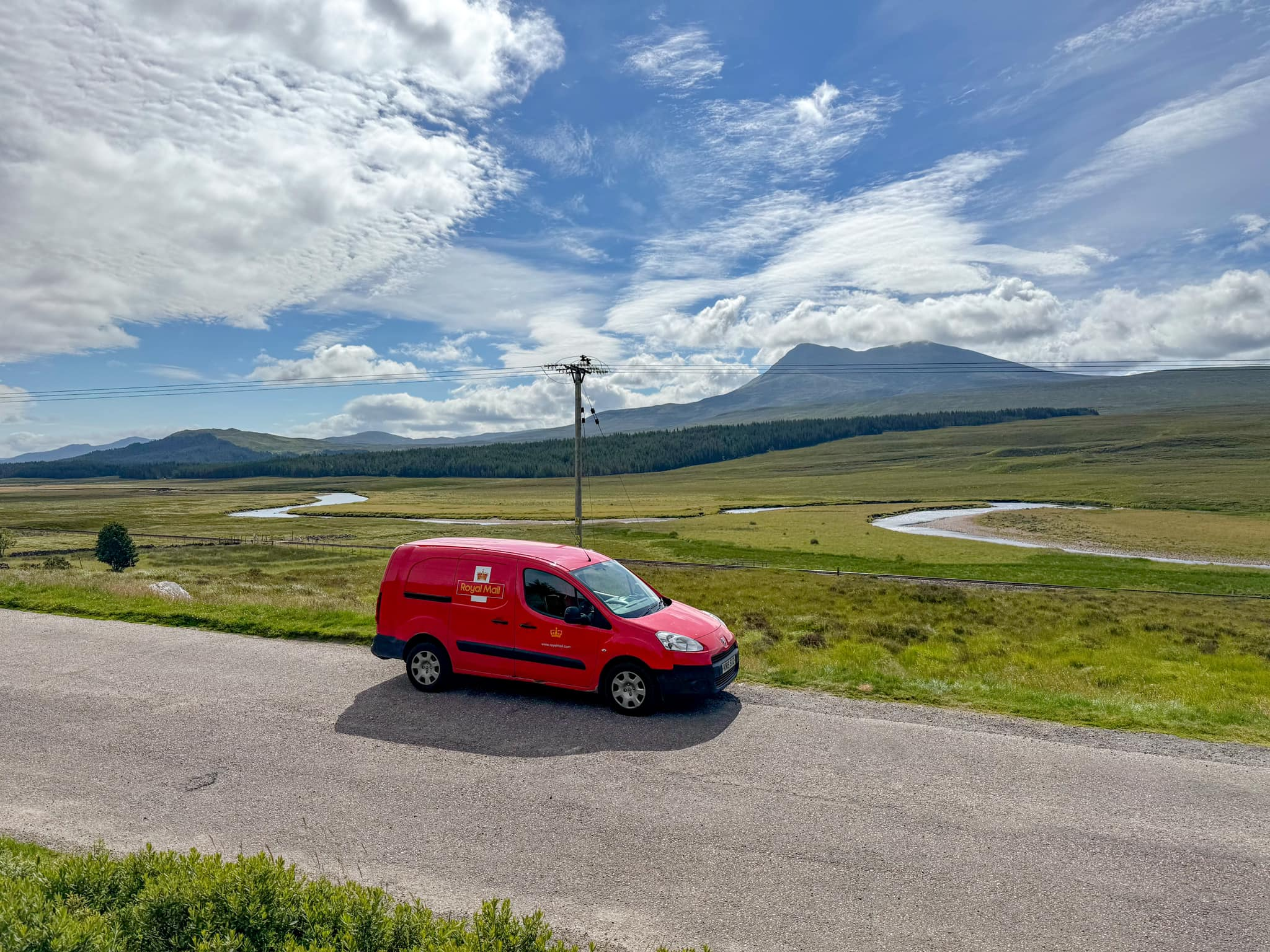

[www.community-council.org.uk/garveanddistrict](http://www.community-council.org.uk/garveanddistrict)

[www.facebook.com/profile.php?id=61552992414355](http://www.facebook.com/profile.php?id=61552992414355)

[garveanddistrictcc@yahoo.com](mailto:garveanddistrictcc@yahoo.com)

This set of minutes were first published (in draft form) at 5.00pm on Thursday 1 August 2024.