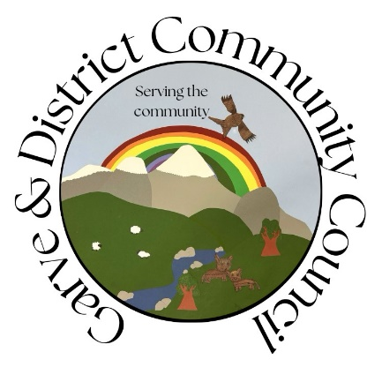

**Minutes of the Garve & District Community Council ordinary meeting**

**held on Tuesday 3 December 2024 on webcam**

**Community Council elected members present on webcam**: Kenny Maclean (Chairman & Secretary), Bob Moir (Vice Chairman), Caroline Gamble (Treasurer) and Sadie-Michaela Harris.

**Also present on webcam**: Cllr Liz Kraft (from 7.40pm until 9.05pm) and one member of the public from 7.40pm (Flora Smith).

**Apologies**: Henry Whitelaw emailed apologies on behalf of Anthony Palmer (Field).

The Chairman opened the meeting at 7.10pm after a brief computer issue and welcomed everyone. He also confirmed that this meeting would be recorded as per the agenda and will be archived and available for viewing for twelve months thereafter - <https://bit.ly/GDCC3rdDEC2024> He reminded members of the public that although our meetings are not public meetings, they were still very welcome to attend Community Council meetings even on webcam and take part in the discussions under his guidance (see section 12 of the Constitution) and that phones should be on silent. Those who cannot attend our meetings can, as always, write to us by post or email with any issues they wish raised at [garveanddistrictcc@yahoo.com](mailto:garveanddistrictcc@yahoo.com) Our website [www.community-council.org.uk/garveanddistrict/](http://www.community-council.org.uk/garveanddistrict/) continues to receive around 200 visitors per month (out of a community of around 230 people). The Community Council area covers from Garve to Aultguish and from Garve to Achnasheen and is the only organisation that represents the whole community.  We are elected by the community every four years or so and usually meet once a month.  Draft minutes and a list of current members of the Community Council can be viewed at our website. We are also on social media - [www.facebook.com/profile.php?id=61552992414355](http://www.facebook.com/profile.php?id=61552992414355) where we now have 149 followers. Research by Community Council elected member Sadie-Michaela Harris showed most are from Inverness, Garve, Achnasheen and Dingwall. 67% are women. We note 45 people have viewed our November ordinary meeting and 62 people have viewed our October ordinary meeting.

Last Friday we learnt the news that **Betty Mackenzie**, a former resident of Achanalt and Muir of Ord had passed peacefully away. Our thoughts are with the family.

Our Chairman attended the **LCT AGM** in Garve Public Hall on Monday 7 October 2024 and **TG&DDC online AGM** on Tuesday 26 November 2024 <https://garve.org/tgddc-agm-2024-update> Marcella Melis is now Chair, she moved into the area around four years ago. Our Chairman met with **Maree Todd MSP** online on Thursday 28 November 2024, more details of which in this minute. He was unable to attend the **Garve Christmas light** switch on event on Saturday 30 November 2024. We understand around 80 people did attend including our Treasurer with around 40 people staying on for the film night in the Hall. Feedback to the organisers (Garve events and Garve Hall Trustees) would be welcome, the new sound system in the Hall has already been complimented.

Bob Moir confirmed he donated the **Postbox for Garve Public Hall** but is happy for TG&DDC and LCT mail to be left in it.

Our Chairman attended the **Christmas Fair** in Garve Public Hall on Sunday 1 December 2024 where a couple of issues were raised with him, more details of which in this minute

**Winter arrived** in our community w/c 11 November 2024 with snow throughout the area. Around a foot of snow was seen in Aultguish and Achnasheen lasting about a week. We sent our thanks to all the gritter drivers who worked so hard to keep the roads open. Special thanks to the Silverbridge crew who spent around an hour in Achnasheen on Thursday 14 November 2024 working hard on roads, side roads etc.

**Declarations of Interest** – the Vice Chairman is a Garve Public Hall Trustee, a Friend of Garve War Memorial, a LCT elected Director and a member of the GD CORe land panel. He also declared an interest in planning application 24/04364/FUL as one of the proposed EV chargers is on Hall land. The Treasurer noted she is a land owner with regards to the SSEN underground cable from the Western Isles to Beauly and Community Council elected member Sadie-Michaela Harris is a member of the Wyvis Natural Playpark group. Cllr Kraft is a member of the North Planning Applications Committee at The Highland Council. Community Council elected members confirmed that they had read all documents due to be discussed tonight before the start of this meeting expect the proposed 20mph permanent zones email as that was only sent at 5.33pm today.

**Approval of the draft minutes** of the ordinary meeting held on Tuesday 5 November 2024 via webcam. Following clarification from Tina Hartley (Community Engagement and Development Officer, TG&DDC) who was present at the GD CORe land panel meeting along with Bob Moir, the Vice Chairman has asked that *"Bob noted the community survey undertaken a few years ago was split 50/50 on what to do with the old staff block.”* should perhaps read *"It was noted that following completion of the GD CORe engagement process, views were split 50/50 around renovation versus new build."*and that*“Costings for the options would also need to be updated before community were asked again."* should be amended to say "*2023 costings will be re-shared with the community; however, it will be important to note that these will have likely increased over the past 12 months."* The draft minute with both amendments was then approved by Bob Moir and seconded by Sadie-Michaela Harris, unanimously agreed. Minutes are available at Garve Post Office, on our website or via email. Hard/electronic copies are also available on request. Minutes will be signed by our Chairman and Treasurer in due course via post.

**Matters arising** – **Boralex** **windfarm** – <https://www.boralex.com> – The Highland Council North Planning Applications Committee notes that the application was approved by them in January 2023. Details for the satisfaction of pre-start planning conditions are pending consideration by the planning department. Fiona Milligan and her team hope to be able to say more to the community in the New Year.

**Kirkan Windfarm** – <http://www.kirkanwindfarm.co.uk> - as reported previously, they are still in the phase of considering options for Kirkan and working through the various planning conditions. We thank Trevor for his regular updates. The Highland Council North Planning Applications Committee notes the Scottish Government issued consent on 25 July 2023 and are now awaiting submission of pre-development planning condition requirements.

**Proposed Tarvie windfarm** – [www.tarviewindfarm.com](http://www.tarviewindfarm.com) - Koehler Renewable Energy UK Limited (KRE) are developing proposals for a wind farm on land south of the A835, approximately 3.7km northwest of Contin that would have 11 x 7MW turbines, with a 200m tip height and 30MW battery energy storage system (BESS). Our Chairman, Vice Chairman and Community Council elected member Sadie-Michaela Harris attended a public event on Thursday 7 November 2024 in Contin but with so many people there, there was no way of talking to the few officials in attendance. We noted from the leaflets that the EIA is underway, further public exhibitions are planned for 2025 before submitting a planning application in the spring of 2026. The Vice Chairman agreed you could not move in the Hall, the display boards and slide show just showed what was already in the leaflets. We thought about 30 members of public in attendance, some going in before the doors officially opened and only what appeared to be three officials. Community council elected member Sadie-Michaela Harris agreed with the above summery.

**Proposed SSE Fairburn windfarm extension** – <https://www.sserenewables.com/onshore-wind/in-development/fairburn-extension> - no further news.

**SSEN Spittal – Beauly 400kV project** - <https://www.ssen-transmission.co.uk/projects/project-map/spittal--loch-buidhe--beauly-400kv-connection> We have received notice that following public consultation events on the potential alignment for the overhead line in Spring 2024, SSEN received detailed feedback from a wide range of stakeholders including, but not limited to, local community members, landowners, local heritage groups, statutory consultees and developers. SSEN would like to thank all those who took the time to attend their in-person consultation events. Their intention, as communicated during the previous public consultation, was to publish a Report on Consultation earlier this year, carry out further Public Consultation on the final alignment in Autumn 2024 and then submit our Section 37 Planning Application in Winter 2024 however, the feedback provided, has led them to carry out further investigations in some areas and consider some changes to the proposals. These further investigations are now being concluded, and SSEN intend to publish a Report on Consultation (ROC) in January 2025. Following publication of the ROC, they plan to carry out further public engagement events early next year.

**SSEN underground cable** from the Western Isles to Beauly – [https://www.ssen-transmission.co.uk/projects/project-map/western-isles](https://www.ssen-transmission.co.uk/projects/project-map/western-isles/) - no further news though we hear a section of the route may be moved, we will await official word.

**Field Corriemoillie** – [www.fieldcorriemoillie.co.uk](http://www.fieldcorriemoillie.co.uk) – Field have provided us with the following statement regarding fire risk … “*Field takes a comprehensive approach to fire risk management through careful design, operating procedures, and emergency planning. Field is an industry leader in relation to fire safety. Workstreams undertaken by Field in relation to BESS fire safety include: sitting on government working groups to help define BESS fire safety standards, working closely with suppliers to understand the latest BESS safety features and fire safety testing and engaging with local fire and rescue services. Whilst fire safety is not explicitly accounted for in the planning process, Field recognises the importance of this to communities and has therefore prepared an Outline Battery Safety Management Plan (OBSMP) to accompany the planning application. The OBSMP provides full details on Field’s approach to battery safety management, including identifying all potential safety risks that may arise from the Proposed Development as well as the proposed measures in place to avoid and mitigate risks. These include consideration of risks relating to, but not limited to, fire events, site security and emergency access.*

*We are engaging with Scottish Fire and Rescue and will continue to do so through the planning, construction and operational phases of the project.  We would look to host the local emergency services, including the fire crews, at a site visit prior to site energisation to discuss the emergency response plan agreed with them. For example, we are hosting the local Fire and Rescue service at our Auchteraw site, prior to it going live.”* We also note the comments by the Scottish Fire & Rescue Service made at the Wester Ross, Strathpeffer & Lochalsh Area Committee on Monday 11 November 2024. Our Chairman, Vice Chairman and Community Council elected member Sadie-Michaela Harris visited another site on Thursday 7 November 2024 and noted the scale of the whole operation. Concern was again raised about fire safety and that planning documents for another site were “a typical” scenario. The planning application drawings were all noted as being a typical fire suppression layout **-**thus indicating a generic plan had been submitted not a specific plan. We will seek further clarification on the matter.

**Proposed Carn Fearna windfarm** – [https://projects.statkraft.co.uk/Carn-Fearna](https://projects.statkraft.co.uk/Carn-Fearna/) - no further news. **In related news** - [www.ssen-transmission.co.uk/carn-fearna-wind-farm-connection](http://www.ssen-transmission.co.uk/carn-fearna-wind-farm-connection) - no further news. *(Post meeting note – SSEN have sent us their Report on Consultation Document for the Carn Fearna Wind Farm Connection. The consultation document concluded that route option two was the preferred route. The consultation process furthered highlighted that route two has lowest impact. Route two will now be taken forward as the proposed route. The project will now be taken into stage three (Alignment Selection), commencing with identification of alignment options within the proposed route. These will be informed by further consultation exercises, and through detailed surveys, which may identify any additional and/or currently unknown engineering, environmental or land use constraints.)*

**The Highland Council updates** – [www.highland.gov.uk](http://www.highland.gov.uk) – **Replanting Trees in The Avenue** – tree planting is now complete, 50 crab apple trees, 50 sessil oak, 50 rowan trees, 55 scots pine and50 sweet cherry trees with ongoing maintenance over the next twelve months as detailed in the updated report on our website. Trees selected were based on The Highland Council Foresty Officers recommendations following his experience, public feedback and species availability. On site there are crab apples which in a few seasons or so will be fruiting and so the community are more than welcome to pick this fruit. The planting has been done to meet the UK woodland assurance standards. The trees were planted the same week as National Tree Week - <https://treecouncil.org.uk/seasonal-campaigns/national-tree-week/> A full list of the monthly updates since February 2022 is available in the library section of our website. Our thanks to all involved. This update has already been shared through our online channels.

*Photo curtesy of our Chairman …*

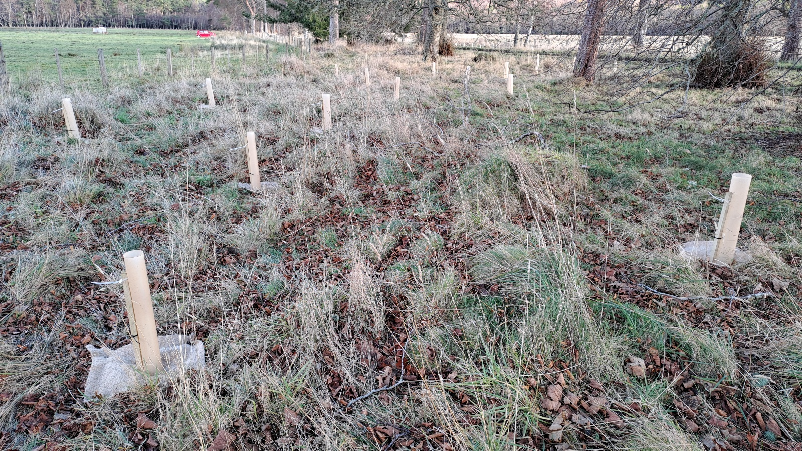

**Wyvis Natural Playpark sign** is still outstanding. We have suggested **a sign for Silverbridge public toilets** in Garve would also be useful, Cllr Kraft continues to make enquiries on both counts but noted The Highland Council cannot put signs on the trunk road. She will ask Andy Bone for guidance for Highland Council roads and Debbie Sutton for toilets.

Cllr Kraft and one member of the public joined the meeting at 7.40pm.

**Wooden fence beside cemetery in Garve** – no further news, Cllr Kraft will ask for an update.

**School’s updates - the building report** **for Strathgarve Primary School and Schoolhouse** is now available in the library section of our website. The school was built in 1870 with the extensions in 1963/4. There is thought to be “low” or “very low” instances of asbestos in the buildings. The Highland Council has been in discussions with parents about a potential mothballing of **Strathconon Primary School** in the summer of 2025.  (Strathgarve, Marybank and Strathconon all share a Headteacher). During these discussions, parents have highlighted that the Strathconon Estate is currently recruiting for new staff, which may or may not lead to new families in the area. The Highland Council remains of the view that it would not be appropriate to continue operating Strathconon Primary School if the roll falls to one as is currently forecast however they will continue to monitor the situation, and will review the decision to mothball should there be appointments to the estate that result in more school-age children within the school’s catchment area. Due to the need to plan in time for August 2025, a final decision will be made by Thursday 1 May 2025. Marybank, Scatwell & Strathconon Community Council have also kept us updated and are amazed that The Highland Council invested considerable resources in the lengthy and thorough renovation of the school, which was reopened only in the spring of this year and are now facing the possibility of mothballing. Concern was raised about staff moral and levels of staff. Cllr Kraft confirmed many staff work in other schools already and length of contract will also be a factor. Uncertainty is not good for parents/children or staff. In other news, at The Highland Council Education Committee on Thursday 21 November 2024, it was agreed that **Kinlochewe Primary School**, whose catchment area includes Achnasheen might be closed depending on an upcoming public consultation. The School has been mothballed since August 2022. A full public consultation is expected in the New Year. Cllr Kraft made it clear that a school will not automatically close, there are lots of options but the community must engage in the process. The Scottish Government prefer to keep rural school open and in some cases remote learning is part of the school week.

**Gorstan Junction** – **white lines** on the A832 approach are still outstanding but we appreciate it is winter time, not ideal to paint the road. Cllr Kraft confirmed the issue is on Andy Bone’s long list. The Treasurer noticed that the **road sign that sits on the island** at the Gorstan Junction must have been pranged as it is close to horizontal! Cllr Kraft has been made aware and the Treasurer reported directly to The Highland Council online on Sunday 24 November 2024 (FS-Case-664860606). Cllr Kraft is liaising with the MSP about the junction who agrees with our Chairman that the **40mph being extended** to cover the junction makes sense BUT Transport Scotland do not like changing these things.  The MSP will raise the matter with the Transport Minister to gather her thoughts on the matter.  We also noted the current consultation to lower the national speed limit.  Data suggests driving standards have fallen since Covid hence the suggestion to lower the speed limit.

It was noted the **Gorstan side road** up to the Old Manse and Myrtle Cottage is still full of potholes. Cllr Kraft has been made aware and will make enquiries. *(Post meeting note – the local crew will have a look when they get time, our thanks to them.)*

Our Chairman was informed on Sunday that **grit bins** in Grudie Bridge and Achanalt were either empty, full of rain water or the grit had gone hard so could not be used. He reported this to the local roads team who looked at the issues today and have already resolved all issues. Achnasheen grit bins have already been refilled. Our thanks again to the local Silverbridge crew for their help.

The **Achnasheen bottle recycling banks** were getting full a few weeks ago so our Chairman asked that both they and the **Garve bottle recycling banks** be emptied. This was done within a few days, our thanks to all.

The elections team have been in touch to ask the Community Council elected members views on the future of the **Achnasheen Polling Station**. Having considered the matter, it was proposed by Kenny Maclean, seconded by Sadie-Michaela Harris, unanimously agreed by all that due to staffing issues in recent years for Achnasheen, Kinlochewe Village Hall would probably by best, it also has step free access. We also noted that 19/46 voters are already on postal votes. There are Postboxes in both Achnasheen and Achanalt.  Anyone can sign up for a postal vote for any election, just contact the elections team for more details - <https://www.highland.gov.uk/info/799/elections_and_voting/1076/voting_information> *(Post meeting note – Cllr Kraft has confirmed that the Connecting Communities Community Transport* *supported by TG&DDC is launching in January 2025. The new transport could be used at election time to take anyone to a polling station that requires assistance. Our thanks to Cllr Kraft for the update.)*

**Public toilets in the Highlands** - at The Highland Council Communities and Place committee on Wednesday 27 November 2024, agreement was reached on a 10 year plan if funding becomes available - <https://www.highland.gov.uk/news/article/16368/committee_confirms_public_conveniences_action_plan> Cllr Kraft confirmed that once Achnasheen Village Hall is sold, all four ward Councillors would like to see the funds be invested in facilities for Achnasheen. Cllrs on Skye and the Convenor are all in agreement. We welcome this news and hope funds can indeed be invested this way in Achnasheen. The Vice Chairman noted vandalism in Dingwall toilets, even the sign on the door has now been vandalised.

**The Highland Council is seeking tenants’ views** on rents for 2025/26 - <https://www.highland.gov.uk/news/article/16371/council_seeks_tenants_views_on_rent_for_202526>

The Highland Council notes that **residents should report issues directly to them** by calling The Highland Council’s Call Centre on 01349 886606 or via [www.highland.gov.uk/report](http://www.highland.gov.uk/report) In all cases, you will be given a reference number. The Highland Council also appreciates photos showing the actual problem.

**A835 Trunk Road issues – “check rail corner”** our Chairman met with the local MSP online on Thursday 28 November 2024 to discuss the matter. The MSP and our Chairman both agreed that the issues with the traffic lights at "check rail corner" was unacceptable and wondered if the fact they are linked by radio rather than cable might be the issue, especially in bad weather, the MSP will seek clarification.  She has already written to the Transport Minister about the situation but is due to see her shortly so will talk to her about it in person, especially as Network Rail are involved.  We note pinning the new wall to the rock under the road will be challenging, this may explain the summer 2025 timescales. We also noted the traffic lights were not working again on Wednesday 20 November 2024. Workers were seen on site within an hour of the incident being reported to BEAR on 0800 028 1414. Sadly, the lights failed again last week. Is that 10 times the lights have failed since January 2024? Concern was also noted about the water that flows over the road, perhaps a sign how weak the embankment really is. Our Chairman walked the section of road on Thursday 7 November 2024 and felt it is not just a new wall that is needed, whole trees have fallen and are now laying against the fence beside the railway, undergrowth makes it difficult to see just how bad the section of road/embankment really is. Further homework required! *(Post meeting note – the Transport Minister via the MSP’s office has been in touch to assure everyone that a programme of work has been developed to progress the necessary re-construction work. As the wall and works are adjacent to the railway, the proposals must be agreed with Network Rail. Network Rail broadly agree with the proposals which have been presented to them and the detailed design is now being progressed. Once the design has been concluded, competitive tenders will be sought and works will commence in the spring of 2025 with the road re-opened in summer 2025. BEAR Scotland have advised the Transport Minister that they are not aware of any correspondence that specifically indicated that the wall would be repaired and that section of the road re-opened by the end of 2024 however, they are committed to completing this work as soon as possible. It is acknowledged that there were initially issues with the reliability of the temporary traffic lights at the site. BEAR Scotland continue to inspect and maintain the lights daily and respond to any reported faults.)*

The MSP agrees with us that **speed surveys in Garve** in Spring/Autumn do not reflect the issues in the summer months and has already requested a new speed survey for summer 2025.  She is awaiting a response from Transport Scotland on the matter.

Flora Smith updated us that although the length of layby at **Killin Railway Crossing** is much longer, it is not as wide as she had hoped which means you are opening your door into oncoming traffic. Cllr Kraft is happy to investigate the matter with the MSP as it is a trunk road issue. It was agreed that Network Rail should also be happy for any further improvements as it makes their crossing safer to use.

It was noted that **speed checks are being done in Contin** today.

In slightly related news, an update from BEAR regarding the **Kessock Bridge**, something to be aware of when out Christmas shopping. Active travel improvements on the A9 northbound carriageway between Kessock Bridge and North Kessock Junction, for people choosing to walk, wheel or cycle, will be in place from Monday 2 December 2024 to Friday 20 December 2024. The project will see BEAR, Transport Scotland’s operating company, widening and improving the surface of a short length of the existing shared-use footway, which forms part of National Cycle Route 1, as well as upgrading the existing safety barrier. The works will make the footway safer and more accessible and will complement the previous upgrades completed in January 2024. To ensure the safety of roadworkers and road users, Lane One on the northbound carriageway will be closed between 7.00am and 3.30pm each working day. No work will be carried out over weekends, and all works are due to be completed by Friday 20 December. A reduced speed limit of 30mph will be in force for the entire duration of the works. The existing National Cycle Route 1 path adjacent to the A9 northbound will be closed north of the existing bus stop layby for the duration of the project. This update has already been shared through our online channels.

**Faults on the Trunk Road (A835)** should be reported via [www.bearscot.com/report-a-defect/](http://www.bearscot.com/report-a-defect/) Members of the public can live track gritters on the trunk road network using Transport Scotland’s online ‘[trunk road gritter tracker’](http://arcg.is/GritterMap). It displays the current location of gritters and where they have recently treated.

The Garve & District Community Council has been asked to take the lead of the **Garve & District** **Road Safety Community Group (formally Traffic Calming Group).** The aim of the group is to promote safety on our roads in and around our district whether they are main roads (Trunk/Council), through our villages or the country lanes.  We hope local residents will join us at our next hybrid meeting on Monday 13 January 2025 at 7.00pm <https://us02web.zoom.us/j/82246919613?pwd=3cfGau6wmneoAZMrMh86bBUcVn8ya4.1> to hear the latest issues and discuss a way forward. You can also attend the meeting by visiting Garve Public Hall meeting room which is at the back of the Hall where a webcam link will be available. This update has already been shared through our online channels and in the local newsletter.

**GD CORe land panel update** – next meeting in January 2025. Our Chairman would welcome a viewing inside the old staff block when possible. Panel members have been given an opportunity to view this coming Saturday. We also note that 2023 costings will be re-shared with the community; however, it will be important to note that these will have likely increased over the past 12 months. Our Chairman would have preferred updated figures shared with the community but the Vice Chairman recalled when work was done on the Hall, contractors would only give quotes nearer the time and the final plan is not known yet. At least 2023 figures are a starting point. *(Post meeting note - Tina Hartley (Community Engagement and Development Officer, TG&DDC) has confirmed that access to the accommodation block is unlikely now for our Chairman before the New Year due to everyone’s work commitments but will keep diaries in mind. Thanks to Tina.)*

**Garve Hotel** – enquiries into ownership of the building through Registers of Scotland has produced a company in Edgware as owning the building. We have written to them to see what plans they have. We wrote to the (then) owners in October 2022 but never received a reply.  The MSP is concerned at the sad state of Garve Hotel and has discussed the matter with Cllr Kraft as this lies more with the local authority than her. Cllr Kraft confirmed she is not able to pass on any details due to client confidentiality but The Highland Council are indeed on the case on several fronts. **In related news**, as reported at our last ordinary meeting, we have received reports from a Garve resident that copper pipes from the gas tank behind Garve Hotel have been removed, possibly stolen and the tank is still full of gas.  Environmental Health and Cllr Kraft have been informed but no update received.

**In other discussions our Chairman held with the local MSP,** the MSP has been in the **refurbished Garve Public Hall** and thought it was great what had been achieved, within time and under budget.  We also noted other Village Halls have visited to see for themselves what can be achieved. As the Scottish Government like to hold cabinet meetings outside Edinburgh, our Chairman has suggested the Hall as a possible future venue. We also touched on **NC500** being recommended to be avoided according to one tour company.  Our Chairman and the MSP both agreed that tourism is needed in this area and indeed the Highlands and courtesy to everyone including tourists is a must.  They also discussed **NHSH appointment letters** being received after the appointment.  It seems letters are printed/posted from England so all this adds time to the process.  Procurement might be more cost effective to NHSH and other health boards, but at what cost to the patient? Our Chairman found the MSP to be helpful and very informed, not just on all matters discussed but with who she was talking to!

**Remembrance Sunday** – a service took place at the Garve War Memorial on Sunday 10 November 2024, it was a mild dry day. Our Chairman was joined by the Vice Chairman and the Treasurer who laid the Community Council wreath on behalf of the community (apologies noted from Community Council elected member Sadie-Michaela Harris). He was also joined by Rev Ronnie Gall, Cllr Liz Kraft, the Lord & Vice Lord Lieutenant, the Lord Lieutenant’s Cadet and around 50 members of the community. After the service, soup and sandwiches were provided in Garve Public Hall. As always in recent years, our Chairman on his way home sat on Eliza’s memorial bench at Lochluichart to remember our old friend and colleague and left his poppy on her gravestone. Eliza as well as a long serving member of the Community Council was a regular attendee of Remembrance Sunday.

*Photo curtesy of our Chairman …*

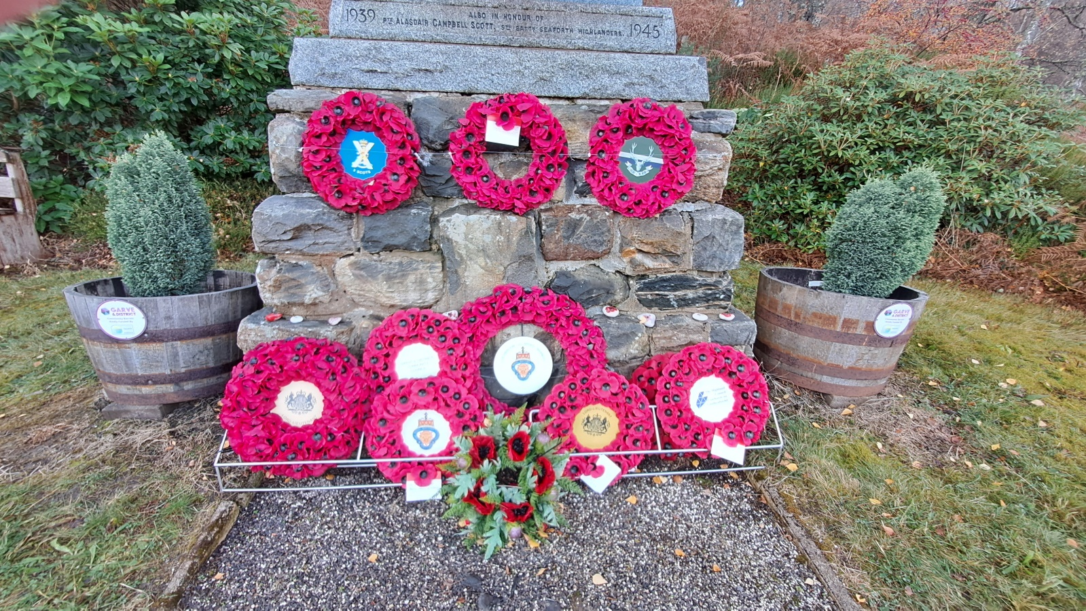

Garve & District Community Council currently has vacancies on the Community Council.  The Community Council elected members consider it to be very important to have as broad a representation of our community as possible, as we cover a wide variety of community issues and to do this well, we would like members from all corners of our large area.  We usually meet on the first Tuesday of the month.  If you are aged 16 or over, live in the Community Council area and are on the electoral roll and would like to be considered for co-option onto the Community Council, please email [garveanddistrictcc@yahoo.com](mailto:garveanddistrictcc@yahoo.com) with your name and contact details. This update has already appeared on our online channels. LCT and TG&DDC have vacancies on their boards, contact them directly for more details.

**Police update -** as reported at previous Community Council meetings, anyone who wishes to raise an issue with the police are asked to **call them directly on 101** at the time of the incident and make a witness statement.  Video, dashcam or photo evidence is also welcomed, indeed encouraged by the police. The police can also be contacted on [www.scotland.police.uk/secureforms/contact/](http://www.scotland.police.uk/secureforms/contact/)

Press reports inform us that an individual has been caught speeding for the second time on the same stretch of road. The individual admitted driving at **102mph near Achanalt** in April 2024. They also admitted a previous conviction which was along similar lines. They were fined £290 and banned from driving for four months.

The Highland Council Trading Standards are urging Highland residents to be aware of **a winter payment scam text** aimed at tricking people into thinking they must act quickly or miss out on a winter payment.

The text refers to your last round of winter heating allowance and gives a deadline that is very close.  It asks you to click on a link and provide personal information, even stating if you do not respond any monies due to you will go to someone else.  If you click on the link it takes you to a fake GOV.UK webpage asking for £1 as a test payment and your payment card details. Scam calls can be reported to Advice Direct Scotland on 0808 164 6000 or by visiting [www.consumeradvice.scot](http://www.consumeradvice.scot). If you think you may have lost money in a scam, report it to Police Scotland on 101. This update has already been shared on our online channels and has been passed onto the local newsletter. Trusted traders can be found at <https://www.trustedtrader.scot/Highland/> We also noted fake texts to “mum” to send money, emails supposedly from Amazon, and requests for money for a parcel to be re-delivered by Royal Mail, all fake. Cllr Kraft suggesting inviting Mark Mcginty to a future Community Council meeting to talk about the various issues in the Highlands.

**Treasurer’s report** - the Treasurer noted our funds (lock, stock and barrel) are now with Virgin Money and the Bank of Scotland account will be closed shortly. Our total bank balance (checked online) is £2,238.80.  The breakdown is as follows … Treasurer's account remains at £205.15. Reserve remains at £1,613.45. Wreath fund (in memory of Eliza) remains at £420.20. £35.00 data protection fee will be due at the end of the year, new direct debit has been set up. There were no questions for the Treasurer.

**Memories from 20 years ago** – as part of our Chairman’s long service to the community (Kenny was first elected to the Community Council in September 2003), we will be looking back from time to time to remember some issues from the past. Tonight our Chairman recalled the December 2004 meeting held in a snowy Achnasheen where four members of the public are noted as being in attendance. There was high praise for the (then) gritter team. Scottish Water issues in Achnasheen were continuing to raise concern as the new treatment plant was continuing to cause issues (all this was addressed eventually). Running out of water meant the Achnasheen public toilets were unavailable to the public (now they are closed for very different reasons). A community printer was suggested to help print the local newsletter and be made available to residents for their own use (in due course, a printer was purchased). Faded white lines were raised as a safety concern at the Achnasheen roundabout (repainted) and tree stumps should be removed to increase car parking at Garve Cemetery (done). All minutes covering the last 30+ years of Community Council meetings are available in the library section of our website - <http://www.community-council.org.uk/garveanddistrict/library.asp>

**AOB from Community Council members** – our Chairman noted that **train passenger numbers at all our train stations** are at a five year high (source [www.orr.gov.uk](http://www.orr.gov.uk)). For 2023/24 Achnasheen has 3,980 passengers, Achanalt had 506 passengers, Lochluichart had 374 passengers and Garve had 4,264 passengers. The Treasurer noted Wades Bridge featured recently on <https://www.channel4.com/programmes/all-aboard-scotlands-poshest-train/on-demand/74743-003> (about 30 minutes in).

**AOB from members of the public** - no issues raised by those present. Those who cannot attend our meetings can, as always, write to us by post or email with any issues they wish raised at [garveanddistrictcc@yahoo.com](mailto:garveanddistrictcc@yahoo.com)

**Screening reports, scoping reports and consultations** – we have been made aware of one scoping report. **Cabuie Estate (Achnasheen) are in the process of preparing a long-term Forest Plan**. The forest plan covers a 20-year period, with detailed proposals and eventual work permissions for the first 10 years and outline proposals for the subsequent years 11-20. The plan will be written to meet the UK woodland assurance standards. Community Council elected members raised no issues.

We are aware of one consultation by The Highland Council regarding **a Highland Visitor Levy** - [www.highland.gov.uk/vlconsultation](https://eur02.safelinks.protection.outlook.com/?url=https%3A%2F%2Fwww.highland.gov.uk%2Fvlconsultation&data=05%7C02%7Csylvia.tarrant%40highland.gov.uk%7C10b0d4d76b644a2389bf08dd03fe4d18%7C89f0b56e6d164fe89dba176fa940f7c9%7C0%7C0%7C638671112922749156%7CUnknown%7CTWFpbGZsb3d8eyJFbXB0eU1hcGkiOnRydWUsIlYiOiIwLjAuMDAwMCIsIlAiOiJXaW4zMiIsIkFOIjoiTWFpbCIsIldUIjoyfQ%3D%3D%7C0%7C%7C%7C&sdata=nzdGC0pYVP7gnHBwVjSJIjLk9hx7857CWIvzzhEX%2B2U%3D&reserved=0) The deadline for comments is Friday 7 February 2025 so there is plenty of time for everyone to take part. The proposed levy would apply to hotels, hostels, guest houses, self-catering, campsites, caravan parks, B&B and accommodation in a vehicle, or on board a vessel, which is permanently or predominantly situated in one place. Such a levy would not be introduced until autumn 2026 at the earliest if agreed. Cllr Kraft has confirmed on social media that motorhomes overnighting in laybys and their impact is something The Highland Council is considering separately along with cruise ships. This update has already been shared through our online channels. It was noted that Highland residents staying in Inverness overnight, perhaps for a Hospital appointment early next morning would not be exempt. Cllr Kraft thought a refund might be possible and that VAT thresholds would also be affected. Cllr Kraft also explained that in accordance with the Visitor Levy (Scotland) Act a local authority considering a levy (which they hope will raise £10m per year) must prepare and publish:

• An outline of the proposed scheme

• A statement about the cases and circumstances under the proposal in which the levy is not payable or should be reimbursed.

• A statement about the objectives of the proposal including how the Local Authority intends to measure and report on the achievement of these objectives.

• An assessment of the impacts of the proposal.

Community council elected member Sadie-Michaela Harris asked about the volunteer charge in place now and how much has that raised and campervans that use laybys every night and that will never use campsites. Cllr Kraft confirmed not as much money raised as they had hoped and exact breakdown of figures was not available yet. More details in the online papers of The Highland Council Economy and Infrastructure committee - <https://www.highland.gov.uk/meetings/meeting/5070/economy_and_infrastructure_committee> (item seven on the agenda).

The Scottish Government has launched a consultation to **lower the national speed limit to 50mph.** More details at <https://consult.gov.scot/transport-scotland/national-speed-management-review/> This update has already been shared through our online channels.

Today, we received noted from The Highland Council that they plan to make the **20mph in Garve** permanent long with various other 20mph zones in the Highlands. Traffic Regulation Order Plans showing the scheme extents can be found at [www.highland.gov.uk/20mph](http://www.highland.gov.uk/20mph) and clicking on ‘locations for the 20mph programme’.

*(Post meeting note –* ***The Highland Council budget consultation for 2025/2026*** *-* [*https://www.highland.gov.uk/news/article/16380/tell_us_more_-_highland_council_launches_budget_engagement*](https://www.highland.gov.uk/news/article/16380/tell_us_more_-_highland_council_launches_budget_engagement)*)*

All Highland Council consultations are available at <http://consult.highland.gov.uk/portal> All Scottish Government consultations are available at <https://consult.gov.scot/consultation_finder>

Cllr Kraft left the meeting at 9.05pm and was thanked for attending.

**Building warrants, planning issues and licensing issues** – we note **one new building warrant. 24/01665/DOM4** is the formation of a new structural opening to external wall and alterations to internal partitions at Fannich Lodge.

**No previous planning applications** have been determined by The Highland Council since our last ordinary meeting but we note **24/03272/FUL**, the proposed installation of a 25m lattice mast and ancillary works on land West Of Loch Glascarnoch which we considered at our September 2024 ordinary meeting has been withdrawn by the applicant.

**There are currently five planning applications** awaiting determination by The Highland Council for our area.

**One new planning application has** been received by The Highland Council since our last ordinary meeting. **24/04364/FUL** is the proposed installation of two EV chargers on land 15M NE Of Garve Public Hall. This update has already been shared through our online channels. Three Community Council elected members raised no objections. The Vice Chairman abstained from this discussion but informed us after that a local contractor would probably carry out the work, as Community council elected member Sadie-Michaela Harris put it, local jobs for local people! *(Post meeting note - Tina Hartley (Community Engagement and Development Officer, TG&DDC) has confirmed that it is hoped that work will start early in the New Year with regards to site work and installation. TG&DDC do not expect to take delivery of the new electric bus until much later, maybe March/April 2025. They will have an interim bus for use from The Highland Council from January 2025 onwards once they have a driver in place. Thanks again to Tina for the update.)*

A possible planning breach can be reported at <https://www.highland.gov.uk/info/180/planning_-_applications_warrants_and_certificates/170/planning_enforcement/2>

All planning applications can be viewed at [www.highland.gov.uk/info/180/planning_-_applications_warrants_and_certificates/143/planning_permission/4](http://www.highland.gov.uk/info/180/planning_-_applications_warrants_and_certificates/143/planning_permission/4)

**There were no new licensing issues** for us to consider this evening.

**Dates of future meetings** - *(Ordinary meetings are usually held on the first Tuesday of every month unless stated otherwise)*. Tuesday 4 February 2025, 7.00pm, online – agreed. Future meetings may be held on Tuesday 4 March 2025 and Tuesday 1 April 2025 tbc.

**Other dates to note** – Christmas wreath workshop on Friday 6 December 2024 in Garve Public Hall from 7.00pm (fully booked). Community Christmas Lunch on Sunday 8 December 2024 in Garve Public Hall from 1.00pm (also fully booked). Ledgowan Lodge Hotel Annual Christmas Fair will be held on Saturday 14 December 2024 from 10.00am until 4.00pm. Strathgarve Primary School Christmas Show on Monday 16 December 2024 in Garve Public Hall from 6.00pm. Christmas Carols on Sunday 22 December 2024 in Garve Public Hall from 2.00pm. United service at Kinlochluichart Church on Sunday 29 December 2024 at 11.00am. New Year community party on Wednesday 1 January 2025 tbc. Garve & District Road Safety Community group meeting on Monday 13 January 2025 in Garve Public Hall meeting room and online from 7.00pm. Connecting Communities Community Transport opening event and lunch in Garve Public Hall on Sunday 19 January 2025 time tbc. Basket weaving workshop in Garve Public Hall on Sunday 26 January 2025 time tbc. If you are holding an event in the community, do let us know and we can help spread the word.

As usual, our Chairman started to draw the meeting to a close by asking all present if anyone had any final questions or thoughts on anything they had heard this evening, a question he often asks throughout the meeting too. Nobody had any final questions or thoughts. Although our meetings are not public meetings, members of the public are still very welcome to attend Community Council meetings and take part in the discussions under the guidance of the Chairman (see section 12 of the Constitution). A copy of our Constitution is available in the library section of our own website and hard/electronic copies are available on request. Those who cannot attend our meetings can, as always, write to us by post or email with any issues they wish raised at [garveanddistrictcc@yahoo.com](mailto:garveanddistrictcc@yahoo.com)

The Chairman thanked everyone for attending.  He also thanked Community Council member Sadie-Michaela Harris for hosting the webcam session and as this was the final scheduled meeting of 2024, wished everyone in the community a Merry Christmas and a peaceful New Year and thanked Community Council elected members for all their hard work over the past twelve months representing the community and for their help supporting him. The Chairman closed the meeting at 9.20pm.

Signed ……………………………..

Signed ……………………………..

Date ……………………………….

*Just some of the Christmas lights in Garve which were switched on at 6.00pm on Saturday 30 November 2024. Thanks to the Treasurer for the picture …*

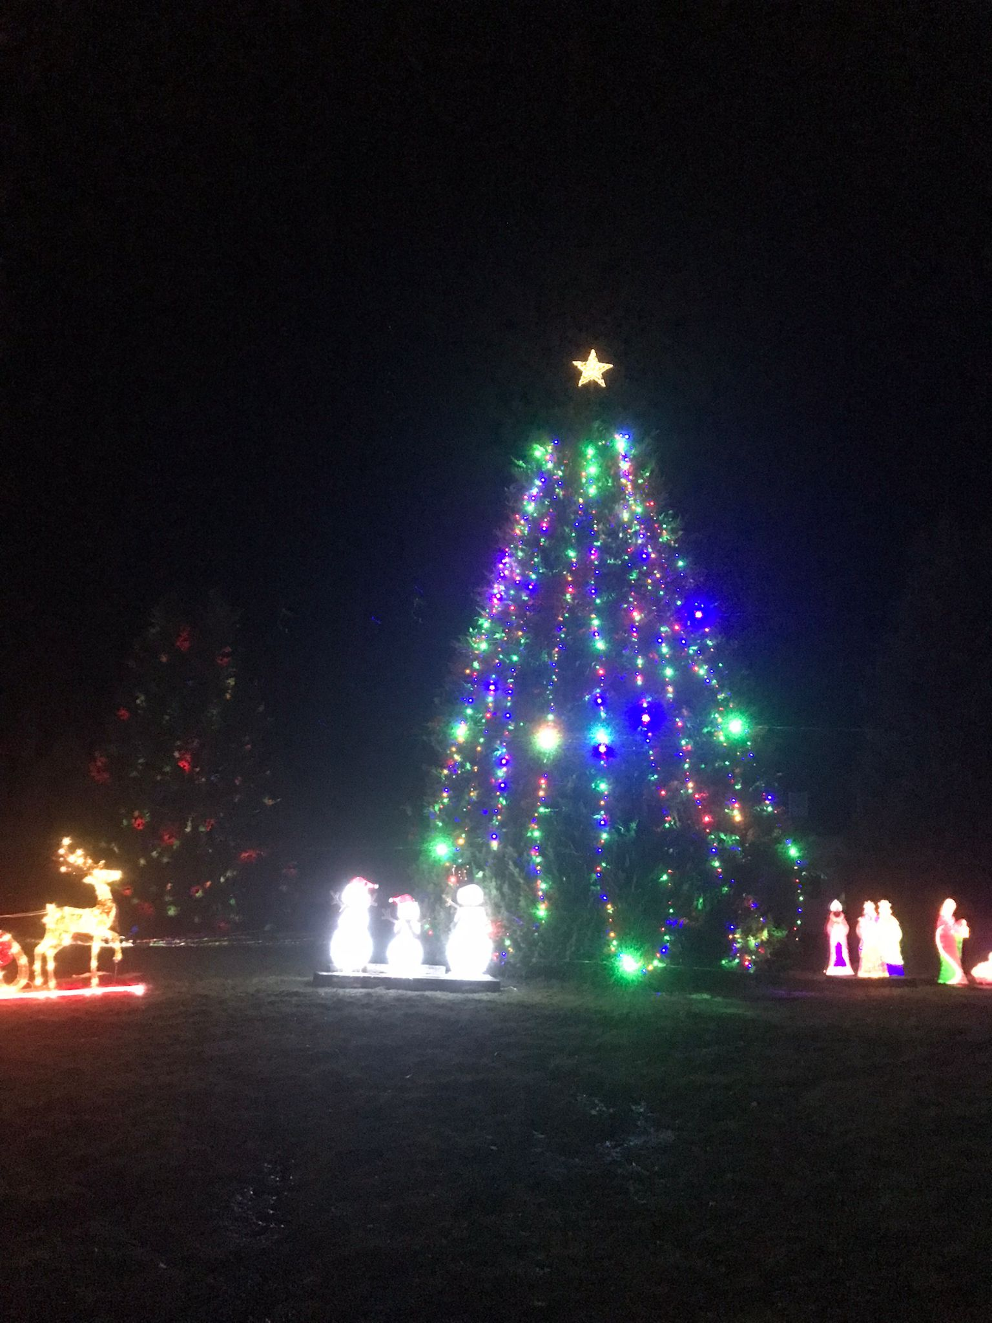

[www.community-council.org.uk/garveanddistrict](http://www.community-council.org.uk/garveanddistrict)

[www.facebook.com/profile.php?id=61552992414355](http://www.facebook.com/profile.php?id=61552992414355)

[garveanddistrictcc@yahoo.com](mailto:garveanddistrictcc@yahoo.com)

This set of minutes were first published (in draft form) at 6.00pm on Saturday 7 December 2024.