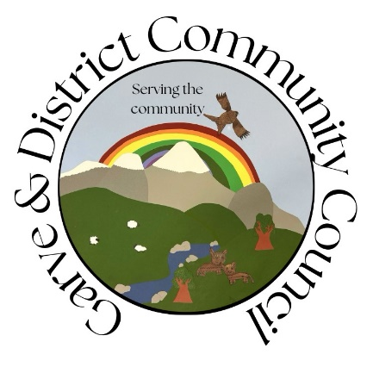

**Minutes of the Garve & District Community Council ordinary meeting**

**held on Tuesday 5 November 2024 on webcam**

**Community Council elected members present on webcam**: Kenny Maclean (Chairman & Secretary), Bob Moir (Vice Chairman), Caroline Gamble (Treasurer) and Sadie-Michaela Harris.

**Also present on webcam**: Cllr Liz Kraft (from 7.45pm until 8.20pm), Scott Vallance (Principal Project Manager, Statkraft UK from 7.45pm until 9.20pm), Richard Carter (Bow Acoustics from 7.45pm until 9.20pm) and Peter Kane (Kane Partnership).

The Chairman opened the meeting at 7.45pm after some IT issues and welcomed everyone. He also confirmed that this meeting would be recorded as per the agenda and will be archived and available for viewing for twelve months thereafter - <https://bit.ly/GDCC-5thNOV2024> He reminded members of the public that although our meetings are not public meetings, they were still very welcome to attend Community Council meetings even on webcam and take part in the discussions under his guidance (see section 12 of the Constitution). Those who cannot attend our meetings can, as always, write to us by post or email with any issues they wish raised at [garveanddistrictcc@yahoo.com](mailto:garveanddistrictcc@yahoo.com)

Community Council elected members were saddened to learn that Lucky2BHere founder Ross Cowie has passed away. Ross died on Sunday 6 October 2024 aged 64 having been transferred to Raigmore Hospital from Skye. Lucky2BHere supplied our local defibrillators. Ross was a truly remarkable man who led Skye to the Camanachd Cup in 1990 and then went on establish the charity in 2007 which has saved lives and benefitted communities the length and breadth of Scotland, around 1,000 defibrillators have been installed by the charity. Just as importantly, the appeal also helped train around 50,000 volunteers to administer the devices and the associated emergency first aid required for incidents like cardiac arrests and strokes. Ross attended the ceremony to mark 25 years since the Scottish Parliament was reconvened just a week or so before his sudden passing. We extend our sincere condolences to Ross’s family and friends. Our Chairman attended the funeral online along with around 500 other “viewers”. We are told a similar number attended the funeral in person in Portree.

Our Chairman attended the Torridon & Kinlochewe Community Council online meeting on Wednesday 24 October 2024.

**Declarations of Interest** – the Vice Chairman is a Garve Public Hall Trustee, a Friend of Garve War Memorial, a LCT elected Director and a member of the GD CORe land panel. Cllr Kraft is a member of the North Planning Applications Committee at The Highland Council. Community Council elected members confirmed that they had read all documents due to be discussed tonight before the start of this meeting.

**Approval of draft minutes** of the ordinary meeting held on Tuesday 1 October 2024 via webcam were proposed without amendment by Bob Moir and seconded by Caroline Gamble, unanimously agreed. Minutes are available at Garve Post Office, Achnasheen Village Noticeboard, on our website or via email. Hard/electronic copies are also available on request. Minutes will be signed by our Chairman and Treasurer in due course via post.

**Matters arising** – **LOCAL PLACE PLAN HAS BEEN VALIDATED!** - We are pleased to say that we learnt today that the Garve & District Local Place Plan, which was facilitated by Garve & District Development Company with support from Garve & District Community Council, has been validated by The Highland Council in accordance with Scottish Government Local Place Plan provisions. It is one of the first to be validated according to The Highland Council’s own website. The Highland Council will now make certain teams in The Highland Council aware that the Local Place Plan has been validated, as some of them may be able to support the community in the delivery of the Local Place Plan. These will include, amongst others, Housing Development, Environment, Highland Community Planning Partnership’s Partnership Development, Economy & Regeneration, and Community Support & Ward Management.

The [Garve and District Local Place Plan](https://www.highland.gov.uk/downloads/download/2445/garve_and_district_local_place_plan) has been published on The Highland Council’s website and they will proceed with adding it to The Highland Council Local Place Plans register: [www.highland.gov.uk/localplaceplanregister](https://www.highland.gov.uk/localplaceplanregister) Our thanks to Tina Hartley (Community Engagement and Development Officer, TG&DDC) for the update which has also been shared with the LCT.

**Boralex** **windfarm** – <https://www.boralex.com> - North Planning Applications Committee notes that the application was approved by them in January 2023. Details for the satisfaction of pre-start planning conditions are pending consideration by the planning department.

**Kirkan Windfarm** – <http://www.kirkanwindfarm.co.uk> - as reported previously, they are still in the phase of considering options for Kirkan and working through the various planning conditions. We thank Trevor for his regular updates. North Planning Applications Committee notes the Scottish Government issued consent on 25 July 2023.

**Proposed Tarvie windfarm** – [www.tarviewindfarm.com](http://www.tarviewindfarm.com) - Koehler Renewable Energy UK Limited (KRE) are developing proposals for a wind farm on land south of the A835, approximately 3.7km northwest of Contin that would have 11 x 7MW turbines, with a 200m tip height and 30MW battery energy storage system (BESS). KRE are committed to meaningful and ongoing community engagement so have invited Community Councils, Cllr’s, MSP’s and the public to an informal meet the developer event to introduce their team ahead of future public consultation events to be held in spring 2025. The event will be held (following confirmation) in Contin Hall on Thursday 7 November 2024 from 4.00pm until 7.00pm. This update has already been posted on our online channels. *(Post meeting note – our Chairman, Vice Chairman and Community Council elected member Sadie-Michaela Harris attended the event but with so many people there, there was no way of talking to the few officials in attendance. We noted from the leaflets that the EIA is underway, further public exhibitions are planned for 2025 before submitting a planning application in the spring of 2026.)*

**Proposed SSE Fairburn windfarm extension** – <https://www.sserenewables.com/onshore-wind/in-development/fairburn-extension> - no update.

**SSEN Spittal – Beauly 400kV project** - <https://www.ssen-transmission.co.uk/projects/project-map/spittal--loch-buidhe--beauly-400kv-connection> no news as such except a presentation explaining why underground, overground or subsea routes are chosen was made available on Wednesday 23 October 2024 and is to be made available on the SSEN website. Community Council member Sadie-Michaela Harris viewed the presentation online and noted that you could not see who else was attending, no chat facility and questions had to be submitted beforehand. Our Chairman has also viewed the presentation <https://bit.ly/SSEN-Underground-Overground-Subsea> (thanks to Sadie for sharing who notes it has been viewed over 100 times) and felt people were reading off scripts, “stage managed” came to mind. Undergrounding cables costs x5 more than overhead lines and land above undergrounded cables is limited in what it can be used for after the cable has been buried such as no tree planting so farmers/crofters need to be aware of such issues. We also note the Scoping Opinion for the EIA has been lodged with the Energy Consents Unit.

**SSEN underground cable** from the Western Isles to Beauly – [https://www.ssen-transmission.co.uk/projects/project-map/western-isles](https://www.ssen-transmission.co.uk/projects/project-map/western-isles/) - no update.

**Field Corriemoillie** – [www.fieldcorriemoillie.co.uk](http://www.fieldcorriemoillie.co.uk) – we were invited to view their Auchteraw site near Fort Augustus last Wednesday, to give us a feel for a battery storage site for real and gather further information regarding BESS. The Vice Chairman was the only Community Council elected member available to attend but the whole thing was a “dog’s dinner”! Bob arrived at HC HQ in Inverness at 8.00am for 8.30am and at 8.20am went to reception who knew nothing about the trip but the receptionist was very polite. After making some phone calls there was confusion was it yesterday or today (it was today) but everyone was inside at a presentation with mobile phones switched off. Apologies were given to our Vice Chairman but we were all less than impressed by the performance that achieved nothing. We have asked the visit be re-scheduled. The potential fire risk of a BESS is not a material concern at planning. Therefore, if not at planning, then where and when is there a risk assessment done? Peat fire risk should also be considered. Water tanks are usually for cooling, not putting out fires. We will ask to see the fire risk assessment and safety plans for their Auchteraw site to give us a better idea what may be before us going forward. *(Post meeting note – our Chairman, Vice Chairman and Community Council elected member Sadie-Michaela Harris visited the Auchteraw site for themselves on Thursday 7 November 2024.)*

**Possible windfarm on the Strathvaich Estate** – a planning application by Glasa windfarm has been lodged for a met mast on site - <https://wam.highland.gov.uk/wam/applicationDetails.do?activeTab=summary&keyVal=SKFI0QIHIED00> The site is to the North East of our area. The proposed mast would be 100m tall and would be in place for up to five years if permission was granted.

Cllr Kraft left the meeting at 8.20pm.

**Proposed Carn Fearna windfarm** – [https://projects.statkraft.co.uk/Carn-Fearna](https://projects.statkraft.co.uk/Carn-Fearna/)  Richard Carter (Bow Acoustics) took us through several slides.  He explained not every property is monitored, just a sample in each area which is representative of that area.  Areas used for this project were Strathgarve, Silverbridge, Garve and near Tarvie.  Wind measured on site and sound levels and then repeated at locations.  Noise data plotted against wind speed and tests done during the day and night.  Spikes like lawnmowers are noted.  Audio is not recorded for privacy reasons at locations, just a list of data against time history that exceeds 90% of 10-minute blocks.  Patterns like central heating coming on, farm machinery also noted.  Why only for a few weeks when a Met mast is up for up to 36 months?  Day to day background noise does not vary much so patterns can be established quickly.  Sound power levels and sound pressure levels are all worked out using the data and then using manufacturers turbine noise data can be added.  If planning is consented, conditions around noise can also be applied such as +2dB above upper limits.  Site design also a factor as the further away the turbines are, the less noise.  Turbines can also be put on noise reduce mode.  Regarding aviation lights, the MOD and the Aviation authority all have guidance.  Planning also regarding landscape and visual impact through the day and night.  The Highland Council are currently discussing which viewpoints will be needed and night views are part of that discussion.  It is still hoped to apply for planning permission in the spring of 2025.  Statkraft have been asked for additional information by the case officer at planning for their met planning application.  Statkraft are working on pulling that information together and they think it will likely be in January 2025 before a decision is made on the proposed application.  The additional information will be available to view on The Highland Council’s planning website.  Our thanks to Peter Kane for that update.  It was also noted that initial feedback from the Case Officer was they wanted more visuals, which tracks to be used to access the site, any borrow pits and welfare facilities if needed.  All updates will appear of the planning website.  It was also noted that the UK government are looking at a root and branch review of the electricity act process.  More details at <https://assets.publishing.service.gov.uk/media/672107c587df31a87d8c482f/electricity-infrastructure-consenting-scotland-consultation-document.pdf>  **In related news** - [www.ssen-transmission.co.uk/carn-fearna-wind-farm-connection](http://www.ssen-transmission.co.uk/carn-fearna-wind-farm-connection) - no further news via us or via Statkraft but Statkraft are happy to pass on any news they do receive.

Scott Vallance and Richard Carter were both thanked for attending and left the meeting at 9.20pm.

**The Highland Council updates** – [www.highland.gov.uk](http://www.highland.gov.uk) – The Highland Council **is ready for winter** - <https://www.highland.gov.uk/news/article/16276/the_highland_council_is_ready_for_winter> At a full meeting of The Highland Council on Thursday 31 October 2024, Cllr’s agreed to make representation to the Minister for Local Government, asking that **Community Councillors be considered within the Ethical Standard in Public Life (Scotland) Act.** We are disappointed that some Community Councils are behaving in such a way that this step has been taken but fully agree with the decision taken at the meeting. We await the response from the Minister with interest. The meeting also agreed to costs associated with **Cllr Crawford’s motion** as discussed at our last ordinary meeting. We also note **changes to waste and recycling services** have resulted in a drop of around 30% of refuse going to landfill.

**Replanting Trees in The Avenue** – The Nature Restoration Fund 2024/25 was pulled from local authorities and so it has taken some time for The Highland Council to look at their existing funds and work out what they have available for this project using funds remaining from 2023/24. They are also currently working on getting stock lists from local nurseries to understand their availability and costs for bare root stock but all being well, planting will go ahead in late November 2024 or early December 2024, date to be confirmed. The planting plan is already available in the library section of our website and has been available since April 2024. We have asked if the planting plan is still the same (yes depending on stock availability) and if we can have a copy of the maintenance schedule that was discussed before once these trees have been planted. A full list of the monthly updates since February 2022 is available in the library section of our website. Our thanks to all involved.

**Wyvis Natural Playpark sign** is still outstanding, Cllr Kraft continues to make enquiries. (*(Post meeting note – sign will be followed up by roads department when resource and time allows.)*

Forestry & Land Scotland have no plans to install **passing places on the road to Strathgarve** as it would only encourage road users to go that way to the Wyvis Natural Playpark. The Highland Council previously said no for the same reason as planning permission for the playpark (**15/04738/FUL, see report of handling)** was based on vehicles parking in Little Garve or Silverbridge. **Pothole repairs** in Strathgarve were temporary and the local roads team will be back when time allows.

**STOP sign and rumble strips for Gorstan Junction (A832)** – request passed on The Highland Council roads department but such a request was turned down before as they feel the junction does not require a STOP sign or rumble strips, drivers should be noting existing signs that advise they are approaching a junction and to give way. Cllr Kraft will discuss the matter with MSP. Where is the white line machine? It is needed for the A832 at the junction. We will ask Cllr Kraft for an update. *(Post meeting note – white lines will be followed up by roads department when resource and time allows.)*

Requests through the Local Place Plan for **Little Garve passing places** to be cleared of bushes and **sightlines to be cut back at the Gorstan Junction** have been passed onto The Highland Council roads department. The local roads team will deal with this when time allows. The Highland Council notes that **residents should report issues directly to them** by calling The Highland Council’s Call Centre on 01349 886606 or via [www.highland.gov.uk/report](http://www.highland.gov.uk/report) In all cases, you will be given a reference number. The Highland Council also appreciates photos showing the actual problem.

**Silverbridge public toilets** remain closed but the plumber will be clear of the site today, once he has finished his works the facility will require cleaning, and the cleaning supervisor is arranging for this to be done so all being well, the toilets will re-open fully tomorrow (Wednesday). These are the only public toilets in our area after Achnasheen Public Toilets closed permanently on Thursday 4 July 2024. *(Post meeting note - Silverbridge public toilets are now open again, thanks to all for getting them operational.)*

**Gateway signs** for Lochluichart, Achanalt and Achnasheen – we have asked if these are still to be installed this financial year and have been advised this is still the intention.

**Slow sign at Mossford** be moved to before the turn off for Lochluichart Railway Station (received through the Local Place Plan) has been passed onto The Highland Council roads department who note “Lochluichart, Please Drive Carefully” sign is already in place before the turning as well as the hazard sign for the turn off, no need for any more signs which may only cause confusion. **It has been noted** that Moray Firth Radio, as part of their traffic reports, are now often mentioning Lochluichart/Mossford warning motorists to slow down due to Pheasants on the road. Pheasants have also been seen as far west as Achnasheen and as far east as Strathgarve recently.

**Dumped tyres in the Lochluichart area** have been reported to The Highland Council - FS658052495 on Monday 28 October 2024 and have since been collected. This was a problem before so we hope it is not starting again.

**Highland Council empty buildings** – Achnasheen Hall is now closed, Achnasheen school closed around 15 years ago and there is an empty classroom in Garve. In respect of the empty classroom at **Strathgarve Primary**, The Highland Council Estates team have confirmed via Cllr Kraft that records from a previous asbestos survey shows any suspected asbestos was removed apart from two very low risk items where asbestos may be an ingredient in the material. Community Council elected members asked to see the building report, we will request a copy. In respect of **Achnasheen school**, the Estates team have no plans for the building. They note services are shared with the neighbouring schoolhouse which is still occupied.  If the schoolhouse become vacant, they may then look to sell the site as one. In respect of **Achnasheen Hall and toilets**, preparations are underway to sell the building as one. Our thanks to all for the updates. Community Council elected member Sadie-Michaela Harris wondered about insurance for all these empty building. We will seek clarification. *(Post meeting note – Cllr Kraft confirmed The Highland Council do not insure building to a huge amount.)*

**Future of Strathconon Primary** – it is not expected anything will change if the families want the school kept open as the presumption from The Scottish Government is to keep rural schools open where possible. If there are no children and the school is mothballed for a period, there is then no automatic move to formal closure. We note there are lots of “out of the box” solutions that communities can consider like hybrid learning and working with other schools. Our thanks to Cllr Kraft for the update. The Vice Chairman heard the local estate in Strathconon was advertising vacancies where it is hoped workers will come with families.

At the Torridon & Kinlochewe Community Council online meeting on Wednesday 24 October 2024, it was confirmed that **Kinlochewe Primary School** (whose catchment area includes Achnasheen since Achnasheen Primary School closed around 15 years ago) is currently mothballed but The Highland Council are now looking at possibly formally closing the school. A public consultation process would need to first be agreed at the education committee meeting later this month before it goes out to public consultation which would include a public meeting probably in January 2025 before a final decision is made.

**A faulty streetlight** in Achnasheen was reported online on Saturday 5 October 2024 - FS652298233 and was repaired a few days later, our thanks to all involved.

**Concern was raised recently about single track roads in our area. Highway code 155 and 156** should be followed … *“These are only wide enough for one vehicle. They may have special passing places. If you see a vehicle coming towards you, or the driver behind wants to overtake, pull into a passing place on your left, or wait opposite a passing place on your right. Give way to road users coming uphill whenever you can. If necessary, reverse until you reach a passing place to let the other vehicle pass. Slow down when passing pedestrians, cyclists and horse riders. Do not park in passing places.”*

**Payphone removal update** - we were advised by BT via The Highland Council that due to a computer error at BT, The Highland Council were not told of the consultation in the proper manor (the first they knew of it was our objections of 30 July 2024) therefore BT have put the whole Highland wide consultation on hold for now until their computer is fixed.

The Highland Council notes that **residents should report issues directly to them** by calling The Highland Council’s Call Centre on 01349 886606 or via [www.highland.gov.uk/report](http://www.highland.gov.uk/report) In all cases, you will be given a reference number. The Highland Council also appreciates photos showing the actual problem.

**A835 Trunk Road issues –** a head on accident reportedly involving a car and lorry took place on the evening of Monday 14 October 2024 at the **“Check Rail Corner”** when both sets of traffic lights were green. Luckily no major injuries but we understand the car is badly damaged. Police, Ambulance and BEAR attended but this is not the first time the traffic lights have been faulty, either stuck on red or green. We have been approached by the press for comment and have informed them of our concerns and we have asked BEAR how many times the lights have been faulty since the wall was damaged in January 2024. We also note the comments on social media - <https://www.facebook.com/groups/704078007117939/posts/1655647485294315/?comment_id=1656165615242502&notif_id=1728989219621421&notif_t=group_comment_follow> The MSP is aware of the accident and has asked Police Scotland for a report. We have again raised our concerns with MSP, BEAR, Transport Scotland, Network Rail, the Transport Minister and the First Minister all of whom tell us that a design of the replacement wall is underway however this is a complex project due to the nature of the steep embankment, long wall length, live traffic and proximity to the railway line. BEAR continue to liaise with Transport Scotland and Network Rail on the construction of a new wall and barrier which is provisionally planned for spring/summer 2025.The full press story is available here - <https://www.ross-shirejournal.co.uk/news/someone-will-die-if-you-continue-to-dither-on-notorious-lo-363947/> BEAR carry out daily checks to ensure the temporary traffic lights are working correctly in addition to reactive checks following any reports received regarding issues or faults. To date (Tuesday 22 October 2024), there have been eight reactive checks carried out following the receipt of such reports. BEAR have also confirmed today that their operations team were and continue to carry out daily checks, including at the weekends. They have had one instance of the traffic lights being switched off by a member of the public and have had signs and cones stolen from the site. Police informed? We will seek clarification. “Red light jumpers” are also an issue. This practice knocks the lights out of sequence. Most times the lights reset themselves but occasionally require manual intervention. Our Chairman will get his yellow jacket out and make a full inspection of the site on Thursday. **In related news**, on Saturday 19 October 2024 a white van broke down just before the traffic lights in the middle of the road causing an obstruction. Police Scotland were called and attended very quickly. *(Post meeting note – our Chairman visited the site for himself on Thursday 7 November 2024 and noted that the top of the remaining wall is crumbing away, vegetation is overgrowing between the wall and railway and whole trees have been blown over and are laying against the railway fence.)*

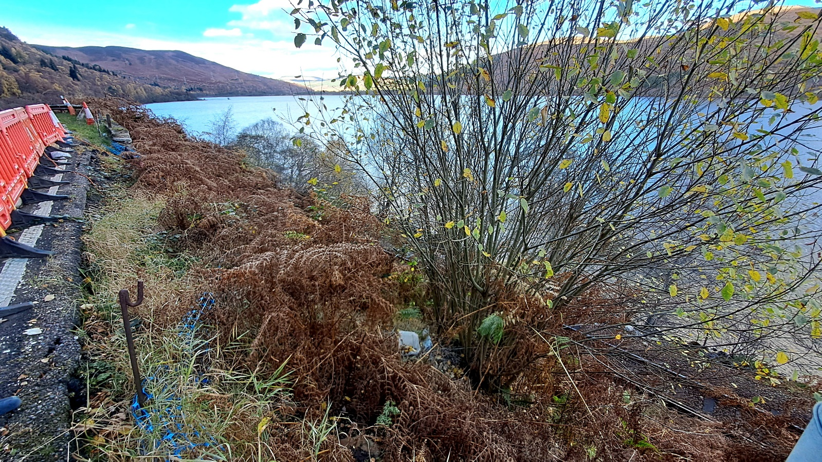

**Concealed entrance signs for Station Road, Garve -** Transport Scotland feels trees/bushes in gardens should be cut back to help residents see oncoming traffic. Garden walls and fences are also, in their opinion, restricting sightlines but they are not able to move them or cut tree/buses back as all this is out with their remit. Residents have been informed by us to keep them fully in the loop but it was also noted the corner itself does not help the whole issue and the houses would probably not have been allowed to be built there under today’s rules and regulations.

**Inchbae settlement sign result – voting papers were** hand delivered to Inchbae residents on Sunday 6 October 2024 with a deadline of Thursday 31 October 2024. 7/16 voting papers returned = 43.7% turnout. One vote in favour of a settlement sign, six against. Feedback received included who owns Inchbae Lodge? (Still Mrs Bishop as far as we can tell). Overflowing bins at Lodge (Environmental Health are already aware, matter in hand). Lodge signs in disrepair (BEAR have carried out checks of all signs in the Inchbae area and rusty poles will be replaced in due course, no other Health & Safety issues found) and households should put up their own house name on their own property (noted). We have passed all concerns onto BEAR, Transport Scotland, Environmental Health and the Tax Office. Inchbae residents who we have email addresses for have been informed of the survey result, feedback received and action taken and have been asked to share with offline residents. Our thanks to all residents in Inchbae who took part in the survey and who shared their thoughts with us. 48 hours after the deadline passed, we received a hand written letter supporting settlement signs but as no contact details were included, it is unclear if they even live in Inchbae and in any case, the deadline had already passed and voting papers should have been used. We were disappointed to learn that the result has already been questioned by one person. They have been advised that we can only go by voting papers received before the deadline, not word of mouth.  Everyone had over three weeks to respond and the Inchbae residents wishes should now be respected. The Vice Chairman felt it should be noted that this was passed onto us by TG&DDC after it was raised during the LPP consultation. *(Post meeting note – a voting paper was received on Saturday 9 November 2024, well after the deadline so cannot be counted. It was against settlement signs.)*

Concern was raised at the Road Safety meeting on Friday 27 September 2024 that the **Killin Railway Crossing improvements** had not been as successful as had been hoped. Both Network Rail and BEAR who carried out the work were surprised to receive our emails following the meeting and requested the recording of the meeting be passed on as they felt all concerns had been addressed and no such issues had been raised with them directly.

**Faults on the Trunk Road (A835)** should be reported via [www.bearscot.com/report-a-defect/](http://www.bearscot.com/report-a-defect/) Members of the public can live track gritters on the trunk road network using Transport Scotland’s online ‘[trunk road gritter tracker’](http://arcg.is/GritterMap). It displays the current location of gritters and where they have recently treated.

The Garve & District Community Council has been asked to take the lead of the **Garve & District** **Road Safety Community Group (formally Traffic Calming Group).** The aim of the group is to promote safety on our roads in and around our district whether they are main roads (Trunk/Council), through our villages or the country lanes.  It is the responsibility for all of us to have an ongoing conversation in our community to promote road safety.  We will, through the Community Council, liaise with agencies such as the Police, Transport Scotland, BEAR, Highland Council, local residents, school, road users and local groups to explore various road safety measures, signage etc.  We hope local residents will join us at our next hybrid meeting on Monday 13 January 2025 at 7.00pm <https://us02web.zoom.us/j/82246919613?pwd=3cfGau6wmneoAZMrMh86bBUcVn8ya4.1> to hear the latest issues and discuss a way forward. You can also attend the meeting by visiting Garve Public Hall meeting room which is at the back of the Hall where a webcam link will be available. In the meantime, we requested personal experiences of local residents travelling in our area by vehicle or on foot to help build up a true picture of the community’s feelings on the matter. This request was sent out online and offline on Wednesday 2 October 2024 as well as in our last set of minutes with a reminder email sent out on Saturday 26 October 2024 to those who had not responded. 8 residents sent concerns in. 38 people in the Local Place Plan raised traffic safety as an issue, so who are the other 30? The comments along with all suggestions received in the Local Place Plan consultation are available in our library section of our website and have been shared with the road authorities as road budgets for 2025/26 will need to be set in the next few months. We have also shared the report with Police Scotland. We also note - <https://www.bbc.co.uk/news/articles/cwye8yn7z2lo> and <https://www.bbc.co.uk/news/articles/c8xpjw9ldpno> The only feedback to the report to date is from Cllr Kraft who will follow up on the local issues. Some of the issues she feels could be addressed at a whole council level when they implement the tourism levy. The Gorstan Junction has been raised before but Cllr Kraft is happy to work with the MSP as it is a council road meeting a trunk road. Lives have been lost there and it is simply not acceptable to continue *“as is.”* **In related news, two residents of Achanalt** have asked the Community Council not to accept comments made on their behalf. *“Neighbours can speak for themselves.”* Our Chairman explained we do not accept second hand reports and have not done so for many years. Those who cannot attend our meetings can, as always, write to us directly by post or email with any issues they wish raised at [garveanddistrictcc@yahoo.com](mailto:garveanddistrictcc@yahoo.com) Our Chairman felt the **2006 Setting Local Speed Limits Guidance** appears a bit dated. He has written to the Department of Transport in London to ask if there are any plans to update the rules. *(Post meeting note - Scotland's Road Safety Framework to 2030 sets out a vision for Scotland to have the best road safety performance in the world by 2030 and an ambitious long-term goal where no one is seriously injured or killed by 2050 therefore there are currently no plans to update 2006 Setting Local Speed Limits Guidance.)*

**GD CORe land panel update** – the first meeting was held last Thursday. Bob Moir as a Garve Public Hall Trustee and Community Council elected member attended and thought it had been a useful first meeting, lots to think about and consider. There are ideas but lots of background still to be done. It was noted that following completion of the GD CORe engagement process, views were split 50/50 around renovation versus new build. 2023 costings will be re-shared with the community; however, it will be important to note that these will have likely increased over the past 12 months. Bob is on the panel with John Macdonald, Sue Tarr, Moragh Wylie, Gordon Mackenzie, Jude Macintosh, Ina Ohlandt with admin covered by Tina Hartley and Heather Donaldson. Planters were suggested to brighten the place up, perhaps herbs too. It has already been agreed that nothing goes on the community land that would detract from the Hall. Costs since the site was purchased will also be made public. Next meeting January 2025. It was noted that those who are believed to own Garve Hotel were invited to the panel meeting but no reply received.

**Garve Hotel** – Cllr Kraft has confirmed that The Highland Council do know who owns the building and are chasing them for business rates but cannot disclose who owns the hotel due to client confidentiality. **In related news**, we have received reports from a Garve resident that copper pipes from the gas tank behind Garve Hotel have been removed, possibly stolen and the tank is still full of gas.  Environmental Health and Cllr Kraft have been informed.

**Garve Public Hall** continues to be well used since re-opening earlier this year and conference equipment was delivered last week. Once set up, local groups will be shown how it all works to allow for hybrid meetings.

**The re-dedication service** to mark the 100th anniversary of the Garve War Memorial was held on Saturday 26 October 2024. It was well attended and the weather held off until after the service. It was by all accounts a lovely event, well organised and all came together nicely. All Community Council members except our Chairman attended. He was working that day but paid his own respects privately when he visited the memorial alone the following afternoon.

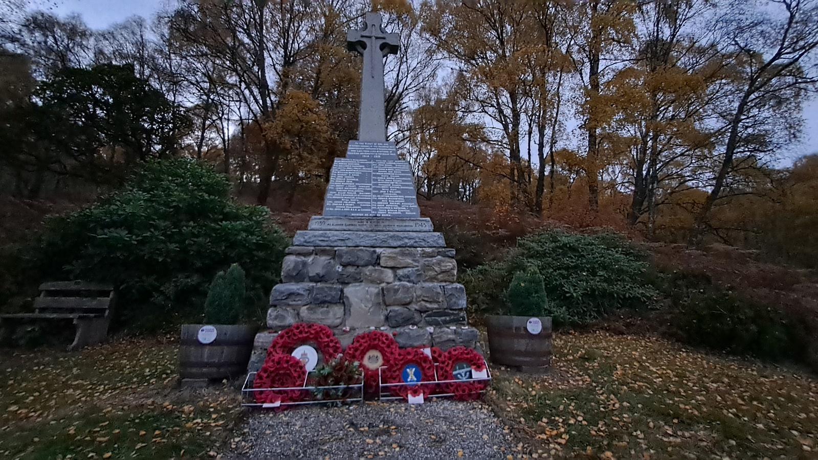

**Remembrance Sunday** service is on Sunday 10 November 2024 at 1.00pm at Garve War Memorial. The Treasurer will lay the Community Council wreath, Cllr Kraft also hopes to attend, tbc. Soup and sandwiches will be available in Garve Public Hall from 12noon until 12.45pm.

LCT have been dealing with local Defibrillators for the last few years.  Our understanding is that the **Achnasheen Defibrillator** will be relocated in due course due to the upcoming sale of the Hall.

Garve & District Community Council currently has vacancies on the Community Council.  The Community Council elected members consider it to be very important to have as broad a representation of our community as possible, as we cover a wide variety of community issues and to do this well, we would like members from all corners of our large area.  We usually meet on the first Tuesday of the month.  If you are aged 16 or over, live in the Community Council area and are on the electoral roll and would like to be considered for co-option onto the Community Council, please email [garveanddistrictcc@yahoo.com](mailto:garveanddistrictcc@yahoo.com) with your name and contact details. This update has already appeared on our online channels. We note both LCT and TG&DDC also have vacancies on their boards, contact them directly for more information. TG&DDC AGM tbc. *(Post meeting note – TG&DDC AGM will be held online on Tuesday 26 November 2024 from 7.00pm, thanks to Tina for the update.)*

**Police update** - as reported at previous Community Council meetings, anyone who wishes to raise an issue with the police are asked to call them directly on 101 at the time of the incident and make a witness statement.  Video, dashcam or photo evidence is also welcomed, indeed encouraged by the police. The police can also be contacted on [www.scotland.police.uk/secureforms/contact/](http://www.scotland.police.uk/secureforms/contact/)

Press reports inform us that Police had to drive at more than 100mph to catch up with a motorist driving at excessive speed. Inverness Sheriff Court heard recently that a 25-year-old fish farm worker was caught at Achanalt on the A832 on the morning of Saturday 31 August 2024. The individual **was clocked doing 93mph** and officers had to travel at 105mph to stop him. The individual was fined £640 and his licence was endorsed with nine penalty points.

We also welcome news from **Dingwall Fire Station** - <https://www.bbc.co.uk/news/articles/c05zpdp3601o> but also note more volunteer fire fighters are needed across the Highlands.

**Treasurer’s report** - the Treasurer noted our total bank balance (checked online today) is £2,238.80.  The breakdown is as follows … Treasurer's account was £238.13 minus £32.98 ink for our Chairman = £205.15. Reserve remains at £1,613.45. Wreath fund (in memory of Eliza) remains at £420.20. From January 2025, we will be charged £4.25 per month if we continue to use our Bank of Scotland bank account. That would be over 10% of our yearly grant funding spent on bank charges. Enquiries are ongoing and other Community Council’s in ward five have been asked for their experiences in this matter. Virgin Money seems a possible way forward. It was proposed by Caroline Gamble, seconded by Kenny Maclean and unanimously agreed by all that we transfer our funds to a new Virgin Money bank account as soon as is possible. There were no other questions for the Treasurer.

**AOB from Community Council members** – The Vice Chairman **noted white lines and the wooden fence** beside Garve cemetery still need attention. The Treasurer noted **vegetation had been cut back** at the Little Garve junction or had it just died back?

**AOB from members of the public** - no issues raised by those present but Peter Kane did note that we cover a wide variety of topics. Those who cannot attend our meetings can, as always, write to us by post or email with any issues they wish raised at [garveanddistrictcc@yahoo.com](mailto:garveanddistrictcc@yahoo.com)

**Screening reports, scoping reports and consultations** – as noted earlier, **one scoping opinion** – request for **scoping opinion for the proposed S37 Spittal to Beauly 400kv overhead line**. On Friday 25 October 2024, Scottish Hydro Electric Transmission plc (the Applicant) submitted a request for a scoping opinion from Scottish Ministers for the proposed S37 application of Spittal to Loch Buidhe to Beauly 400kV Overhead Line Connection. The proposed development is for approximately 167km of Overhead Line supported on steel lattice towers with an average height of 57m above ground levellocated in the planning authority area of The Highland Council, in line with regulation 12 of The Electricity Works (Environmental Impact Assessment) (Scotland) Regulations 2017. Under regulation 12, Scottish Ministers are required to provide a scoping opinion outlining the information they consider should be included in the EIA report. Ministers are also required to consult the relevant consultation bodies and any other interested party which is likely to have an interest in the proposed development by reason of its specific environmental responsibilities or local and regional competencies. The scoping report and supporting information can be viewed at the Scottish Government’s Energy Consents Unit website [www.energyconsents.scot](http://www.energyconsents.scot/)

**Two consultations for our area.** First is from The Wester Ross Biosphere, a **Area Place Plan for Ward Five** - <https://engagehighland.co.uk/wester-ross-strathpeffer-and-lochalsh-place-plan> Drop in events are planned for next week - <https://engagehighland.co.uk/wester-ross-strathpeffer-and-lochalsh-place-plan/widgets/107096/key_dates> This update has already been posted on our online channels. It was noted just two hours in each venue is not very long.

Second consultation is from The Highland Council. **Highland Local Transport Strategy 2025 to 2035.** The Highland Council is developing a new Local Transport Strategy (LTS) for the next 10-year period from 2025 to 2035. The LTS will play a key role in setting out the future direction and policy focus for transport in Highland over the coming years. The vision of the LTS is that “Our communities, businesses and visitors in Highland will be served by a low carbon transport system that is sustainable, inclusive, safe, resilient and accessible.” Further information is available on The Highland Council’s website at [www.highland.gov.uk/lts](http://www.highland.gov.uk/lts), including details of how to give feedback by **Tuesday 3 December 2024**.

All Highland Council consultations are available at <http://consult.highland.gov.uk/portal> All Scottish Government consultations are available at <https://consult.gov.scot/consultation_finder>

**Building warrants, planning issues and licensing issues** **– three previous applications** has been determined by The Highland Council since our last ordinary meeting. At our March 2024 ordinary meeting, we considered **23/05905/FUL**, a battery energy storage facility comprising a compound of battery and electrical equipment, access track, landscaping and ancillary works on land 705M NW of Grudie. Permission was granted at the North Planning Applications Committee on Tuesday 29 October 2024 with twenty conditions including fire risk assessment, all of which are available to view on the planning website. At our August 2024 ordinary meeting we considered **24/02112/FUL**, an installation of a 20m high lattice tower, ancillary equipment, compound, access track and associated development on land 460M NE of Fannich Lodge.  Permission was granted at the North Planning Applications Committee on Tuesday 29 October 2024 with seven conditions, all of which are available to view on the planning website. At our September 2024 ordinary meeting we considered **24/03495/PNO**, a prior notification order for Forestry-related tracks (Non-residential) on land 3.3KM West of Carn View, Garbat. The Case Officer has determined that prior approval is not required but askes that the work starts within the next three years.

**One new planning application** has been received by The Highland Council since our last ordinary meeting for our area. **24/04147/FUL** is the proposed erection of 25m lattice tower, 2no. shared antennas, 4no. transmission dishes, with 3no. associated equipment cabinets, formation of access and off grid generator within a fenced compound on land 3.4KM SW of Ault Dearg. This update has already been shared on our online channels. To meet deadlines, Community Council elected members were informed via email and raised no objections.

As noted earlier, one planning application on the Strathvaich Estate for a met mast which would be located outside of our area. **24/04106/FUL**, the proposed erection of 100m high meteorological mast on land 3853M NE Of Moorlands, Strathrannoch. The proposed mast would be 100m tall and would be in place for up to five years if permission was granted.

A possible planning breach can be reported at <https://www.highland.gov.uk/info/180/planning_-_applications_warrants_and_certificates/170/planning_enforcement/2>

All planning applications can be viewed at [www.highland.gov.uk/info/180/planning_-_applications_warrants_and_certificates/143/planning_permission/4](http://www.highland.gov.uk/info/180/planning_-_applications_warrants_and_certificates/143/planning_permission/4)

**There was one new licensing issue** since our last meeting for Garve - <https://www.highland.gov.uk/directory_record/2191288/garve_loch_ewe_brewing_co_stall_at_market_3_november_2024/category/35/ross_skye_and_lochaber> (Loch Ewe Brewing Co Stall at community fair held last Sunday). This update has already been posted online. Community Council elected members raised no objections.

**Dates of future meetings** - *(Ordinary meetings are usually held on the first Tuesday of every month unless stated otherwise)*. Tuesday 3 December 2024, 7.00pm, online – agreed. Future meetings may be held on Tuesday 4 February 2025 and Tuesday 4 March 2025 tbc.

**Other dates to note** – Open night at Rosemount Cottages in Garve with cheese and wine on Friday 8 November 2024 from 5pm until 8pm. Remembrance Sunday Service on Sunday 10 November 2024 at 1.00pm at Garve War Memorial, soap and sandwiches will be available in Garve Public Hall from 12noon. Church of Scotland venison and baking fundraising sale in Garve Public Hall on Saturday 23 November 2024 from 10am until 12noon. Christmas Lights switch on and movie night (Home Alone, licence already in place) in Garve Public Hall on Saturday 30 November 2024 from 6.00pm, BYOB. Community Fair in Garve Public Hall on Sunday 1 December 2024 from 12noon until 4pm. Community Christmas Lunch on Sunday 8 December 2024 in Garve Public Hall, time tbc. Strathgarve Primary School Christmas Show on Monday 16 December 2024 in Garve Public Hall from 6.00pm. Christmas Carols on Sunday 22 December 2024 in Garve Public Hall from 2.00pm. New Year community party on Wednesday 1 January 2025 tbc. Garve & District Road Safety Community group meeting on Monday 13 January 2025 in Garve Public Hall and online from 7.00pm. If you are holding an event in the community, do let us know and we can help spread the word. Community Council elected members do try and attend as many events as we can and are happy to talk about community matters, come and say hello, we do not bite!

As usual, our Chairman started to draw the meeting to a close by asking all present if anyone had any final questions or thoughts on anything they had heard this evening, a question he often asks throughout the meeting too. Nobody had any final questions or thoughts. Although our meetings are not public meetings, members of the public are still very welcome to attend Community Council meetings and take part in the discussions under the guidance of the Chairman (see section 12 of the Constitution). A copy of our Constitution is available in the library section of our own website and hard/electronic copies are available on request. Those who cannot attend our meetings can, as always, write to us by post or email with any issues they wish raised at [garveanddistrictcc@yahoo.com](mailto:garveanddistrictcc@yahoo.com)

The Chairman thanked everyone for attending.  He also thanked Community Council member Sadie-Michaela Harris for hosting the webcam session.  The Chairman closed the meeting at 10.40pm.

Signed ……………………………..

Signed ……………………………..

Date ……………………………….

*Autumn arrived in our community during the month of October. Here is Achnasheen on Sunday 20 October 2024 …*

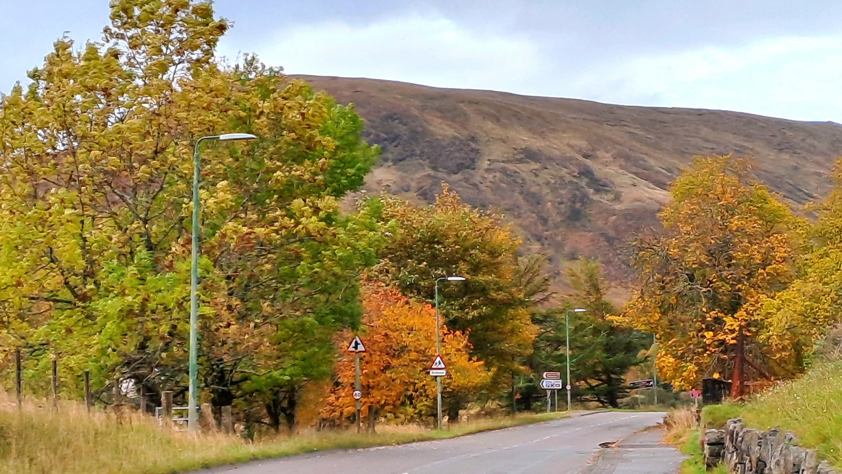

[www.community-council.org.uk/garveanddistrict](http://www.community-council.org.uk/garveanddistrict)

[www.facebook.com/profile.php?id=61552992414355](http://www.facebook.com/profile.php?id=61552992414355)

[garveanddistrictcc@yahoo.com](mailto:garveanddistrictcc@yahoo.com)

This set of minutes were first published (in draft form) at 6.00pm on Saturday 9 November 2024.