Ian Montcrieff
Roads Operational Manager
Highland Council Office
Burn Place
Dingwall

8th December 2018

Dear Ian

Blocked Drains in Fortrose and Rosemarkie

CC: Ward Councillors, Ward Manager

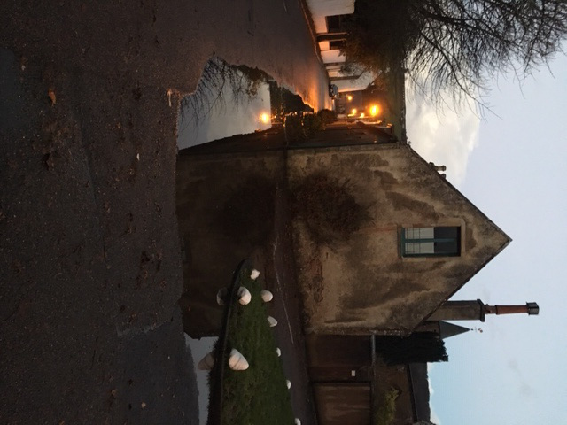
Over the last few years we have written to you and your council colleagues on a number of occasions about the blocked drains in Academy Street Fortrose in particular and the high number of non-functioning drains in our area in general. Whilst, over this period cursory attempts have been made by council staff to clear the drains the situation has not substantially changed. The picture below shows flooding this morning in Academy Street. This shows the same problem reported to you at this time last year with the water threatening to overflow into the adjacent dwelling. Can you please advise:

- Why have the drains not been cleared properly in the intervening period?
- When will the issue be addressed both in Academy Street and more widely in the area?

Yours Faithfully


Dr.T.V.Heath
20 Canonbury Terrace
Fortrose IV10 8TT
For Fortrose and Rosemarkie Community Council

