**Black Isle walkers stride out with a purpose**

Last year a number of people contacted Transition Black Isle about the poor state of local paths and cycle tracks. Further enquiries revealed a group happy to undertake some footpath maintenance while enjoying a walk together. Two months later on Sunday 18 February the first meeting of the group, a twenty-strong party, armed with pruning saws, loppers, secateurs and strong gloves arrived by bus at North Kessock Pier for the 11 km walk back to Munlochy.

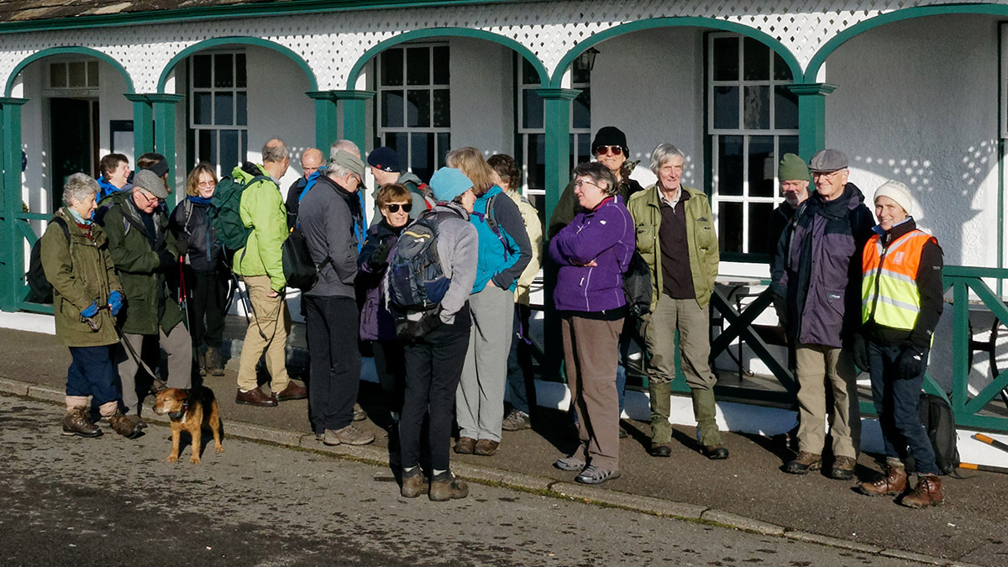

*Meeting at North Kessock*

The plan was to walk a section of the newly created John o’ Groats Trail. The trail starts from Inverness, passes over the Kessock Bridge, and continues in 14 stages to John o’ Groats. The first stage ends at Culbokie and the group planned to walk half of it. The John o’ Groats Trail website describes each stage of the route with detailed mapping. http://www.jogt.org.uk/

Jay Wilson, the mastermind and co-ordinator of the John o’ Groats Trail, joined the group for the walk. The Black Isle section has been fully way-marked. Parts of the trail are new and link established footpaths, and Jay had negotiated rights of access to produce a logical route. An important aspect of the walk was to ensure these new links were clear of encroaching vegetation.

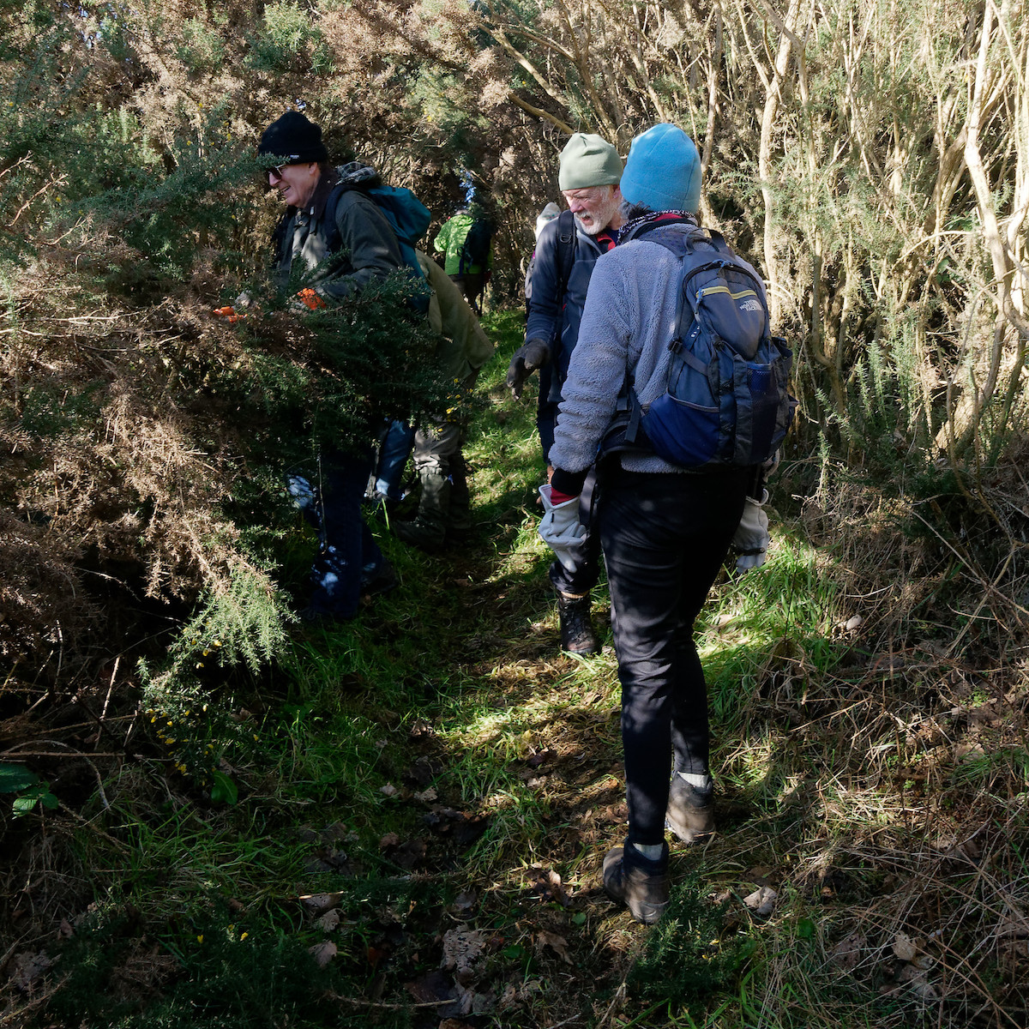

*Opening up the footpath up Ord Hill from Kessock Bridge*

Sunday was a beautiful day and it seemed no one was in a hurry until gorse, broom, overhanging branches and minor obstacles were cleared. Lunch was spent overlooking Loch Lundie while some cleared a blocked path nearby, forgoing the break.

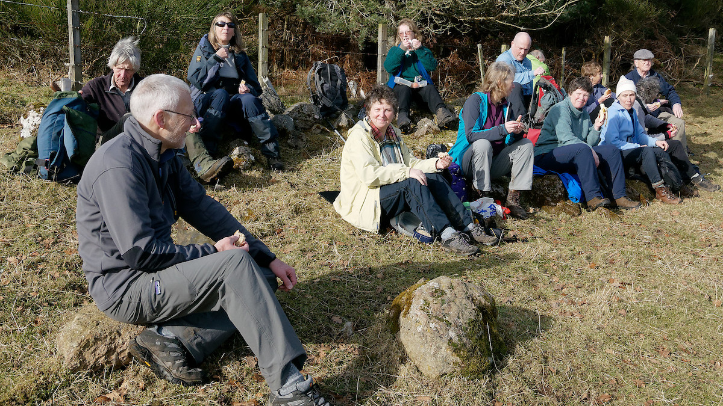

*Lunch above Loch Lundie*

The final tasks of the day were to add additional signs to a “high-tide” diversion by Munlochy Bay and clear gorse from a new section that replaces a tidal footpath below Bayhead.

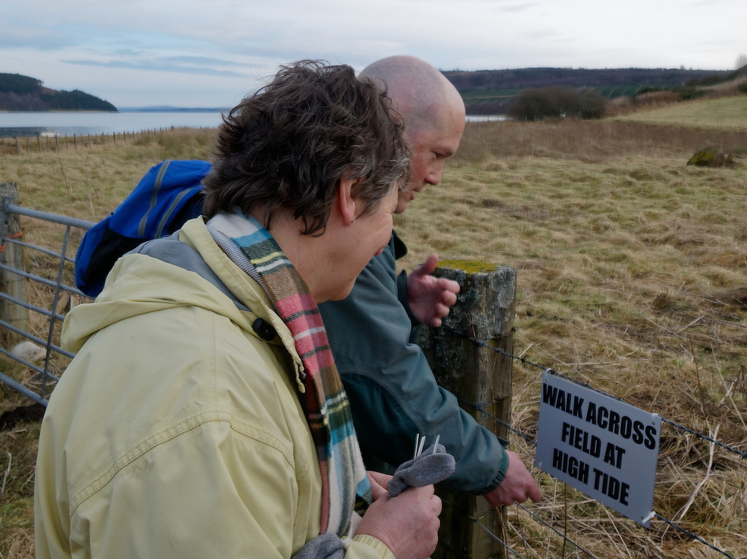

*Jay Wilson attaching a sign above Munlochy Bay*

For those who want a good quiet 11 km walk with no hazards, this walk is highly recommended, and the return can be made by bus.

Before and during the walk, many suggestions were made of where the group should focus its next activities. Paths in Spittal Wood, Fairy Glen, Bogallan Wood, Agnes Hill and Swallow Den, the A9 underpass at North Kessock, and Avoch-Fortrose railway line were all put on a list.

The group plans to meet monthly and would welcome new active members and champions who could “Adopt-a Path” especially those where access is becoming difficult through neglect. The walk was great fun, and a real difference was made.

For future activities and to be kept informed by e-mail please contact Julian Paren at Transition Black Isle. [julian.paren@gmail.com](mailto:julian.paren@gmail.com)