Guidance regarding the exercise of public rights

Please complete and return the Notice of appointment of date for the exercise of public rights on Page 3
The Parish Council must inform the electorate of an exact 30 working day period during which public rights may be exercised. This is inclusive of the start and finish dates.
You may find the calendar guide overleaf useful.
Please note that because the earliest date to start a compliant public rights period is 03 June 2026 and the definition of ‘as soon as practical’ excludes any earlier dates than this.

The inspection period must commence no later than 1 July 2026 and must include the first 10 working days of July.
The elector’s rights must start exactly one working day after the annual return has been published on your website (or other free to access website used by the Council) with the statutory notice – see below. Publication of the annual return must be as soon as practicable after the unaudited annual return has been approved by the Parish Council, and in line with the regulatory inspection period.

Working days are defined as Monday – Friday. They do not include Saturdays, Sundays, and Bank Holidays.

The rest of this page is intentionally blank – do not return this page.

Exercise of public rights – calendar guide 2026
03 June is the earliest date you can start the inspection period to include the first 10 working days of July (the inspection period would end on 14 July). The Date of Announcement will be 02 June 2026.
June 2026
Mo | Tu | We | Th | Fr | Sa | Su
 | 2 | 3 | 4 | 5 | 6 | 7
8 | 9 | 10 | 11 | 12 | 13 | 14
15 | 16 | 17 | 18 | 19 | 20 | 21
22 | 23 | 24 | 25 | 26 | 27 | 28
29 | 30
The inspection period MUST include the first 10 working days of July – highlighted in blue.

01 July is the latest date you can start the inspection period (the inspection period would end on the 11 August). The Date of Announcement will be 30 June 2026.
July 2026
Mo | Tu | We | Th | Fr | Sa | Su
 |  | 1 | 2 | 3 | 4 | 5
6 | 7 | 8 | 9 | 10 | 11 | 12
13 | 14 | 15 | 16 | 17 | 18 | 19
20 | 21 | 22 | 23 | 24 | 25 | 26
27 | 28 | 29 | 30 | 31
The inspection period end date can be no later than 11 August as this is the 30th working day after 01 July 2026, the latest date the period can start.
August 2026
Mo | Tu | We | Th | Fr | Sa | Su
 |  |  |  |  | 1 | 2
3 | 4 | 5 | 6 | 7 | 8 | 9
10 | 11 | 12 | 13 | 14 | 15 | 16

Local council name: Whessoe Parish Council

Notice of appointment of date for the exercise of public rights
Accounts for the year ended 31st March 2026
The Local Audit and Accountability Act 2014, and
The Accounts and Audit (England) Regulations 2015 (SI 234)
1. Date of announcement: 2nd June 2026 (a) | (a) Insert date of placing of this notice on your website.
2. Any person interested has the right to inspect and make copies of the accounts to be audited and all books, deeds, contracts, bills, vouchers and receipts relating to them. For the year ended 31 March 2026 these documents will be available on reasonable notice on application to:
(b) Bill Goldfinch, Parish Clerk  Email: clerk@whessoeparishcouncil.gov.uk  Tel/Txt: 07471 062395 | (b) Insert name, position and contact details of the Clerk or other person to whom any person may apply to inspect the accounts.
commencing on (c) 3rd June 2026 | (c )And
and ending on (d) 14th July 2026 | (d)The inspection period must be 30 working days in total and commence no later than 1 July 2026.
3. Local Government Electors and their representatives also have:
- the opportunity to question the auditor about the accounts; and
- the right to make objections to the accounts or any item in them. Written notice of an objection must first be given to the auditor and a copy sent to the Authority (f).

The auditor can be contacted at the address in paragraph 4 below for this purpose during the inspection period at 2 above.
- The auditor’s limited assurance review is being conducted under the provisions of the Local Audit and Accountability Act 2014, the Accounts and Audit (England) Regulations 2015 and the National Audit Office’ Code of Audit Practice. Your review is being carried out by:
Forvis Mazars LLP, Newcastle Office via 30 Old Bailey, London, EC4M 7AU
Email: local.councils@mazars.co.uk
5. This announcement is made by (e)) Bill Goldfinch, Clerk and RFO | (e) Insert name and position of person placing the notice

What councils need to do to advertise the audit

The Local Audit and Accountability Act 2014 as summarised in the Accounts and Audit (England) Regulations 2015 (Statutory Instrument No. 234), and subsequent amendments and the Code of Audit Practice require that:
- The accounts to be audited (the Annual Return) and other documents such as books, deeds, contracts, bills, vouchers and receipts relating to them must be made available for inspection by any person interested on reasonable notice, during a period of 30 working days selected by the Parish Council.
- The notice advertising the inspection period must be published with the accounts and must state:
(1) The period of 30 working days during which the Annual Return, and other documents referred to in paragraph 1 above will be available for public inspection;
(2) Details of the manner in which notice should be given of an intention to inspect the accounts and other documents;
(3) The name and address of the auditor; and
(4) The provisions contained in section 26 (inspection of documents and questions at audit) and section 27 (right to make objections at audit) of the Act
The Parish Council may wish to use the template at attachment 3.2 to advertise the audit.
Please see the link below for the Accounts and Audit Regulations that apply at the date of drafting this guidance. If any amendment is passed that impacts on smaller authorities in 2025/26 we will inform you promptly.
https://www.legislation.gov.uk/uksi/2015/234/contents/made

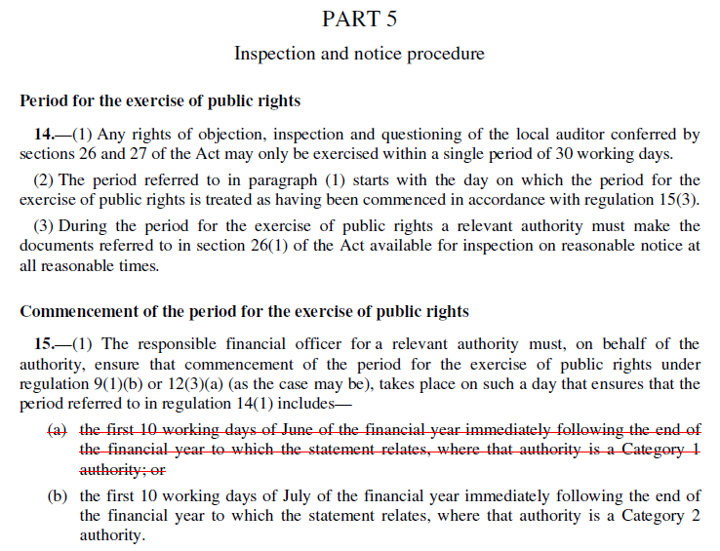

Councils’ Accounts: A Summary of Public Rights
The basic position
By law, any interested person has the right to inspect a council’s/meeting’s accounts. If you are entitled and registered to vote in local council elections then you (or your representative) have additional rights to ask the appointed auditor questions about the Council’s accounts or object to an item of account contained within them.
The right to inspect the accounts
When your council has finalised its accounts for the previous financial year it must advertise that they are available for people to inspect. Having given the Council reasonable notice of your intentions, you then have 30 working days to look through the accounting statements in the Annual Return and any supporting documents. By arrangement, you will be able to inspect and make copies of the accounts and the relevant documents. You may have to pay a copying charge.
The right to ask the auditor questions about the accounts
You can only ask the appointed auditor questions about the accounts. The auditor does not have to answer questions about the council’s policies, finances, procedures or anything else not related to the accounts. Your questions must be about the accounts for the financial year just ended. The auditor does not have to say whether they think something the Council has done, or an item in its accounts, is lawful or reasonable.
The right to object to the accounts
If you think that the council has spent money that it should not have, or that someone has caused a loss to the council deliberately or by behaving irresponsibly, you can request the auditor to apply to the courts for a declaration that an item of account is contrary to law. You do this by sending a formal ‘notice of objection’ to the auditor at the address below. The notice must be in writing and copied to the council. In it, you must tell the auditor why you are objecting and what you want the auditor to do about it. The auditor must reach a decision on your objection. If you are not happy with that decision, you can appeal to the courts.
You may also object if you think that there is something in the accounts that the auditor should discuss with the Council or tell the public about in a ‘public interest report’. You must follow the same procedure as outlined in the previous paragraph. The auditor must then decide whether to take any action. The auditor does not have to, but usually will, give reasons for his/her decision and you cannot appeal to the courts. More information is available on the National Audit Office website (see contact details below).
You may not use this ‘right to object’ to make a personal complaint or claim against your council. You should take such complaints to your local Citizens’ Advice Bureau, local Law Centre or your solicitor. You may also be able to approach the Standards Committee of your local principal authority if you believe that a member of the council has broken the Code of Conduct for Members.
What else you can do
Instead of objecting, you can give the auditor information that is relevant to his/her responsibilities. For example, you can simply tell the auditor if you think that something is wrong with the accounts or about waste and inefficiency in the way the Council runs its services. You should make it clear that you are providing information rather than making a formal objection. You do not have to follow any set time limits or procedures. The auditor does not have to give you a detailed report of any subsequent investigation, but will usually tell you the outcome.

A final word
Councils, and so local taxpayers, must meet the costs of dealing with questions and objections. In deciding whether to take your objection forward, one of a series of factors the auditor must take into account is the cost that will be involved. The auditor will only continue with the objection if it is in the public interest to do so. If you appeal to the courts, you might have to pay for the action yourself.

Who should you contact?
For more detailed guidance on electors’ rights and the special powers of auditors, copies of the publication Council Accounts – a guide to your rights are available by calling the National Audit Office on 020 7798 7000 or downloading from the website https://www.nao.org.uk/ | If you wish to contact your Council’s appointed external auditor please write to:  James Collins, Director, Forvis Mazars LLP, local.councils@mazars.co.uk

