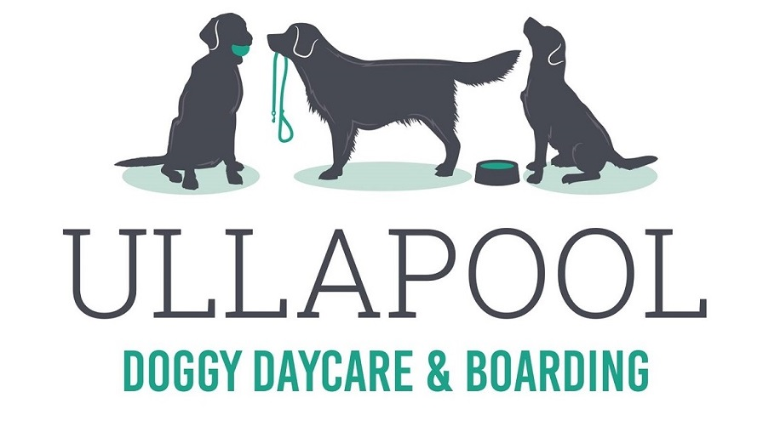
I offer professional dog care in my own home in Ullapool. I am fully licenced and insured and your dog will be treated like my own. NO kennels.

Various services available:
Half Day: £10 / Full Day: £20 / Overnight only: £15 / 24 hours: £25
Evening up to 4 hours: £10 – enjoy a meal out!
Reductions for 2 or more dogs from same household

Holiday House owners, B&B or Hotel’s – let your guests know there is somewhere for their dogs, rather than leaving unattended in the property.

Contact me or visit my Facebook page for more info!
www.facebook.com/ullapooldogboarding

Please rest assured your dog is in good hands. I have many years’ experience and worked closely with the SSPCA and dog trainers when re-homing rescue dogs.

Catherine Bentley
9 St Valery Place Tel: 01854 612391
Ullapool Mob: 07788 425077
IV26 2TD Email: familybentley3@outlook.com

