EDLINGHAM PARISH COUNCIL
AGENDA PAPER
You are hereby summoned to attend a meeting of Edlingham Parish Council to be held at Bolton Village Hall on Tuesday August 22nd 2017 at 8pm, for the purpose of transacting the business contained within this Agenda.
A five minute participation session will be held for members of the public before the meeting commences
2017/29 Apologies for Absence
2017/30 Declaration of Interests
Members are invited to disclose any Disclosable Pecuniary Interests or other personal interests they may have in any of the items of business on the agenda in accordance with the Code of Conduct.
2017/31 Co-option Vacancies
2017/32 County Cllr Update
2017/33 Minutes of previous meeting held 17th May 2017
2017/34 Matters Arising from previous meeting
2017/35 Planning
2017/35/01 Planning Applications received
- 17/01797/FUL: Mr B Plews, 2 Corby Cottage OVerthwarts Farm road, construction of single storey glazed in-fill extension with arched roof, gym extension to existing outbuilding and approved.
- 17/02308/FUL: Mrs R Robson, land west of Appletree Cottage, construction of new dwelling
2017/35/02 Approval of Planning Application received
- 17/00723/FUL – Mr H Ruff, construction of wooden dog kennel, Lemmington Hall

2017/35/03 Northumberland Local Plan Core Strategy – withdrawal from Examination

2017/36 Correspondence
- Northumberland County Council – The Green Dog Walkers Responsible Dog Ownership Campaign
- Fire and Rescue Service – Plan 2017 – 2021
- County Council – LTP 2018 – 19 – to agree/discuss priorities

2017/37 Finance
201737/01 The following invoices are to be authorised:
- Bolton Village Hall rent of hall - £8.00
- Northumberland County Council – annual insurance policy - £175.07 – authorised between meetings

2017/38 Neighbourhood Management

2017/39 Urgent Business
2017/40 Date of Next Meeting

Dated this 10th day of August 2017
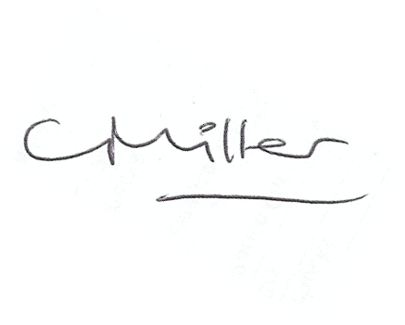
Claire Miller
Parish Clerk

www.parish-council.com/edlingham/links.asp

