EDLINGHAM PARISH COUNCIL
AGENDA PAPER
You are hereby summoned to attend a meeting of Edlingham Parish Council to be held at Bolton Village Hall on Wednesday 1st March 2017 at 730pm, for the purpose of transacting the business contained within this Agenda.
2017/01 Apologies for Absence
2017/02 Declaration of Interests
Members are invited to disclose any Disclosable Pecuniary Interests or other personal interests they may have in any of the items of business on the agenda in accordance with the Code of Conduct.
2017/03 Opportunity for members of the public to raise any matter on the agenda
2017/04 Vacancy
2017/05 County Cllr Update
2017/06 Minutes of previous meeting held 22nd November 2016
2017/07 Matters Arising from previous meeting
2017/08 Planning
2017/08/01 Planning Applications received
2017/08/02 Approval of Planning Application received
- 16/02778/FUL: Mr & Mrs J Duncan, conversion of railway structure to holiday let, former coal drops, Edlingham
2017/09 Correspondence
- Northumberland County Council – Archaeology in Northumberland
- Northumberland County Council – Winter Services

2017/10 Finance
2017/10/01 The following invoices are to be authorised:
- Bolton Village Hall rent of hall - £8.00
- C Miller – annual salary and expenses – £293.57
- HMRC – PAYE on above - £56.00
2017/10/02 Request for Donation
- Alnwick Bailiffgate Museum

2017/11 Neighbourhood Management
2017/12 Annual Review of Risk Assessment
2017/13 Urgent Business
2017/14 Date of Next Meeting

Dated this 15th day of February 2017
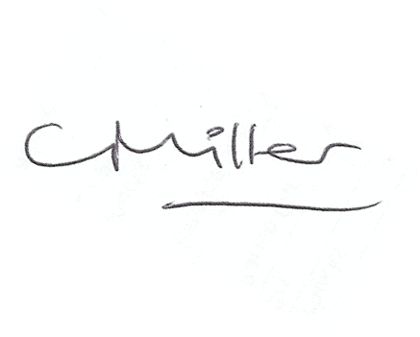
Claire Miller
Parish Clerk

www.parish-council.com/edlingham/links.asp

