EDLINGHAM PARISH COUNCIL
AGENDA PAPER
You are hereby summoned to attend a meeting of Edlingham Parish Council to be held at Bolton Village Hall on Tuesday 16th May 2017 at 830pm, for the purpose of transacting the business contained within this Agenda.
2017/15 Apologies for Absence
2017/16 Declaration of Interests
Members are invited to disclose any Disclosable Pecuniary Interests or other personal interests they may have in any of the items of business on the agenda in accordance with the Code of Conduct.
2017/17 Election of Officers
2017/18 Co-option Vacancies
2017/19 Opportunity for members of the public to raise any matter on the agenda

2017/20 County Cllr Update
2017/21 Minutes of previous meeting held 1st March 2017
2017/22 Matters Arising from previous meeting
2017/23 Planning
2017/23/01 Planning Applications received
- 17/00723/FUL: Mrs H Ruff, Lemmington Hall – construction of wooden dog kennel

2017/24 Correspondence

2017/25 Finance
2017/25/01 The following invoices are to be authorised:
- Bolton Village Hall rent of hall - £8.00
- NALC – annual subscription - £63.92
2017/25/02 Audit of Accounts year ending 31/3/17: to discuss and approve Annual Governance Statement and Accounting Statements year ending 31/3/17

2017/26 Neighbourhood Management
- Notice of resurfacing – Bridge of Aln to Garminedge Bank

2017/27 Urgent Business
2017/28 Date of Next Meeting

Dated this 4th day of May 2017
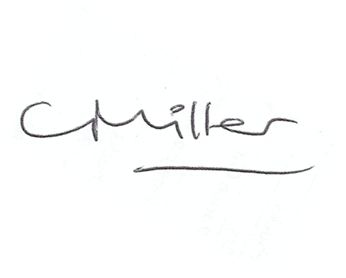
Claire Miller
Parish Clerk

www.parish-council.com/edlingham/links.asp

