EDLINGHAM PARISH COUNCIL
AGENDA PAPER
You are hereby summoned to attend a meeting of Edlingham Parish Council to be held at Bolton Village Hall on Tuesday 21st November 2017 at 730pm, for the purpose of transacting the business contained within this Agenda.
A five minute participation session will be held for members of the public before the meeting commences
2017/41 Apologies for Absence
2017/42 Declaration of Interests
Members are invited to disclose any Disclosable Pecuniary Interests or other personal interests they may have in any of the items of business on the agenda in accordance with the Code of Conduct.
2017/43 Co-option Vacancies
2017/44 Superfast Broadband
2017/45 County Cllr Update
2017/46 Minutes of previous meeting held 22nd August 2017
2017/47 Matters Arising from previous meeting held 22nd August 2017
2017/48 Planning
2017/48/01 Planning Applications received
- 17/03424/FUL: Mrs Robson, Land West of Appletree Cottage, Edlingham – construction of new dwelling to be restricted to short term holiday letting
- 17/03436/VARYCO – Mr E McCallum, Poultry Farm, Atheys Moor, Longframlington – application for removal of condition ten of 16/000762/VARYCO, so that temporary permission is made permanent
2017/48/02 Approval of Planning Application received
- 15/03531/FUL: Mr & Mrs A Ruff, Lemmington Hall – demolition of 1960’s extension, construction of replacement extension and construction of 3 new build holiday let/staff accommodation unites
2017/48/03 Other Planning Matters
2017/49 Correspondence
- Hospicecare Northumberland – Light up a Life
- Northumberland County Council – consultation on Northumberland Area Special Education Needs School Place Planning Strategy
2017/50 Finance
2017/50/01 The following invoices are to be authorised:
- Bolton Village Hall rent of hall - £8.00
- To discuss grant requests received from Great North Air Ambulance and Community Action Northumberland
2017/50/02 Audit of Accounts year ending 31/3/17
2017/50/03 To discuss/agree precept 2018 - 2019

2017/51 Neighbourhood Management
2017/52 Review of Parish Council Standing Orders/Grievance Policy
2017/53 Clerk Contract
2017/54 Urgent Business
2017/55 Date of Next Meeting

Dated this 9th day of November 2017
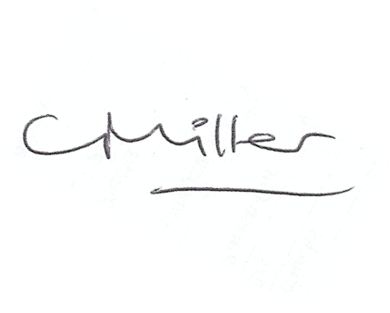
Claire Miller
Parish Clerk

www.parish-council.com/edlingham/links.asp

