Agenda for the Annual Assembly of Edlingham Parish to be held on Wednesday 22nd May 2019 commencing 8pm at Thrunton Fishery
1/19 Apologies for Absence
2/19 Minutes of previous meeting held 23rd May 2018
3/19 Matters arising from previous meeting held 23rd May 2018
4/19 Public Participation
5/19 Any Other Business

EDLINGHAM PARISH COUNCIL
AGENDA PAPER
You are hereby summoned to attend the Annual meeting of Edlingham Parish Council to be held at Thrunton Fishery on Wednesday 22nd May 2019 commencing after the Annual Meeting of the Parish at 8pm, for the purpose of transacting the business contained within this Agenda.
A five minute participation session will be held for members of the public before the meeting commences

2019/14 Apologies for Absence

2019/15 Declaration of Interests
Members are invited to disclose any Disclosable Pecuniary Interests or other personal interests they may have in any of the items of business on the agenda in accordance with the Code of Conduct.

2019/16 Election of Chairman
2019/17 Election of Vice Chairman

2019/18 County Cllr Update

2019/19 Minutes of previous meeting held 12th February 2019
2019/20 Matters arising from previous meeting held 12th February 2019

2019/21 Planning
2019/21/01 Planning Applications received:
- 19/00664/FUL: 4 Overthwarts Farm, Swinhope Cottage, Edlingham – erection of 3m x 3m summerhouse in corner of front garden
- 19/00974/FUL: Land North East of Black Lough, Alnwick Moor – change of use from agricultural to A5 unit leisure development and associated ground works, as part of farm diversification

2019/22 Correspondence
- CPRE newsletter
- County Council – notice of surface dressing – Lemmington Bank to Battle Bridge
- County Council – Housing Strategy for Northumberland 2019-2021 Consultation

2019/23 Finance
2019/23/01 The following payments are to be authorised:
- NALC – annual subscription - £66.56
2019/24 Audit of Accounts year ending 31/3/19
2019/24/01 To consider and agree any actions arising from the report of the internal auditor
2019/24/02 To approve the Governance Statement
2019/24/03 To approve the draft annual accounts for 2018/2019
2019/24/04 To approve the Accounting Statement and explanation of variances
2019/24/05 To approve exemption certificate

2019/25 Neighbourhood Management

2019/26 Edlingham Community Association

2019/27 Urgent Business

2019/28 Date of Next Meeting

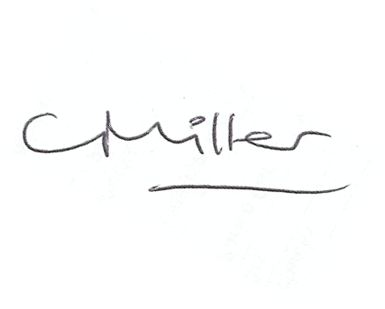
Claire Miller
Parish Clerk

11th May 2019

www.parish-council.com/edlingham/links.asp

