EDLINGHAM PARISH COUNCIL
AGENDA PAPER
You are hereby summoned to attend an ordinary meeting of Edlingham Parish Council to be held at Thrunton Fishery on Monday 24th February 2020 commencing 730pm, for the purpose of transacting the business contained within this Agenda.
A five minute participation session will be held for members of the public before the meeting commences

2020/01 Apologies for Absence
2020/02 Declaration of Interests
Members are invited to disclose any Disclosable Pecuniary Interests or other personal interests they may have in any of the items of business on the agenda in accordance with the Code of Conduct.

2020/03 Minutes of previous meeting held 2nd December 2019
2020/04 Matters arising from previous meeting held 2nd December 2019
2020/05 County Cllr Update

2020/06 Planning
2020/06/01 Planning Applications received:
- 19/04779/FUL: Land to West of Battle Bridge farmhouse – construction of office block, replacing mobile units
- 19/04909/LBC: Lemmington Hall, Listed building consent for replacement of existing double doors to south west elevation
2020/06/02 Notice of Planning Application refusal:
- 19/00974/FUL: Land North East of Black Lough Alnwick Moor – Change of use from agricultural to C3 unit leisure development and associated ground works, as part of farm diversification
2020/07 Correspondence
- CPRE newsletter
2020/08 Finance
2020/08/01 To approve the following payments
- C Miller, annual salary and expenses - £347.71
- HMRC – PAYE - £71.80

2020/09 Neighbourhood Management
2020/10 Edlingham Community Association
2020/11 Review of Internal Auditor and Internal Controls
2020/12 Review of Risk Assessment
2020/13 Review of Asset Register
2020/14 Review of insurance policy

2020/16 Northumberland County Council – Consultation on library services
2020/17 Northumberland Association of Local Councils – Member Council Survey Anti-Social Behaviour and Petty Crime

2020/18 Urgent Business
2020/19 Date of Next Meeting

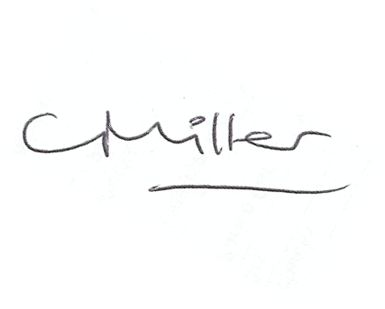
Claire Miller
Parish Clerk

14th February 2020

www.parish-council.com/edlingham/links.asp

