Minutes of meeting of Edlingham Parish Council held at Bolton Village Hall on Tuesday August 22nd 2017 commencing at 8pm
Those present: Cllr C Blythe, Cllr T Drummond, Cllr G Herdman, Cllr T Drummond, County Cllr W Pattison, C Miller (Clerk)

2017/29 Apologies for Absence
Cllr N Hargreaves
2017/30 Declaration of Interests
There were no Declaration of Interests.

2017/31 Co-option Vacancies
No further applicants had been forthcoming.

2017/32 County Cllr Update
- A697 undergoing programme of schemes to improve road safety between Powburn and Shawdonhill, consisting of signage and road marking improvements with any necessary vegetation clearance and gully clearing.
- Informal meeting to be he held with County Cllr and all nine Parish Council Chairman within Longhoughton Ward. Whittingham PC were to look into creating a Neighbourhood Plan with the possibility of joining up with neighbouring parishes.
- Edlingham broadband roll out to begin within the next phase in 2018.
- Core Strategy had been withdrawn from examination with County Cllr officers to undertake a full review of housing and employment numbers, with national planning guidelines currently being used to assess planning applications.
- Five new Area Councils are to replace the former area committees.
- Tour of Britain to pass through 26 communities in Northumberland.
- Alnwick Playhouse now owned by Northumberland County Council.
- Community Action Northumberland involved in delivering community-led housing and establishing the level of interest across the area.
- List of portfolio holders available.

2017/33 Minutes of previous meeting held 17th May 2017
The minutes of the previous meeting were agreed as a true record.

2017/34 Matters Arising from previous meeting
Clerk had contacted County Council solicitor who had advised the matter concerning parishioner not being co-opted by the Parish Council was not a matter they would be concerned about.

2017/35 Planning
2017/35/01 Planning Applications received
- 17/01797/FUL: Mr B Plews, 2 Corby Cottage Overthwarts Farm road, construction of single storey glazed in-fill extension with arched roof, gym extension to existing outbuilding APPLICATION APPROVED.
- 17/02308/FUL: Mrs R Robson, land west of Appletree Cottage, construction of new dwelling APPLICATION REFUSED
2017/35/02 Approval of Planning Application received
- 17/00723/FUL – Mr H Ruff, construction of wooden dog kennel, Lemmington Hall
2017/35/03 Northumberland Local Plan Core Strategy – withdrawal from Examination
As previously minuted Draft Core Strategy had been withdrawn from examination.

2017/36 Correspondence
- Northumberland County Council – The Green Dog Walkers Responsible Dog Ownership Campaign – campaign to encourage dog walkers to pick up their dog mess.
- Fire and Rescue Service – Plan 2017 – 2021 – consultation available on-line
- County Council – LTP 2018 – 19 – to agree/discuss priorities – Priorities from 2017-18 being; extensive resurfacing works on Lemmington Bank; road signage refurbishment/replacement within the parish, which had been actioned/were to be actioned. After discussion it was agreed to request A697 works to south of fishery on bridge of Coburn to improve safety. Trees on A697 still require additional maintenance – Clerk to report to NCC.
- County Council – Joint meetings with parish councils – Thursday 19th October – Cllr C Blythe maybe able to attend.
- Hospicecare Northumberland – newsletter.

2017/37 Finance
201737/01 The following invoices were authorised:
- Bolton Village Hall rent of hall - £8.00
- Northumberland County Council – annual insurance policy - £175.07 – authorised between meetings

2017/38 Neighbourhood Management
Nothing to report.

2017/39 Urgent Business
There was no urgent business.

2017/40 Date of Next Meeting
The next meeting of Edlingham Parish Council will be held on Tuesday 21st November 2017 commencing 730pm in Bolton Village Hall.

The meeting closed at 840pm.
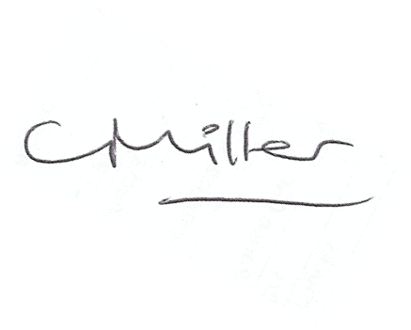
Claire Miller
Parish Clerk

www.parish-council.com/edlingham/links.asp

