Minutes of meeting of Edlingham Parish Council held at Bolton Village Hall on Wednesday 1st March 2017 commencing at 730pm
Those Present: Cllr C Blythe (Chairman), Cllr G Herdman, Cllr T Drummond, Cllr J Herriman, Cllr F Manners,
Cllr N Hargreaves, C Miller (Clerk), one member of the public

2017/01 Apologies for Absence
Cllr J Herdman, County Cllr K Cairns
2017/02 Declaration of Interests
Cllr J Herriman declared an interest in planning application NO 16/02778/FUL.

2017/03 Opportunity for members of the public to raise any matter on the agenda
No public questions.

2017/04 Vacancy
Four yearly elections May 2017.

2017/05 County Cllr Update
- NCC Area Committee meeting to be held 13/3/17, 6pm, Hindmarsh Hall, Alnmouth.
- NCC had produced a video to highlight how parking behaviours of parents impact on safety of children at drop off and pick up times.

2017/06 Minutes of previous meeting held 22nd November 2016
The minutes of the previous meeting were agreed as a true record.

2017/07 Matters Arising from previous meeting
- C89 had been inspected this morning with no water found to be flowing across the road above T Junction at Broome Park Lodge.
- Potholes on A697 South of Thrunton to be filled within the next 14 days.
- Pothole and rippled area in Edlingham had been repaired and plaster patched on 13/12/16. Discussion followed -regarding the poor condition of several roads within the parish.
- Minor road maintenance had been carried out at Lemmington Bank.
- Ongoing concerns regarding ragwort.

2017/08 Planning
2017/08/01 Planning Applications received
- None received.
2017/08/02 Approval of Planning Application received
- 16/02778/FUL: Mr & Mrs J Duncan, conversion of railway structure to holiday let, former coal drops, Edlingham.
- 16/03694/VARYCO: Mr P Cussins, land South of Learchild Crossing Cottage, variation of condition 2 to allow existing walls to be strengthened

2017/09 Correspondence
- Northumberland County Council – Archaeology in Northumberland
- Northumberland County Council – Winter Services

2017/10 Finance
2017/10/01 The following invoices were authorised:
- Bolton Village Hall rent of hall - £8.00
- C Miller – annual salary and expenses – £293.57
- HMRC – PAYE on above - £56.00

2017/10/02 Request for Donation
- Alnwick Bailiffgate Museum – it was agreed not to donate to this organisation.

2017/11 Neighbourhood Management
- Litter on sides of roads prevalent within the parish, including Lemmington Bank, Corby Crags and A697. Clerk to report to County Council.

2017/12 Annual Review of Risk Assessment
Risk Assessment had been circulated to all and it was agreed as sufficient for the present needs of Edlingham Parish Council.

2017/13 Urgent Business
There was no urgent business.

2017/14 Date of Next Meeting
The next meeting of Edlingham Parish Council will be held on Tuesday 16h May 2017 commencing 830pm in Bolton Village Hall.

The meeting closed at 810pm.
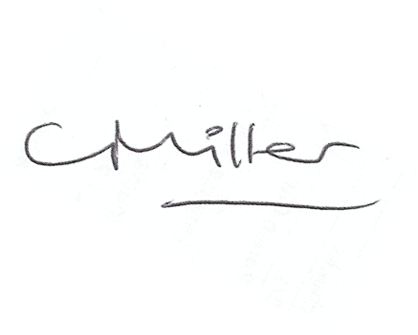
Claire Miller
Parish Clerk

www.parish-council.com/edlingham/links.asp

