Minutes of the Annual Meeting of Edlingham Parish Council held at Bolton Village Hall on Wednesday 16th May 2017 at 830pm
Those present: Cllr C Blythe, Cllr T Drummond, Cllr G Herdman, Cllr F Manners, Cllr N Hargreaves, J Herdman, A Hall, County Cllr W Pattison, C Miller (Clerk), G Cooper (Parishioner)

2017/15 Apologies for Absence
There were no apologies for absence.

2017/16 Declaration of Interests
There were no Declaration of Interests

2017/17 Election of Officers
Cllr Hargreaves proposed Cllr Blythe as Chairman, Cllr Drummond seconded, all in agreement. Cllr Blythe proposed Cllr Drummond as Vice Chairman, Cllr Hargreaves seconded, all in agreement,

2017/18 Co-option Vacancies
Currently four co-option vacancies, Adam Hall and James Herdman had applied to be co-opted and this was agreed. Parishioner Gary Cooper present who attempted to advise the council the procedures for co-option, however clerk advised, further to four yearly election notice being advertised, further co-option vacancy notices are not required, and he could be co-opted on to the council tonight, a slight altercation then followed whereby Cllrs were shocked at his aggressive and inappropriate attitude to proceedings which was making it difficult for the Chair to control the meeting. Later in the meeting Gary Cooper apologised for his earlier behaviour, stating he did wish to join the council, and requested Cllrs vote on this, which was carried out with Gary Cooper not present. After a lengthy discussion and then voting, with three abstentions, and four against, Gary Cooper was not co-opted onto the Parish Council, .

2017/19 Opportunity for members of the public to raise any matter on the agenda
No matters raised.

2017/20 County Cllr Update
Outgoing Cllr Kate Cairns had forwarded final report detailing achievements since becoming County Cllr for the Longhoughton ward, and it was agreed the Parish Council would thank Kate for her help in the last four years. Incoming County Cllr Wendy Pattison present, who was welcomed and congratulated on her election success.

2017/21 Minutes of previous meeting held 17th May 2017
The minutes of the previous meeting were agreed as a true record.

2017/22 Matters Arising from previous meeting
- Potholes on A697 had been partially actioned, however do need readdressing. South of Thrunton there exists a bad dip over the bridge, with wagons swerving, County Cllr to meet on site with Cllr C Blythe.
- Minor road maintenance had been carried out at Lemmington Bank.

2017/23 Planning
2017/23/01 Planning Applications received
- 17/00723/FUL: Mrs H Ruff, Lemmington Hall – construction of wooden dog kennel

2017/24 Correspondence
No correspondence received.

2017/25 Finance
2017/25/01 The following invoices were authorised:
- Bolton Village Hall rent of hall - £8.00
- NALC – annual subscription - £63.92
2017/25/02 Audit of Accounts year ending 31/3/17: to discuss and approve Section 1 Annual Governance Statement and Accounting Statements year ending 31/3/17 Section 2 Statement and Accounting Statements year ending 31/3/17: Clerk read out points which were agreed with and figures accepted as a true record, year end financial reports had been circulated by Clerk to all members.

2017/26 Neighbourhood Management
- Notice of resurfacing – Bridge of Aln to Garmintedge Bank

2017/27 Urgent Business
- Parishioner brought up the issue of road sign obscuring vision on A697 from Broome Park road, however County Council had attended site and do not believe there is a problem in this area with Chair meeting County Council official who had pointed out rules and regulations regarding road signage.
- Narrow bridge would benefit from road markings stating bridge is not passable for two vehicles. Cllr C Blythe and several neighbouring parishes had compiled a report regarding danger areas within the parish. Chair to point area out to W Pattison.
- Cattlegrid at Lemmington had moved again, no further information regarding planning application.
- Litter in several areas of the parish an ongoing concern, County Council do collect litter at times, however if bins not full Council do not empty, Chair and County Cllr to also discuss these issues.

2017/28 Date of Next Meeting
The next meeting of Edlingham Parish Council will be held on Tuesday 22nd August 2017 commencing 8pm in Bolton Village Hall.

The meeting closed at 930pm.
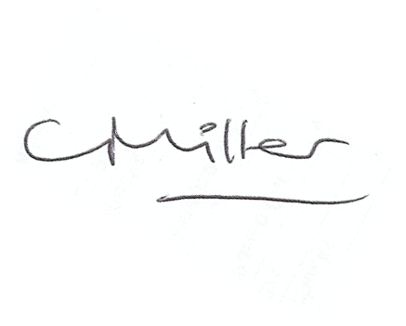
Claire Miller
Parish Clerk

www.parish-council.com/edlingham/links.asp

