Minutes of meeting of Edlingham Parish Council held at Bolton Village Hall on Tuesday 20th November 2018 commencing at 730pm
Those present: Cllr C Blythe (Chairman), Cllr R Robson, Cllr T Drummond, Cllr N Hargreaves, Cllr J Herdman, Cllr G Herdman, C Miller (Clerk), County Cllr W Pattison

2018/47 Apologies for Absence
Cllr F Manners

2018/48 Declaration of Interests
There were no Declaration of Interests.

2018/49 County Cllr Update
Chairmanship meeting being held on a regular basis with all parishes within the ward attending, with Clerk’s to be invited to next meeting; 7.7million for potholes had been received from Central Government; warm-hub event could be held at Edlingham church; state of road from Corby to Lemmington Hall and then to Lemmington Crossroads in need of attention – Cllr R Robson to forward details to County Cllr as a parishioner email complaint.

2018/50 Minutes of previous meetings held 23rd May 2018 and 15th August 2018
The minutes of the previous meetings held 23rd May 2019 and 15th August 2018 were agreed as a true record.

2018/51 Matters arising from previous meetings held 23rd May and 15th August 2018
There were no matters arising from the previous meetings held 23rd May and 15th August 2018.

2018/52 Planning
2018/52/01 Planning Applications received
- No planning applications had been received.
2018/52/02 Approval of Planning Application received
- 18/02499/FUL: Learchild Crossing Cottage U3058 – construction of rear single storey extension with roof terrace and open porch to side.

2018/53 Correspondence
- CPRE - newsletter

2018/54 Finance
2018/54/01 The following invoices were authorised:
- Bolton Village Hall rent of hall - £8.00
- Northumberland County Council – annual insurance premium - £175.07

2018/54/02 To approve precept 2019-20
It was agreed to retain the precept at the current level of £700.

2018/55 Neighbourhood Management
Lack of broadband of ongoing concern, however the service is live in Edlingham village with fibre to premises but
there are only certain broadband providers who can supply the service. County Cllr to query with County Council official
problems several Parish Cllr’s are still experiencing. Cllr C Blythe liaising with Alncom to boost speeds in areas lacking
broadband service.

2018/56 Adoption of documents relating to General Data Protection Regulations (GDPR): Information & Data Protection Policy; Publication Scheme and Councillor Details; Subject Access Request Form; Privacy Notice; Email Contact Privacy Notice; Councillor Privacy Notice; Document Retention Policy
The documents were agreed as acceptable for the current needs of Edlingham Parish Council and adopted by the Council.

2018/57 Edlingham Community Association
Successful fund raising events held, however restrictions due to no W/C facilities. Space heater had been hired for quiz event and funding bid for a space heater, camping W/C and tent as temporary measures had been submitted, along with bid for a small cooker and CCTV, due to donation box being raided. Long-term, a permanent W/C would be installed. Heritage Lottery Fund bid submitted for conservation architect survey, with extension for kitchen/W/C being progressed. Flooding unresolved with no proper solution given. Drainage improvements had aided the situation, however water still backs up. Parishioner had offered to repair gates; small community orchard in graveyard with fruit trees to be created; County Council would not permit a Christmas tree to be donated through County Cllr grant scheme, however the Woodland Trust were providing free trees.

2018/58 Urgent Business
There was no urgent business.

PART II
The Council is invited to consider the following resolution: That under the Public Bodies (Admission to Meetings) Act 1960, the press and public be excluded from the meeting during consideration of the following items on the agenda, as those items involve the discussion of personal information/contractual negotiations.

2018/59 To review Clerk Salary
Clerk request to be placed on NJC Scale 20 at 34 hours annual, £350.23.

2018/60 Date of Next Meeting
The next meeting of Edlingham Parish Council will be held on Tuesday 12th February 2019 commencing 730pm at Thrunton Fishery.
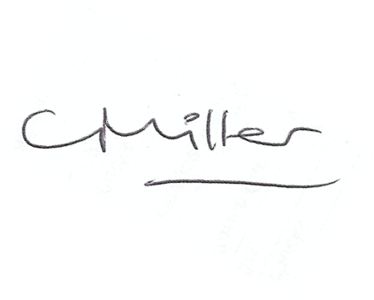
Claire Miller
Parish Clerk

The meeting closed at 810pm

www.parish-council.com/edlingham/links.asp

