EDLINGHAM PARISH COUNCIL
AGENDA PAPER
You are hereby summoned to attend a meeting of Edlingham Parish Council to be held at Bolton Village Hall on Wednesday 15th August 2018 commencing at 8pm, for the purpose of transacting the business contained within this Agenda.
A five minute participation session will be held for members of the public before the meeting commences

2018/33 Apologies for Absence
2018/34 Declaration of Interests
Members are invited to disclose any Disclosable Pecuniary Interests or other personal interests they may have in any of the items of business on the agenda in accordance with the Code of Conduct.

2018/35 County Cllr Update
2018/36 Minutes of previous meeting held 23rd May 2018
2018/37 Matters Arising from previous meeting held 23rd May 2018
2018/38 Planning
2018/38/01 Planning Applications received
- 18/02499/FUL: Learchild Crossing Cottage – construction of rear single storey extension with roof terrace and open porch to side
2018/38/02 Approval of Planning Application received
2018/38/03 Northumberland Local Plan Consultation

2018/39 Correspondence
- CPRE – newsletter
- County Council – disposing of hazardous waste
- County Council – Safety Scheme, B6341/C90 Lemmington Bank Crossroads
- County Council – notice of Annual Town and Parish Conference 11/10/18

2018/40 Finance
2018/40/01 The following invoices are to be authorised:
- Bolton Village Hall rent of hall - £8.00
- NALC – annual subscription - £65.64

2018/41 Neighbourhood Management
2018/42 Adoption of documents relating to General Data Protection Regulations (GDPR): Information & Data Protection Policy; Publication Scheme and Councillor Details; Subject Access Request Form; Privacy Notice; Email Contact Privacy Notice; Councillor Privacy Notice; Document Retention Policy
2018/43 Edlingham Community Association
2018/44 Local transport plan feedback 2018/19 and to agree submission 2019/20
2018/45 Urgent Business
2018/46 Date of Next Meeting

Dated this 4th day of August 2018
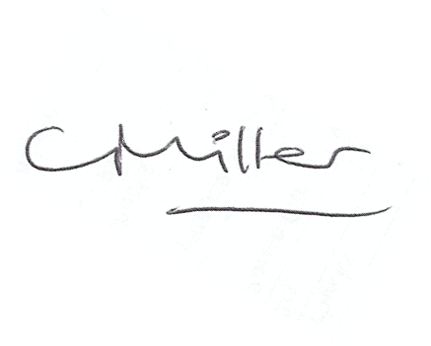
Claire Miller
Parish Clerk

www.parish-council.com/edlingham/links.asp

