EDLINGHAM PARISH COUNCIL
AGENDA PAPER
You are hereby summoned to attend a meeting of Edlingham Parish Council to be held at Bolton Village Hall on Tuesday 20th February 2018 commencing at 730pm, for the purpose of transacting the business contained within this Agenda.
A five minute participation session will be held for members of the public before the meeting commences
2018/01 Apologies for Absence
2018/02 Declaration of Interests
Members are invited to disclose any Disclosable Pecuniary Interests or other personal interests they may have in any of the items of business on the agenda in accordance with the Code of Conduct.
2018/03 Co-option Vacancies
2018/04 County Cllr Update
2018/05 Minutes of previous meeting held 21st November 2017
2018/06 Matters Arising from previous meeting held 21st November 2017
2018/07 Planning
2018/07/01 Planning Applications received
2018/07/02 Approval of Planning Application received
- 17/03436/VARYCO: Mr E McCallum, Poultry Farm, Atheys Moor – removal of condition 10 of 16/00762/VARYCO
2018/07/03 Other Planning Matters

2018/08 Correspondence
- CPRE - newsletter

2018/09 Finance
2018/09/01 The following invoices are to be authorised:
- Bolton Village Hall rent of hall - £8.00
- C Miller – annual salary & expenses - £346.49
- HMRC – PAYE on above - £56.00
2018/09/02 Request for donation received from Bailiffgate Museum Galery

2018/10 Neighbourhood Management

2018/11 Woodland creation Lumbylaw Hill

2018/12 Annual Review of Risk Assessment

2018/13 Clerk Contract

2018/14 Urgent Business

2018/15 Date of Next Meeting

Dated this 8th day of February 2018
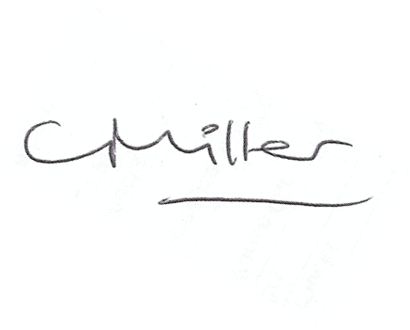
Claire Miller
Parish Clerk

www.parish-council.com/edlingham/links.asp

