Agenda for the Annual Assembly of Edlingham Parish to be held on Wednesday 23rd May 2018 commencing 8pm in Bolton Village Hall

1/18 Apologies for Absence

2/18 Public Participation

3/18 Any Other Business

4/18 Date of Next Meeting

C Miller, Clerk
Edlingham Parish Council

EDLINGHAM PARISH COUNCIL
AGENDA PAPER
You are hereby summoned to attend a meeting of Edlingham Parish Council to be held at Bolton Village Hall on Wednesday 23rd May 2018 commencing after the Annual Assembly of the parish at 8pm, for the purpose of transacting the business contained within this Agenda.
A five minute participation session will be held for members of the public before the meeting commences
2018/16 Apologies for Absence
2018/17 Declaration of Interests
Members are invited to disclose any Disclosable Pecuniary Interests or other personal interests they may have in any of the items of business on the agenda in accordance with the Code of Conduct.

2018/18 Election of Chairman
2018/19 Election of Vice Chairman
2018/20 Co-option Vacancies
2018/21 Meeting with Sylvia Pringle regarding superfast broadband
2018/22 County Cllr Update
2018/23 Minutes of previous meeting held 20th February 2018
2018/24 Matters Arising from previous meeting held 20th February 2018
2018/25 Planning
2018/25/01 Planning Applications received
2018/25/02 Approval of Planning Application received
- 17/03424/FUL: Mrs Robson, Land West of Appletree Cottage – construction of purpose built holiday let
2018/26 Correspondence
- Northumberland County Council, Love Northumberland Awards 2018
- Northumberland County Council, waste recycling
- Northumberland County Council, weed control
- Northumberland County Council, road hierarchy consultation
2018/27 Finance
2018/27/01 The following invoices are to be authorised:
- Bolton Village Hall rent of hall - £8.00
- Northumberland County Council – annual insurance policy - £175.07

2018/28 Audit of Accounts year ending 31/3/18
2018/28/01 To review the effectiveness of the system of internal control and consider the findings
2018/28/02 To consider and agree any actions arising from the report of the internal auditor
2018/28/03 To approve the Governance Statement
2018/28/04 To approve the draft annual accounts for 2017/2018
2018/28/05 To approve the Accounting Statement and explanation of variances
2018/28/06 To confirm and approve the Certificate of Exemption
2018/29 Neighbourhood Management
2018/30 To receive/discuss information relating to General Data Protection Regulations (GDPR)
2018/31 Urgent Business
2018/32 Date of Next Meeting

Dated this 12th day of May 2018
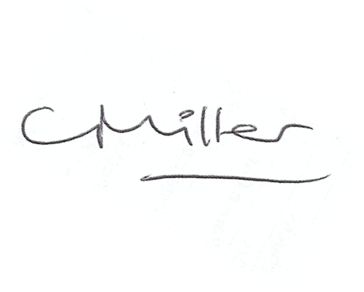
Claire Miller
Parish Clerk

www.parish-council.com/edlingham/links.asp

