EDLINGHAM PARISH COUNCIL
AGENDA PAPER
You are hereby summoned to attend a meeting of Edlingham Parish Council to be held at Bolton Village Hall on Tuesday 20th November 2018 commencing at 730pm, for the purpose of transacting the business contained within this Agenda.
A five minute participation session will be held for members of the public before the meeting commences

2018/47 Apologies for Absence
2018/48 Declaration of Interests
Members are invited to disclose any Disclosable Pecuniary Interests or other personal interests they may have in any of the items of business on the agenda in accordance with the Code of Conduct.

2018/49 County Cllr Update
2018/50 Minutes of previous meetings held 23rd May 2018 and 15th August 2018
2018/51 Matters arising from previous meeting held 23rd May and 15th August 2018
2018/52 Planning
2018/52/01 Planning Applications received
2018/52/02 Approval of Planning Application received
- 18/02499/FUL: Learchild Crossing Cottage U3058 – construction of rear single storey extension with roof terrace and open porch to side

2018/53 Correspondence
- CPRE - newsletter

2018/54 Finance
2018/54/01 The following invoices are to be authorised:
- Bolton Village Hall rent of hall - £8.00
- Northumberland County Council – annual insurance premium - £175.07
2018/54/02 To approve precept 2019-20

2018/55 Neighbourhood Management
2018/56 Adoption of documents relating to General Data Protection Regulations (GDPR): Information & Data Protection Policy; Publication Scheme and Councillor Details; Subject Access Request Form; Privacy Notice; Email Contact Privacy Notice; Councillor Privacy Notice; Document Retention Policy

2018/57 Edlingham Community Association
2018/58 Urgent Business

PART II
The Council is invited to consider the following resolution: That under the Public Bodies (Admission to Meetings) Act 1960, the press and public be excluded from the meeting during consideration of the following items on the agenda, as those items involve the discussion of personal information/contractual negotiations.

2018/59 To review Clerk Salary
2018/60 Date of Next Meeting

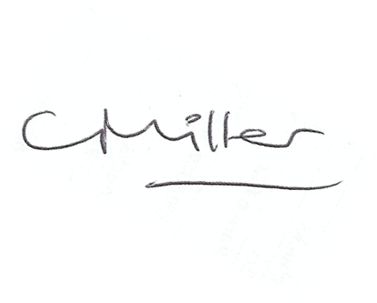
Claire Miller
Parish Clerk

www.parish-council.com/edlingham/links.asp

