EDLINGHAM PARISH COUNCIL
AGENDA PAPER
You are hereby summoned to attend an ordinary meeting of Edlingham Parish Council to be held at Thrunton Fishery on Wednesday 21st August 2019 commencing at 8pm, for the purpose of transacting the business contained within this Agenda.
A five minute participation session will be held for members of the public before the meeting commences

2019/29 Apologies for Absence

2019/30 Declaration of Interests
Members are invited to disclose any Disclosable Pecuniary Interests or other personal interests they may have in any of the items of business on the agenda in accordance with the Code of Conduct.

2019/31 County Cllr Update

2019/32 Minutes of previous meeting held 22nd May 2019
2019/33 Matters arising from previous meeting held 22nd May 2019

2019/34 Planning
2019/34/01 Planning Applications received:
- 19/01932/LBC: The Stables, 1 Lemmington Hall, Listed Building Consent for new glazed opening to existing arch
2019/34/02 Approval of Planning Application received
- 19/00664/FUL: 4 Overthwarts Farm, Swinhope Cottage, erection of 3m x 3m summerhouse in corner of front garden
- 19/01932/LBC: The Stables, 1 Lemmington Hall, Listed Building Consent for new glazed opening to existing arch

2019/35 Correspondence
- CPRE newsletter
- Northumberland Age UK
- Hospicecare North Northumberland – Fund raising events
- Northumberland County Council – Waste leaflets & stickers

2019/36 Finance
2019/36/01 The following payments are to be authorised:
- Northumberland County Council – annual insurance premium - £175.07

2019/37 Neighbourhood Management
2019/38 Local Transport Plan Programme 2020-21
2019/39 Edlingham Community Association
2019/40 Urgent Business
2019/41 Date of Next Meeting

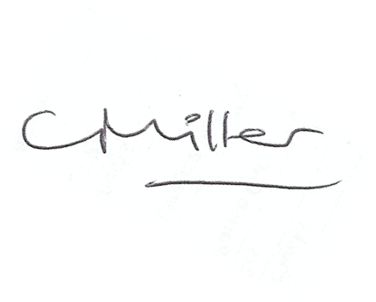
Claire Miller
Parish Clerk

12th August 2019

www.parish-council.com/edlingham/links.asp

